|  |  |  |  |
| --- | --- | --- | --- |
|  | United Nations | ST/SG/AC.10/C.3/2022/43 | |
| _unlogo | **Secretariat** | | Distr.: General  13 April 2022  Original: English |

**Committee of Experts on the Transport of Dangerous Goods  
and on the Globally Harmonized System of Classification  
and Labelling of Chemicals**

**Sub-Committee of Experts on the Transport of Dangerous Goods**

**Sixtieth session**

Geneva, 27 June - 6 July 2022

Item 3 of the provisional agenda

**Listing, classification and packing**

New UN entry for N-Nitroaminoimidazoline

Transmitted by the expert from China[[1]](#footnote-2)

Introduction

1. N-Nitroaminoimidazoline (also known as 4,5-dihydro-n-nitro-1h-imidazol-2-amine, Chemical Abstracts Service (CAS) no. 5465-96-3) is a solid substance used as an intermediate of imidacloprid, a highly effective and low toxic pesticide.
2. It is estimated that the annual production of N-Nitroaminoimidazoline in China reached thousands of tons. A large amount of the product is shipped around the world as unrestricted goods every year. So far, no accident has been reported during manufacturing and transportation.
3. An explosion involving N-Nitroaminoimidazoline in Yancheng on 21 March 2019 caused a large number of casualties and caught the attention of regulators and manufacturers in China on the hazards of nitro compounds. Uncertainty over the classification of N-Nitroaminoimidazoline has become one of the focuses of concern.
4. As discussed below in more detail, N-Nitroaminoimidazoline is not intended to function as an explosive or as a pyrotechnic and does not pose a hazard warranting its consideration as an explosive substance based on the UN definition in 2.1.1.3 (a) and will not “… cause damage to the surroundings” by explosion. Classification of N-Nitroaminoimidazoline as a Class 1 explosive would misrepresent its predominant hazard of flammable solid, per 2.1.1.1 (a): “… except those … where the predominant hazard is appropriate to another class”.
5. An assignment of a UN number and a proper shipping name to N-Nitroaminoimidazoline is proposed to solve the current problem of missing classification. The purpose of this proposal is to establish a uniform classification for N-Nitroaminoimidazoline as oxidizing solid of Division 5.1 and of packing group Ⅲ. A completed data sheet is attached in the annex.

Classification of substances not intended to function as explosives

1. The Model Regulations identify the situations where substances, though not intended to function as explosives, must nevertheless be considered as explosive substances. According to 2.1.1.3 (a), a substance which, though not intended to function as an explosive, is considered to be an explosive substance when the substance:

“is in itself capable, by chemical reaction, of producing gas at such a temperature and pressure and at such a speed as to cause damage to the surroundings”.

Further on in 2.1.1.1 (a), explosive substances are excluded from Class 1 when the “predominant hazard is appropriate to another class”.

1. Analogously other regulations define explosive substances in a similar manner. The ADR defines explosive substances as “solid or liquid substances (or mixtures of substances) capable by chemical reaction of producing gases at such a temperature and pressure and at such a speed as to cause damage to the surroundings”.
2. From the above regulation excerpts, it is seen that the transport regulations consistently exclude a substance not intended to function as an explosive from Class 1 unless it is:

“in itself capable, by chemical reaction, of producing gas at such a temperature and pressure and at such a speed as to cause damage to the surroundings”.

1. However, there is no criterion to determine how a substance not intended to function as an explosive shall be considered as an explosive substance on the basis of burning characteristics which do not produce “gas at a temperature and pressure at such a speed as to cause damage to the surroundings”. Rather, it is suggested that substances whose “predominant hazard” is ordinary burning should be appropriately classified into other classes (e.g., Classes 2.1, 3 and 4). Still, other products with energetic properties may be classified as self-reactive substances or organic peroxides.

Classification of N-Nitroaminoimidazoline

10.N-Nitroaminoimidazoline test results:

(a) Upon Test Series 1, results of the UN gap test, Koenen test and time/pressure test are all “+”, indicating that the substance may have explosive properties. Figures 1 and 2 show the witness plate and tube after the UN gap test and Koenen test respectively. In the time/pressure test, the maximum pressure is 8400 kPa.

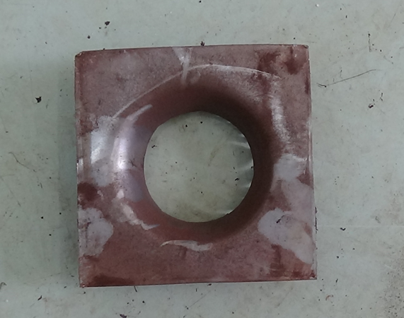

Figure 1: Witness plate after the UN gap test (Test Series 1)

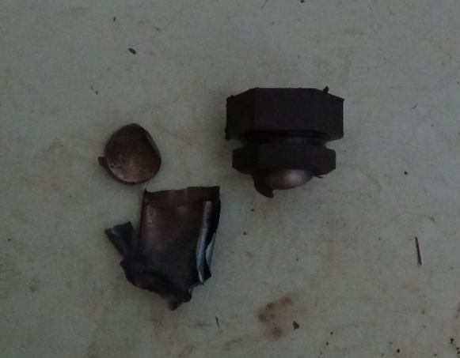

Figure 2: Test tube after the Koenen test (series 1), “F” type

(b) Upon Test Series 2, the outcomes from the UN gap test and time/pressure test are all “-”, but that from the Koenen test is “+”. Figures 3 and 4 show the witness plate and tube after the UN gap test and Koenen test respectively. In the time/pressure test, the time for the pressure rise from 690 kPa to 2070 kPa is 270 ms, much longer than 30 ms.

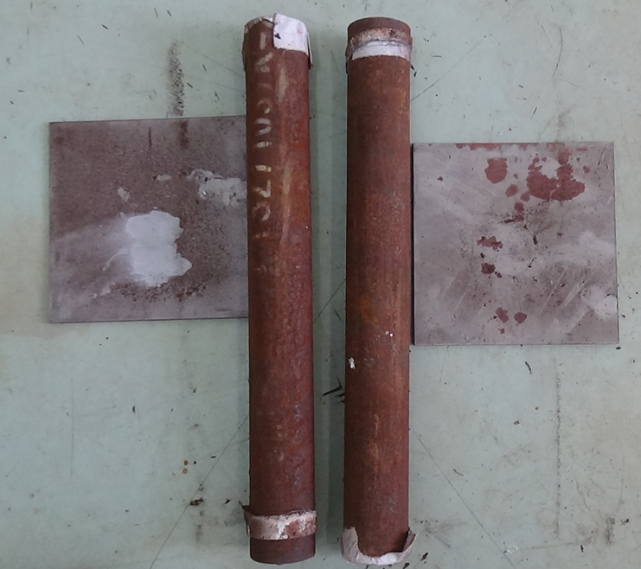

Figure 3: Tube and witness plate after the UN gap test (series 2)

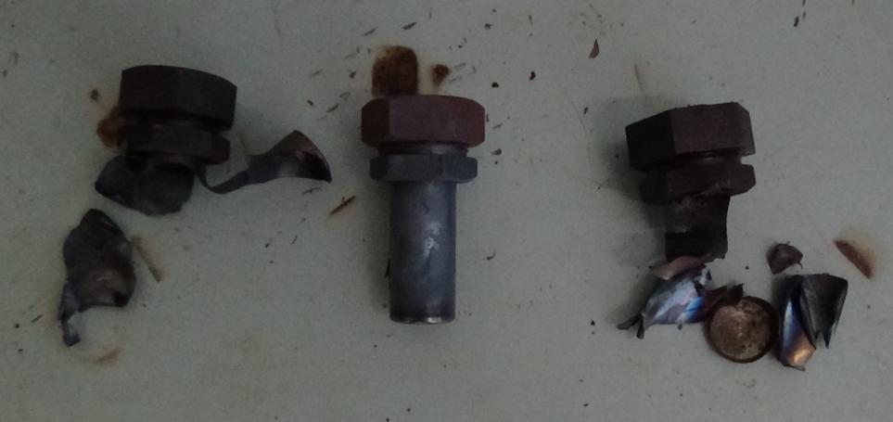

Figure 4: Tube after the Koenen test (series 2)

(c) Upon Test Series 3, the test results of the Impact sensitivity test, Friction sensitivity test, thermal stability test at 75 ℃, and the small-scale burning test are all “‑”, indicating the substance should be considered into Class 1.

(d) Upon Test Series 6 Type 6 (a), single package test, no mass explosion was observed. Only a small amount of the substance around the detonator changed color. Figure 5 shows the package of N-Nitroaminoimidazoline.



Figure 5: 25 kg N-Nitroaminoimidazoline in a kraft bag

11. Fire Behaviour: A fire test of seven 25 kg kraft bags of N-Nitroaminoimidazoline in accordance with the UN 6(c) test was conducted. As can be seen from Figures 6 and 7, the fire from burning mixture of N-Nitroaminoimidazoline, wood shavings soaked with a kerosene and wood is less severe than what might be expected from many flammable liquids (e.g., kerosene) when tested under similar conditions. Combined with heat of combustion (15558 J/g) and burn time (550 s / 100 kg), it shows N-Nitroaminoimidazoline is a candidate to dangerous goods other than substances or articles intended to function as explosives.

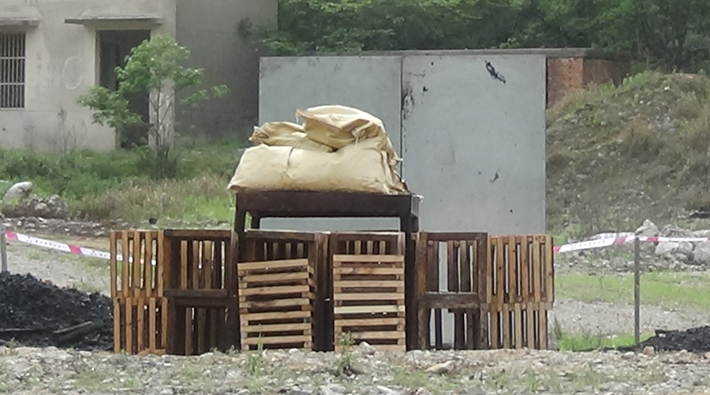

Figure 6: Set-up of the burning test (where wood shavings were inserted between the wood and soaked with kerosene, 7 packages of N-Nitroaminoimidazoline put on metal grid)

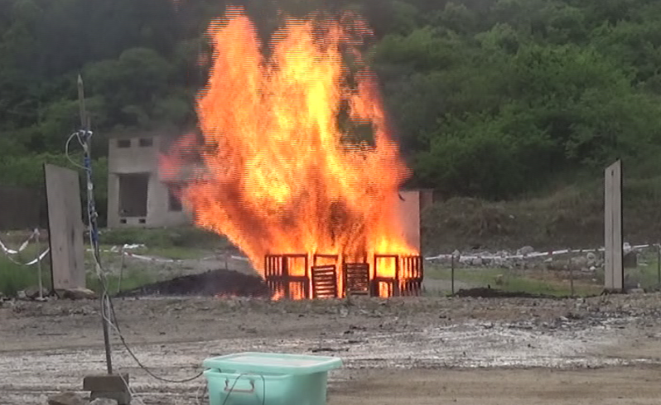

Figure 7 full fire phase (maximum flame) after ignition

12. The test results of N-Nitroaminoimidazoline showed that its hazard is similar to MUSK XYLENE which is finally classified as 4.1 (UN2956).

13. N-Nitroaminoimidazoline was tested and determined to have a self-accelerating decomposition temperature (SADT) of greater than 75 °C, using the heat accumulation storage test (UN H.4). Further, according to test result of differential scanning calorimetry (DSC), N-Nitroaminoimidazoline was determined to have an onset decomposition temperature of 220.4 °C, indicating, on the basis of new provisions in the UN Manual of Tests and Criteria (see 20.3.4 of the seventh revised edition, as amended by Amendment 1), that its SADT is significantly higher. In any case, N-Nitroaminoimidazoline does not qualify as a Division 4.1 self-reactive substance at any level.

14. Division 4.1 Flammable Solid Testing: N-Nitroaminoimidazoline was subjected to the burning rate test for flammable solids. It can be ignited but the flame went out automatically. The test result shows N-Nitroaminoimidazoline is not a flammable solid.

15. Division 5.1 Oxidizing Solid Testing:N-Nitroaminoimidazoline was subjected to the oxidizing test. N-Nitroaminoimidazoline which, in the 4:1 sample-to-cellulose ratio (by mass) tested, exhibits a mean burning time (80s) less than that of the 3:7 mixture (by mass) of potassium bromate and cellulose(100s), but more than that of the 2:3 mixture (by mass) of potassium bromate and cellulose(54s). The test result shows that N-Nitroaminoimidazoline qualifies as a Division 5.1 oxidizing solid packing group III.

Proposal

16. On the basis of the above test results, it is proposed to amend the 3.2 Dangerous Goods List by introducing a new Division 5.1 UN entry for N-Nitroaminoimidazoline (and amend the text of special provision SP133 accordingly), as follows:

|  |  |  |  |  |  |  |  |  |  |  |  |
| --- | --- | --- | --- | --- | --- | --- | --- | --- | --- | --- | --- |
| UN No. | Name and description | Class or division | Subsidiary Hazard | UN packing group | Special provisions | Limited and excepted quantities | | Packagings and IBCs | | Portable tanks and bulk containers | |
| Packing instruction | Special packing provisions | Instructions | Special provisions |
| XXXX | N-Nitroaminoimidazoline | 5.1 |  | Ⅲ | 132  133 | 1 kg | E0 | P5XX |  |  |  |

**“133** If over-confined in packagings, this substance may exhibit explosive behaviour. Packagings authorized under packing instruction**s** P409 **and P5XX** are intended to prevent over-confinement. When a packaging other than those prescribed under packing instruction**s** P409 **and P5XX** is authorized by the competent authority of the country of origin in accordance with 4.1.3.7, the package shall bear an “EXPLOSIVE” subsidiary hazard label (Model No. 1, see 5.2.2.2.2) unless the competent authority of the country of origin has permitted this label to be dispensed with for the specific packaging employed because test data have proved that the substance in this packaging does not exhibit explosive behaviour (see 5.4.1.5.5.1). The provisions of 7.1.3.1 shall also be then considered.”

|  |
| --- |
| P5XX Packing instruction P5XX |
| This instruction applies to UN xxxx. |
| The following packagings are authorized, provided that the general provisions of 4.1.1 and 4.1.3 are met:   1. Fibre drum (1G) which may be fitted with a liner or coating; maximum net mass: 50 kg 2. Combination packagings: Fibreboard box (4G) with a single inner plastic bag; 3. Combination packagings: Fibreboard box (4G) or fibre drum (1G) with inner plastic packagings each containing a maximum of 5kg; maximum net mass:25kg. |

Annex

Data sheet to be submitted to the United Nations  
for new or amended classification of substances

**Submitted by**: **CHINA**  **Date**: 1 April, 2022

**Section 1. SUBSTANCE IDENTITY**

1.1 Chemical name: N-Nitroaminoimidazoline

1.2 Chemical formula: C3H6N4O2

1.3 Other names/synonyms: 4,5-dihydro-n-nitro-1h-imidazol-2-amine

1.4.1 UN number: **XXXX** 1.4.2 CAS number: 5465-96-3

1.5 Proposed classification for the Recommendations

1.5.1 Proper shipping name (3.1.2): N-Nitroaminoimidazoline

1.5.2 class/division: **5.1** Subsidiary risk(s): **None** Packing group: **Ⅲ**

1.5.3 proposed special provisions, if any: **None**

1.5.4 proposed packing instruction(s): **P5XX**

**Section 2. PHYSICAL PROPERTIES**

2.1 Melting point or range: 220 °C

2.2 Boiling point or range: 255.1±23.0 °C(Predicted)

2.3 Relative density at:

2.3.1 15 °C: Not determined

2.3.2 20 °C: 1.81±0.1 g/cm3(Predicted)

2.3.3 50 °C: Not determined

2.4 Vapour pressure at:

2.4.1 50 °C: Not determined

2.4.2 65 °C: Not determined

2.5 Viscosity at 20 °C[[2]](#footnote-3)2: Not determined

2.6 Solubility in water at 20 °C: Slightly soluble

2.7 Physical state at 20 °C: Solid (solid/liquid/gas)

2.8 Appearance at normal transportation temperatures, including colour and odour: Very slight chemical odour, but not offensive. white powder.

2.9 Other relevant physical properties: N/A

**Section 3. Flammability**

3.1 Flammable vapour

3.1.1 Flash point: Not Determined

3.1.2 Is combustion sustained?: Not Determined

3.2 Autoignition temperature: Not Determined

3.3 Flammability range (LEL/UEL): Not Determined

3.4 Is the substance a flammable solid?: No

**Section 4. CHEMICAL PROPERTIES**

4.1 Does the substance require inhibition/stabilization or other treatment such as nitrogen blanket to prevent hazardous reactivity? No

4.2 Is the substance explosive according to paragraph 2.1.1.1? (2.1) No

4.3 Is the substance a desensitized explosive? (2.4.2.4) No

4.4 Is the substance a self-reactive substance? (2.4.1) No

4.5 Is the substance pyrophoric? (2.4.3) No

4.6 Is the substance liable to self-heating? (2.4.3) No

4.7 Is the substance an organic peroxide? (2.5.1) No

4.8 Does the substance in contact with water emit flammable gasses? (2.4.4) No

4.9 Does the substance have oxidizing properties? (2.5.1) Yes

4.9.1 According to Test O.1: test for *Oxidizing Solids,* N-Nitroaminoimidazoline which, in the 4:1 sample-to-cellulose ratio (by mass) tested, exhibits a mean burning time (80s) is less than the mean burning time of a 3:7 mixture (by mass) of potassium bromate and cellulose(100s), but is more than the mean burning time of a 2:3 mixture (by mass) of potassium bromate and cellulose(54s)

4.10 Corrosivity (2.8) to: **There are no corrosive properties associated with this substance**

4.10.1 Mild steel ………….mm/year at ………………………………. °C N/A

4.10.2 Aluminum ………….mm/year at ………………………………. °C N/A

4.10.1 Other packaging materials (specify)

……………….mm/year at ………………………………. °C

……………….mm/year at ………………………………. °C

4.11 Other relevant chemical properties: N/A

**Section 5. HARMFUL BIOLOGICAL EFFECTS**

5.1 LD50, Oral (2.6.2.1.1) Animal species? Not determined

5.2 LD50, Dermal (2.6.2.1.2): Not determined

5.3 LC50, Inhalation (2.6.2.1.3) Exposure time: Not listed

5.4 Saturated vapour concentration at 20 °C (2.6.2.2.4.3) Not determined

5.5 Skin exposure (2.8) results: Not determined

5.6 Other data: N/A

5.7 Human experience: Not determined

**Section 6. SUPPLEMENTARY INFORMATION**

6.1 Recommended emergency action

6.1.1 Fire (include suitable and unsuitable extinguishing agent): Carbon Dioxide, Dry Chemical, Foam, Water Fog

6.1.2 Spillage: Remove all sources of ignition. Avoid breathing dust and keep dust to a minimum. Wet with water if necessary. Contain and remove with a broom and non-sparking tools.

6.2 Is it proposed to transport the substance in:

6.2.1 Bulk Containers (6.8\*) No

6.2.2 Intermediate Bulk Containers (6.5\*) No

6.2.3 Portable tanks (6.7\*) No

\*If yes provide details in Sections 7, 8 and/or 9

**Section 7. BULK CONTAINERS (Only complete if yes 6.2.1) …N/A**

**Section 8. INTERMEDIATE BULK CONTAINERS (Only complete if yes in 6.2.2) …N/A**

**Section 9. MULTIMODAL TANK TRANSPORT (Only complete if yes in 6.2.3) …N/A**

**Appendix** [English only]

Figure 1: the provisional acceptance procedure

Results from the application of the provisional acceptance procedure   
in the class of explosives of N-Nitroaminoimidazoline

|  |  |
| --- | --- |
| 1. Name of substance:： | N-Nitroaminoimidazoline |
| 1. **General data** |  |
| 2.1 Composition： | 99% N-Nitroaminoimidazoline |
| 2.2 Molecular formula： | C3H6N4O2 |
| 2.3 Physical form： | Fine powder |
| 2.4 Color： | White |
| 2.5 Apparent density： | 1.81g/cm3 |
| 2.6 Particle size： |  |
| 1. **Box 2：** | Is the substance manufactured with the view to producing a practical explosive or pyrotechnic effect? |
| 3.1 Answer： | No |
| 3.2 Exit： | Go to Box 3 |
| 1. **Box 3：** | Is it a candidate for ammonium nitrate emulsion, suspension or gel, intermediate for blasting explosives, ANE? |
| 4.1 Answer： | No |
| 4.2 Exit： | Go to Box 4 |
| 1. **Box 4：** | Test Series 1 |
| 5.1 Propagation of detonation： | UN gap test (test 1(a)) |
| 5.2 Sample conditions： | Ambient temperature |
| 5.3 Observations： | Fragmentation length 40 cm |
| 5.4 Result： | “+”, propagation of detonation |
| 5.5 Effect of heating under confinement： | Koenen test (test 1(b)) |
| 5.6 Sample conditions： | Mass 16.5 g |
| 5.7 Observations： | Limiting diameter 2.0 mm  Fragmentation type "F" (time to reaction 17 s, duration of reaction 10 s) |
| 5.8 Result： | “+”, shows some explosive effects on heating under confinement |
| 5.9 Effect of ignition under confinement： | Time/pressure test (test 1 (c) (i)) |
| 5.10 Sample conditions： | Ambient temperature |
| 5.11 Observations： | Ignition, the maximum pressure is 8400 kPa |
| 5.12 Result： | “+”, the substance to show the ability to deflagrate under confinement |
| 5.13 Exit： | Go to Box 5 |
| 1. **Box 5：** | Does it have explosive properties? |
| 6.1 Answer from Test Series 1： | Yes |
| 6.2 Exit： | Go to Box 6 |
| 1. **Box 6：** | Test Series 2 |
| 7.1 Sensitivity to shock： | UN gap test (test 2(a)) |
| 7.2 Sample conditions： | Ambient temperature |
| 7.3 Observations： | No propagation |
| 7.4 Result： | “-”, not sensitive to shock |
| 7.5 Effect of heating under confinement： | Koenen test (test 2(b)) |
| 7.6 Sample conditions： | Mass 16.5 g |
| 7.7 Observations： | Limiting diameter 2.0mm  Fragmentation type "F" (time to reaction 17 s, duration of reaction 10 s) |
| 7.8 Result： | “+”, violent effect on heating under confinement |
| 7.9 Effect of ignition under confinement： | Time/pressure test (test 2 (c) (i)) |
| 7.10 Time/pressure test (test 1 (c) (i))： | Ambient temperature |
| 7.11 Observations： | Ignition, the maximum pressure is 8400 kPa, and the time for a pressure rise from 690 kPa to 2070 kPa is 270 ms, less than 30 ms |
| 7.12 Result： | “-”, the substance to show slow deflagration under confinement |
| 7.13 Exit： | Go to Box 7 |
| 1. **Box 7：** | Is it too insensitive for acceptance into this class? |
| 8.1 Answer from Test Series 2： | No |
| 8.2 Conclusion： | Substance to be considered in this class (box 10) |
| 8.3 Exit： | Go to Box 11 |
| 1. **Box 11：** | Test Series 3 |
| 9.1 Thermal stability： | 75 °C/48 hour test (test 3(c)(i)) |
| 9.2 Sample conditions： | 100 g of substance at 75 °C |
| 9.3 Observations： | No ignition, explosion, self-heating or visible decomposition |
| 9.4 Result： | “-”, thermally stable |
| 9.5 Impact sensitivity： | BAM fallhammer test (test 3 (a) (ii)) |
| 9.6 Sample conditions： | as received |
| 9.7 Observations： | Limiting impact energy > 100 J |
| 9.8 Result： | “-”， not unstable in the form it was tested |
| 9.9 Friction sensitivity： | BAM friction test (test 3 (b) (i)) |
| 9.10 Sample conditions： | as received |
| 9.11 Observations： | Limiting load > 360 N |
| 9.12 Result： | “-”， not unstable in the form it was tested |
| 9.13 Ease of deflagration to detonation transition： | Small scale burning test (test 3 (d)) |
| 9.14 Sample conditions： | Ambient temperature |
| 9.15 Observations： | Ignites and burns slowly |
| 9.16 Result： | “-”, not unstable in the form it was tested |
| 9.17 Exit： | Go to Box 12 |
| 1. **Box 12：** | Is it thermally stable？ |
| 10.1 Answer from test 3(c)： | Yes |
| 10.2 Exit： | Go to Box 13 |
| 1. **Box 13：** | Is it unstable in the form it was tested? |
| 11.1 Answer from Test Series 3： | No |
| 11.2 Exit： | Go to Box 19 |
| 1. **Conclusion：** | PROVISIONALLY ACCEPT INTO THIS CLASS |
| 12.2 Exit： | Apply procedure for assignment to a division of the class of explosives |



Figure 2 the procedure for assignment to a division of the class of explosives

Results from the application of the procedure for assignment to   
a division of the class of explosives of N-Nitroaminoimidazoline

|  |  |
| --- | --- |
| 1. **Box 26：** | Is the substance a candidate for Division 1.5? |
| 1.1 Answer： | No |
| 1.2 Result： | Package the substance (box 30) |
| 1.3 Exit： | Go to box 31 |
| 1. **Box 31：** | Test Series 6 |
| 2.1 Effect of initiation in the package： | Test 6 (a) with detonator |
| 2.2 Sample conditions： | Ambient temperature, 25 kg kraft bag |
| 2.3 Observations： | Only a few substances around the detonator change color |
| 2.4 Result： | No significant reaction |
| 2.5 Effect on ignition in the package： | not required as the test result of 2(c)( i) is “-” |
| 2.6 Effect of propagation： | Type 6 (b) test not required as no effect outside package between packages in 6 (a) test |
| 2.7 Effect of fire engulfment： | Test 6 (c) |
| 2.8 Sample conditions： | 7×25 kg kraft bag mounted on steel frame above wooden crib fire |
| 2.9 Observations： | Only show burning |
| 2.10 Result： | No effects which would hinder fire fighting |
| 2.11 Exit： | Go to box 32 |
| 1. **Box 32：** | Is the result a mass explosion? |
| 3.1 Answer from Test Series 6： | No |
| 3.2 Exit： | Go to box 33 |
| 1. **Box 33** | Is the major hazard that from dangerous projections? |
| 4.1 Answer from Test Series： | No |
| 4.2 Exit： | Go to box 34 |
| 1. **Box 34：** | Is the major hazard radiant heat and/or violent burning but with no dangerous blast or projection hazard? |
| 5.1 Answer from Test Series 6： | No |
| 5.2 Exit： | Go to box 35 |
| 1. **Box 35：** | Would the hazard hinder fire-fighting in the immediate vicinity? |
| 6.1 Answer from Test Series 6： | No |
| 6.2 Exit： | Go to box 36 |
| 1. **Box 36：** | Does special provision 347 apply? |
| 7.1 Answer： | No |
| 7.2 Exit： | Go to box 38 |
| 1. **Box 38：** | Is the substance or article manufactured with the view of producing a practical explosive or pyrotechnic effect? |
| 8.1 Answer： | No |
| 8.2 Exit： | Go to box 24 |
| 1. **Conclusion：** | NOT AN EXPLOSIVE |
| 9.1 Exit： | Consider for another class/division |

1. A/75/6 (Sect.20), para. 20.51 [↑](#footnote-ref-2)
2. 2 See definition of "liquid" in 1.2.1 of the Model Regulations on the Transport of Dangerous Goods. [↑](#footnote-ref-3)