|  |  |  |  |
| --- | --- | --- | --- |
|  | United Nations | ST/SG/AC.10/C.3/2022/40 | |
| _unlogo | **Secretariat** | | Distr.: General  12 April 2022  Original: English |

**Committee of Experts on the Transport of Dangerous Goods  
and on the Globally Harmonized System of Classification  
and Labelling of Chemicals**

**Sub-Committee of Experts on the Transport of Dangerous Goods**

**Sixtieth session**

Geneva, 27 June-6 July 2022

Item 3 of the provisional agenda

**Listing, classification and packing**

New special provision and special packing provision of UN 2029

Transmitted by the expert from China[[1]](#footnote-2)

Introduction

1. Hydrazine anhydrous (CAS No. 302-01-2) is a widely used raw material. With high combustion heat, it can be used as fuel for rockets and fuel cells, foaming agents, crop insecticides, water treatment agents, etc. UN number 2029 in the Model Regulations is assigned, and the hazard class is Class 8. The subsidiary hazard is Class 3 and/or 6.1.
2. After hydrazine anhydrous based propellants (content ≥ 99 %) have caused many explosion accidents, its hazard classification was examined by the Nanjing University of Science and Technology (NUST). For this purpose, UN test series 1, 3 and 6 have been performed.
3. The test results showed that: (i) In UN test series 1, the results of UN gap test and time/pressure test are both "-" while the result of Koenen test is "+" with the limiting diameter of 3.0 mm; (ii) in test series 3, the results of 3 (a), 3 (b), 3 (c) and 3 (d) are all "-"; (iii) after the sample was packaged in stainless steel tank, test series 6 was carried out and in UN test 6 (a), the test result is "-". In UN test 6 (c), the reaction characteristics of the sample are highly dependent on packaging configurations. Different reactions such as explosion, deflagration and burning of the hydrazine anhydrous may occur under different packaging configurations. The stronger the confinement, the more hazardous the reaction. More details of the test results are presented in the annex to this document.

Proposal

4. In 3.2 Dangerous Goods List, amend the entry for UN 2029 by adding special provision 132, a new special provision XXX and special packing provision PP5, as follows (newt text is bold underlined):

|  |  |  |  |  |  |  |  |  |  |  |  |
| --- | --- | --- | --- | --- | --- | --- | --- | --- | --- | --- | --- |
| UN No. | Name and description | Class | Subsidiary hazard | UN packing group | Special provisions | Limited and excepted quantities | | Packagings and IBCs | | Portable tanks and bulk containers | |
| Packing instruction | Special packing provisions | Instructions | Special provisions |
| 2029 | Hydrazine Anhydrous | 8 | 3  6.1 | I | **132**  **XXX** | 0 | E0 | P001 | **PP5** |  |  |

5. In 3.3 add a new special provision XXX for UN 2029 to read as follow:

“XXX: If over-confined in packagings, this substance may exhibit explosive behaviour. This entry may only be used for goods that are not classified into Class 1 (see *Manual of Tests and Criteria*, Part I). Packagings authorized under packing instruction P001 and special packing provision PP5 are intended to prevent over-confinement. When a packaging other than those prescribed under P001 and PP5 is authorized by the competent authority of the country of origin in accordance with 4.1.3.7, the hazard class as an explosive shall be considered first.”

6. In 4.1.4.1 amend special packing provision PP5 to read as follow (new text is underlined):

“**PP5** For UN Nos. 1204 and 2029, packagings shall be so constructed that explosion is not possible by reason of increased internal pressure. Gas cylinders and gas receptacles shall not be used for these substances.”

7. The explosiveness of hydrazine anhydrous may lead it be classified as different divisions and compatibility groups, including 1.1C, 1.2C, 1.3C, 1.4C and 1.4S, depending on packaging used. There are two options: (i) Adding new Class 1 UN entries into the 3.2 Dangerous Goods List; or (ii) Using the generic and “not otherwise specified” proper shipping names to solve this problem. Experts from China consider option (i) as most appropriate and would like to hear the comments from the Sub-Committee.

Annex

Results of test series 6 (c) for hydrazine anhydrous under different packaging conditions

Submitted by: CHINA Date: 1 April, 2022

1. **Preliminary 6 (c) test on hydrazine anhydrous**

Test condition：20 L cylindrical stainless steel storage tank. Pressure resistance of the tank shell is 1 MPa. Kerosene was used as fuel.

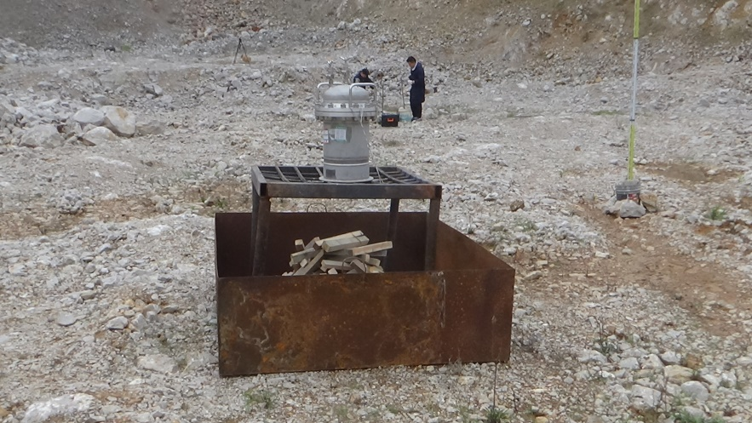

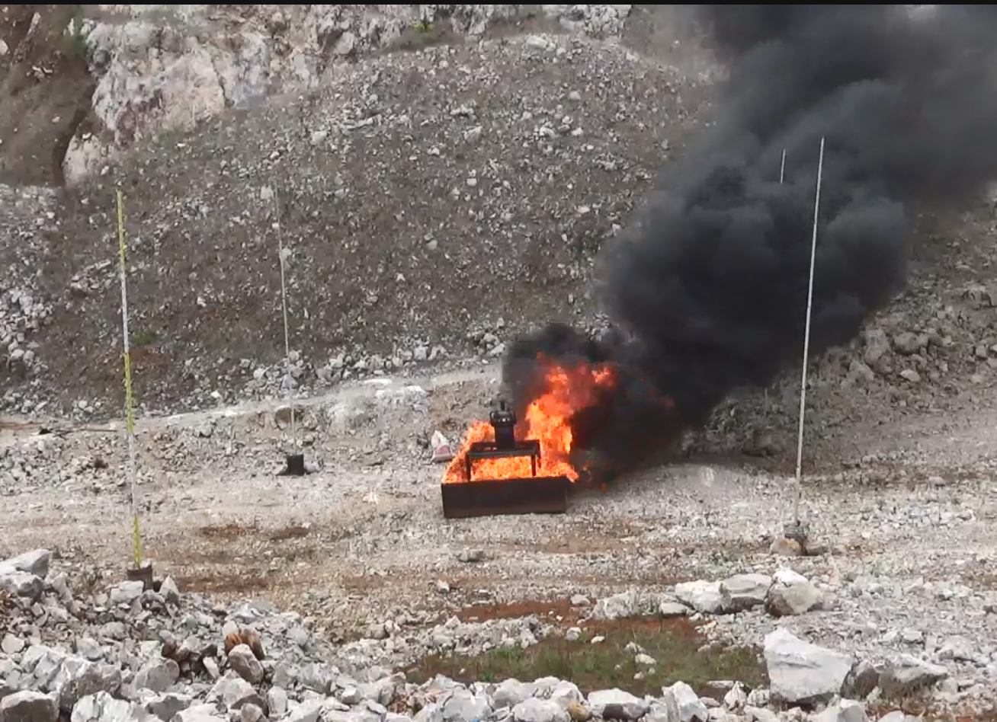

Figure 1: 20 L cylindrical stainless steel storage tank in the 6 (c) test.

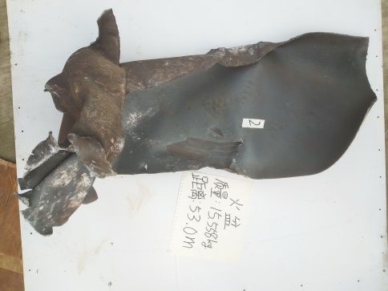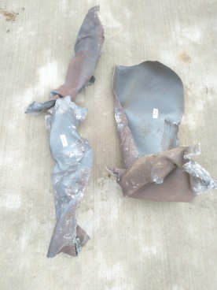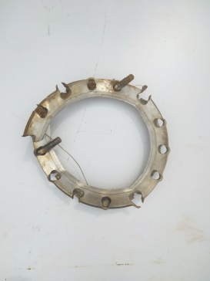

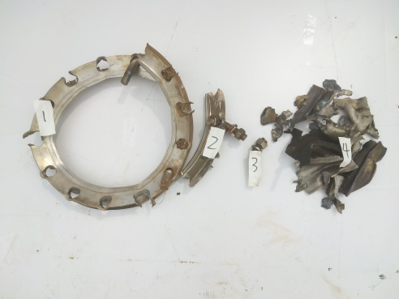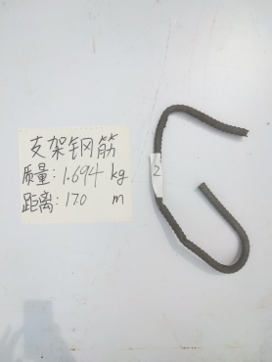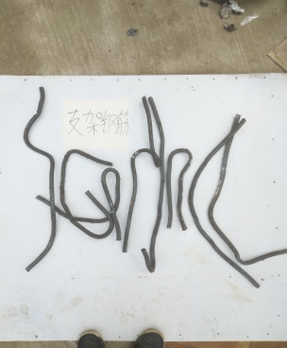

Figure 2: Fragments of the tank after the test.

Test result：mass explosion occurred, and the storage tank was completely shattered.

Remark：This test was designed to simulate an accident scene. Considering that hydrazine anhydrous is classified as UN 2029 (Class 8), no explosion was anticipated. Therefore, shock wave measurement system and high-speed video were not deployed during the test. Based on this test results, the second repetition test was designed.

1. **Second 6 (c) test on hydrazine anhydrous**

Test condition：20 L cylindrical stainless steel storage tank. Pressure resistance of tank shell is 1 MPa. Kerosene was used as fuel.

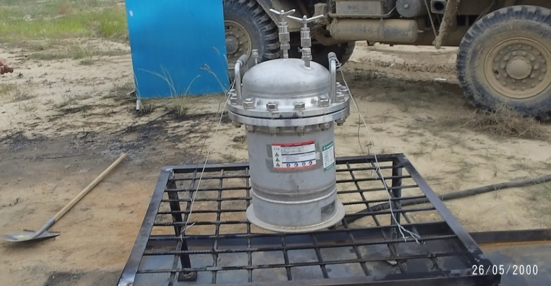

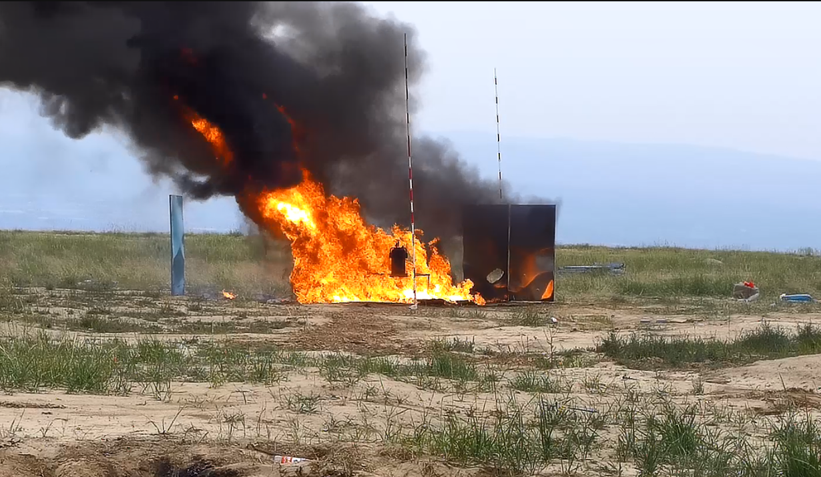

Figure 3: 20 L cylindrical stainless steel storage tank in the 6 (c) test.

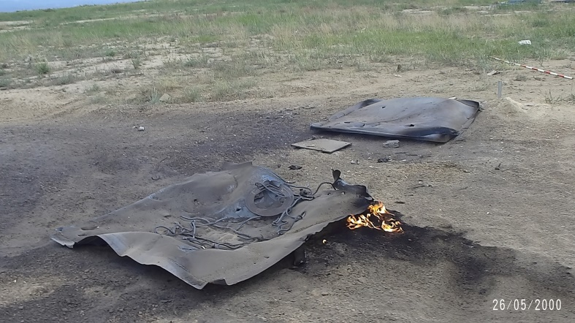

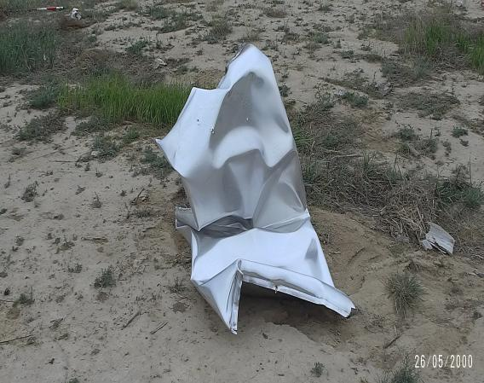

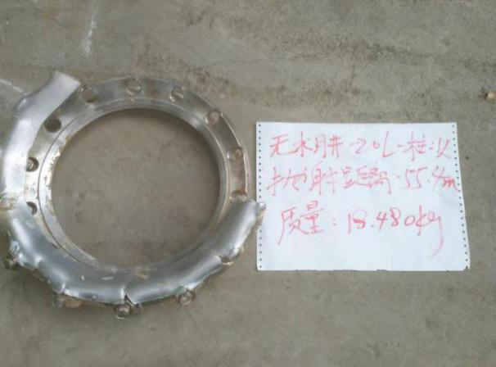

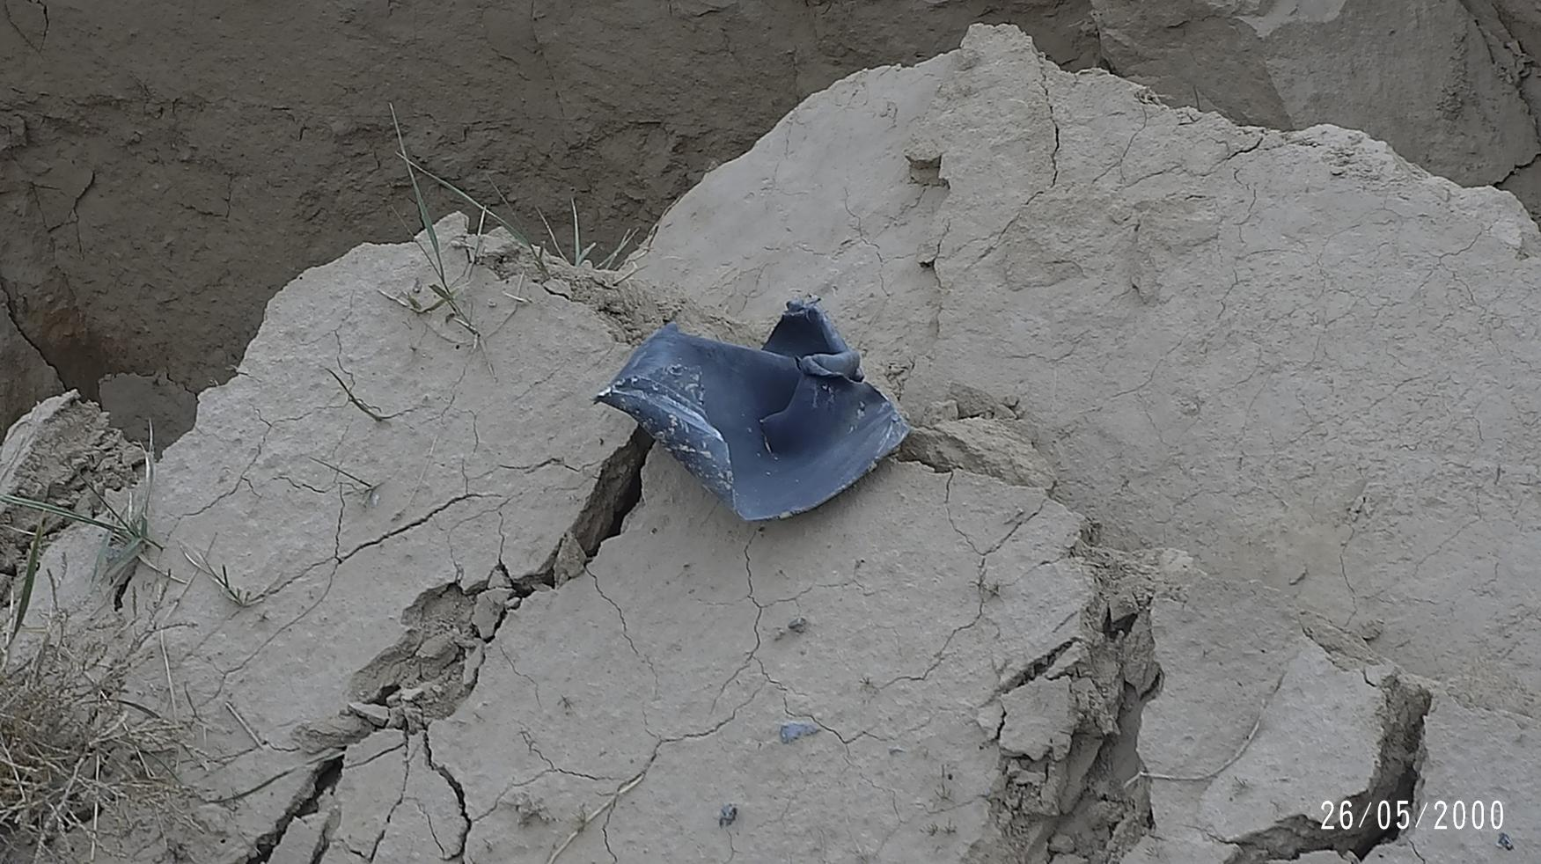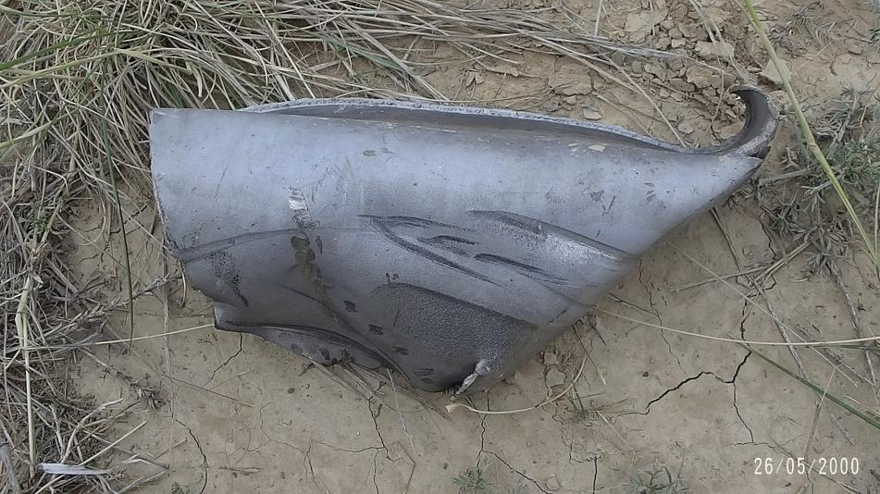

Figure 4: Fragments of the tank after the test.

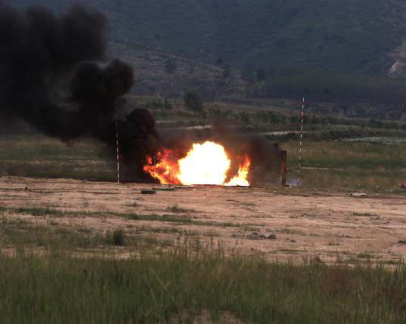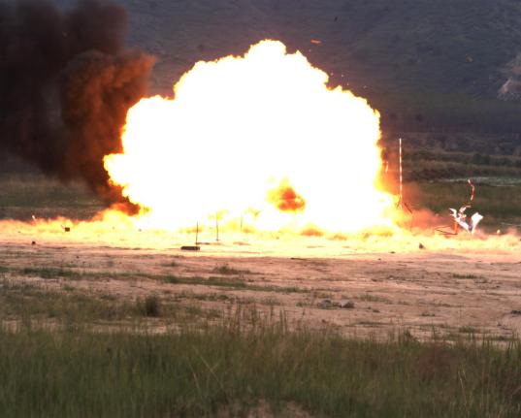

0 ms 100 ms

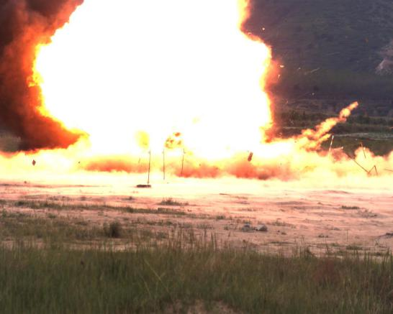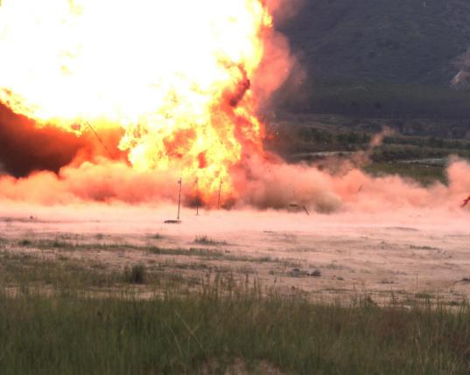

500 ms 1000 ms

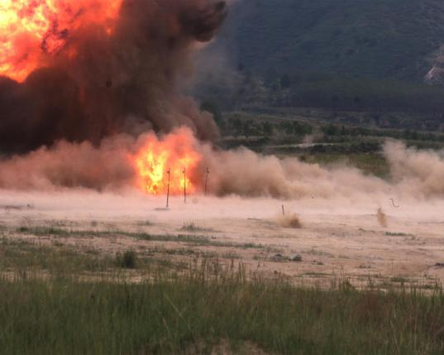

1500 ms

Figure 5: Screen shots from high-speed video during the test.

**Results of the shock wave overpressure in the air measured during the second test.**

Table 1 shows the peak of shock wave overpressure in the air when the sample exploded.

Table 1: the peak of shock wave overpressure

|  |  |  |  |  |  |  |  |  |  |
| --- | --- | --- | --- | --- | --- | --- | --- | --- | --- |
| Sample | Test line | Shock wave overpressure (kPa) | | | | | | | |
| 5 m | 7 m | 9 m | 11 m | 14 m | 16 m | 18 m | 21 m |
| hydrazine anhydrous packaged in 20 L cylindrical stainless steel tank | 1 | 320.72 | 172.05 | 91.86 | 72.51 | 50.11 | 41.48 | 30.42 | 25.95 |
| 2 | 339.60 | 148.89 | 96.38 | 65.63 | 43.47 | 32.33 | 25.63 | 21.14 |



Distance [m]

Anhydrous hydrazine-20 L

Average overpressure of shock wave [kPa]

Figure 6: The relationship between shock wave overpressure and distance

Take as abscissa, and shock wave overpressure as ordinate. Using the explosion similarity law, the fitted curve and the equation of the fitted curve can be obtained by fitting the shock wave over pressure to the distance.



Ground reflection over pressure [kPa]

Anhydrous hydrazine-20 L  
Anhydrous hydrazine-20 L fitting curve

Figure 7: Relationship between shock wave overpressure and $\overline{R}$

Fitting equation：



Substitute the shock wave overpressure of the sample into the fitting equation of TNT(）, Table 2 shows the TNT equivalent of the sample explosion.

Table 2: TNT equivalent of hydrazine anhydrous explosion

|  |  |  |  |  |  |  |  |  |  |  |
| --- | --- | --- | --- | --- | --- | --- | --- | --- | --- | --- |
| Sample | TNT equivalent [kg] | | | | | | | | | TNT equivalent |
| 5 m | 7 m | 9 m | 11 m | 14 m | 16 m | 18 m | 21 m | Average |
| hydrazine anhydrous packaged in 20 L cylindrical stainless steel tank | 10.86 | 11.57 | 11.56 | 13.25 | 14.68 | 14.69 | 12.85 | 14.79 | 13.03 | 0.72 |

Test result: mass explosion occurred, storage tank was completely shattered, and the evident shock wave overpressure was measured.

1. **Third 6 (c) test on hydrazine anhydrous**

Test condition：120 L cylindrical stainless steel storage tank. Pressure resistance of tank shell is 0.33 MPa. Kerosene was used as fuel.

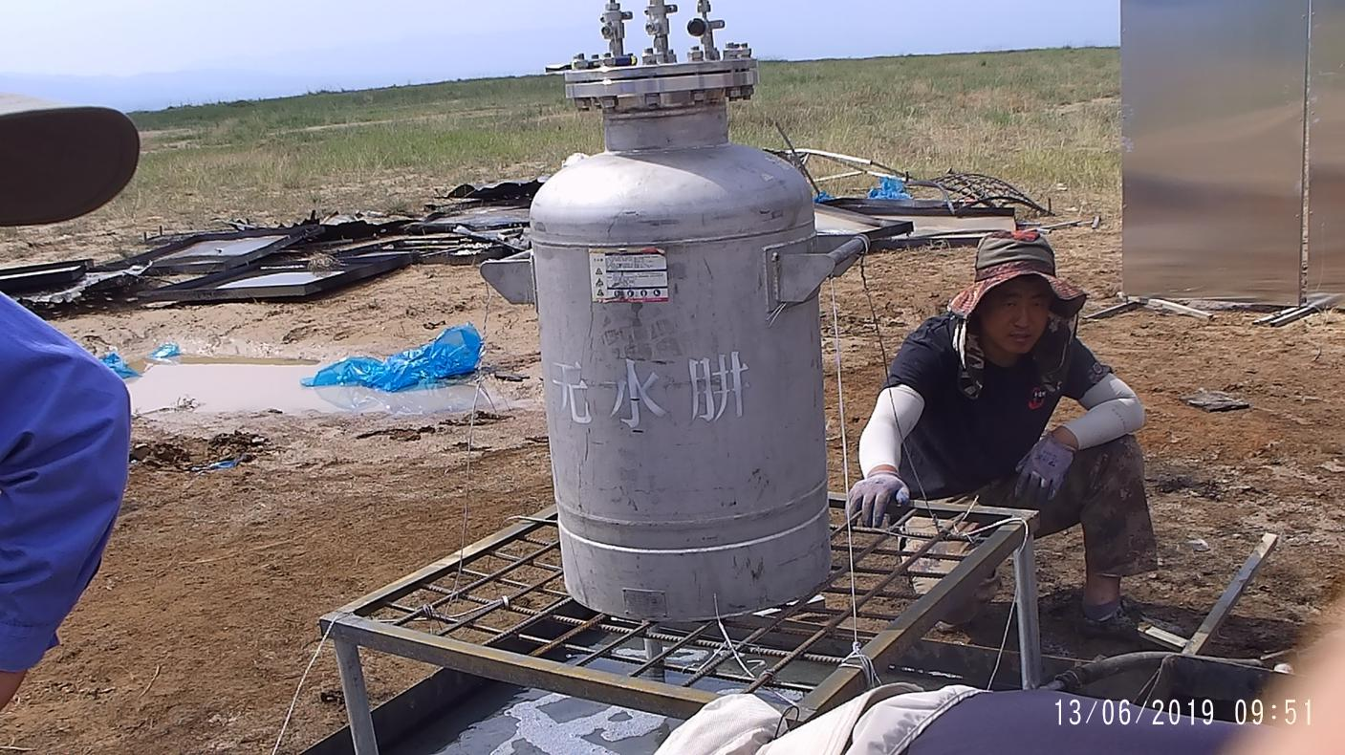

Figure 8: Hydrazine anhydrous packaged in 120 L cylindrical stainless steel storage tank.

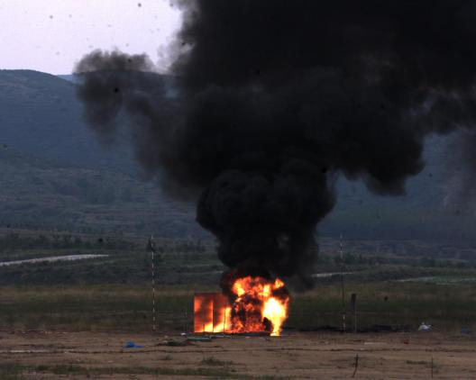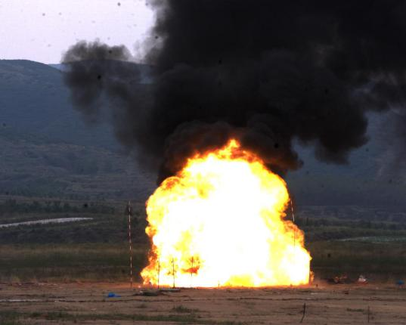

0 ms 100 ms

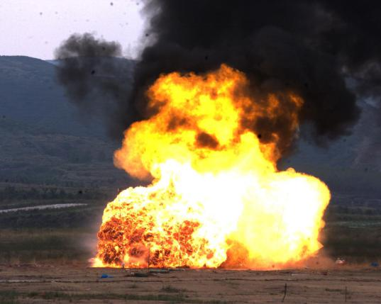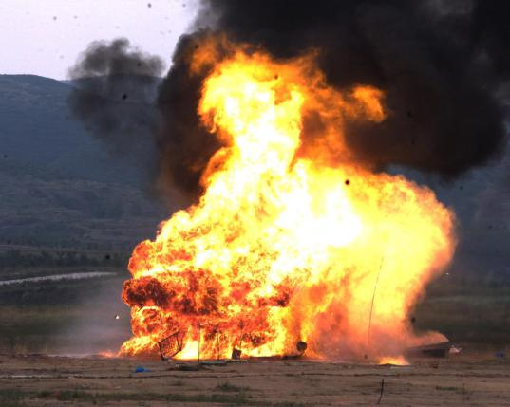

500 ms 1000 ms

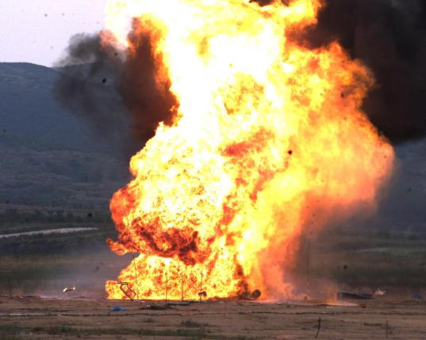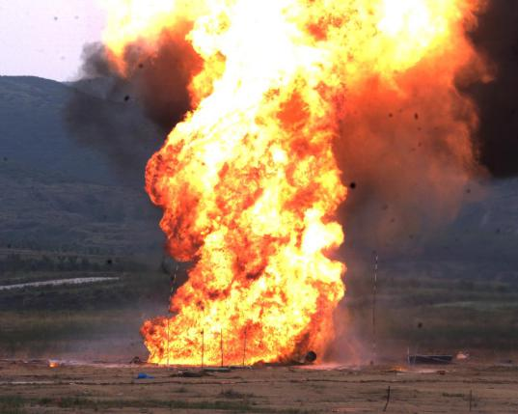

1500 ms 2000 ms

Figure 9: Screen shots from high-speed video during the third test.

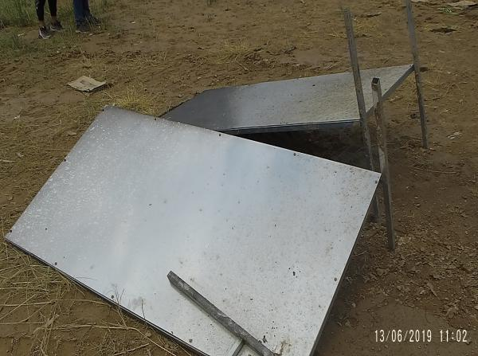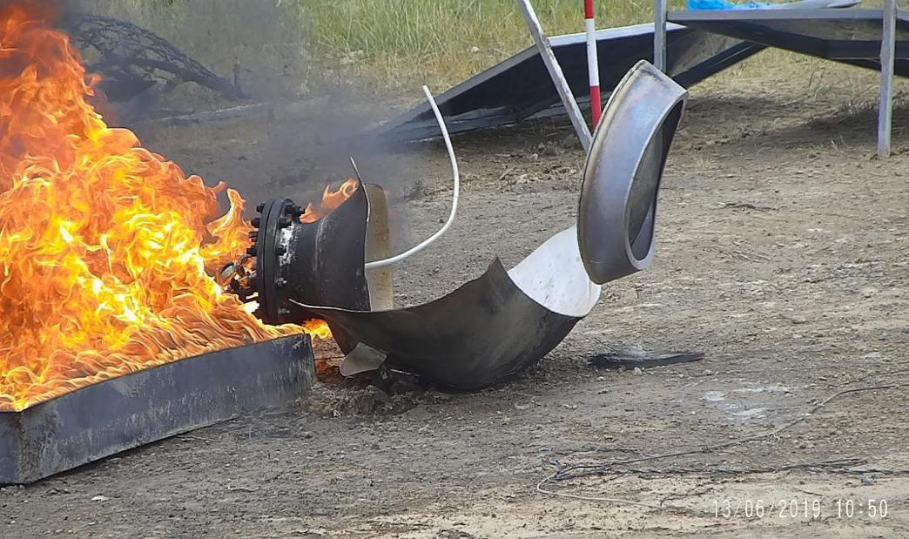

Figure 10: The witness plate and tank after test.

Results of shock wave overpressure measured during test.

Table 3 shows the peak of shock wave overpressure when the sample exploded.

Table 3: The peak of shock wave overpressure

|  |  |  |  |  |  |  |  |  |  |
| --- | --- | --- | --- | --- | --- | --- | --- | --- | --- |
| Sample | Test line | Shock wave overpressure [kPa] | | | | | | | |
| 5 m | 7 m | 9 m | 11 m | 14 m | 16 m | 18 m | 21 m |
| hydrazine anhydrous packaged in 120 L cylindrical stainless steel tank | 1 | 10.382 | 8.390 | 5.755 | 4.511 | 3.264 | 2.437 | 1.867 | 1.600 |
| 2 | 9.242 | 7.801 | 6.357 | 4.165 | 3.765 | 2.915 | 2.760 | 0.729 |



Distance [m]

Anhydrous hydrazine-120 L

Average overpressure shock wave [kPa]

Figure 11: Relationship between shockwave overpressure and distance

Take as abscissa, and shock wave over pressure as ordinate. Using the explosion similarity law, the fitted curve and the equation of the fitted curve can be obtained by fitting the shock wave over pressure with the distance.



120kg-AH-columnar

120kg-AH-columnar fitting curve

Ground reflection over pressure

Figure 12: Relationship between shock wave overpressure and $\overline{R}$

Fitting equation：



Substitute the shock wave overpressure of sample into fitting the equation of TNT(）, Table 2 shows the TNT equivalent of sample explosion.

Table 4: TNT equivalent of hydrazine anhydrous explosion

|  |  |  |  |  |  |  |  |  |  |  |
| --- | --- | --- | --- | --- | --- | --- | --- | --- | --- | --- |
| Sample | TNT equivalent /kg | | | | | | | | | TNT equivalent |
| 5 m | 7 m | 9 m | 11 m | 14 m | 16 m | 18 m | 21 m | average |
| hydrazine anhydrous packaged in 120 L cylindrical stainless steel tank | 0.034 | 0.059 | 0.063 | 0.049 | 0.059 | 0.044 | 0.041 | 0.011 | 0.045 | 0.00038 |

Test result: during the test, the tank burst and the hydrazine anhydrous burnt stably. No mass explosion occurred. After test, no damage or perforation of the witness screens was observed, and no shock wave overpressure was measured in the air.

1. Conclusion

The above test results have shown that the packaging configurations have a significant impact on the hazardous reaction of hydrazine anhydrous. In over-confined packagings, it will react violently and explode in a fire. To avoid major changes to the classification of hydrazine anhydrous in the UN Model Regulations and significant impact on the existing hydrazine anhydrous industry, it is proposed to add special provisions on hydrazine anhydrous and its packaging configurations to effectively improve the safety of hydrazine anhydrous during transportation.

1. A/75/6 (Sect.20), para. 20.51 [↑](#footnote-ref-2)