Proposal for amendments to
ECE/TRANS/WP.29/GRVA/2022/3 and ECE/TRANS/WP.29/GRVA/2022/4

The text reproduced below was prepared by the experts from the ‘task force on testing’ lead by JRC/EC. The proposal is aimed at modifying the text concerning Annex 5 and 6 contained in document ECE/TRANS/WP.29/GRVA/2022/3 and ECE/TRANS/WP.29/GRVA/2022/4 by the Special Interest Group on Regulation 157 (ALKS). The modifications to the existing text of UN Regulation No. 157 (incl. Supplement 2) are given in blue text. Deletions are indicated by red strikethrough text.
I. Proposal – Annex 5
Annex 5, Paragraph 1., amend to read:
Test Specifications for track testing of ALKS vehicles
1. Introduction
This annex defines track tests with the purpose to verify the technical requirements on ALKS. All the tests in this annex shall be performed or witnessed by the Technical Service during the approval process as specified below.
Until such time that specific test provisions have been agreed, the type-approval authority or the Technical Service acting on its behalf (hereafter referred as type-approval authority) shall ensure that the ALKS is subject to at least the tests outlined in Annexes 5 and 6. The specific test parameters for each test shall be selected by the Technical Service type-approval authority and shall be recorded in the test report in such a manner that allows traceability and repeatability of the test setup.
Pass- and Fail-Criteria for tests are derived solely from the technical requirements in paragraphs 5 to 7 of the Regulation. These requirements are worded in a way that they allow the derivation of pass-fail-criteria not only for a given set of test parameters, but for any combination of parameters in which the system is designed to work (e.g. operating speed range, operating lateral acceleration range, curvature range as contained in the system boundaries).
The test specifications specified in this document are meant to be shall be intended as a minimum set of tests., the technical service Type-approval authorities may perform any other additional tests within the system ODD boundaries and may then compare the measured results against the requirements (concrete: expected test outcome).
Annex 5, Paragraph 2.6. and 2.7., insert to read:
2.6. "Difficult" parameter range identifies the set of concrete scenarios causing imminent collision risk.
2.7. A “passable object” is such an object, that may be rolled over without causing an unreasonable risk to the vehicle occupants or other road users.
Annex 5, Paragraph 3., amended to read:
3. General principles
3.1. Track testing
The system shall be verified on a closed-access area with various scenario elements to test the capabilities and functioning of an ALKS.
3.12. Test conditions
3.12.1. The tests shall be performed under conditions (e.g. environmental, road geometry) that allow the activation of the ALKS. For conditions not tested that may occur within the defined operating range of the vehicle, the vehicle manufacturer shall demonstrate as part of the audit described in Annex 4 to the satisfaction of the type-approval authority that the vehicle is safely controlled.
3.12.2. If system modifications are required in order to allow testing, e.g. road type assessment criteria or road type information (map data), it shall be ensured that these modifications don’t have an effect on the test results. These modifications shall in principle be documented and annexed to the test report. The description and the evidence of influence (if any) of these modifications shall be documented and annexed to the test report.
3.2.3. In order to test the requirements for failure of functions, self-testing and initialization of the system, and implementation of a minimal risk manoeuvre, errors may be artificially induced and the vehicle may be artificially brought into situations where it reaches the limits of the defined operating range (e.g., environmental conditions).
It shall be verified, that the condition of the system is according to the intended testing purpose (e.g. in a fault-free condition or with the specific faults to be tested).
3.12.34. The test surface shall afford at least the adhesion required by the scenario in order to achieve the expected test result.
3.2.5. Vehicle conditions
3.2.5.1. Test mass
The subject vehicle shall be tested in a load condition agreed between the manufacturer and the type-approval authority. No load alteration shall be made once the test procedure has begun. The vehicle manufacturer shall demonstrate, through the use of documentation, that the system works at all load conditions.
3.2.5.2. The subject vehicle shall be tested at the tyre pressure recommended by the vehicle manufacturer.
3.12.46. Test Targets Tools
3.12.46.1. The target used for the vehicle detection tests shall be a regular high-volume series production vehicle of Category M or N or alternatively a "soft target" representative of a vehicle in terms of its identification characteristics applicable to the sensor system of the ALKS under test according to ISO 19206-3:2018. The reference point for the location of the vehicle shall be the most rearward point on the centreline of the vehicle.
3.12.46.2. The target used for the Powered-Two-wheeler tests shall be a test device according to ISO CD 19206-5 or a type approved high volume series production motorcycle of Category L3 with an engine capacity not exceeding 600 cm3. The reference point for the location of the motorcycle shall be the most backward point on the centreline of the motorcycle.
3.12.46.3. The target used for the pedestrian detection tests shall be an "articulated soft target" and be representative of the human attributes applicable to the sensor system of the AEBS under test according to ISO 19206-2:2018.
3.2.6.4. As an alternative to reference targets, driverless robotised vehicles or state-of-the-art test tools (e.g., soft targets, mobile platforms, etc.) may be used to carry out the tests, replacing real vehicles and other road users that could reasonably be encountered within the ODD, including those with poor radar signatures (e.g., plastic or carbon fibre bodywork, very small vehicles, etc.). It shall be ensured that the test tools replacing the reference targets have comparable characteristics to those, or to the vehicle / road user they are intended to represent. Tests must not be carried out in such a way as to endanger the personnel involved and significant damage of the vehicle under test must be avoided where other means of validation are available.
3.12.46.45. Details that enable the target(s) to be specifically identified and reproduced shall be recorded in the vehicle type approval documentation.
3.3. Test parameter variation
The manufacturer shall declare the system boundaries to the Technical Service type-approval authority. The Technical Service type-approval authority shall define different combinations of test parameters (e.g. present speed of the ALKS vehicle, type and offset of target, curvature of lane) in order to cover scenarios in accordance with paragraph 3.3.1 of this annexwhich a collision shall be avoided by the system as well as those in which a collision is not expected to be avoided, where applicable.
If this is deemed justified, the Technical Service may test additionally any other combination of parameters may be additionally tested.
If a collision cannot be avoided for some test parameters, the manufacturer shall demonstrate either by documentation or, if possible, by verification/testing that the system doesn’t unreasonably switch its control strategy.
3.3.1. The type-approval authority shall define the approach to classify the difficulty level of the testing scenarios. Parameters of the traffic critical scenarios shall be chosen in order to ensure a certain difficulty level. The type-approval authority shall include tests of traffic critical scenarios, if any:
(a) in the “difficult” parameter range and;
(b) in the “unavoidable collision” parameter range for the given scenario.
Type-approval authorities may use the method(s) presented for guidance in Appendix 1 to determine the difficulty of the tests.
For scenarios in the “unavoidable collision” class, in agreement with the type approval authority the manufacturer may demonstrate either by documentation or, if possible, by verification/testing that the system doesn’t unreasonably switch its control strategy.

Annex 5, Paragraph 4., amended to read:
4. Test scenarios to assess the performance of the system with regard to the dynamic driving task
Test scenarios shall be selected depending on the Operational Design Domain (ODD)).
At the time of type approval, the Technical Service type approval authority shall conduct or shall witness at least the following tests to assess the behaviour of the ALKS:
4.1. Lane Keeping
4.1.1. The test shall demonstrate that the ALKS does not leave its lane and maintains a stable position motion inside its ego lane across the speed range and different curvatures within its system boundaries.
4.1.2. The test shall be executed at least:
(a) With a minimum test duration of 5 minutes;
(b) With a passenger car target as well as a PTW target as the lead vehicle / other vehicle;
(c) With a lead vehicle swerving in the lane; and
(d) With another vehicle driving close beside in the adjacent lane.
4.2. Avoid a collision with a road user or object blocking the lane
4.2.1. The test shall demonstrate that the ALKS avoids a collision with a stationary vehicle, road user or fully or partially blocked lane up to the maximum specified speed of the system.
4.2.2. This test shall be executed at least:
(a) With a stationary passenger car target;
(b) With a stationary powered two-wheeler target;
(c) With a stationary pedestrian target;
(d) With a pedestrian target crossing the lane with a speed of 5 km/h for speeds of the ALKS vehicle up to 60km/h;
(e) With a target representing a blocked lane;
(f) With a target partially within the lane;
(g) With multiple consecutive obstacles blocking the lane (e.g. in the following order: ego-ALKS vehicle -motorcycle PTW - car);
(h) On a curved section of road.
4.3. Following a lead vehicle
4.3.1. The test shall demonstrate that the ALKS is able to maintain and restore the required safety distance to a vehicle in front and is able to avoid a collision with a lead vehicle which decelerates up to its maximum deceleration.
4.3.2. This test shall be executed at least:
(a) Across the entire speed range of the ALKS
(b) Using For a passenger car target as well as a PTW target as lead vehicle, provided standardized PTW targets suitable to safely perform the test are available;
(c) For constant and varying lead vehicle velocities (e.g. following a realistic speed profile from existing driving database);
(d) For straight and curved sections of road;
(e) For different lateral positions of lead vehicle in the lane;
(f) With a deceleration of the lead vehicle of at least 6 m/s² mean fully developed deceleration until standstill.
4.4. Lane change of another vehicle into lane
4.4.1. The test shall demonstrate that the ALKS is capable of avoiding a collision with a vehicle cutting into the lane of the ALKS vehicle up to a certain criticality of the cut-in manoeuvre in accordance with paragraph 4.4.2. of this annex.
4.4.2. The criticality of the cut-in manoeuvre shall be determined according to TTC, longitudinal distance between rear-most point of the cutting in vehicle and front-most point of the ALKS vehicle, the lateral velocity of the cutting-in vehicle and the longitudinal movement of the cutting-in vehicle, as defined in paragraph 5.2.5 of this Regulation.
4.4.3. This test shall be executed taking into consideration at least with the following conditions:
(a) For different TTC, distance and relative velocity values of the cut-in manoeuvre, covering types of cut-in scenarios in which a collision can be avoided and those in which a collision cannot be avoided;
(b) For cutting-in vehicles travelling at constant longitudinal speed, accelerating and decelerating;
(c) For different lateral velocities, lateral accelerations of the cut-in vehicle;
(d) For passenger car as well as PTW targets as the cutting-in vehicle, provided standardized PTW targets suitable to safely perform the test are available.
4.5. Stationary obstacle after lane change of the lead vehicle
4.5.1. The test shall demonstrate that the ALKS is capable of avoiding a collision with a stationary vehicle, road user or blocked lane that becomes visible after a preceding vehicle avoided a collision by an evasive manoeuvre.
4.5.2. The test shall be executed at least with:
(a) With a stationary passenger car target centred in lane;
(b) With a powered two-wheeler target centred in lane;
(c) With a stationary pedestrian target centred in lane;
(d) With a target representing a blocked lane centred in lane;
(e) With multiple consecutive obstacles blocking the lane (e.g. in the following order: ego-ALKS vehicle – lane change vehicle – motorcyclePTW – car).
4.6. Field of View test
4.6.1. The test shall demonstrate that the ALKS vehicle is capable of detecting another road user within the forward detection area up to the declared forward detection range and a vehicle beside within the lateral detection area up to at least the full width of the adjacent lane. [If the ALKS is capable of performing lane changes, it shall additionally demonstrate that the ALKS is capable of detecting another vehicle within the front, side and rearward detection range as declared in paragraphs 7.1., 7.1.1.1., 7.1.2.1. and 7.1.3..]
4.6.2. Forward detection range
4.6.2.1. The test for the forward detection range shall be executed at least when:
(a) When approaching a motorcyclePTW target positioned at the outer edge of each adjacent lane;
(b) When approaching a stationary pedestrian target positioned at the outer edge of each adjacent lane;
(c) When approaching a stationary motorcyclePTW target positioned within the ego lane;
(d) When approaching a stationary pedestrian target positioned within the ego lane.
[4.6.2.2. The requirements of this paragraph apply to the system, if the ALKS is capable to perform a LCP.
The test for the forward detection range shall be executed at least when approaching a PTW target positioned 9m to the side(s) to which the ALKS performs a LCP, measured from the centre of the ALKS vehicle.]
4.6.3. Lateral detection range
4.6.3.1. The test for the lateral detection range shall be executed at least with:
(a) With a motorcyclePTW target approaching the ALKS vehicle from the left adjacent lane;
(b) With a motorcyclePTW target approaching the ALKS vehicle from the right adjacent lane.
[4.6.3.2 The requirements of this paragraph apply to the system, if the ALKS is capable to perform a LCP.
The test for the lateral detection range shall be executed at least with:
(a) a PTW target approaching the ALKS vehicle 9m to the left side of the ALKS, measured from the centre of the ALKS vehicle;
(b) a PTW target approaching the ALKS vehicle 9m to the right side of the ALKS, measured from the centre of the ALKS vehicle.
4.6.4. Reward detection range
4.6.4.1. The requirements of this paragraph apply to the system, if the ALKS is capable to perform a LCP.
The test for the rear detection range shall be executed at least with:
(a) a PTW approaching the ALKS from the rear within an area 9m to the left of the ALKS vehicle, measured from the centre of the ALKS vehicle;
(b) a PTW approaching the ALKS from the rear within an area 9m to the right of the ALKS vehicle, measured from the centre of the ALKS vehicle.
4.6.5. Direction indicator status detection range
4.6.5.1. The provisions of this paragraph apply to the ALKS that has a capability of detecting the direction indicator status of another vehicle.
The test for the detection area of direction indicator shall be executed at least with:
(a) an activation of direction indicator of a vehicle positioned at random within the area declared in paragraph 7.1.4. of this Regulation;
(b) different types of vehicles, including passenger car and PTW.]
4.7. Lane changing
4.7.1. Lane Change tests are only required if the ALKS is capable of performing lane changes
The test shall demonstrate that the ALKS vehicle does not cause an unreasonable risk to safety of the vehicle occupants and other road users during a LCP, that the system is capable of correctly performing lane changes, and is able to assess the criticality of the surrounding situation before starting the LCM.
4.7.3. The tests shall be executed at least:
(a) with different vehicles, including a PTW approaching from the rear;
(b) in a scenario where a LCM in regular operation is possible and executed;
(c) in a scenario where a LCM in regular operation is not possible due to a vehicle approaching from the rear;
(d) with an equally fast vehicle following behind in the adjacent lane, preventing a lane change;
(e) with a vehicle driving beside in the adjacent lane preventing a lane change;
(f) in a scenario where a LCM during a MRM is possible and executed.
(g) in a scenario where the ALKS vehicle reacts to another vehicle that starts changing into the same space within the target lane, to avoid a potential risk of collision.
4.8. Avoid emergency manoeuvre before a passable object in the lane
4.8.1. The test shall demonstrate that the ALKS vehicle is not initiating an emergency manoeuvre with a deceleration demand greater than 5 m/s² due to a passable object in the lane (e.g., a manhole lid or a small branch).
4.8.2. The test shall be executed at least:
(a) without a lead vehicle;
(b) with a passenger car target as the lead vehicle;
(c) with a PTW target as the lead vehicle.

Annex 5, Paragraph 5.2., amend to read:
5.2. Compliance with the following provisions shall be demonstrated by the manufacturer as part of the assessment under Annex 4 and be verified by the Technical Service type approval authority as part of the tests under paragraphs 4 and 5.4. of this annex and 5 of annex 6:
…
Annex 5, Paragraph 5.3. and 5.4., amend to read:
5.3 Additional other scenarios that may or may not be part of the ODD shall be assessed (e.g. by physical or virtual testing or appropriate documentation) if deemed justified by the Technical Service type-approval authority. Some of the cases may include:
(a) Y-split of highway lanes
(b) Vehicles entering or exiting the highway
(c) Partially blocked ego lane, tunnel
(db) Traffic lights
(ec) Emergency vehicles
(f) Construction zones
(gd) Faded/erased/hidden lane markings
(he) Emergency/Service personnel directing traffic
(if) Change in road characteristics (no longer divided, pedestrians permitted, roundabout, intersection)
(j) Normal traffic flow resumed (i.e. all vehicles moving > 60km/h)
(g) Oncoming traffic / wrong way driver
(h) Pedestrian target crossing the lane with a speed of 5 km/h for speeds of the ALKS vehicle above 60km/h.
5.4 Real-world test
The Technical Service shall conduct, or shall witness, an assessment of the system, in a fault-free condition, in the presence of traffic (a ‘real-world’ test). The purpose of this test is to support the Technical Service in understanding the functionality of the system in its operating environment and to complement the assessment of the documentation provided under Annex 4.
Together, the assessment of Annex 4 and the real-world test shall enable the Technical Service to identify areas of system performance that may require further assessment, either through testing or further review of Annex 4.
During the real-world assessment, the Technical Service shall assess at least:
(a) Prevention of activation when the system is outside of its technical boundaries/requirements for ALKS
(b) No violation of traffic rules
(c) Response to a planned event
(d) Response to an unplanned event
(e) Detection of the presence of other road users within the frontal and lateral detection ranges
(f) Vehicle behaviour in response to other road users (following distance, cut-in scenario, cut-out scenario etc).
(g) System override
The location and selection of the test route, time-of-day and environmental conditions shall be determined by the Technical Service.
The test drive shall be recorded and the test vehicle instrumented with non-perturbing equipment. The Technical Service may log, or request logs of any data channels used or generated by the system as deemed necessary for post-test evaluation.
It is recommended that the real-world test is undertaken once the system has passed all of the other tests outlined in this Annex and upon completion of a risk assessment by the Technical Service.

Annex 6, insert to read:
Specification for public road testing of ALKS
1. Introduction
This annex defines public road tests on ALKS. The purpose of this test is to assess the behaviour of the system, in a fault-free condition, in its operating environment and to complement the assessment of the documentation provided under Annex 4 and the assessment of Annex 5. The test parameters covered in the test shall be recorded in the test report in such a manner that allows traceability.
Together, the assessment of Annex 4, Annex 5 and the public road test shall enable the type-approval authority or the technical service acting on its behalf (hereafter referred as type-approval authority) to identify areas of system performance that may require further assessment, either through testing or further review of Annex 4.
Pass- and Fail-Criteria for tests are derived solely from the technical requirements in paragraphs 5 to 7 of the Regulation. These requirements are worded in a way that they allow the derivation of pass-fail-criteria but for any combination of parameters in which the system is designed to work (e.g. operating speed range, operating lateral acceleration range, curvature range as contained in the system boundaries).
The scenarios specified in this document shall be intended as a minimum. The type-approval authority may perform additional tests within the system ODD and compare the measured results against the requirements.
The public road test shall be undertaken once the system has passed the tests under the provisions outlined in paragraphs 3 to 4.8. of this annex and paragraph 5 of Annex 5 and upon completion of a risk assessment by the type-approval authority.
2. Definitions
for the purposes of this Annex
2.1. “Emergency operation” means the operation outside the operational limits specified by the manufacturer, when safety systems come into action in order to prevent or mitigate possible damage.
2.2. “Normal operation” means the operation within specified operational limits and conditions to perform the designed activity, including actions to ensure that the system stays within its operational limits.
2.3. “Dense traffic conditions” means that ALKS operations have the main objective to maintain a safe distance from the surrounding vehicles. In this case the average speed shall be greater than or equal to 15 km/h and lower than or equal to [55] km/h.
2.4. “Free flow traffic conditions” means that ALKS operations are not heavily affected on a continuous basis by the behaviour of the surrounding vehicles. In this case the average speed shall be greater than [90] km/h and lower than or equal to either the system maximum speed or the road maximum allowed, whichever lowest.
2.5. “Congested traffic conditions” means that ALKS operations are affected on a continuous basis by the behaviour of the surrounding vehicles. In this case the vehicle average speed shall be greater than [55] km/h and lower than or equal to [90] km/h.
3. General Principles
3.1. The public road test shall primarily verify the ALKS normal operation within (but including coming close to) the system boundaries. The manufacturer shall declare the system boundaries to the type-approval authority in accordance with Annex 4.
3.2. For the public road test the type-approval authority shall assess the system in a fault-free condition of the vehicle and its ALKS system. The systems carrying out the DDT shall not be modified for this test or set of tests; but additional system monitoring functions may be activated.
3.3. A public road test is always a test with other naïve traffic participants. A test on public roads that are closed to other traffic shall be considered a test corresponding to Annex 5.
3.4. Modifications to the external appearance of the test vehicle (e.g. sensors, cameras, camouflage) may be made in agreement with the type approval authority; however, such modifications shall be minimised in order to reduce the likelihood of other road users modifying their behaviour as a result of being aware the vehicle is being tested.
4. Test conditions
4.1. The tests shall be performed under starting conditions (e.g. environmental, road geometry) that allow the activation of the ALKS (excluding scenarios according to paragraph 5.7).
4.2. If applicable to the system’s ODD, the composition of the public road test shall allow the verification of the system on motorway free-flow condition and on motorway congested conditions.
4.3. The location and selection of the test routes, time-of-day and environmental conditions shall be determined by the type-approval authority. Such tests shall cover different time-of-day and light intensity. They shall include scenarios in which the ALKS is expected to experience challenging scenarios (e.g. tight curvatures, speed changes caused by variable infrastructural or traffic conditions, merging situations) and to approach the limits of its declared ODD during ALKS operation (changes in visibility or road conditions, planned or sudden end of ODD).
5. Test scenarios to assess the behaviour of the system under normal operation on public roads
Public road testing shall include the following test scenarios to assess the behaviour of the system with regard to the DDT during a public road test under normal operating conditions.
Test scenarios shall be selected depending on the ODD.
Table A6/1
Public road scenarios
Category | Type of scenario |  | Mandatory / Recommended | Main reference requirements (non- exhaustive list)
Prevention of activation when the system is outside of its technical boundaries | On a section of highway that is not suitable |  | Mandatory | 6.2.3.
 | In an urban environment |  | Mandatory
 | On a normally suitable road when other conditions (e.g. weather/time of day) are not met |  | Recommended
System override by the driver | Intervention made by the steering wheel |  | Mandatory | 6.3.1.
 | Intervention made by the acceleration pedal |  | Mandatory | 6.3.3. and 6.3.4.
 | Intervention made by the brake pedal |  | Mandatory | 6.3.2. and 6.3.4.
No violation of traffic rules | Adheres to speed limits |  | Mandatory | 5.1.2
 | Repeated changes in speed limit above 60 km/h |  | Mandatory | 5.1.2 and 5.2.3
 | Exposure to different road signs which require system reaction (at least [3] different times) |  | Mandatory
 | Sufficient distance to vehicle in front |  | Mandatory | 5.2.3.3
 | Does not cross solid lane markings where lane change is prohibited |  | Recommended | 5.1.2 and 5.2.1
Response to road events | Tunnel |  | Recommended | 5.4.2.1
 | End of motorway |  | Recommended
 | Work zone |  | Recommended | § 5.4.2.1 or 5.4.2.2
 | Toll station |  | Recommended | 5.4.2.1
 | Reacts to closed lane |  | Recommended | 5.4.2.1 or 5.4.2.2
 | Emergency vehicle approaching |  | Recommended | 5.4.2.2
 | Change in environmental conditions |  | Recommended
Response to other road users within the frontal and lateral detection range | Response to the acceleration and deceleration of a lead vehicle |  | Mandatory | 5.2.5
 | PTW as lead vehicle |  | Recommended
 | HDV as lead vehicle |  | Mandatory
 | Another vehicle merging at an entry lane |  | Mandatory
 | Another vehicle merging at an ending lane | Free flow and dense traffic conditions | Mandatory
 |  | Congested traffic conditions (repetition of at least [10] times) | Recommended
 | Another vehicle merging with little longitudinal distance between the vehicles |  | Recommended
 | Cut-out of another vehicle (e.g. at highway exit) |  | Mandatory | 5.2.5 and 5.2.3.3
 | The ALKS approaching stop and go traffic situations with different initial speeds (at least [10] situations) |  | Mandatory
Lane Keeping | Lane keeping on roads with different lane curvature |  | Mandatory | 5.2.1
 | Another vehicle driving close beside in the adjacent lane |  | Recommended | 5.2.2
Lane changing performed by the system | The ALKS performing lane change in the adjacent (target) lane with and without surrounding traffic |  | Mandatory | 5.2.6
 | Merging at motorway entry |  | Mandatory
 | Merging at lane end | Free flow and dense traffic conditions | Mandatory
 |  | Congested traffic conditions (repetition of at least [10] times) | Mandatory
* The type approval authority shall aim to cover the ‘recommended’ scenarios during the public road testing. However, if these are not available in the country where the ALKS is tested or do not occur within the duration of the testing, the manufacturer may, in agreement with the type approval authority, provide documentation to demonstrate compliance.
6. Test duration
6.1. The test, or combination of tests, shall be such that allows recording the ALKS operation including:
(a) at least [5] operating hours in dense traffic conditions; and, if applicable to the system’s ODD,
(b) at least [10] operating hours in free-flow traffic conditions.
6.2. Test duration is deemed to be sufficient when all mandatory scenarios have been covered and either:
(a) the durations prescribed above are met; or
(b) testing has continued for at least 16 hours.
6.3. While test scheduling and route planning shall aim to achieve as much system operation time as possible for the public road test, any recommended scenarios that could not be encountered within 16 hours of testing, shall be provided from the manufacturer’s internal system validation tests to the satisfactory of the type approval authority.
7. Data collection
7.1. Minimum data channels
To verify the performance of the system with regard to the dynamic driving task of the ALKS during normal operation on the test scenarios prescribed in paragraph 5, the minimum data to be recorded during the public road test, or series of tests, shall include:
- ALKS longitudinal acceleration;
- ALKS lateral acceleration;
- ALKS longitudinal velocity;
- ALKS lateral velocity;
- ALKS relative position on the road;
- ALKS distance to leading vehicle;
- Leading vehicle relative speed;
- Relative position of the ALKS from lane markings;
- Traffic signs recognition and their relative position;
- Following vehicle’s distance to ALKS;
- Follower vehicle’s relative velocity to ALKS;
- Position of the vehicle/s in the adjacent (target) lane;
- Velocity of the vehicle/s in the adjacent (target) lane.
Data from the test, or combination of tests, shall be recorded and the test vehicle instrumented with non-perturbing equipment.
Where data cannot be generated without external measurement equipment, internal measurement data may be used, provided its tolerances have been assessed.
Data from the test, or combination of tests, shall not be modified or be removed from the assessed test.
7.2. Further data channels
The parameters listed in paragraph 7.1 are meant to be a minimum set of parameters. Any data channels used or generated by the system as deemed necessary for post-test evaluation by the type-approval authority shall be logged. Relevant warning signals received (via communication/life HD map) or identified otherwise by the ALKS (acoustical or optical emergency vehicle recognition) shall be logged.
7.3. Data evaluation
7.3.1. The data recorded from activated system shall be assessed for the sections falling within the declared ODD including those sections when the system has left the ODD inadvertently without correctly ending its operation.
7.3.2. Even if a collision or emergency manoeuvre cannot be avoided during the public road testing, the collected data shall be used for the verification.
7.3.3. During the test, or combination of tests, it shall be evaluated at least qualitatively that the ALKS complies with requirements of the Regulation including that it:
(a) complies with the traffic rules;
(b) adapts its operations to environmental conditions.
And that the ALKS:
a) does not show an unpredictable behaviour creating a danger to surrounding traffic, such as: Phantom-breaks, unreasonable lane-changes etc.;
b) shows reasonable cooperative behaviour in relevant situations (i.e. merging in dense traffic).
7.3.4. Time gap to leading vehicle, time gap left to the upcoming vehicle in the target lane in case of lane-change and lateral position deviation shall be quantitatively evaluated according to the technical requirements in paragraph 5 in this Regulation.
7.4. Test report
A test report shall be prepared in accordance with a Data Reporting File and shall be made available to the type-approval authority.

Appendix 1
Guidance to determine the difficulty of the test

Following data sheets are pictorial examples of simulations, which determines conditions under which ALKS shall avoid a collision, taking into account the combination of every parameter in accordance to the Performance models of Annex 4 Appendix 3, at and below the maximum permitted ALKS vehicle speed.
- In case of performance model 1 in Annex 4
Where collision is deemed to be avoidable, three subsets are defined, to differentiate between the parameter sets based on their difficulty in accordance to the Performance model 1 laid down in paragraph 3.3 of Annex 4 Appendix 3:
- “Avoidable” conditions are highlighted by green colour,
- “Difficult” conditions are highlighted by blue colour, while
- “Unavoidable” is highlighted by red colour.
1.1. Cut in
Classification of difficulty of the scenarios based on the initial parameters is done the following way in accordance to Performance model 1:
- “Avoidable” can be avoided by a braking demand with lower than 5 m/s².
- "Difficult" cannot be avoided by a braking demand with lower than 5 m/s².
- “Unavoidable” cannot be avoided by a braking demand with 7.6 m/s².
Based on these equations the classification may be done for any parameter set; to show some examples, a number of figures are presented below with different ego vehicle speeds.
Figure 1
For Ve0 = 130 kph
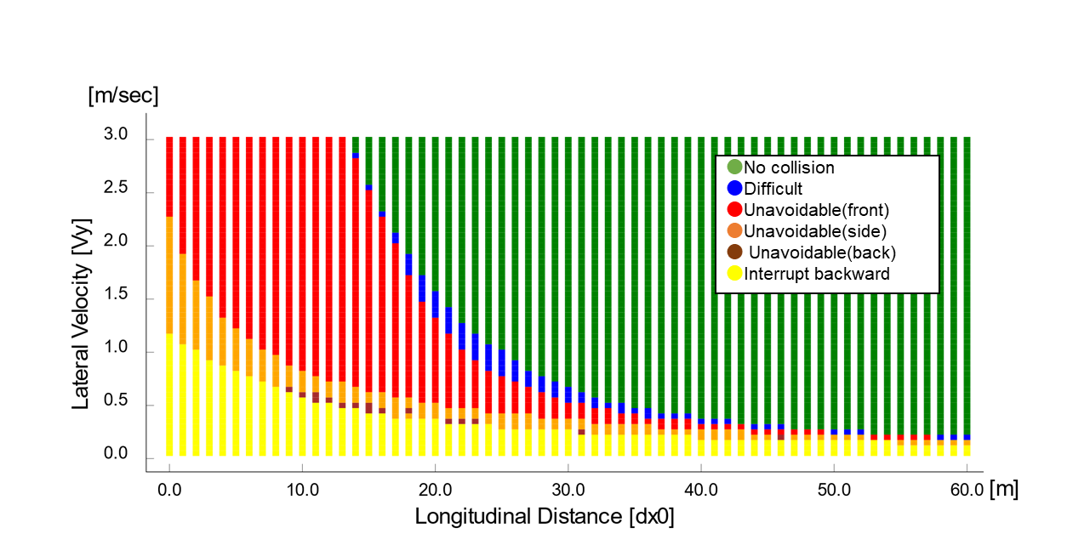

Figure 2
For Ve0 = 60 kph
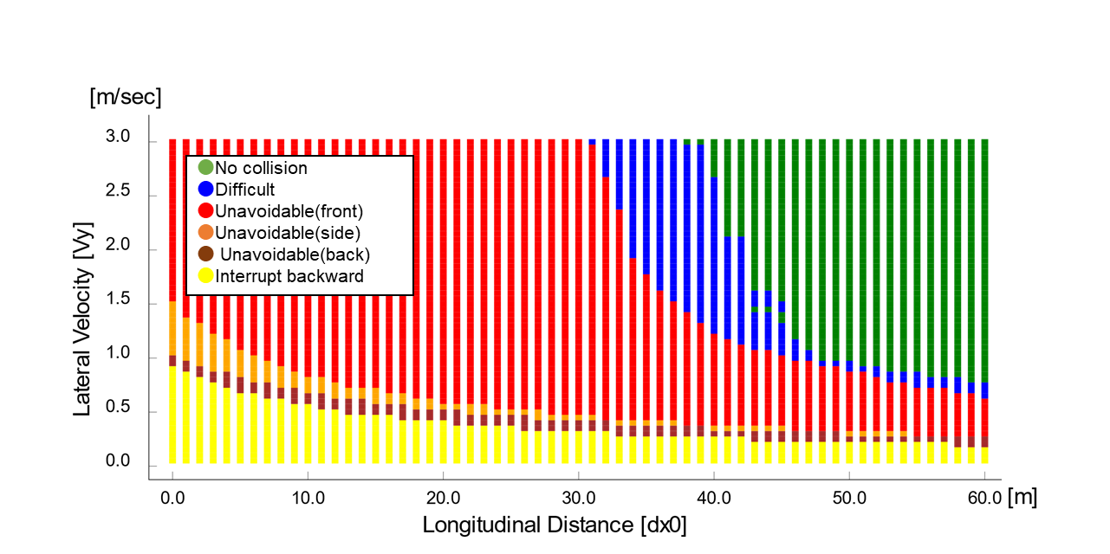

1.2. Cut out
Classification of difficulty of the scenarios based on the initial parameters is done the following way in accordance to the Performance model 1:
- “Avoidable” can be avoided by a braking demand with lower than 5 m/s².
- "Difficult" cannot be avoided by a braking demand with lower than 5 m/s².
- “Unavoidable” cannot be avoided by a braking demand with 7.6 m/s².
Based on these equations the classification may be done for any parameter set; to show some examples, a number of figures are presented below with different ego vehicle speeds.
Figure 3
For Ve0 = 130 kph
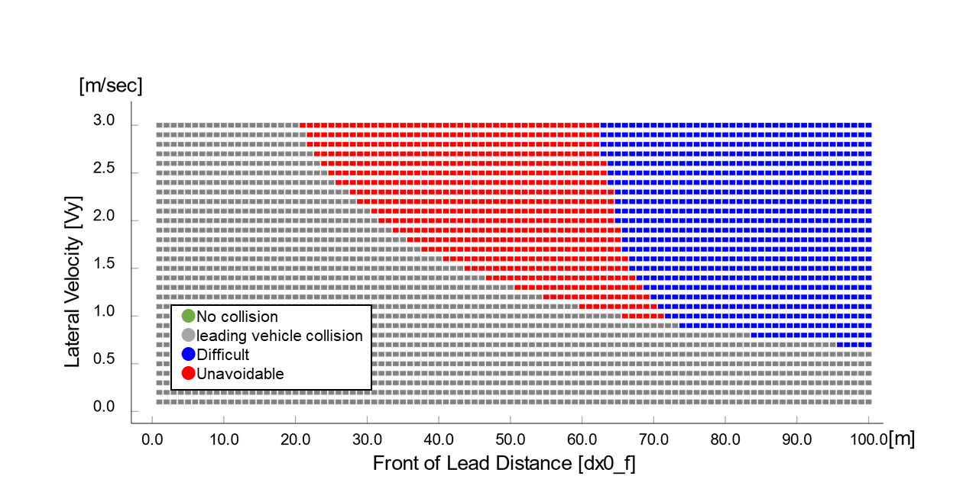

Figure 4
For Ve0 = 120 kph
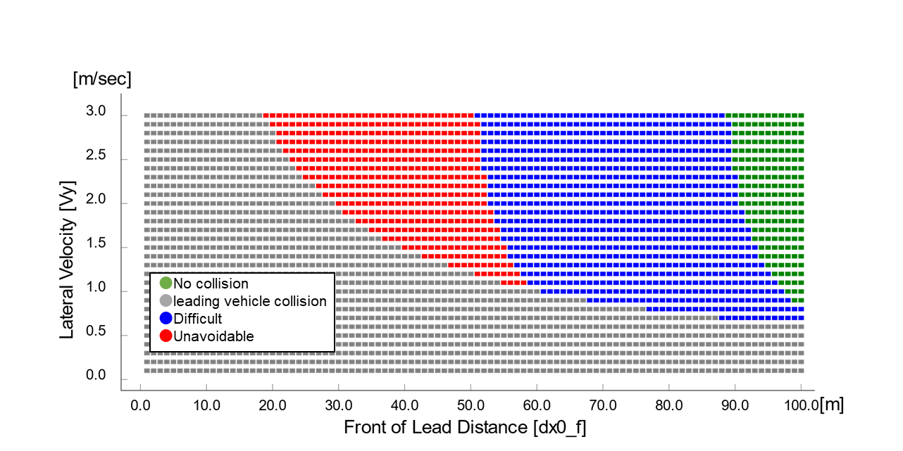

Figure 5
For Ve0 = 110 kph
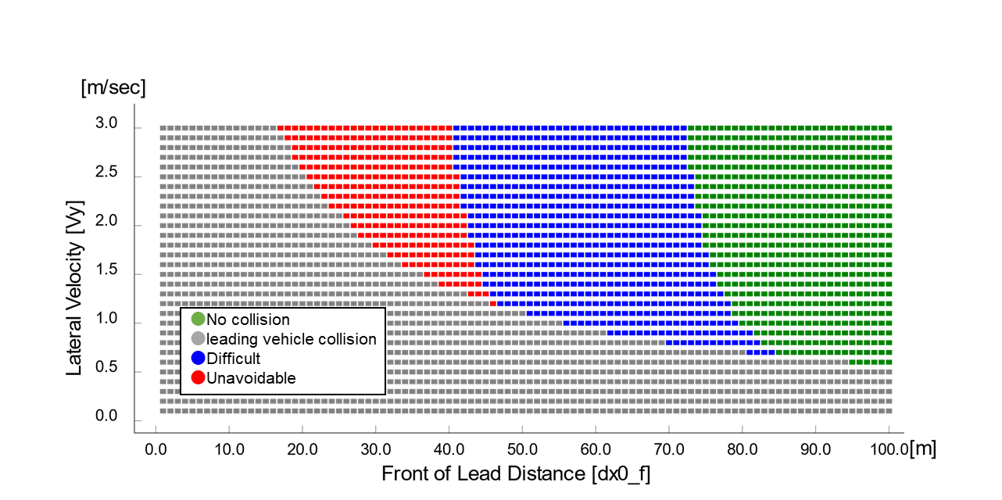

Figure 6
For Ve0 = 100 kph
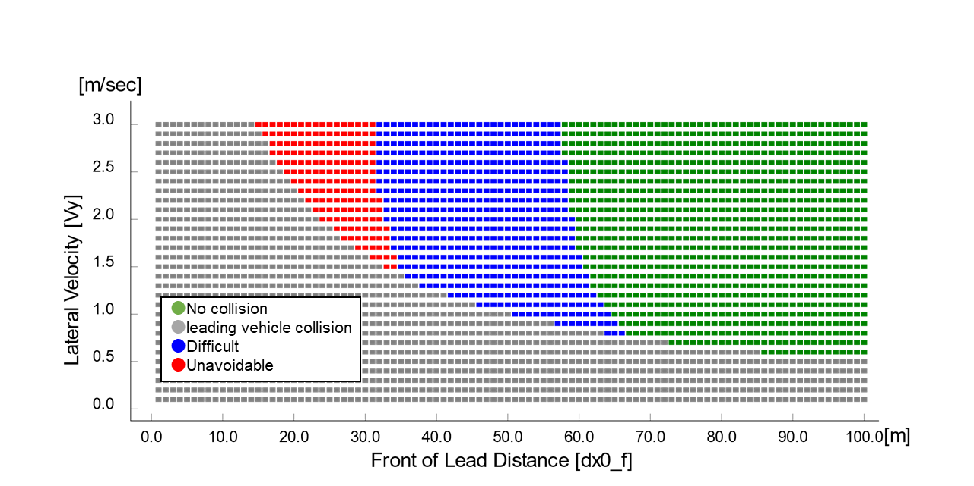

Figure 7
For Ve0 = 90 kph
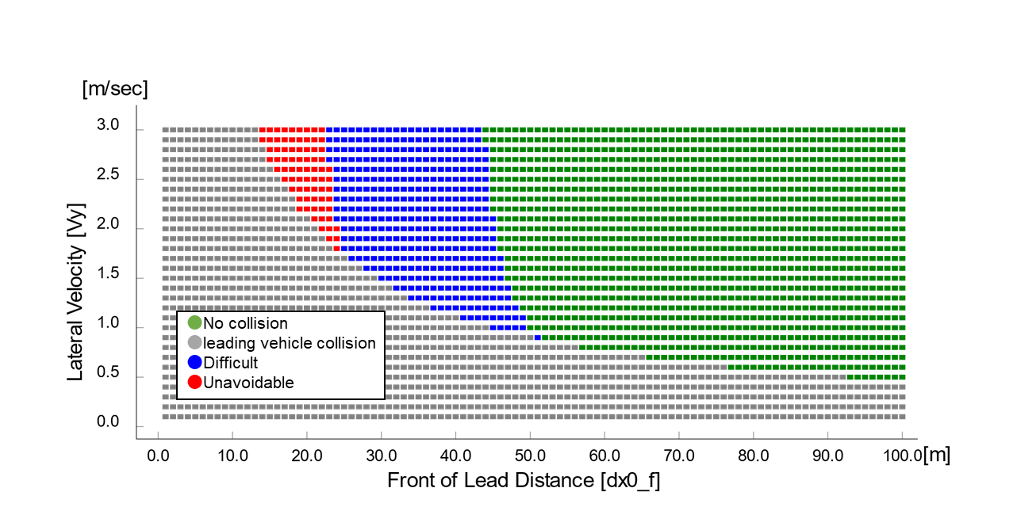

Figure 8
For Ve0 = 80 kph
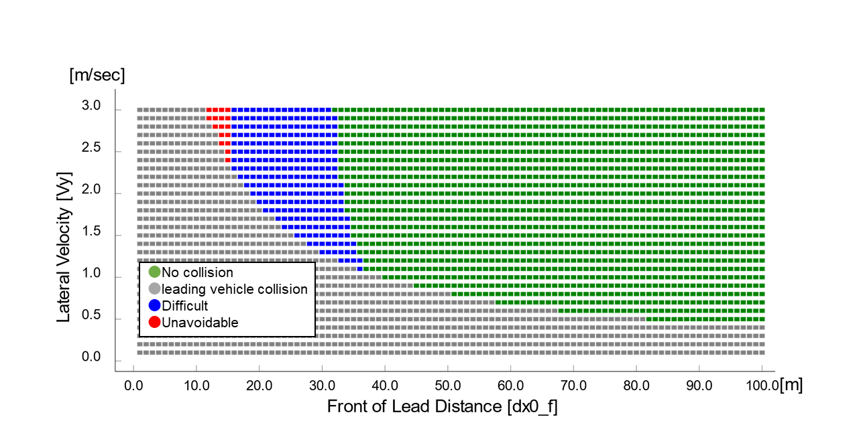

1.3. Deceleration
Classification of difficulty of the scenarios based on the initial parameters is done the following way in accordance to the Performance model 1 :
- “Avoidable” can be avoided by a braking demand with lower than 5 m/s².
- "Difficult" cannot be avoided by a braking demand with lower than 5 m/s².
- “Unavoidable” cannot be avoided by a braking demand with 7.6 m/s².
Based on these equations the classification may be done for any parameter set; to show some examples, a number of figures are presented below with different ego vehicle speeds.
Figure 9
Deceleration

Difficult area and Unavoidable area are not found.
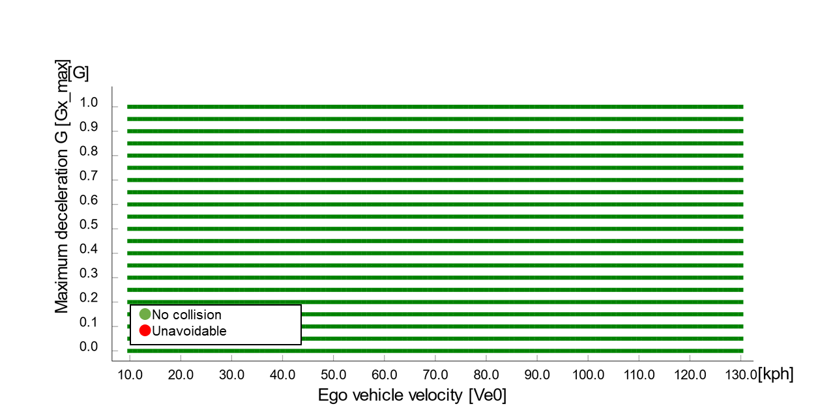

2. In case of performance model 2 of Annex 4
Following data sheets are pictorial examples of simulations which determine conditions under which ALKS shall avoid a collision, taking into account the combination of every parameter, at and below the maximum permitted ALKS vehicle speed.
Where collision is deemed to be avoidable, three subsets are defined, to differentiate between the parameter sets based on their difficulty in accordance to the performance model 2 laid down in paragraph 3.4 of Annex 4 Appendix 3:
- “Easy” conditions are highlighted by green colour,
- “Medium” conditions are highlighted by yellow colour,
- “Difficult” conditions are highlighted by red colour, while
- “Unavoidable collision” is highlighted by red colour with black “X”.
2.1. Cut in
Classification of difficulty of the scenarios based on the initial parameters is done the following way in accordance to the performance model laid down in paragraph 3.4 of Annex 4 Appendix 3:
- Easy: PFS <= 0.85;
- Medium: PFS > 0.85 and CFS < 0.9;
- Difficult: CFS => 0.9.
Based on these equations the classification may be done for any parameter set; to show some examples, a number of figures are presented below with different ego vehicle speeds.
Figure 10
For Ve0 = 130 kph
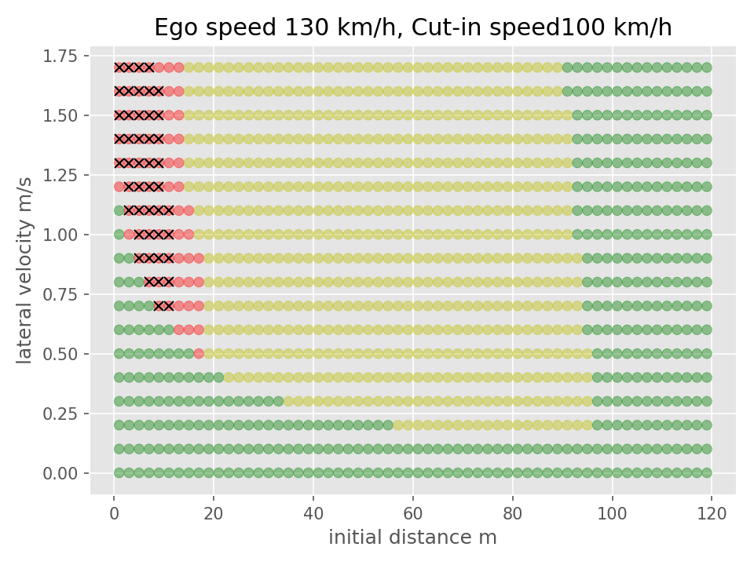

Figure 11
For Ve0 = 110 kph
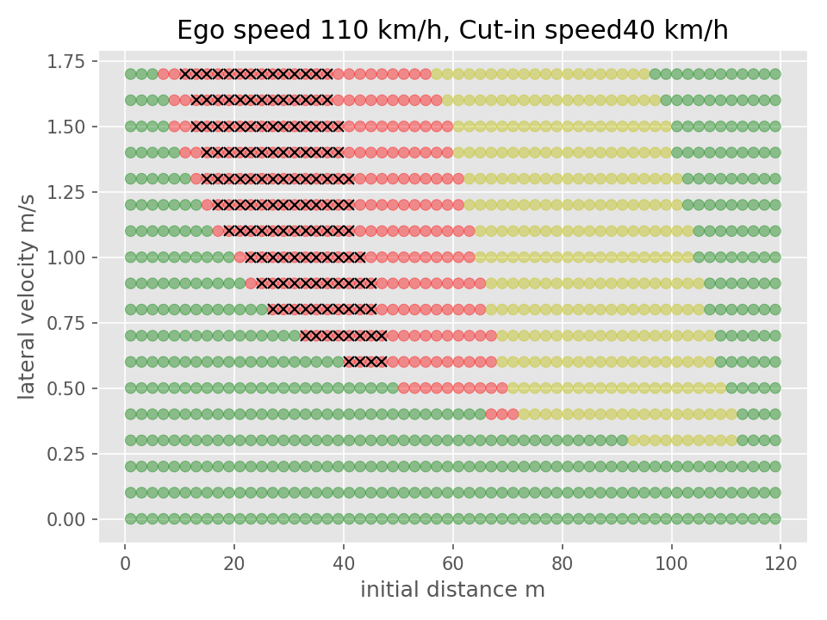

Figure 12
For Ve0 = 90 kph
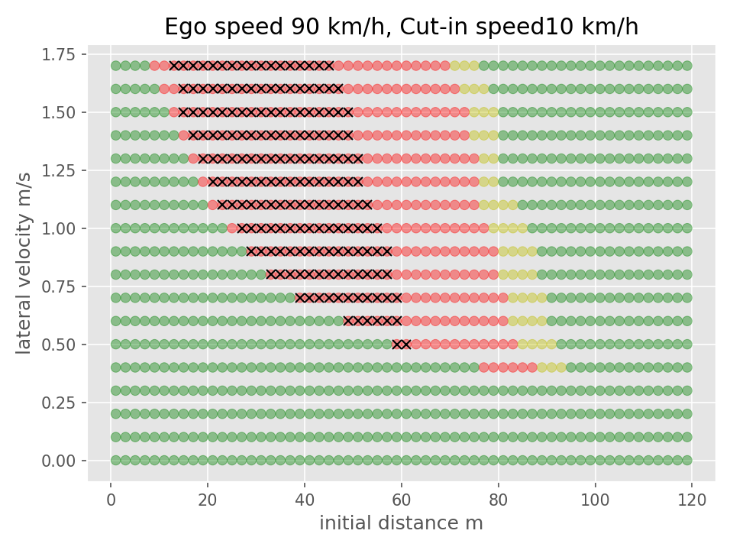

Figure 13
For Ve0 = 60 kph
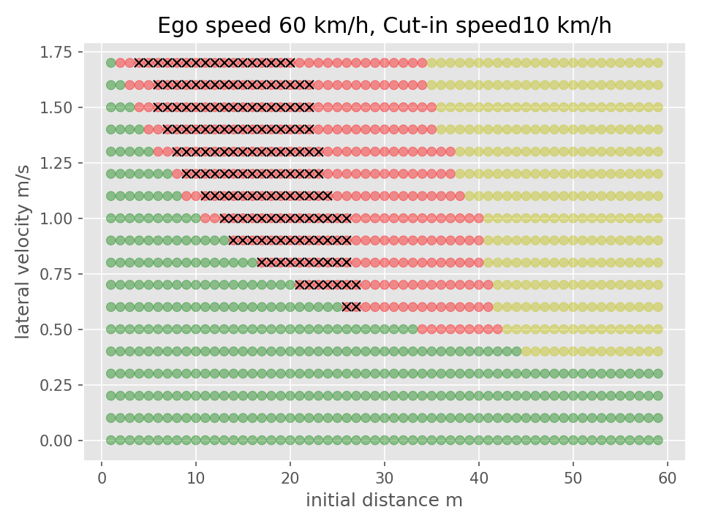

2.2. Cut out
Classification of difficulty of the scenarios based on the initial parameters is done the following way in accordance to the performance model 2 laid down in paragraph 3.4 of Annex 4 Appendix 3:
- Easy: PFS = 0;
- Medium: PFS > 0 and CFS < 0.5;
- Difficult: CFS => 0.5.
Based on these equations the classification may be done for any parameter set; to show some examples, a number of figures are presented below with different ego vehicle speeds.

Figure 14
For Ve0 = 130 kph
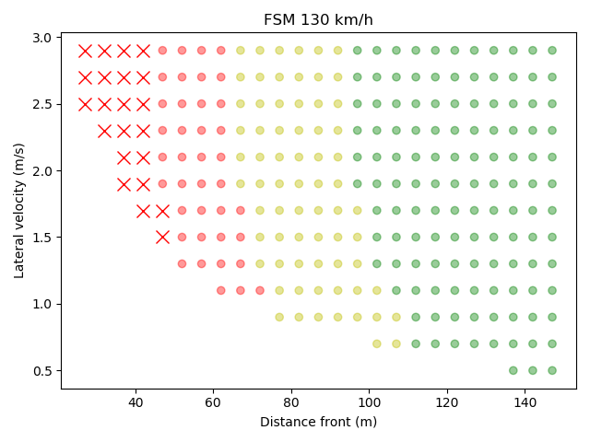

Figure 15
For Ve0 = 120 kph
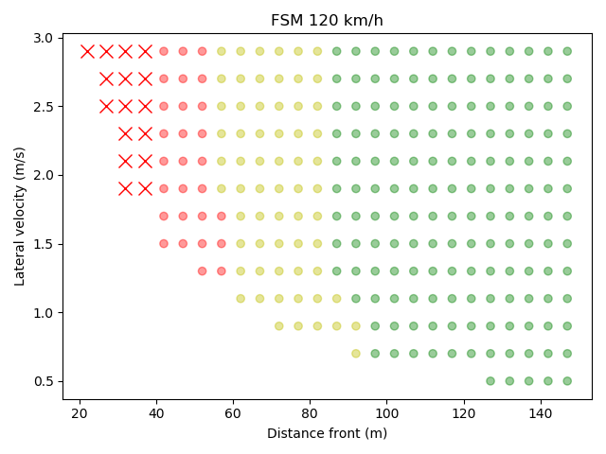

Figure 16
For Ve0 = 110 kph
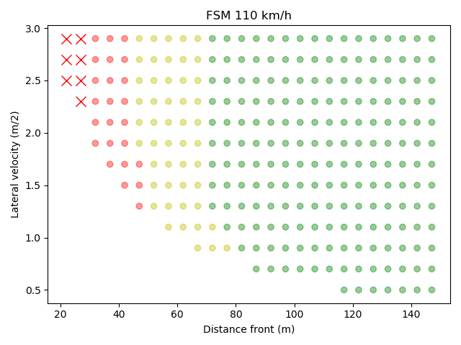

Figure 17
For Ve0 = 100 kph
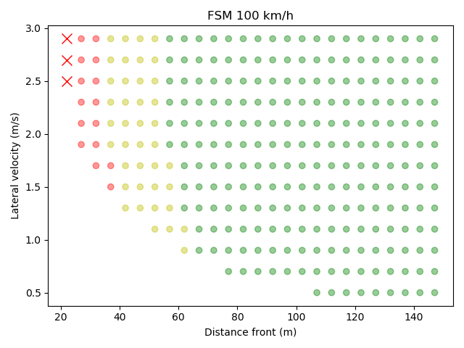

Figure 18
For Ve0 = 90 kph
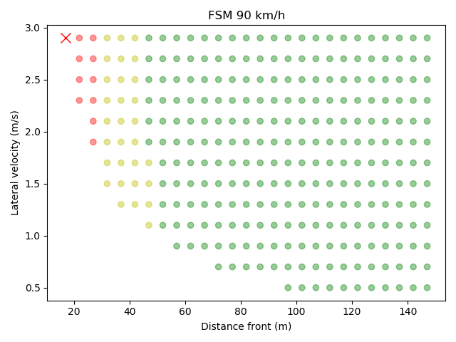

Figure 19
For Ve0 = 80 kph
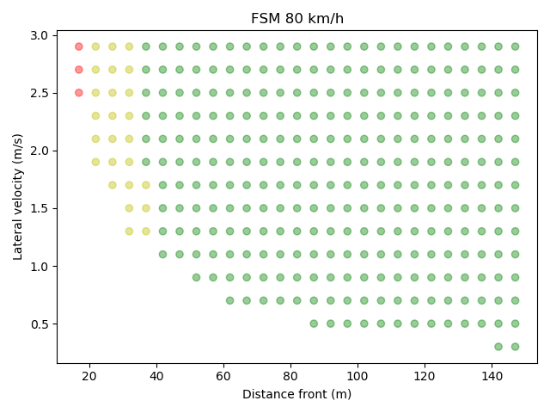

Figure 20
For Ve0 = 70 kph
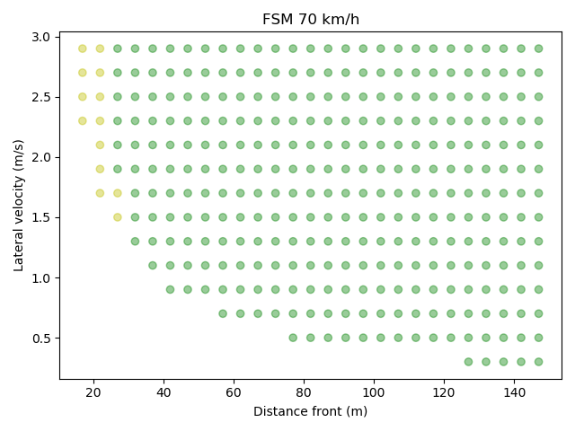

Figure 21
For Ve0 = 60 kph
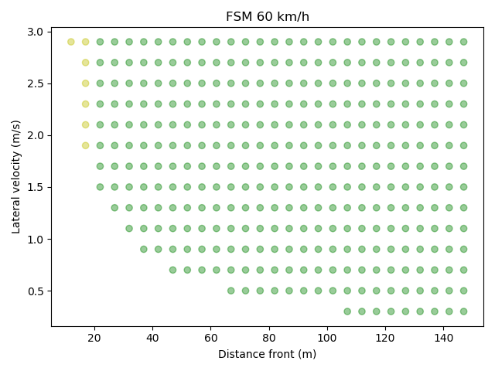

3. Deceleration
Classification of difficulty of the scenarios based on the initial parameters is done the following way in accordance to the performance model laid down in paragraph 3.4 of Annex 4 Appendix 3:
- Easy: PFS = 0;
- Medium: PFS > 0 and CFS < 0.5;
- Difficult: CFS => 0.5.
Based on these equations the classification may be done for any parameter set. The classification matrix for the different cases is presented below in Fig. 22.

Figure 22
Deceleration
