Proposal for amendments to ECE/TRANS/WP.29/GRVA/2021/29
Proposal for amendments to UN Regulation No. 90 (Uniform provisions concerning the approval of replacement brake lining assemblies, drum-brake linings and discs and drums for power-driven vehicles and their trailer)

This document reflects the outcome of discussions held during the GRVA-11. The modifications to the current text of the UN Regulation are marked bold for added text and strike through for deleted text. The changes proposed to document ECE/TRANS/WP.29/GRVA/2021/29 are indicated below.
- Proposal
Annex 7a:

Paragraph 1, amend to read:

1. Grouping criteria
The grouping is made according to the following approach:
(a) According to the individual friction material of the brake lining;
(b) Depending on the area of the friction material area of the brake lining assembly operated by the piston/pistons of only one side of the brake caliper or, in case of drum brakes, of only one brake shoe.
Friction material area means all the area enclosed within the perimeter of the brake lining (see the red cross-hatched area, Figure 1, Figure 2), thus excluding the presence of any grooves and/or chamfers:

Figure 1
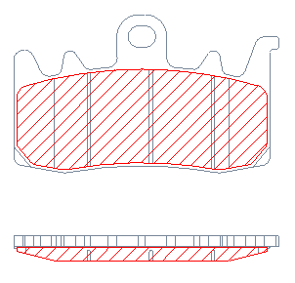

Figure 2
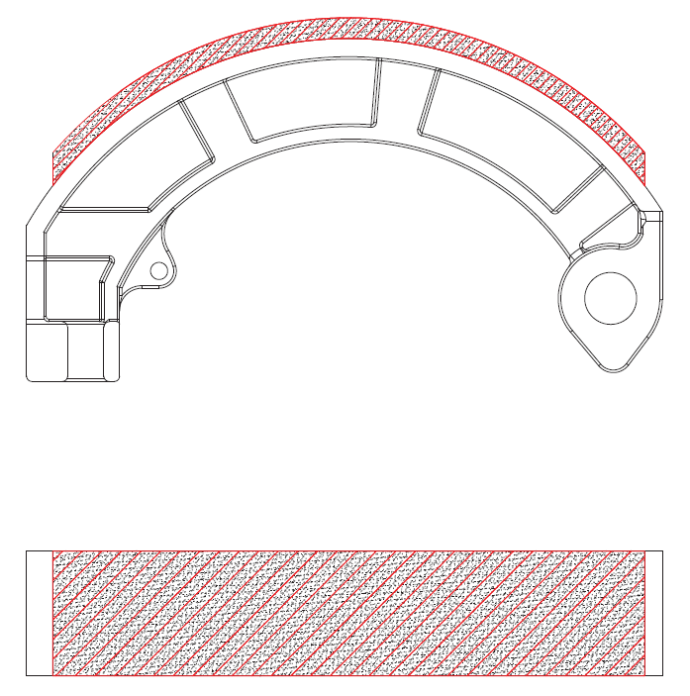

3 area groups are foreseen, as in Table 1 (for brake pads) and in Table 2 (for brake shoes):

………..

Table 2:
Group | Brake lining area  [cm²]
A | ≤21
B | > 21 ≤ 54
C | > 54

II. Justification
During the 11th session of GRVA – where proposal ECE/TRANS/WP.29/GRVA/2021/29 was presented - some observations were raised concerning the applicability of the 3 area groups indicated in Table 1, as far as grouping criteria for brake shoes are concerned.
This proposal is meant to specify area groups fully aligned with product range currently on the market, as follows:
GROUP A, relative to small size vehicle brake shoes,
GROUP B, relative to medium size vehicle brake shoes,
GROUP C, relative to big vehicle brake shoes.
GROUPING CRITERIA
The following considerations are based on the range of brake shoes currently produced by main brake shoes manufacturer, covering more than 98% of the brake shoes EU market used on L cat vehicles.
On the basis of the current catalogue, the brake shoes area rank from 9cm2 to 80cm2.
The proposed Group B (GROUP 2 in the figure) is centered about the average value of the areas while its amplitude corresponds to 2.00 standard deviations (Average +/-1.00 St.Dev).
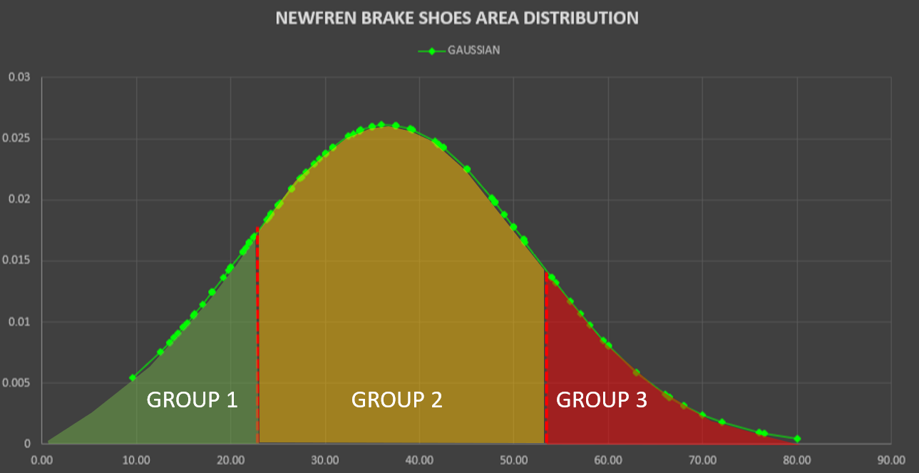

Therefore, its brake shoes areas Gaussian distribution is fully representative of the real state of the art on the market.
Considering that the brake shoes are originally sized from the vehicle manufacturers (based on vehicle performance and mass) it is reasonable to say that the distribution also reflects the Gaussian distribution of all L-cat vehicles kinetic energy.
It is therefore reasonable to say that all the average kinetic energy vehicles will be included in Group B, the lower energy ones will be included in Group A (GROUP 1 in the figure) while the high-kinetic energy vehicle will be in Group C (GROUP 3 in the figure).
In real world, motorcycle within different group have the following technical features:
GRUPPO 1
COD. | Area (cm2) | CC (cm³] | AXLE
GF1093 | 13,50 | 50 | F/R
GF0035 | 20,00 | 50 | F/R
GRUPPO 2
COD. | Area (cm2) | CC (cm³] | AXLE
GF0261 | 21,25 | 150 | R
GF1256 | 50,00 | 750 | R
GF1126 | 50,00 | 500 | R
GRUPPO 3
COD. | Area (cm2) | CC (cm³] | AXLE
GF1257 | 54,00 | 750 | F
GF0176 | 80,00 | 700 | F
GF1240 | 76,00 | 850 | R

