|  |  |  |  |
| --- | --- | --- | --- |
|  | United Nations | ECE/TRANS/WP.29/2022/3 | |
| _unlogo | **Economic and Social Council** | | Distr.: General  14 December 2021  Original: English |

**Economic Commission for Europe**

Inland Transport Committee

**World Forum for Harmonization of Vehicle Regulations**

**186th session**

Geneva, 8-11 March 2022

Item 4.6.1 of the provisional agenda

**1958 Agreement:  
Consideration of draft amendments to existing   
UN Regulations submitted by GRBP**

Proposal for Supplement 2 to the 08 series of amendments to UN Regulation No. 9 (Noise of three-wheeled vehicles)

Submitted by the Working Party on Noise and Tyres[[1]](#footnote-2)\*

The text reproduced below was adopted by the Working Party on Noise and Tyres (GRBP) at its seventy-fourth session (ECE/TRANS/WP.29/GRBP/72, para. 3). It is based on ECE/TRANS/WP.29/GRBP/2021/23 and Informal document GRBP-74-43. It is submitted to the World Forum for Harmonization of Vehicle Regulations (WP.29) and to the Administrative Committee (AC.1) for consideration at their March 2022 sessions.

*Table of Contents, Annexes,* amend to read:

"5 Test track layout"

*Paragraph 11.,* amend to read:

"11.1. As from the official date of entry into force of the 08 series of amendments, no Contracting Party applying this Regulation shall refuse to grant or refuse to accept type approvals under this Regulation as amended by the 08 series of amendments.

11.2. As from 1 September 2021, Contracting Parties applying this Regulation shall not be obliged to accept UN type approvals to the preceding series of amendments, first issued after that date.

11.3. Contracting Parties applying this Regulation may grant type approvals according to any preceding series of amendments to this Regulation. However, the specification of the test track may conform to ISO 10844:2014.

11.4. Contracting Parties applying this Regulation shall continue to grant extensions of existing approvals to any preceding series of amendments to this Regulation. However, the specification of the test track may conform to ISO 10844:2014.

11.5. Until 1 September 2024, Contracting Parties applying this Regulation shall accept UN type approvals to the preceding series of amendments, first issued before 1 September 2021.

11.6. As from 1 September 2024, Contracting Parties applying this Regulation shall not be obliged to accept UN type approvals issued to the preceding series of amendments to this Regulation.

11.7. Notwithstanding the transitional provisions above, Contracting Parties who start to apply this Regulation after the date of entry into force of the most recent series of amendments are not obliged to accept UN type approvals which were granted in accordance with any of the preceding series of amendments to this Regulation.

11.8. Notwithstanding paragraph 11.6., Contracting Parties applying this Regulation shall continue to accept UN type approvals issued according to the preceding series of amendments to this Regulation, for the vehicles/vehicle systems which are not affected by the changes introduced by the 08 series of amendments."

*Annex 3,*

*Paragraph 2.1.1.*, amend to read:

"2.1.1. Test site

The test site shall consist of a central acceleration track surrounded by a substantially level test area. The test track shall be level; the track surface shall be dry and so designed that tyre sound remains low.

On the test site, free sound field conditions shall be maintained to within ±1 dB between the sound source placed in the middle of the acceleration section and the microphone. This condition shall be deemed to be met if there are no large sound-reflecting objects such as fences, rocks, bridges or buildings within 50 m of the centre of the acceleration section.

No obstacle likely to affect the sound field shall be close to the microphone and no one shall come between the microphone and the sound source. The observer taking the measurements shall take up position so as to avoid influencing the metre readings.

The surface of the test track shall conform to ISO10844:2014.

*Annex 5,*

*Title,* amend to read:

"Test track layout"

*Footnote 1 to the title,* delete.

*Footnote 2 to paragraph 1.,* delete.

*Footnote 3 to paragraph 2.2.,* delete.

*Paragraphs 1., 2., and 2.1. to 2.5.,* delete.

*Paragraphs 3., 3.1., 3.2., 3.2.1., 3.2.1.1. to 3.2.1.4., and 3.2.2.,* delete.

*Figure 1*, amend to read:

"Figure 1

**Test track layout with dimensions in meters**

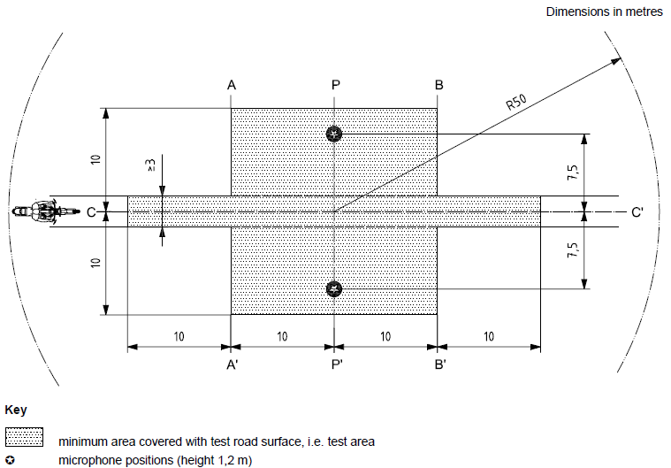

Key

|  |  |
| --- | --- |
|  | Minimum area covered with test road surface, i.e. test area |
|  | Microphone positions (height 1,2m) |

Source: ISO 10844:1994, with modifications."

*Figure 2 and Table 1,* delete.

*Paragraphs 4., 4.1. to 4.3., 5. and 5.1. to 5.3.,* delete.

*Paragraphs 6., 6.1., 6.1.1. to 6.1.6., 6.1.6.1. to 6.1.6.7. and 6.2.,* delete.

1. \* In accordance with the programme of work of the Inland Transport Committee for 2022 as outlined in proposed programme budget for 2022 (A/76/6 (part V sect. 20) para 20.76), the World Forum will develop, harmonize and update UN Regulations in order to enhance the performance of vehicles. The present document is submitted in conformity with that mandate. [↑](#footnote-ref-2)