|  |  |  |  |
| --- | --- | --- | --- |
|  | United Nations | ECE/TRANS/WP.29/GRVA/2022/4 | |
| Description: _unlogo | **Economic and Social Council** | | Distr.: General  12 November 2021  Original: English |

**Economic Commission for Europe**

Inland Transport Committee

**World Forum for Harmonization of Vehicle Regulations**

**Working Party on Automated/Autonomous and Connected Vehicles**

**Twelfth session**

Geneva, 24 - 28 January 2022

Item 4(d) of the provisional agenda

**Automated/autonomous and connected vehicles:**

**UN Regulation on Automated Lane Keeping System**

Proposal for amendments to UN Regulation No. 157 (Automated Lane Keeping System)

Submitted by the leadership of the special interest group on UN Regulation No. 157 [[1]](#footnote-2)\*

The text reproduced below reflects the discussion state of play of the Special Interest Group on UN Regulation No. 157 (Automated Lane Keeping System) presented to the Working Party on Automated/Autonomous and Connected Vehicles (GRVA) at the eleventh session, on raising the specified maximum speed of Automated Lane Keeping System (ALKS) up to 130 km/h. The test below incorporates the contents of ECE/TRANS/WP.29/GRVA/2020/32, ECE/TRANS/WP.29/GRVA/2021/31 and   
GRVA-11-33 and therefore replaces the aforementioned documents. Modifications to the existing text of UN Regulation No. 157 (incl. Supplement 2) are marked inbold for new or strikethrough for deleted characters. Open issues are noted in square brackets.

I. Proposal

*Paragraph 2.1.,* amend to read:

“2.1. “*Automated Lane Keeping System* *(ALKS)*” ~~for low speed application~~ is a system which is activated by the driver and which keeps the vehicle within its lane for travelling speed of ~~60~~ **130** km/h or less by controlling the lateral and longitudinal movements of the vehicle for extended periods without the need for further driver input.

Within this Regulation, ALKS is also referred to as “*the system*”.”

*Paragraph 2.21.,* insert to read:

**“2.21. “*String instability*” is when a disturbance in the speed profile of the vehicle in front is amplified by the following vehicle.”**

*Paragraph 5.1.1.1,* insert to read:

**“5.1.1.1. The system shall demonstrate anticipatory behaviour in interaction with other road user(s), in order to ensure stable, low-dynamic, longitudinal behaviour and risk minimising behaviour when critical situations could become imminent, e.g. with pedestrians or cutting-in vehicles.”**

*Paragraph 5.2.1.,* amend to read:

**“**5.2.1. The activated system shall keep the vehicle inside its lane of travel and ensure that the vehicle does not cross any lane marking (outer edge of the front tyre to outer edge of the lane marking). The system shall aim to keep the vehicle in a stable lateral **and longitudinal** ~~position~~ **motion** inside the lane of travelto avoid confusing other road users.

**The system shall aim to recover the original safe state of motion after disturbances not requiring an emergency manoeuvre.”**

*Paragraph 5.2.3.1.,* amend to read:

“5.2.3.1. **Speed**

**The manufacturer shall declare the specified maximum speed based on the forward detection range of the system as described in paragraph 7.1.1.**

The maximum speed up to which the system is permitted to operate is ~~60~~ **130** km/h.

**Specified maximum speeds of more than 60 km/h shall only be permissible if the ALKS is capable of bringing the vehicle to standstill on the hard shoulder during an MRM according to paragraph [x].**

**[Operational speeds of more than [60 km/h] are permitted either:**

**(a) Up to [90]km/h exclusively in the slowest lane of travel, provided there is surrounding traffic travelling at a similar speed (e.g. dense traffic or following a lead vehicle); or**

**(b) In all lanes of travel, if the ALKS is capable of changing lanes to bring the vehicle to a standstill outside of the regular lanes of travel during an MRM according to paragraph [X].**

**Systems that operate above 60 km/h up to [90] km/h without lane change capability shall implement strategies to minimize the risk of stopping in lane to the vehicle occupants and other road users, e.g. adapted deceleration strategy, operation only under good visibility.]”**

*Paragraph 5.2.3.3.,* amend to read:

“5.2.3.3. The activated system shall detect the distance to the next vehicle in front as defined in paragraph 7.1.1. and shall adapt the vehicle speed **to adjust a safe following distance** in order to avoid **a** collision.

While the ALKS vehicle is not at standstill **and operating in speed range up to 60 km/h**, the system shall adapt the speed to adjust the distance to a vehicle in front in the same lane to be equal or greater than the minimum following distance **according to the table below**.

**For speeds above 60 km/h the activated system shall comply with minimum following distances in the country of operation as defined in paragraph 5.1.2.**

In case ~~the minimum time gap cannot be respected temporarily because of other road users~~ **this following distance to a vehicle in front is temporarily disrupted** (e.g. vehicle is cutting in, decelerating lead vehicle, etc.), the vehicle shall readjust the ~~minimum~~ following distance at the next available opportunity without any harsh braking **implementing strategies aiming to address significant string instability in order to not disrupt traffic flow,** unless an emergency manoeuvre would become necessary.

**For speeds up to 60 km/h** ~~T~~**t**he minimum following distance shall be calculated using the formula:

dmin = vALKS\* tfront

Where:

dmin = the minimum following distance

vALKS = the present speed of the ALKS vehicle in m/s

tfront = minimum time gap in seconds between the ALKS vehicle and a leading vehicle in front as per the table below:

| *Present speed  of the ALKS vehicle* | | *Minimum time gap* | *Minimum following distance* |
| --- | --- | --- | --- |
| (km/h) | (m/s) | (s) | (m) |
| 7.2 | 2.0 | 1.0 | 2.0 |
| 10 | 2.78 | 1.1 | 3.1 |
| 20 | 5.56 | 1.2 | 6.7 |
| 30 | 8.33 | 1.3 | 10.8 |
| 40 | 11.11 | 1.4 | 15.6 |
| 50 | 13.89 | 1.5 | 20.8 |
| 60 | 16.67 | 1.6 | 26.7 |

For speed values **up to 60 km/h which are** not mentioned in the table, linear interpolation shall be applied.

Notwithstanding the result of the formula above for present speeds below 2 m/s the minimum following distance shall never be less than 2 m.

**The requirements of this paragraph are without prejudice to other requirements in this Regulation, most notably paragraphs 5.2.4. and 5.2.5. including subparagraphs.**”

*Insert new paragraph 5.2.8.,* to read:

**“5.2.8. In the situation where a vehicle is proceeding in the opposite direction in the ALKS vehicle’s lane of travel, the ALKS shall implement strategies to react to the vehicle with the aim of mitigating the effects of a potential collision.”**

*Paragraph 5.2.5.3.,* amend to read:

“5.2.5.3. The activated system shall avoid a collision with an unobstructed crossing pedestrian in front of the vehicle.

In a scenario with an unobstructed pedestrian crossing with a lateral speed component of not more than 5 km/h where the anticipated impact point is displaced by not more than 0.2 m compared to the vehicle longitudinal ~~center~~ **centre** plane, the activated ALKS shall avoid a collision up to ~~the maximum operational speed of the system~~ **60 km/h**.

**At higher speeds, upon detection of pedestrians crossing the carriageway the ALKS shall implement strategies to reduce the potential for a collision.”**

*Paragraph 5.2.7.,* amend to read:

“5.2.7. For conditions not specified in paragraphs 5.2.4., 5.2.5. or its subparagraphs, the performance of the system shall be ensured at least to the level at which a competent and careful human driver could minimize the risks. The attentive human driver performance model**s** and related parameters in ~~the~~ traffic critical disturbance scenarios ~~from~~ **in** Annex 3 may be taken as guidance. The capabilities of the system shall be demonstrated in the assessment carried out under Annex 4.”

*Paragraph 5.3.2.,* amend to read:

“5.3.2. This manoeuvre shall decelerate the vehicle up to its full braking performance if necessary and/or may perform an automatic evasive manoeuvre, when appropriate.

If failures are affecting the braking or steering performance of the system, the manoeuvre shall be carried out with consideration for the remaining performance.

During the evasive manoeuvre the ALKS vehicle shall not cross the lane marking (outer edge of the front tyre to outer edge of the lane marking).

After the evasive manoeuvre the vehicle shall aim at resuming a stable ~~position~~ **motion**.”

*Paragraph 5.4.2.3.,* amend to read:

“5.4.2.3 In case of any failure affecting the ~~operation of the system~~ **ability of the system to meet the requirements of this Regulation**, the system shall immediately initiate a transition demand upon detection.”

*Paragraph 6.4.1.,* amend to read:

“6.4.1. The following information shall be indicated to the driver:

(a) The system status as defined in paragraph 6.4.2.

(b) Any failure affecting the ~~operation of the system~~ **ability of the system to meet the requirements of this Regulation** with at least an optical signal unless the system is deactivated (off mode),

(c) Transition demand by at least an optical and in addition an acoustic and/or haptic warning signal.

At the latest 4 s after the initiation of the transition demand, the transition demand shall:

(i) Contain a constant or intermittent haptic warning unless the vehicle is at standstill; and

(ii) Be escalated and remain escalated until the transition demand ends.

(d) Minimum risk manoeuvre by at least an optical signal and in addition an acoustic and/or a haptic warning signal and

(e) Emergency manoeuvre by an optical signal

The optical signals above shall be adequate insize and contrast. The acoustic signals above shall be loud and clear.”

*“Paragraph 7.1.1.,* amend to read:

7.1.1. Forward detection range

The manufacturer shall declare the forward detection range measured from the forward most point of the vehicle. This declared value shall be at least 46 metres **for a specified maximum speed of 60 km/h**.

**A specified maximum speed above 60 km/h shall only be declared by the manufacturer, if the declared forward detection range fulfils the corresponding minimum value according the following table based on deceleration of 5m/s²:**

| *Specified maximum speed /*  *km/h* | *Minimum forward detection range /*  *m* |
| --- | --- |
|  |  |
| **0…60** | **46** |
| **70** | **50** |
| **80** | **60** |
| **90** | **75** |
| **100** | **90** |
| **110** | **110** |
| **120** | **130** |
| **130** | **150** |

**For values not mentioned in the table, linear interpolation shall be applied.**

**It is recognized that the minimum forward detection range and vehicle deceleration of 5m/s² cannot be achieved under all conditions (e.g. on slippery roads). The system shall implement control strategies to adapt its maximum speed due the actual detection range and the actual deceleration capability to comply with paragraph 5.2.4. Those strategies shall be demonstrated and approved by the Technical Service.**

The Technical Service shall verify that the distance at which the vehicle sensing system detects a road user during the relevant test in Annex 5 is equal or greater than the declared value.”

*Annex 3,* amend to read:

“[1. General

1. This document clarifies derivation process to define conditions under which ~~Automated Lane Keeping Systems (~~**the** ALKS~~)~~ **vehicle** shall avoid a collision. Conditions under which ALKS shall avoid a collision are determined by ~~a general simulation program with following attentive human driver~~ **two possible** performance model**s** and~~[[2]](#endnote-2)~~ related parameters in the traffic critical disturbance scenarios.

2. Traffic critical scenarios

2.1. Traffic disturbance critical scenarios are those which have conditions under which **the** ALKS **vehicle** may not be able to avoid a collision.

2.2. Following three are traffic critical scenario:

(a) Cut-in: the ‘other vehicle’ suddenly merges in front of the ~~‘ego~~ **ALKS** vehicle~~’~~

(b) Cut-out: the ‘other vehicle’ suddenly exits the lane of the **ALKS vehicle** ~~‘ego vehicle’~~

(c) Deceleration: the ‘other vehicle’ suddenly decelerates in front of the **ALKS vehicle** ~~‘ego vehicle’~~

2.3. Each of these traffic critical scenarios can be created using the following parameters/elements:

(a) Road geometry

(b) Other vehicles’ ~~behavior/maneuver~~ **behaviour/manoeuvre**

3. Performance models of ALKS

3.1. Traffic critical scenarios of ALKS are divided into preventable and unpreventable scenarios. The threshold for preventable/unpreventable is based on the simulated performance of a ~~skilled~~ **competent** and **careful** ~~attentive~~ human driver. It is expected that some of the "unpreventable" scenarios by human standards may actually be preventable by the ALKS system.

3.2. **For the purpose of determining whether a traffic critical scenario is preventable or unpreventable, guidance can be taken from the following two performance models below.**

3.3. **“Performance model 1”**

**3.3.1. In the first performance model,** the avoidance capability of the driver model is assumed to be only by braking. The driver model is separated into the following three segments: "Perception"; "Decision"; and, "Reaction". The ~~following~~ diagram **in Figure 1** is a visual representation of these segments**.**~~:~~

**3.3.1.1.** To determine conditions under which Automated Lane Keeping Systems (ALKS) shall avoid a collision, performance model factors for these three segments in ~~the following~~ **Table 1** ~~table~~ should be used as the performance model of ALKS considering attentive human drivers’ ~~behavior~~ **behaviour** with ADAS.

Figure 1

**~~Skilled~~ Competent and careful human performance model**

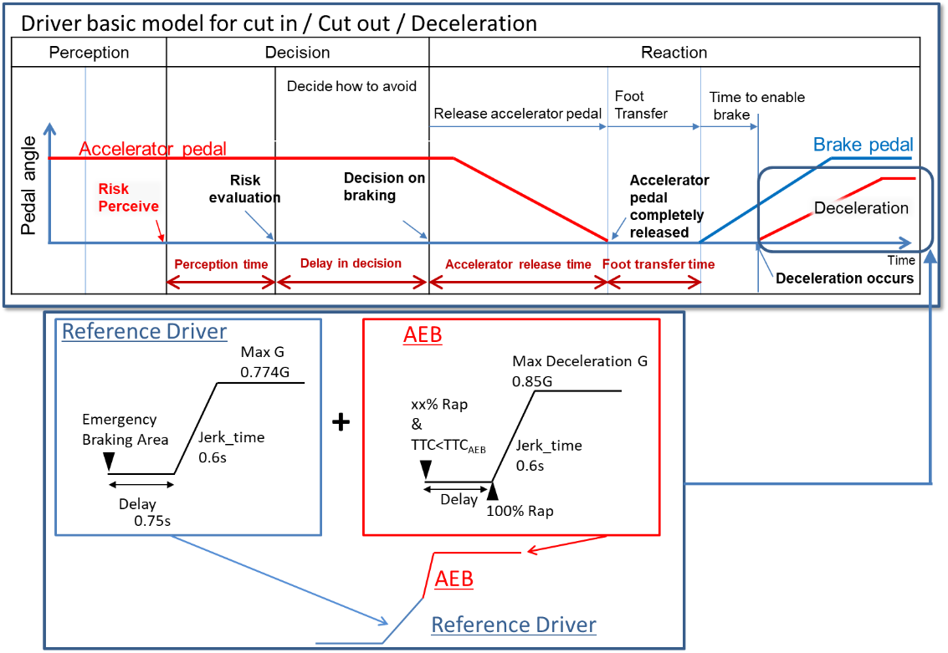

# Table 1

**Performance model factors for vehicles**

|  |  |  |
| --- | --- | --- |
|  |  | *Factors* |
| Risk perception point | Lane change (cutting in, cutting out) | Deviation of the ~~center~~ **centre** of a vehicle over 0.375m from the ~~center~~ **centre** of the driving lane  ~~(derived from research by Japan)~~ |
| Deceleration | Deceleration ratio of preceding vehicle and following distance of ego vehicle |
| Risk evaluation time | | 0.4 seconds  ~~(from research by Japan)~~ |
| Time duration from having finished perception until starting deceleration | | 0.75 seconds  ~~(common data in Japan)~~ |
| Jerking time to full deceleration (road friction 1.0) | | 0.6 seconds to 0.774~~G~~**g**  ~~(from experiments by NHTSA and Japan)~~ |
| Jerking time to full deceleration (after full wrap of ego vehicle and cut-in vehicle, road friction 1.0) | | 0.6 seconds to 0.85~~G~~**g**  ~~(derived from UN Regulation No. 152 on AEBS)~~ |

**3.3.2.** Driver model for the three ALKS scenarios:

**3.3.2.1.** For Cut in scenario:

The lateral wandering distance the vehicle will normally wander within the lane is 0.375m.

The perceived boundary for cut-in occurs when the vehicle exceeds the normal lateral wandering distance (possibly prior to actual lane change)

The distance a. is the perception distance based on the perception time [a]. It defines the lateral distance required to perceive that a vehicle is executing a cut-in manoeuvre a. is obtained from the following formula;

a.= lateral movement speed x Risk perception time [a] (0.4sec)

The risk perception time begins when the leading vehicle exceeds the cut-in boundary threshold.

~~Max lateral movement speed is real world data in Japan.~~

~~Risk perception time [a] is driving simulator data in Japan.~~

2sec\* is specified as the maximum Time To Collision (TTC) below which it was concluded that there is a danger of collision in the longitudinal direction.

~~Note: TTC = 2.0sec is chosen based on the UN Regulation guidelines on warning signals.~~

Figure 2  
**Driver model for the cut-in scenario**

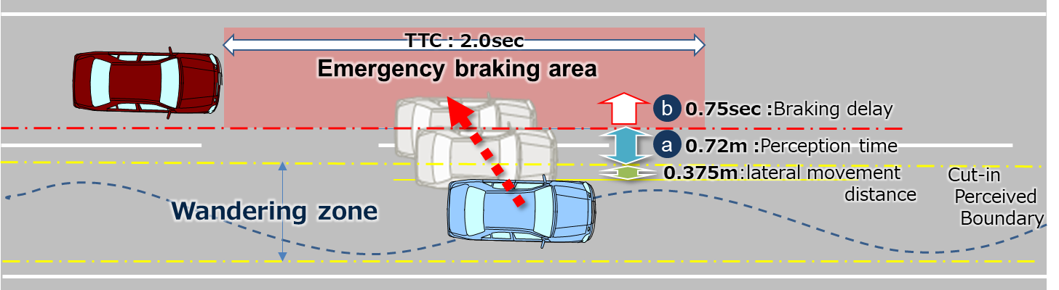

**3.3.2.2.** For Cut out scenario:

The lateral wandering distance the vehicle will normally wander within the lane is 0.375m.

The perceived boundary for cut-out occurs when the vehicle exceeds the normal lateral wandering distance (possibly prior to actual lane change)

The risk perception time [a] is 0.4 seconds #and begins when the leading vehicle exceeds the cut-out boundary threshold.

The time 2 sec is specified as the maximum Time Head Way (THW) for which it was concluded that there is a danger in longitudinal direction.

~~Note: THW = 2.0sec is chosen according to other countries’ regulations and guidelines.~~

Figure 3  
**Cut in scenario**

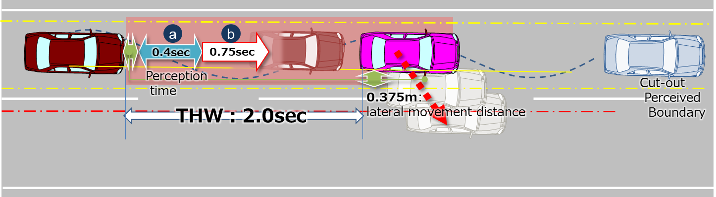

**3.3.2.3.** For Deceleration scenario:

The risk perception time [a] is 0.4 seconds. The risk perception time [a] begins when the leading vehicle exceeds a deceleration threshold 5m/s2.

Figure 4  
**Deceleration scenario**

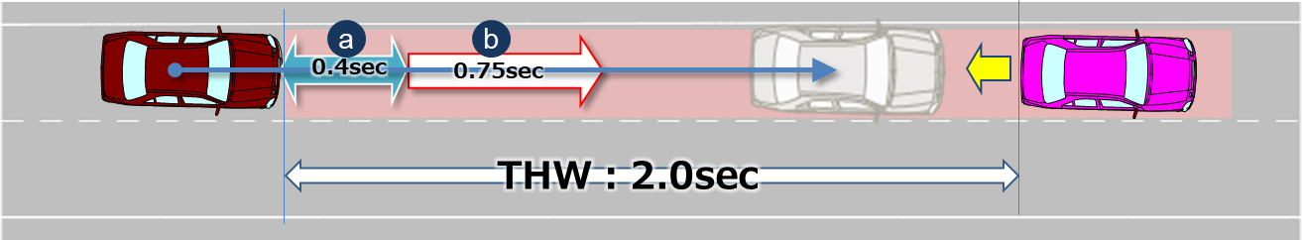

~~4. Parameters~~

**3.3.3. Parameters**

**3.3.3.1.** Parameters below are essential when describing the pattern of the traffic critical scenarios in section 2.1.

**3.3.3.2.** Additional parameters could be added according to the operating environment (e.g. friction rate of the road, road curvature, lighting conditions).

Table 2  
**Additional parameters**

|  |  |  |
| --- | --- | --- |
| • Operating conditions | • Roadway | • **Number of lanes** = The number of parallel and adjacent lanes in the same direction of travel  • **Lane Width** = The width of each lane  • **Roadway grade** = The grade of the roadway in the area of test  • **Roadway condition** = the condition of the roadway (dry, wet, icy, snow, new, worn) including coefficient of friction  • **Lane markings** = the type, colour, width, visibility of lane markings |
| • Environmental conditions | • **Lighting conditions** = The amount of light and direction (i.e., day, night, sunny, cloudy)  • **Weather conditions** = The amount, type and intensity of wind, rain, snow etc. |
| • Initial condition | • Initial velocity | • **Ve0** = Ego vehicle |
| • **Vo0** = Leading vehicle in lane or in adjacent lane |
| • **Vf0** = Vehicle in front of leading vehicle in lane |
| • Initial distance | • **dx0** = Distance in Longitudinal direction between the front end of the ego vehicle and the rear end of the leading vehicle in ego vehicle’s lane or in adjacent lane |
| • **dy0** = Inside Lateral distance between outside edge line of ego vehicle in parallel to the vehicle's median longitudinal plane within lanes and outside edge line of leading vehicle in parallel to the vehicle's median longitudinal plane in adjacent lines. |
| • **dy0\_f** = Inside Lateral distance between outside edge line of leading vehicle in parallel to the vehicle's median longitudinal plane within lanes and outside edge line of vehicle in front of the leading vehicle in parallel to the vehicle's median longitudinal plane in adjacent lines. |
| • **dx0\_f** = Distance in longitudinal direction between front end of leading vehicle and rear end of vehicle in front of leading vehicle |
| • **dfy** = Width of vehicle in front of leading vehicle |
| • **doy** = Width of leading vehicle |
| • **dox** = Length of the leading vehicle |
| • Vehicle motion | • Lateral motion | • **Vy** =Leading vehicle lateral velocity |
| • Deceleration | • **Gx\_max** = Maximum deceleration of the leading vehicle in ~~G~~ **g** |
| • **dG/dt** = Deceleration rate (Jerk) of the leading vehicle |

**3.3.3.3.** Following are visual representations of parameters for the three types of scenarios

Figure 5  
**Visualisation**

|  |  |
| --- | --- |
| Cut in |  |
| Cut out |  |
| Deceleration |  |

~~5~~**.3.3.4. Reference**

Following data sheets are pictorial examples of simulations which determines conditions under which ALKS **travelling at a speed up to 60 km/**h shall avoid a collision**,** taking into account the combination of every parameter, *at and below* the maximum permitted ALKS vehicle speed.

~~5.1~~**. 3.3.4.1.** Cut in

Figure 6  
**Parameters**

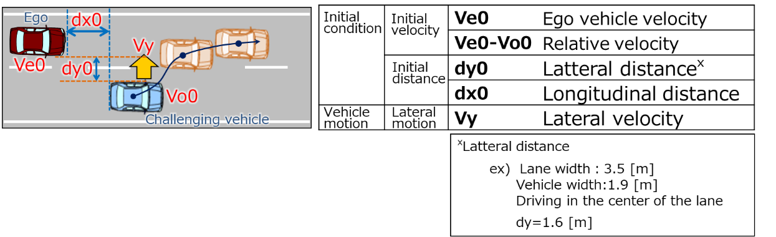

(Data sheets image)

Figure 7  
**Overview**

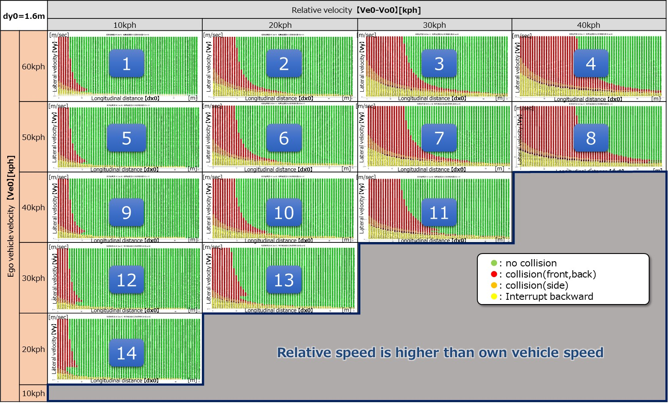

Figure 8

**For Ve0 = 60 kph**

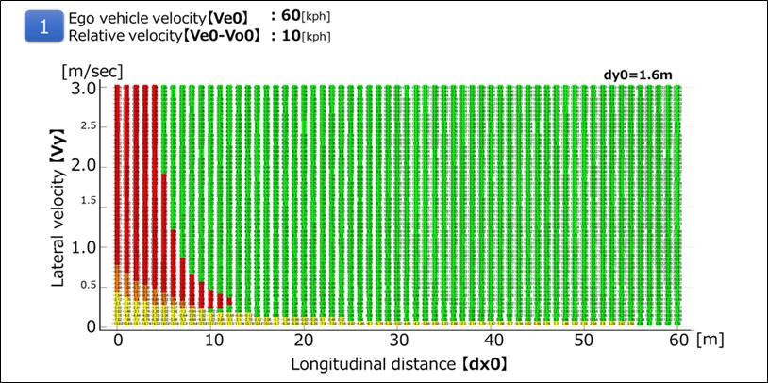

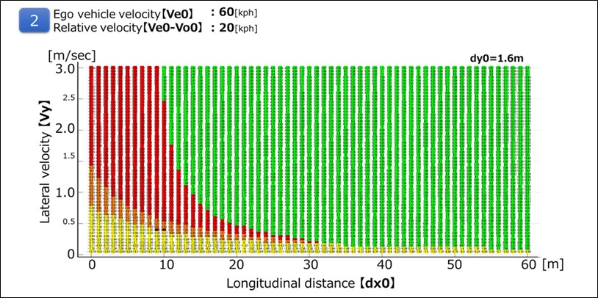

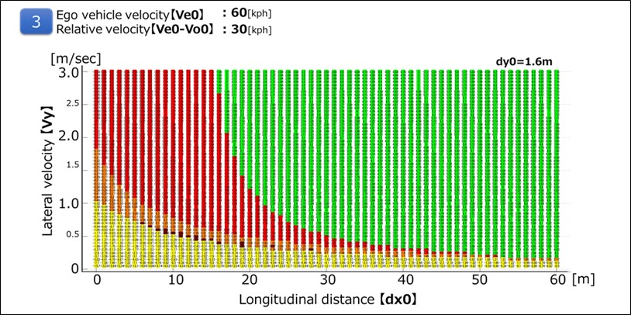

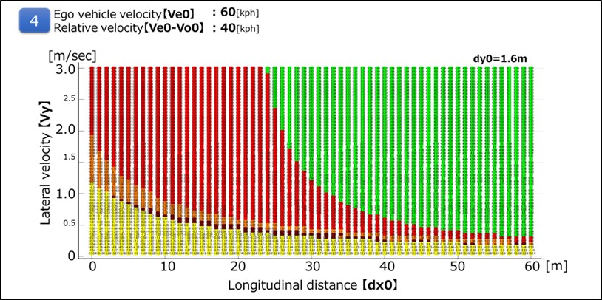

Figure 9

**For Ve0 = 50 kph**

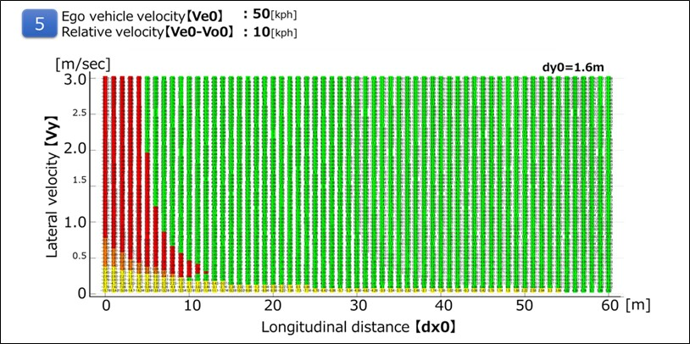

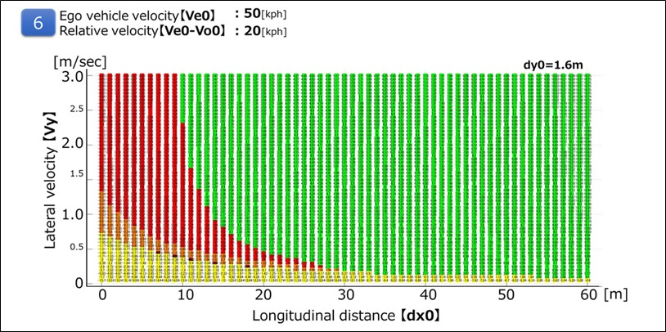

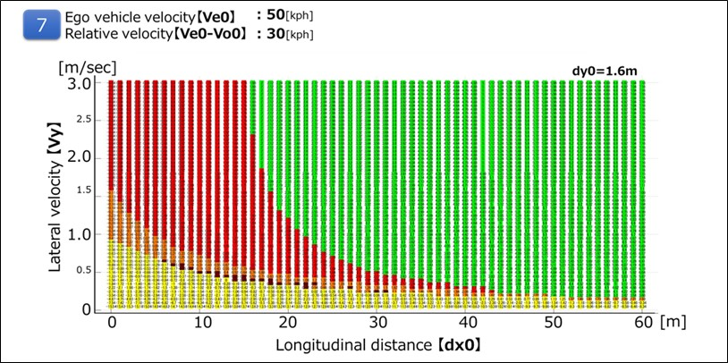

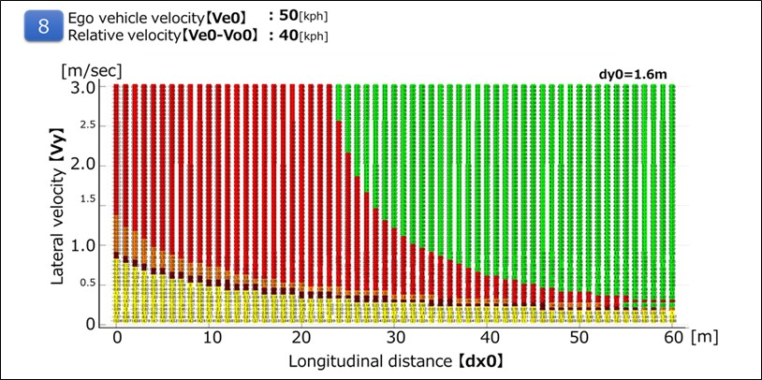

Figure 10

**For Ve0 = 40 kph**

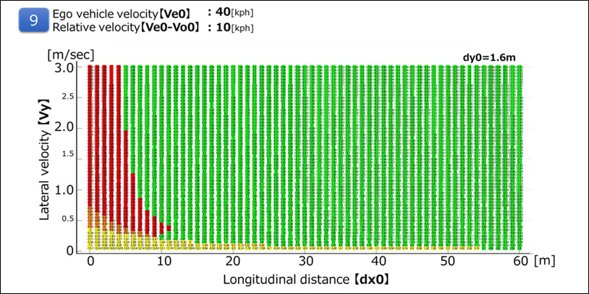

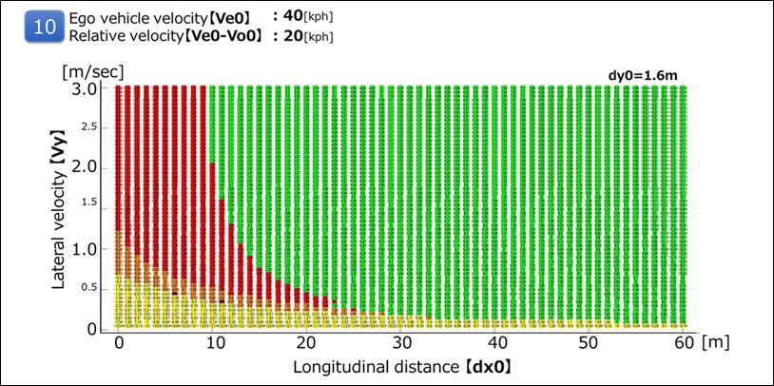

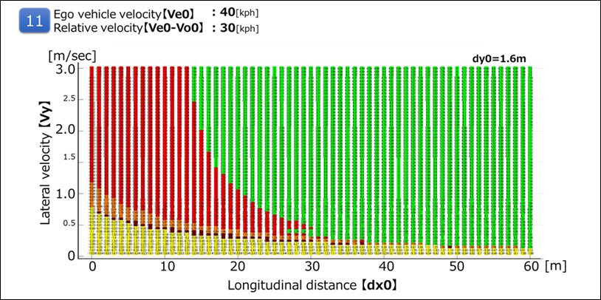

Figure 11

**For Ve0 = 30 kph**

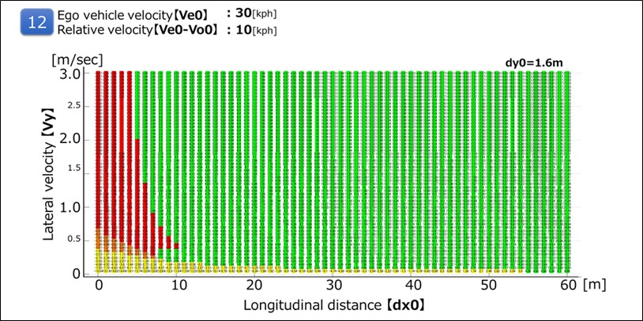

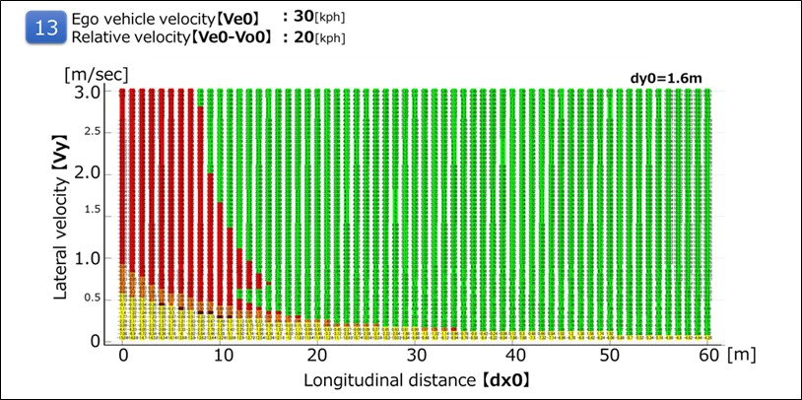

Figure 12

**For Ve0 =20 kph**

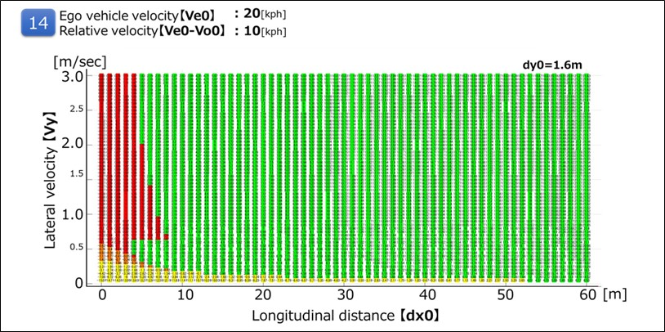

~~5.2.~~ **3.3.4.2.** Cut out

It is possible to avoid all the deceleration (stop) vehicles ahead of the preceding vehicle cut-out in the following running condition at THW 2.0 sec.

Figure 13  
**Parameters**

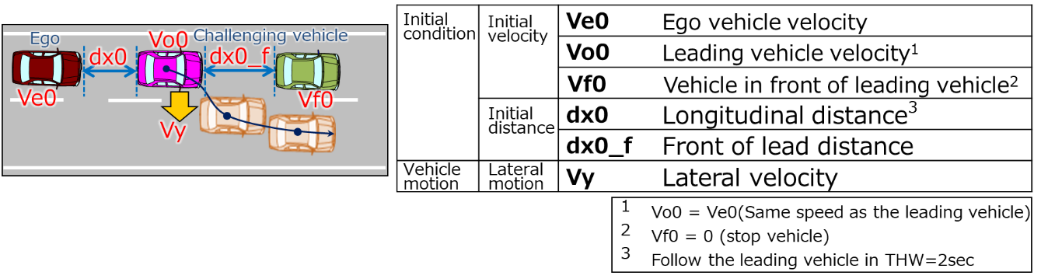

(Data sheets image)

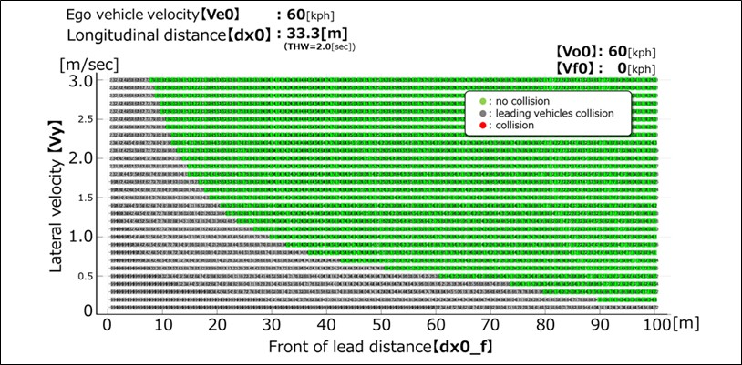

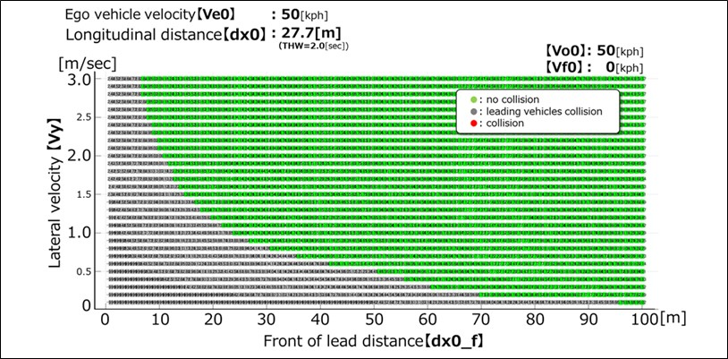

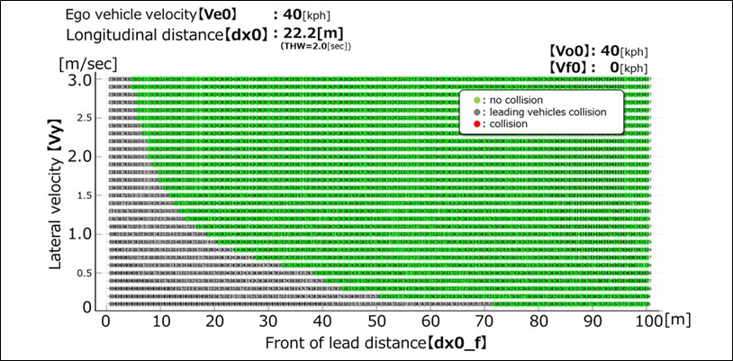

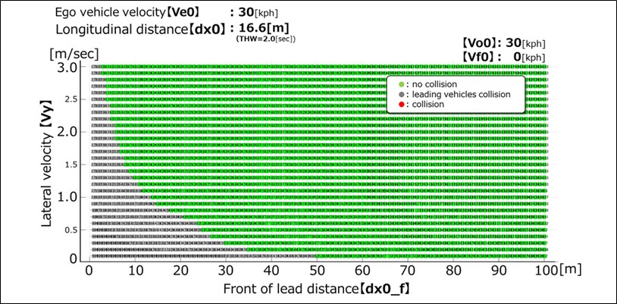

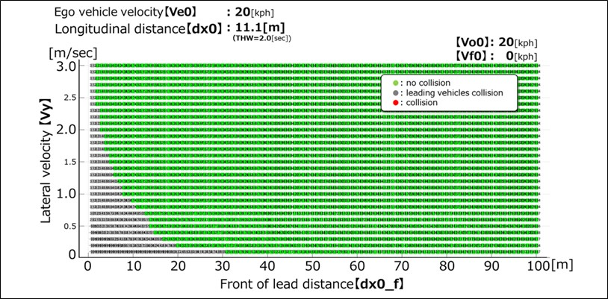

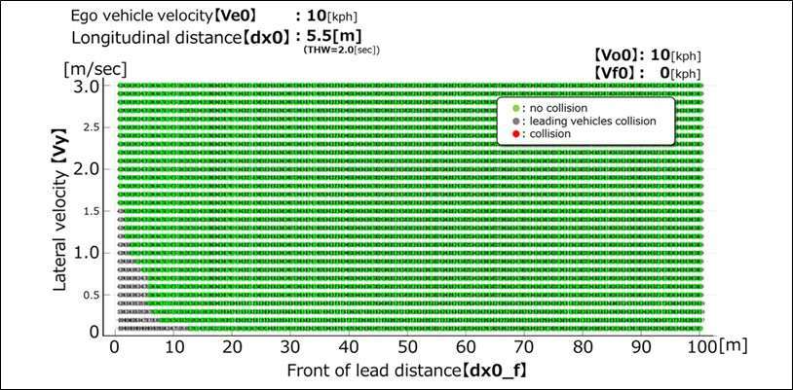

~~5.4.~~  **3.3.4.3.** Deceleration

It is possible to avoid sudden deceleration of -1.0G or less in the follow-up driving situation at THW 2.0sec.

(Data sheet image)

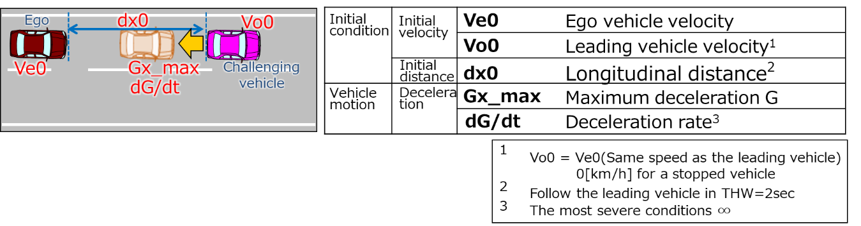

(Data sheets image)

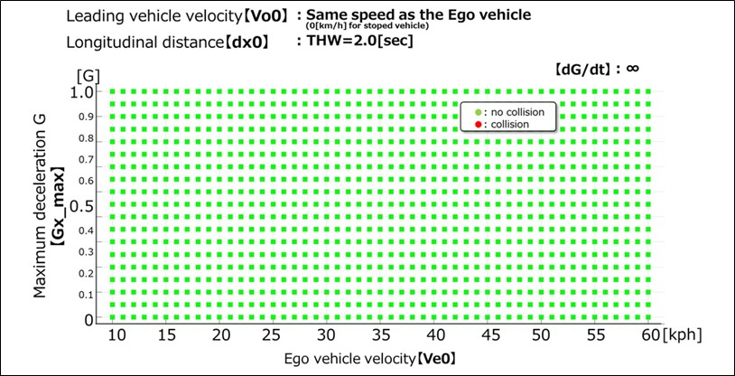

**3.4. “Performance model 2”**

**3.4.1. In the second performance model, it is assumed that the driver can anticipate the risk of a collision and apply proportionate braking. In this case, the performance model considers the following three actions: "Lateral Safety Check"; "Longitudinal Safety Check"; and, "Reaction". A Reaction is implemented only if the Lateral and Longitudinal Safety Checks identify a risk of imminent collision. The diagram reported in Figure 2 provides a visual representation of the decision flow followed by the driver in the second performance model for the case of the cut-in traffic critical scenario.**

# Figure 14

**Flow-chart of the second ALKS performance model for the case of the cut in traffic critical scenario**

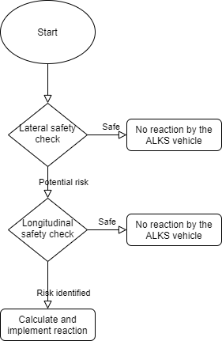

**3.4.2. Cut-in traffic critical scenario.**

**3.4.2.1. The Lateral Safety Check identifies a potential risk of collision if the following conditions hold true:**

**(a) The rear of the ‘other vehicle’ is ahead of the front of the ALKS vehicle along the longitudinal direction of motion;**

**(b) The ‘other vehicle’ is moving towards the ALKS vehicle**

**(c) The longitudinal speed of the ALKS vehicle is greater than the longitudinal speed of the ‘other vehicle’**

**(d) The following equation is satisfied**

$\frac{dist_{lat}}{u_{cut-in,lat}}<\frac{dist_{lon}+length_{ego}+length_{cut-in}}{u_{ego,lon}-u_{cut-in,lon}}+0.1$

**Where:**

$dist_{lat}$**is the instantaneous lateral distance between the two vehicles**

$dist_{lon}$**is the instantaneous longitudinal distance between the two vehicles**

$length_{ego}$**is the length of the ALKS vehicle**

$length_{cut-in}$**is the length of the ‘other vehicle’**

$u_{cut-in,lat}$**is the instantaneous lateral speed of the ‘other vehicle’**

$u_{ego,lon}$**is the instantaneous longitudinal speed of the ALKS vehicle**

$u_{cut-in,lon}$**is the instantaneous longitudinal speed of the ‘other’ vehicle.**

**3.4.2.2. The Longitudinal Safety Check requires the assessment of two Fuzzy Surrogate Safety Metrics, the Proactive Fuzzy Surrogate Safety Metric (PFS), and the Critical Fuzzy Surrogate Safety Metric (CFS).**

**3.4.2.2.1. The PFS is defined by the following equation:**

$PFS\left(dist_{lon}\right)= \left\{\begin{aligned}1 \\ 0 \\ \frac{dist_{lon}-d_{safe}-d_{1}}{d_{unsafe}-d_{safe}}\end{aligned} \begin{matrix}if 0<dist_{lon}-d_{1}<d_{unsafe} \\ if dist_{lon}-d_{1}>d_{safe} \\ if d_{unsafe}<dist_{lon}-d_{1}<d_{safe}\end{matrix}\right.$

**Where:**

$d_{1}$**is the safety distance when the two vehicles reach complete stop**

$$d_{safe}=u_{ego,lon}τ+\frac{u_{ego,lon}^{2}}{2b_{ego,comf}}- \frac{u_{cut-in,lon}^{2}}{2b_{cut-in,max}}+d_{1}$$

$$d_{unsafe}= u_{ego,lon}τ+\frac{u_{ego,lon}^{2}}{2b_{ego,max}}- \frac{u_{cut-in,lon}^{2}}{2b_{cut-in,max}}$$

**With:**

$τ$**the reaction time of the ALKS vehicle defined as the total time from the moment in which the need for a reaction is identified until it starts to be implemented**

$b_{ego,comf}$**the comfortable deceleration of the ALKS vehicle**

$b_{ego,max}$**the maximum deceleration of the ALKS vehicle**

$b_{cut-in,max}$**the maximum deceleration of the ‘other vehicle’**

**3.4.2.2.2. The CFS is defined by the following equation:**

$CFS\left(dist_{lon}\right)= \left\{\begin{aligned}1 \\ 0 \\ \frac{dist_{lon}-d_{safe}}{d_{unsafe}-d_{safe}}\end{aligned}\right. \begin{matrix}if 0<dist_{lon}<d_{unsafe} \\ if dist_{lon}≥d_{safe} \\ if d_{unsafe}≤dist_{lon}<d_{safe}\end{matrix}$

**Where**

$d_{safe}=\left\{\begin{matrix}\frac{{\left(u_{ego,lon}- u_{cut-in,lon}\right)}^{2}}{2a_{ego}^{'}} \\ d_{new}+\frac{{\left(u_{ego,lon,ΝΕΧΤ}-u_{cut-in,lon} \right)}^{2}}{2b_{ego,comf}}\end{matrix}\right. \begin{matrix}\begin{matrix}if u_{ego,lon,ΝΕΧΤ}≤u_{cut-in,lon} \\ \end{matrix} \\ if u_{ego,lon,ΝΕΧΤ}>u_{cut-in,lon}\end{matrix}$

$d_{unsafe}=\left\{\begin{matrix}\frac{{\left(u_{ego,lon}- u_{cut-in,lon}\right)}^{2}}{2a_{ego}^{'}} \\ d_{new}+\frac{{\left(u_{ego,lon,ΝΕΧΤ}-u_{cut-in,lon} \right)}^{2}}{2b_{ego,max}}\end{matrix}\right. \begin{matrix}\begin{matrix}if u_{ego,lon,ΝΕΧΤ}≤u_{cut-in,lon} \\ \end{matrix} \\ if u_{ego,lon,ΝΕΧΤ}>u_{cut-in,lon}\end{matrix}$

**in which:**

$a_{ego}^{'}=max⁡(a_{ego}, {-b}_{ego,comf})$

$u_{ego,lon,ΝΕΧΤ}=u_{ego,lon}+a_{ego}^{'}τ$

$d_{new}=\left(\frac{{(u}_{ego,lon}+u_{ego,lon,ΝΕΧΤ})}{2}- u_{cut-in,lon}\right)τ$

**Where:**

$a_{ego}$**is the instantaneous longitudinal acceleration of the ALKS vehicle**

$a_{ego}^{'}$**is a modified instantaneous acceleration which assume that ALKS vehicle cannot decelerate by more than $b_{ego,comf}$**

$u_{ego,lon,ΝΕΧΤ}$**is the expected longitudinal speed of the ALKS vehicle after the reaction time assuming constant acceleration**

$d_{new}$**is the expected longitudinal change in distance between the ALKS vehicle and the ‘other vehicle’ after the reaction time**

**3.4.2.2.3. The Longitudinal Safety Check identifies a potential risk if either PFS or CFS are greater than 0.**

**3.4.2.3. If a risk is identified the ALKS vehicle is assumed to plan and implement a reaction by decelerating according to the following equation:**

$b_{reaction}=\left\{\begin{matrix}CFS∙\left(b_{ego,max}- b_{ego,comf}\right)+b_{ego,comf} \\ PFS∙b_{ego,comf}\end{matrix}\right. \begin{matrix}if CFS>0 \\ if CFS=0\end{matrix}$

**3.4.2.3.1. The deceleration is implemented after a time equal to $τ$ when it starts to increase with a constant rate equal to the maximum jerk.**

**3.4.2.4. In the case the reaction is not able to prevent the vehicle to collide with the cutting-in vehicle, the scenario is classified as unpreventable, otherwise it is classified as preventable.**

**3.4.3. Cut-out traffic critical scenario.**

**In case of a cut-out, the model follows the same flow chart described in 3.4.1. for the cut-in scenario, with three changes:**

**(a) The Lateral Safety check is ignored, as the ALKS vehicle and the static object are already in the same lane.**

**(b) The Longitudinal Safety check is evaluated as in paragraph 3.4.2.2. with the state parameters being calculated for the static object instead of the cutting in vehicle.**

**(c) The ALKS vehicle is assumed not to be able to start the reaction time before the cutting out vehicle’s centre is outside the wandering zone of 0.375 m from the centre of the lane.**

**3.4.4. Deceleration traffic critical scenario**

**In case of a sudden deceleration of the preceding vehicle, the model follows the same flow chart described in 3.4.1. for the cut-in scenario, with two changes:**

**(a) The Lateral Safety check is ignored, as the ALKS vehicle and the preceding vehicle are already in the same lane.**

**(b) The Longitudinal Safety check is evaluated as in 3.4.2.2. with the state parameters being calculated for the preceding vehicle instead of the cutting in vehicle.**

**3.4.5. A software implementation of the second performance model to derive the scenario classification from simulation applied to the three traffic critical scenarios described in paragraph 2.2. of the present appendix is openly available[[3]](#footnote-3).**

**3.4.6. To determine conditions under which the ALKS vehicle shall avoid a collision, the following performance model factors shall be used.**

# **Table 3**

**Performance model factors for vehicles**

|  |  |
| --- | --- |
|  | ***Factor*** |
| **Risk perception point** | **The time when either PFS or CFS value is not any longer 0** |
| **In the case of cut-out the ALKS vehicle reaction time cannot start before the cutting out vehicle’s centre is outside the wandering zone of 0.375 m from the centre of the lane** |
| **Reaction time of the ALKS vehicle** | $τ$**= 0.75 seconds** |
| **Jerking (road friction 1.0)** | **12.65 m/s3** |
| **Safety distance when the two vehicles reach complete stop** | $d_{1}$**= 2 meters** |
| **Comfortable deceleration of the ALKS vehicle** | **4 m/s2** |
| **Maximum deceleration of the ALKS vehicle** | **6 m/s2** |
| **Maximum deceleration of the ‘other vehicle’** | **7 m/s2** |

*Annex 5, paragraphs 4.7. and 4.8.,* insert to read:

**[4.7. Detect and response to traffic rules and road furniture**

**4.7.1. These tests shall ensure that the ALKS respects traffic rules, detects and adapts to a variation of permanent and temporary road furniture.**

**4.7.2. The test shall be executed at least with the list of scenarios below, but based on the ODD of the given system:**

**(a) Different speed limit signs, so that the ALKS vehicle has to change its speed according to the indicated values;**

**(b) Signal lights of an ending lane. The signal lights are set above the belonging lanes, and the signal lights of adjacent lanes are kept in green state, while the one of the current lane for the ALKS vehicle is kept red.;**

**(c) Driving through a tunnel: at least [X]m long section of the road with no sunlight and availability of the positioning system.**

**(d) Toll station: a section of the motorway with toll station-, speed limit signs and buildings (ticket machines, barriers, etc.).**

**(e) Temporary modifications: e.g., road maintenance operations indicated by traffic signs, cones and other modifications.**

**4.7.3. Each test shall be executed at least:**

**(a) Without a lead vehicle;**

**(b) With a passenger car target as well as a PTW target as the lead vehicle / other vehicle.**

**4.8. Avoid braking before a passable object in the lane**

**4.8.1. The test shall demonstrate that the ALKS vehicle is not braking without a reason before a passable object in the lane (e.g., a manhole lid or a small branch).**

**4.8.2. The test shall be executed at least:**

**(a) Without a lead vehicle;**

**(b) With a passenger car target as well as a PTW target as the lead vehicle / other vehicle.]**

*Annex 5, paragraph 4.9.,* insert to read:

**[4.9. Oncoming traffic / Wrong way driver**

**4.9.1. The test shall demonstrate that ALKS is capable of detecting and reacting to oncoming traffic in an adjacent lane.**

**4.9.2. The test for oncoming vehicle shall be executed at least:**

**(a) Without a lead vehicle;**

**(b) With a passenger car target as well as a PTW target as the lead vehicle / other vehicle]**

II. Justification

1. This proposal aims at increasing the specified maximum speed of ALKS up to 130 km/h. It is based on ECE/TRANS/WP.29/GRVA/2020/32 presented to GRVA at its September 2020 session by the expert from Germany. Following an agreement by GRVA and WP.29, a Special Interest Group on UN Regulation No. 157 (SIG R.157) was established to take forward the proposal as well as handle the subsequent proposals for amendments received.

2. The document reflects the discussion and conclusions in the SIG R.157 up until its 8th session of 17 September 2021. It incorporates ECE/TRANS/WP.29/GRVA/2021/31 and GRVA-11-33 that were presented at the eleventh session of GRVA to form a new working document that replaces all the aforementioned documents.

3. An informal document from group is expected before the next GRVA session to close the remaining open issues related to speed increase noted by square brackets. These are whether to permit ALKS to operate above 60 km/h if it does not have lane change capability during Minimum Risk Manoeuvre (MRM) (para. 5.2.3.1.) and the test requirement (Annex 5). Below is a summary of the reasons behind the significant changes considered necessary by the SIG R.157 in increasing the speed at which ALKS can operate:

(a) Para. 2.21. and 5.1.1.1. are introduced and 5.2.1. changed to avoid the system from behaving in an unstable manner that could amplify the response to a perturbation in the traffic flow and to promote a more anticipatory behaviour in the driving style of the system.

(b) The table of minimum following distances in para. 5.2.3.3. is not extended beyond the current 60 km/h for higher speeds but instead the system should comply with local traffic rules. It was considered that there wasn’t a need to specify distance or time gaps beyond 60 km/h as such requirements varied from country to country and the requirement to avoid a collision would mean that the system was already required to maintain a sufficient gap.

(c) Para. 5.2.8. is introduced so that the ALKS responds to a vehicle driving the wrong way on a divided carriageway. It was recognised that this would be a difficult scenario to detail appropriately or to design the system for. As such, the ALKS should at least try and mitigate a potential collision.

(d) Para. 5.2.5.3. is modified in a similar manner for responding to pedestrians at speeds higher than 60 km/h as it was also recognised that it would be a difficult scenario to detail or design for. Trying to use the same crossing scenario would not be realistic since a pedestrian is unlikely to be unobstructed for the length of time required for higher speeds.

(e) Para. 5.4.2.3. and 6.4.1. are modified so as to allow the system to continue to operate even in the event of a failure it can continue to meet all the requirements of the Regulation.

(f) Para 7.1.1. is modified to stipulate the minimum forward detection capabilities needed to operate at speeds higher than 60 km/h. The ranges were based on a 5 m/s2 deceleration capability that is generally expected to be achieved. Specific provisions have been included that require the control strategy to be modified if such braking performance cannot be achieved or the minimum sensor detection range is not obtainable, either due to the environmental conditions or the condition of the vehicle.

(g) Annex 3 is modified to introduce a second performance model to assess the system’s performance against for critical scenarios. The new model has been developed by JRC and utilises fuzzy logic to represent the anticipatory behaviour of a human driver for evaluating what scenarios should a collision be avoided by the ALKS.

1. \* In accordance with the programme of work of the Inland Transport Committee for 2022 as outlined in proposed programme budget for 2022 (A/76/6 (Sect.20), para 20.76), the World Forum will develop, harmonize and update UN Regulations in order to enhance the performance of vehicles. The present document is submitted in conformity with that mandate. [↑](#footnote-ref-2)
2. [↑](#endnote-ref-2)
3. **Software implementation available at: https://github.com/ec-jrc/JRC-FSM** [↑](#footnote-ref-3)