UN/SCETDG/59/INF.26

Committee of Experts on the Transport of Dangerous Goods
and on the Globally Harmonized System of Classification
and Labelling of Chemicals 23 November 2021
Sub-Committee of Experts on the Transport of Dangerous Goods
Fifty-ninth session
Geneva, 29 November-8 December 2021
Item 4 (c) of the provisional agenda
Electric storage systems: transport provisions
Lithium-ion batteries SP 188 update
Submitted by the European Association for Advanced Rechargeable Batteries (RECHARGE)
1. This document is following the proposal made in informal document INF.32 (58th session) of the Sub-Committee.
2. Informal document INF.32 did present the technical progress of the lithium batteries industry, making it possible to produce batteries with a higher energy content, but without weight increase (better energy density), when compared to the technology available at the time the regulation was implemented. This information is reminded in the appendix to informal document INF.32.
3. Due to this improvement, the maximum limit defined in the special provision SP188 expressed in Wh is now exceeded in several cases for applications like smart phones or powertools, where the energy of some of the cells or batteries used is now exceeding the thresholds of 20 Wh or 100 Wh, but without weight or size increase.
4. The main concern expressed during the fifty-eighth session of the Sub-Committee was the fact that the batteries with a higher energy density may present a higher hazard. Based on this, it was considered that the change in the Wh limit as proposed in the document was not justified.
5. The purpose of this document is to present the safety data collected during the work of the UN IWG mandated to study the lithium batteries classifications according to the hazards. The data presented in Appendix 1 of this document demonstrate that the energy of combustion of the lithium batteries (and therefore the hazards they may represent) is not related to the energy of the batteries, but to the weight of the combustible material contained (the “active material” of the cells).
6. The author of this document would appreciate the opinion of the Sub-Committee on how this data can be used to facilitate the changes in the regulation following the technical progress of the industry.

Appendix 1
- The heat of reaction for multiple lithium-ion cells and batteries has been represented in the figures below. The heat of reaction is either based on a direct measure in a calorimeter, or based on a calculation using the specific heat of the batteries and the maximum temperature reached. Despite a high variability, it is observed as expected that the energy of combustion is roughly proportional to the amount of combustible material, measured by the size of the battery, expressed in Wh or expressed in kg.
- The high variability observed is due to the fact that the dataset contains the result of various tests methods, different cells size and chemistries, etc. It is observed that depending on the conditions, the thermal runaway reaction of the cells or batteries may not be complete, but the measured values are always less than 7 kJ/Wh (or 1.5 MJ/Kg): compared to other combustibles, about 20-40 times less energy than plastic, fuel, and other combustible material.

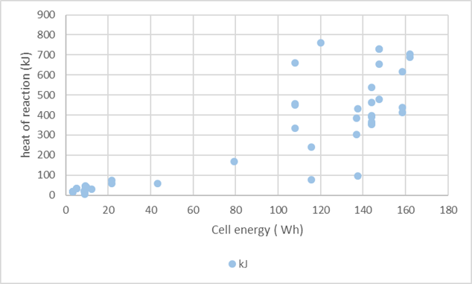
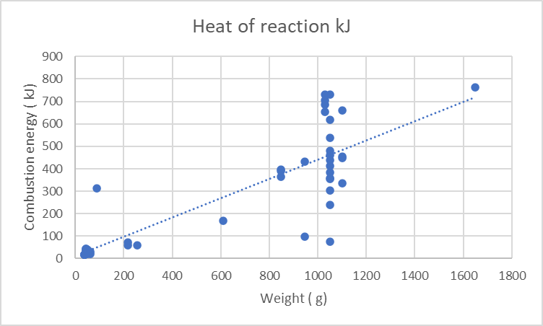
- Based on the data presented above, the specific energy (in Wh/kg) has been calculated (dividing the energy by the weight) for each of the products tested. The heat of reaction during the thermal runaway is presented in the graph below, as a function of the specific energy. Contrary to the previous graphs, this diagram indicates that there is no clear correlation between the heat of reaction and the energy density.
