UN/SCETDG/59/INF.23

Committee of Experts on the Transport of Dangerous Goods
and on the Globally Harmonized System of Classification
and Labelling of Chemicals 22 November 2021
Sub-Committee of Experts on the Transport of Dangerous Goods
Fifty-ninth session
Geneva, 29 November-8 December 2021
Item 6 (d) of the provisional agenda
Miscellaneous proposals for amendments to the Model Regulations
on the Transport of Dangerous Goods: other miscellaneous proposals
Comments on working document ST/SG/AC.10/C.3/2021/42 (59th session) - Proposal for displaying the prevention of dangerous electrostatic discharge
Submitted by the International Confederation of Container Reconditioners (ICCR), International Council of Intermediate Bulk Container Associations (ICIBCA) and the International Confederation of Plastics Packaging Manufacturers (ICPP)
Introduction
1. The expert from the Republic of Korea proposes to add new provisions in the UN Model Regulations for a unified display of a symbol or mark on IBCs to indicate that electrostatic discharge (ESD) protection has been measured according to provision 4.1.2.1.
2. A symbol shall be placed on the IBCs for which measures have been taken to prevent hazardous electrostatic discharge in accordance with 4.1.2.1.
Discussion
3. ICCR, ICIBCA and ICPP do not support document ST/SG/AC.10/C.3/2021/42 from the Republic of Korea to add a new symbol under 6.5.2.1.3 or 6.5.2.2.3 for the following reasons.
(a) The measures mentioned in 4.1.2.1 are general requirements that include not only the design of the IBCs but also, for example, their handling, proper grounding, and the material contained.
(b) The symbol proposed in document ST/SG/AC.10/C.3/2021/42 is too unspecific and cannot cover all the measures under 4.1.2.1. The user might be wrongly reassured thinking that no further precautions need to be taken. ESD preventing measures are primarily to be taken during filling and emptying of the packaging or IBCs and generally only play a subordinate role during transport.

(c) When appropriate, our members already use a label according to IEC 61340-4-4 for flexible IBCs with the supplementary information e.g.:
(d) In addition, when appropriate, our members already use a label on composite IBCs providing supplementary information. A new standard is currently being developed (IEC 61340-4-11 Electrostatics – Part 4-11: Standard test methods for specific applications – Testing of electrostatic properties of composite IBC) that will include the label also e.g.:
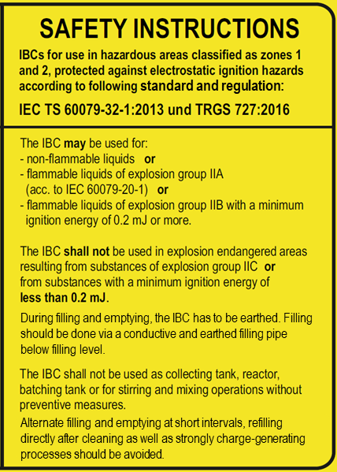
Proposal
4. Based on the above-mentioned reasons ICCR, ICIBCA and ICPP currently see no need to include an additional symbol under 6.5.2.1.3 or 6.5.2.2.3 of the Model Regulations.

