SAE proposal for improvement of “lane keeping assist warning” display

This informal document is based on an intervention from SAE during the discussion of driver assistance projections (documents GRE/2021/18 (GTB), GRE-85-20 (GTB) and GRE-85-25 (Japan)). The changes proposed here are based on document GRE-85-25 and marked in bold blue font for new or bold red strikethrough for deleted characters.
Proposal
A. New Supplement to the 06, 07 and 08 series of amendments to UN Regulation No. 48
Proposed new Annex [16] amend to read:
“Annex [16]
Symbols and patterns for the use as Driver Assistance Projections and Explanations of the Warnings/Highlights

or or | Lane keeping assist warning | Activated when the vehicle is about to unintentionally exits its lane.  Shall not flash.
”

Alternatively, this could be displayed as:

 | Lane keeping assist warning | Activated when the vehicle is about to unintentionally exits its lane towards the right.  Shall not flash.
 | Lane keeping assist warning | Activated when the vehicle is about to unintentionally exits its lane towards the left.  Shall not flash.

II. Justification
- With reference to the lane keeping assist warning it is SAE’s understanding that the intent of this warning is to allow the driver to make a gradual (smooth) manoeuvre instead of an abrupt one. To achieve this, the warning shall be provided in advance, when the vehicle is about to exit the lane (before it crosses the lane marking), as opposed to when the vehicle has exited its lane (started crossing or has crossed the lane marking). This appeared to be the case during the GRE demo in October 2019 (see photos below), where projections were activated when the vehicle was still in its lane. Moreover, a situation could occur where there is no road surface to project on, if the projection were activated in case the vehicle exits its lane, as could be the case for the exit towards the right, like the one during the GRE-82 demonstration.
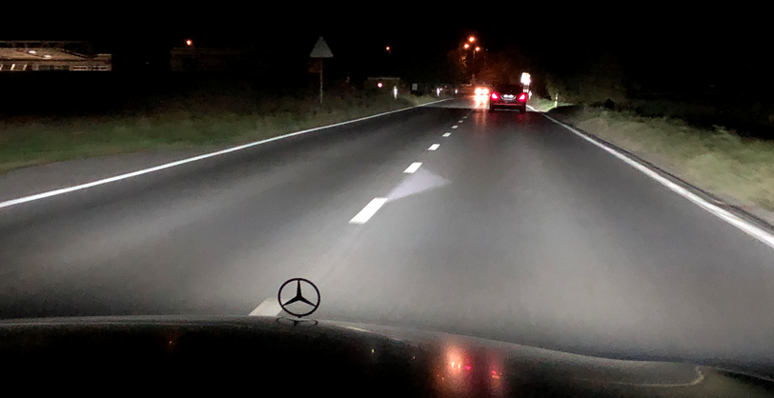
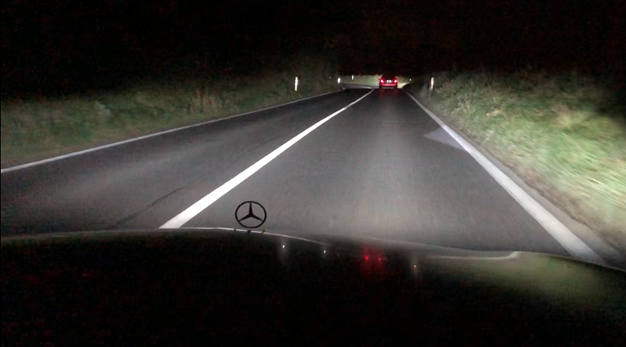
Photos taken during demonstration of Maybach vehicle at GRE-82 (23 October 2019)

- SAE believes that only one direction of the two chevrons intended for the lane keeping assist warning should be projected at a given time, dependent on the direction of lane departure of the vehicle. To clarify this and “or” should be added between the two symbols, or alternatively the two directions could be separated into two separate lines in the table.

