Correction of errors in the proposal for the 01 series of amendments to
UN Regulation No. 148 (Light-signalling devices)

The text reproduced below was prepared by the GRE Informal Working Group on Simplification of Lighting and Light-Signalling Regulations (IWG SLR) with the aim to correct some errors identified in the proposal for the 01 series of amendments to UN Regulation No. 148 (doc. ECE/TRANS/WP.29/GRE/2021/13).

The modifications to text in document ECE/TRANS/WP.29/GRE/2021/13 are marked in bold for new or strikethrough for deleted characters. For prompt reference, all the modifications are highlighted in yellow. The red circles are only intended to indicate where the correction shall be made.

I. Proposal
Paragraph 5.10.1.2., amend to read:

“5.10.1.2. The lamp must be so designed that the light emitted directly towards the side, the front or the rear of the vehicle does not exceed 5∙10⁻¹ cd within the angular field as defined below.
(a) The vertical minimum angle φmin (in degrees) is:
φmin = arctan ((1-h)/10); where h is mounting height in m
(b) The vertical maximum angle φmax (in degrees) is: φmax = φmin + 11.3
The measurement shall be limited to a horizontal angle ranging from +90° to -90° with respect to the line which cuts the reference axis and which is perpendicular to the vertical longitudinal plane of the vehicle. ”

Annex 1
Item 10, amend to read:
“10. Position of the approval mark or Unique Identifier (UI)²..................”

Annex 2
Figure A2-III, reduce the size of the figure on the left “Horizontal angles” in order to read the text properly
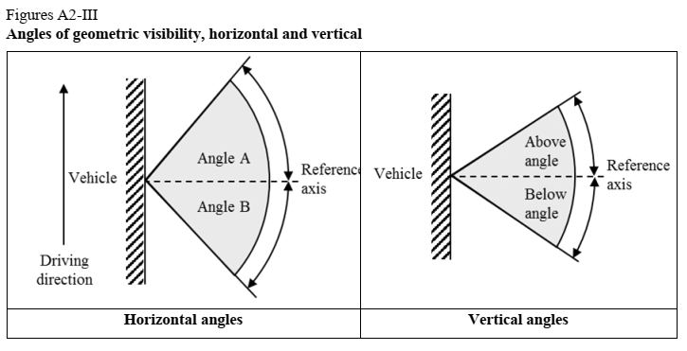

Annex 3
Figure A3-II, correct figure to read the full values in the boxes
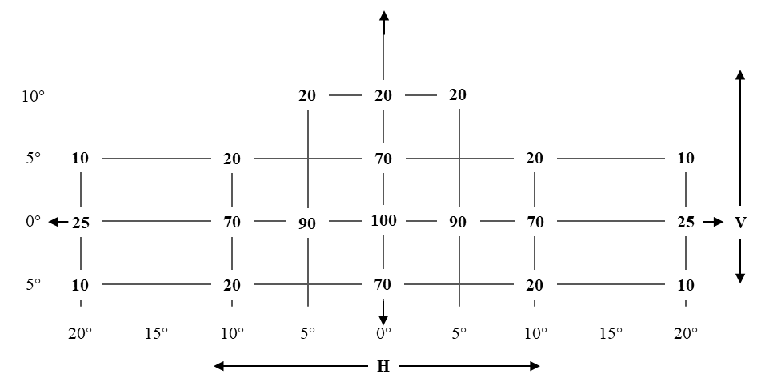

Figure A3-III, correct figure to read the full values in the boxes
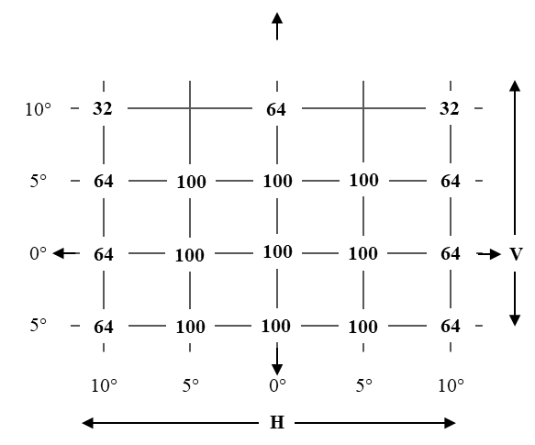

Figure A3-IV, correct figure to read the full values in the boxes
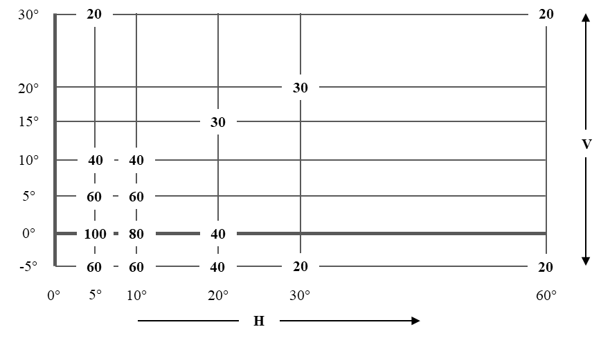

Figure A3-V, correct to read the full values in the boxes and add the “°” sign
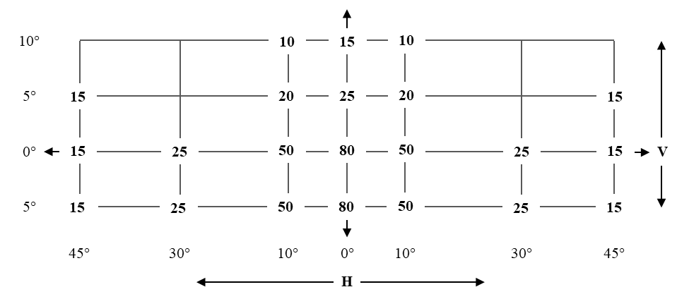

Figure A3-VI, correct to remove white corner and add the “°” sign
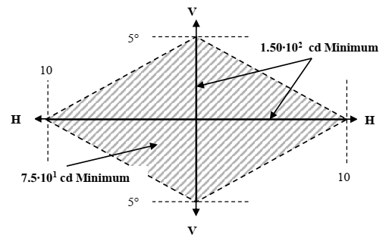

Figure A3-IX, correct figure to read the full values in the legend
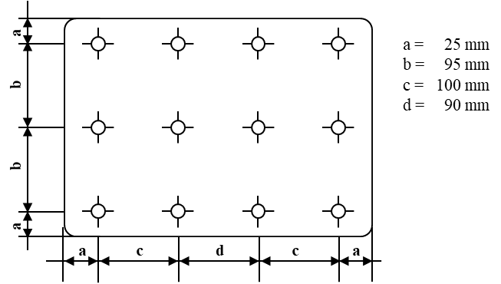

Figure A3-X, correct figure to read the full values in the legend
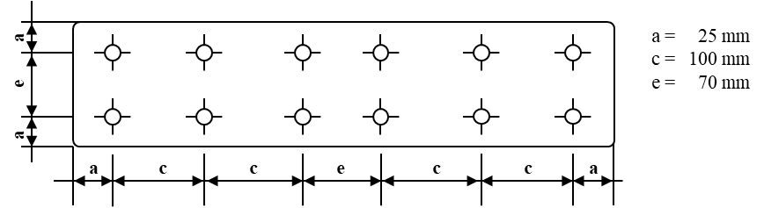

II. Justification
- In paragraph 5.10.1.2., the lack of two parentheses in the angular field formula leads to wrong results. The proposed correction intends to correct this.
- The footnote 2 “Strike out what does not apply” in conjunction with item 10 of Annex 1 was wrong since the item refers to the position of the of the approval mark or Unique Identifier and not to their presence.
- All the corrections to the Figures in Annexes 2 and 3 are necessary to make the text and the values in the boxes properly readable. During the preparation of the official proposals, the text boxes have inadvertently been resized resulting in the wrong values showed.

