|  |  |  |  |
| --- | --- | --- | --- |
|  | United Nations | ST/SG/AC.10/C.3/2021/39 | |
| _unlogo | **Secretariat** | | Distr.: General  14 September 2021  Original: English |

**Committee of Experts on the Transport of Dangerous Goods  
and on the Globally Harmonized System of Classification  
and Labelling of Chemicals**

**Sub-Committee of Experts on the Transport of Dangerous Goods**

**Fifty-ninth session**

Geneva, 29 November – 8 December 2021  
Item 3 of the provisional agenda

**Listing, classification and packing**

New UN entry for Quinone dioxime (also known as 1,4‑benzoquinone dioxime, or p-benzoquinone dioxime; CAS no. 105-11-3)

Submitted by the Council on Safe Transportation of Hazardous Articles (COSTHA)[[1]](#footnote-2)

Introduction

1. Quinone dioxime (QDO; Chemical Abstracts Service (CAS) no. 105-11-3) is a solid that is manufactured worldwide by some forty companies and is variously classified as unregulated or as Division 4.1, packing group PG II or PG III as confirmed by the current European Chemicals Agency (ECHA) classification data.[[2]](#footnote-3)1
2. First patented in 1945, beginning in 1956, QDO has been manufactured and safely transported without any known incident for more than sixty years. A predominant use of QDO is in the manufacture of tires. QDO is a rubber vulcanization curative and accelerator producing unique properties. QDO is important to tire safety and hence transport safety in that it imparts to tire rubber a high impermeability through high-density polymer / molecular cross-linking, and resistance to de-crosslinking when attacked by heat or chemicals. These same advantages are also relevant to other essential industries such as those engaged in manufacturing medical bottle closures, worker chemical personal protection equipment (PPE), high voltage insulators, as well as for production of pharmaceuticals.
3. It is estimated that worldwide over 1350 tons of QDO are manufactured annually with known manufacturing locations in the United States of America, Germany, China, Russia, and India.
4. Uncertainty over the classification of QDO has recently arisen based on REACH testing showing QDO to meet criteria in test series 6(c). More than likely, many substances classified as flammable liquids or flammable solids demonstrate more severe or similar burning behaviour than that of QDO, especially when evaluated by thermal flux alone.

5. As discussed below in more detail, QDO is not intended to function as an explosive or as a pyrotechnic and does not pose a hazard warranting its consideration as an explosive substance based on the UN definition in 2.1.1.3(a) and will not “… cause damage to the surroundings” by explosion. Classification of QDO as a Class 1 explosive would misrepresent its predominant hazard of flammable solid, per 2.1.1.1(a): “… except those … where the predominant hazard is appropriate to another class”.

6. Assignment of a UN number and proper shipping name to QDO is proposed to resolve the current uncertainty regarding its correct classification. The purpose of this proposal is to establish a uniform classification for QDO as a Packing Group II, Division 4.1 flammable solid. A completed data sheet is attached as an annex.

Classification of substances not intended to function as explosives

7. The Model Regulations identifies which substances, though not intended to function as explosives, must nevertheless still be considered explosives substances. Under 2.1.1.3(a), a substance which, though not intended to function as an explosive, is considered to be an explosive substance when the substance:

“is in itself capable, by chemical reaction, of producing gas at such a temperature and pressure and at such a speed as to cause damage to the surroundings.”

Further as also noted under 2.1.1.1(a), substances are excluded from Class 1 when the “predominant hazard is appropriate to another class”.

8. Analogously other regulations define explosive substances in a similar manner.

(a) The ADR defines explosives substances as “solid or liquid substances (or mixtures of substances) capable by chemical reaction of producing gases at such a temperature and pressure and at such a speed as to cause damage to the surroundings”.

(b) The United States Department of Transportation regulations defines explosive substances as including:

“an explosive means any substance or article, including a device, which is designed to function by explosion (i.e., an extremely rapid release of gas and heat) or which, by chemical reaction within itself, is able to function in a similar manner even if not designed to function by explosion, unless the substance or article is otherwise classed under the provisions of this subchapter”.

(c) Likewise, the Canadian Transport of Dangerous Goods regulations include substances not intended to function as explosives when they are:

“capable, by chemical reaction, of producing gas at a temperature, pressure and speed that would damage the surroundings;”

9. From the above regulation excerpts, it is seen that the transport regulations consistently exclude a substance not intended to function as an explosive unless it is:

“itself capable, by chemical reaction, of producing gas at such a temperature and pressure and at such a speed as to cause damage to the surroundings”.

10. Significantly, there is no criterion indicating a substance not intended to function as an explosive is considered an explosive substance on the basis of ordinary burning characteristics which do not produce “gas at a temperature and pressure at such a speed as to cause damage to the surroundings”. Rather, substances where the “predominant hazard” is ordinary burning are appropriately covered in other classes (e.g., Classes 2.1, 3 and 4). Still others with energetic properties may be classified as self-reactive substances or organic peroxides.

Testing/classification of QDO

11. *QDO Fire Behaviour.* A fire test of more than 135.2 kg mass in three 45 kg fibreboard drums of QDO in accordance with the UN 6(c) test showed that it produced a flame radius of 2 meters (see figure 1).

**Figure 1. External fire test**

Wood shavings were inserted between the wooden slats and soaked with a gasoline/diesel mixture.

Test set-up for external fire test, full fire phase (maximum flame) after ignition

12. As can be seen from photos (see figure 1), the burning behaviour of QDO in combination with wood shavings soaked with a gasoline/diesel mixture and wood is less severe than might be expected of many flammable liquids (e.g., diesel oil) when tested under similar conditions. Further, fire intensity is not even a classification criterion that is applicable to dangerous goods other than substances or articles intended to function as explosives.

13. Such burning behaviour is not unlike that of many flammable liquids and solids for which the appropriate hazard classification is other than Class 1. QDO does not detonate based on the Test Series 1 gap test, a test more severe than that required for transport. Importantly, from testing there was no indication that QDO will produce “gas at such a temperature and pressure and at such a speed as to cause damage to the surroundings”. As such there is no basis for considering it as an explosive substance in that, as a substance not intended to function as an explosive, it does not meet the defining criteria for an explosive substance in 2.1.1.3.

14. *QDO SADT.* QDO was tested by a German laboratory and determined to have a self-accelerating decomposition temperature (SADT) of greater than 75 °C when tested using the heat accumulation storage test (UN H.4). Further QDO was determined to have an onset decomposition temperature of 227 °C indicating on the basis of new provisions in the UN Manual of Tests and Criteria (see para. 20.3.4 of the 7th revised edition, as amended by Amendment 1) that its SADT is significantly higher (i.e., on the order of 120 °C or more). In any case QDO does not qualify as a Division 4.1 self-reactive substance at any level.

15. *Division 4.1 Flammable Solid Testing.* QDO was subjected to the burning rate test for flammable solids and determined to meet the criteria for a Packing Group II Flammable Solid on the basis of a burning time of 2 seconds and the flame passing the wetted zone.

Proposal

16. On the basis of the above, it is proposed to amend the 3.2 Dangerous Goods List by introducing a new Division 4.1 UN entry for QDO, as follows:

|  |  |  |  |  |  |  |  |  |  |  |
| --- | --- | --- | --- | --- | --- | --- | --- | --- | --- | --- |
| UN No.  Substance | Class | Subsidiary Hazard | UN packing group | Special provisions | Limited and excepted quantities | | Packagings and IBCs | | Portable tanks and bulk containers | |
| Packing instruction | Special packing provisions | Instructions | Special provisions |
| UN XXXX  QUINONE DIOXIME | 4.1 |  | II |  | 1 kg | E2 | P002 |  |  |  |

Annex

Data sheet to be submitted to the United Nations for new or amended classification of substances

**Submitted by**: COSTHA **Date**: July 16, 2021

**Section 1. SUBSTANCE IDENTITY**

1.1 Chemical name: 1,4-benzoquinone dioxime

1.2 Chemical formula: C6H6N2O2

1.3 Other names/synonyms: p-benzoquinone dioxime; 2,5-Cyclohexadiene-1,4-dione, 1,4-dioxime

1.4.1 UN number: **1325** 1.4.2 CAS number: **105-11-3**

1.5 Proposed classification for the Recommendations

1.5.1 Proper shipping name (3.1.2): **1,4-benzoquinone dioxime**

1.5.2 class/division: **4.1** Subsidiary risk(s): **None** Packing group: **II**

1.5.3 proposed special provisions, if any: **None**

1.5.4 proposed packing instruction(s): **P002**

**Section 2. PHYSICAL PROPERTIES**

2.1 Melting point or range: Not determined

2.2 Boiling point or range: Not determined

2.3 Relative density at:

2.3.1 15 °C: Not determined

2.3.2 20 °C: 1.47 g/cm3 (12.26 lb/gal)

2.3.3 50 °C: Not determined

2.4 Vapour pressure at:

2.4.1 50 °C: Not determined

2.4.2 65 °C: Not determined

2.5 Viscosity at 20 °C[[3]](#footnote-4)2: Not determined

2.6 Solubility in water at 20 °C: Insoluble

2.7 Physical state at 20 °C (2.2.1.1): Solid (solid/liquid/gas)

2.8 Appearance at normal transportation temperatures, including colour and odour: Very slight chemical odour, but not offensive. Fine particles - brown powder.

2.9 Other relevant physical properties: N/A

**Section 3. Flammability**

3.1 Flammable vapour

3.1.1 Flash point (2.3.3): >/= 93 °C cc

3.1.2 Is combustion sustained? (2.3.1.3): Yes

3.2 Autoignition temperature:>/= 165.5 °C

3.3 Flammability range (LEL/UEL): Not Determined

3.4 Is the substance a flammable solid? (2.4.2): YES

3.4.1 If yes, give details: **UN Test N.1, Test Method for Readily Combustible Solids, demonstrated that 1,4-benzoquinone dioxime propagated combustion for a length of 100 mm in less than 45 seconds, and the flame passed the wetted zone. See also attached test report #21048.**

**Section 4. CHEMICAL PROPERTIES**

4.1 Does the substance require inhibition/stabilization or other treatment such as nitrogen blanket to prevent hazardous reactivity? No

4.2 Is the substance explosive according to paragraph 2.1.1.1? (2.1) No

4.3 Is the substance a desensitized explosive? (2.4.2.4) No

4.4 Is the substance a self-reactive substance? (2.4.1) No

4.5 Is the substance pyrophoric? (2.4.3) No

4.6 Is the substance liable to self-heating? (2.4.3) No

4.7 Is the substance an organic peroxide? (2.5.1) No

4.8 Does the substance in contact with water emit flammable gasses? (2.4.4) No

4.9 Does the substance have oxidizing properties? (2.5.1) No

4.10 Corrosivity (2.8) to: **There are no corrosive properties associated with this substance**

4.10.1 Mild steel ………….mm/year at ………………………………. °C N/A

4.10.2 Aluminum ………….mm/year at ………………………………. °C N/A

4.10.1 Other packaging materials (specify)

……………….mm/year at ………………………………. °C

……………….mm/year at ………………………………. °C

4.11 Other relevant chemical properties: N/A

**Section 5. HARMFUL BIOLOGICAL EFFECTS**

5.1 LD50, Oral (2.6.2.1.1) 464 mg/kg Animal species? Rat

5.2 LD50, Dermal (2.6.2.1.2) Not determined

5.3 LC50, Inhalation (2.6.2.1.3) 55 mg/litre Exposure time: Not listed

5.4 Saturated vapour concentration at 20 °C (2.6.2.2.4.3) Not determined

5.5 Skin exposure (2.8) results: Not determined

5.6 Other data: N/A

5.7 Human experience: Not determined

**Section 6. SUPPLEMENTARY INFORMATION**

6.1 Recommended emergency action

6.1.1 Fire (include suitable and unsuitable extinguishing agent): Carbon Dioxide, Dry Chemical, Foam, Water Fog

6.1.2 Spillage: Remove all sources of ignition. Avoid breathing dust and keep dust to a minimum. Wet with water if necessary. Contain and remove with a broom and non-sparking tools.

6.2 Is it proposed to transport the substance in:

6.2.1 Bulk Containers (6.8) No

6.2.2 Intermediate Bulk Containers (6.5) No

6.2.3 Portable tanks (6.7) No

\*\*\*If yes provide details in Sections 7, 8 and/or 9

**Section 7. BULK CONTAINERS (Only complete if yes 6.2.1) …N/A**

**Section 8. INTERMEDIATE BULK CONTAINERS (Only complete if yes in 6.2.2) …N/A**

**Section 9. MULTIMODAL TANK TRANSPORT (Only complete if yes in 6.2.3) …N/A**

**Appendix** [English only]

**STRESAU TEST REPORT # 21048**

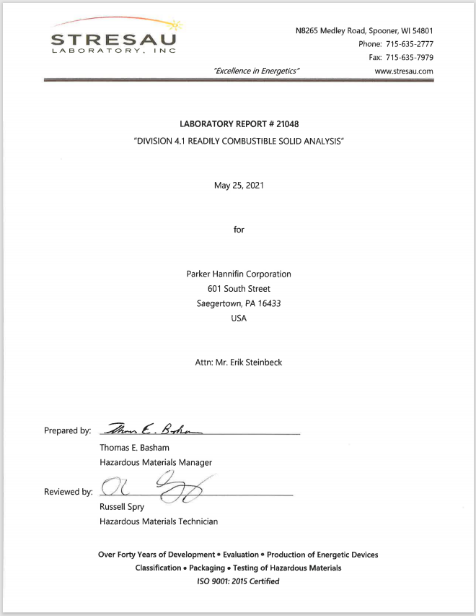

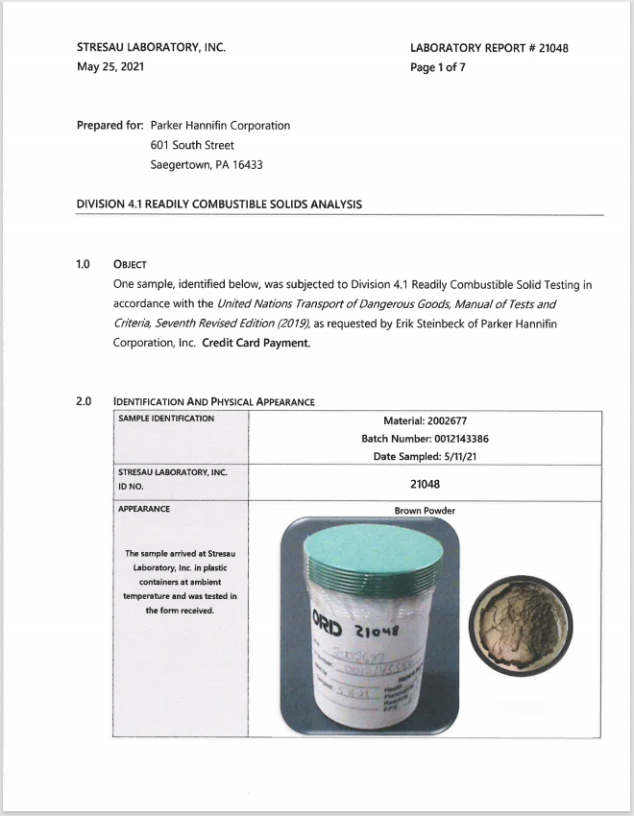

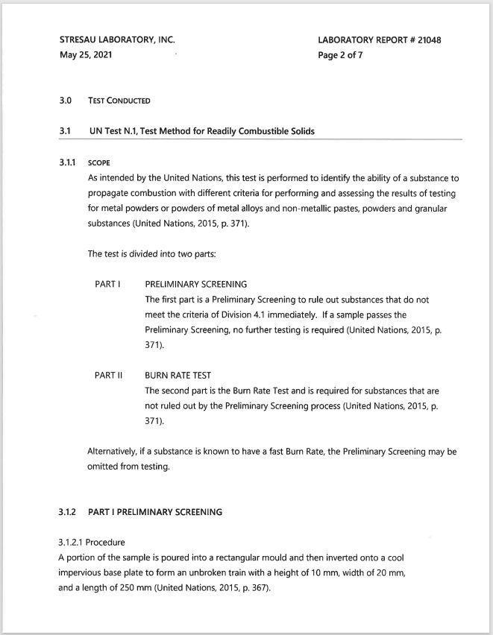

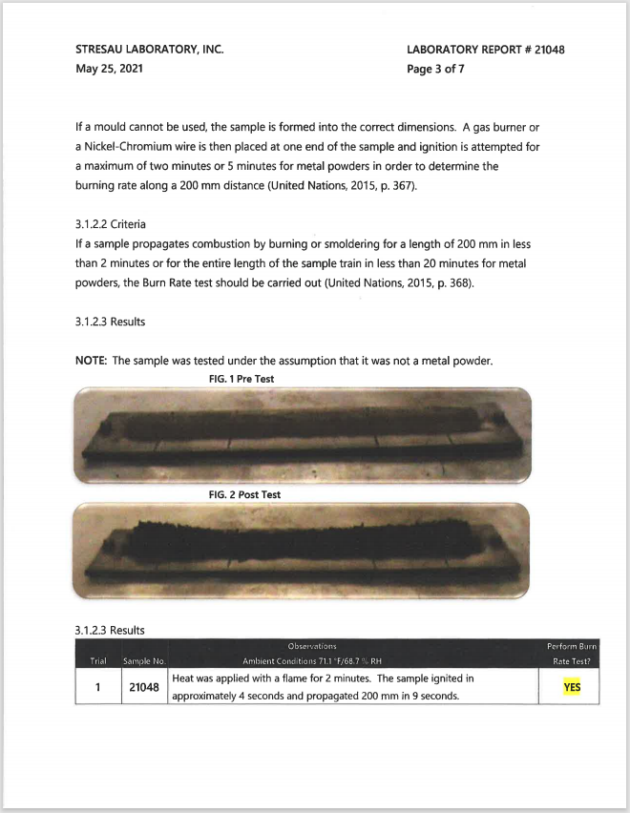

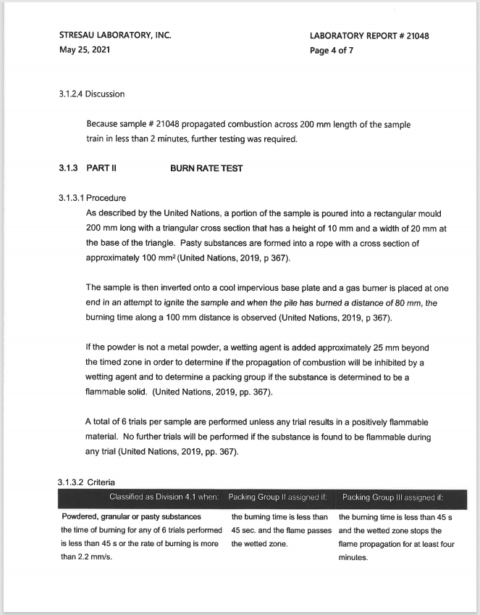

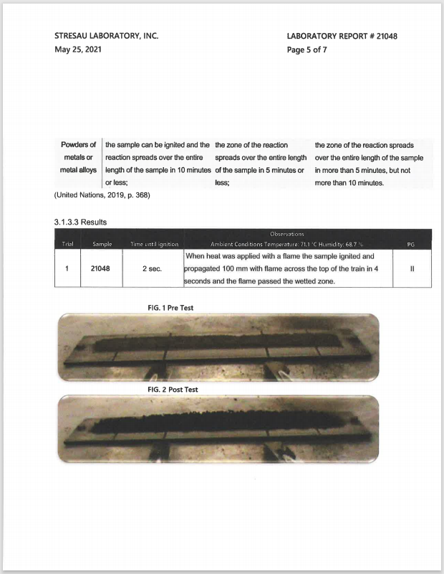

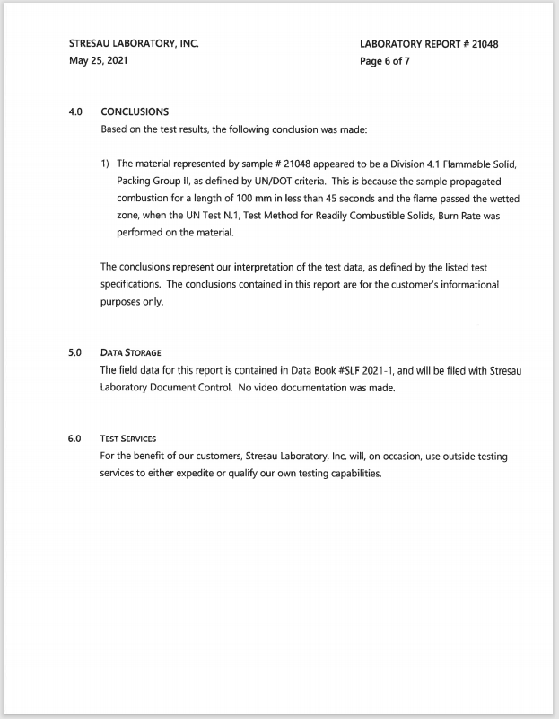

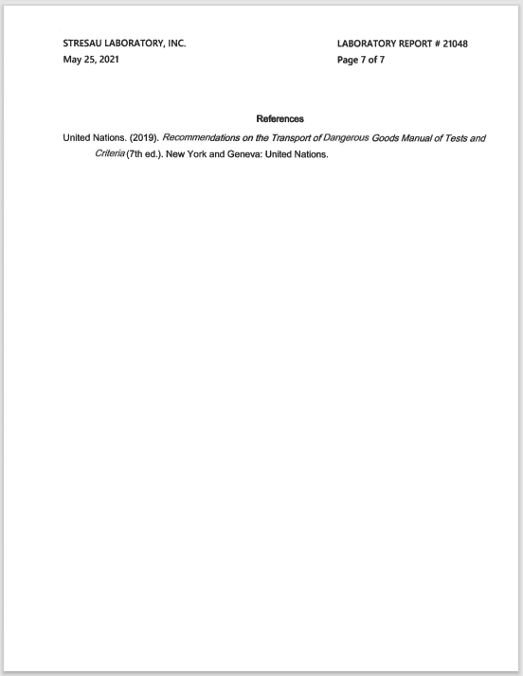

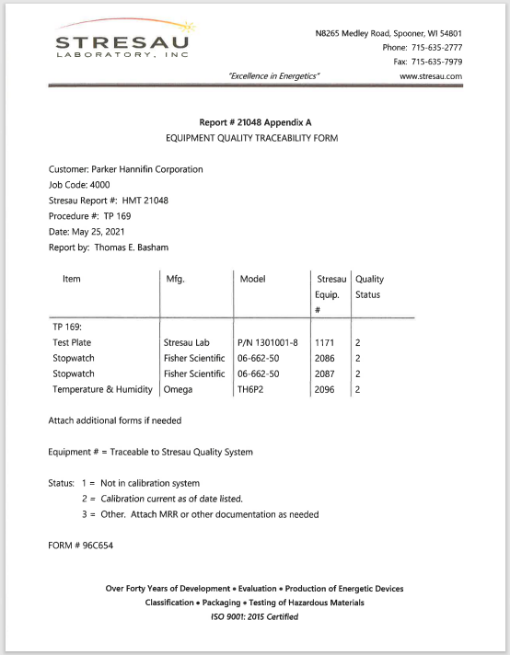

1. A/75/6 (Sect.20), para. 20.51 [↑](#footnote-ref-2)
2. 1 See [p-benzoquinone dioxime - Substance Information - ECHA (europa.eu)](https://echa.europa.eu/substance-information/-/substanceinfo/100.002.974) [↑](#footnote-ref-3)
3. 2 See definition of "liquid" in 1.2.1 of the Model Regulations on the Transport of Dangerous Goods. [↑](#footnote-ref-4)