|  |  |  |  |
| --- | --- | --- | --- |
|  | United Nations | ECE/TRANS/WP.29/GRE/2021/12 | |
| Description: _unlogo | **Economic and Social Council** | | Distr.: General  5 August 2021  Original: English |

**Economic Commission for Europe**

Inland Transport Committee

**World Forum for Harmonization of Vehicle Regulations**

**Working Party on Lighting and Light-Signalling**

**Eighty-fifth session**

Geneva, 26-29 October 2021

Item 4 (c) of the provisional agenda

**Simplification of lighting and light-signalling UN Regulations:**

**UN Regulation No. 149 (Road illumination devices)**

Proposal for amendments to UN Regulation No. 149

Submitted by the Informal Working Group on Simplification of Lighting and Light-Signalling Regulations (IWG SLR)[[1]](#footnote-1)\*

The text reproduced below was prepared by the Informal Working Group on Simplification of Lighting and Light-Signalling Regulations (IWG SLR) with the aim to clarify and to correct the text of the UN Regulation No. 149. The modifications are marked in bold for new or strikethrough for deleted characters.

I. Proposal

*Paragraph 3.3.2.4.*, amend to read:

“3.3.2.4. **Symbol(s), according to Table 1, and** additional symbol**(**s**), if any** ~~for headlamps, AFS and front fog lamps:~~ ”

*Paragraph 3.3.2.4.4.*, amend to read:

“3.3.2.4.4. In the case of front fog lamps, headlamps and AFS installation unit**s** incorporating a**n outer** lens of plastic material, the group of letters "PL" to be affixed near the symbols identifying the ~~lighting~~ **function(s)**; ”

*Add a new paragraph 3.3.2.4.8.,* to read:

“**3.3.2.4.8. In the case of AFS, in addition the symbol “T”, after the symbol(s) of all lighting function(s) and/or class(es) designed to comply with the respective bend lighting provisions, with said symbol(s) arranged together and leftmost to the symbol “T”.** ”

*Paragraph 4.5.2.6.*, amend to read:

“4.5.2.6. Except for AFS and cornering lamps, in case of a lamp incorporating one or more light source(s) or LED module(s) producing the principal passing-beam or the front fog beam and having a total objective luminous flux which exceeds 2,000 lumens, a reference shall be made in the communication form in Annex 1.

In case of an AFS incorporating light sources and/or LED module(s) producing the basic passing beam and having a total objective luminous flux of the lighting units as indicated under item **~~9.3.2.3.~~ 9.3.3.(a)** of the communication form which exceeds 2,000 lumen per side, a reference shall be made in the communication form in Annex 1.

The objective luminous flux of LED modules shall be measured as described in paragraph 5. of Annex 9.”

*Figure A4-V,* amend to read:

“Figure A4-V

**Passing-beam for right-hand traffic**

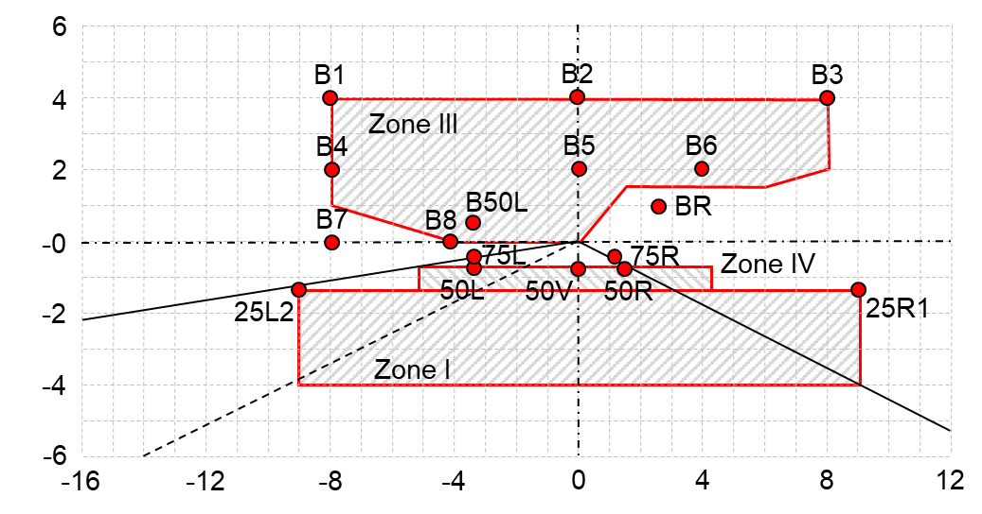

The test point locations for left-hand traffic are mirrored about the VV line”

*Figure A4-VII,* amend to reads:

“Figure A4-VII

**AFS Passing-beam for right-hand traffic**\*

\* *Note*: The measurement procedure is prescribed in Annex 4

For the purpose of this Annex:

"above it" means vertically above, only;

"below it" means vertically below, only.

Angular positions of passing-beam photometric requirements are indicated for right-hand traffic and are expressed in degrees up (U) or down (D) from H-H respectively right (R) or left (L) from V-V.

The test point locations for left-hand traffic are mirrored about the V-V line

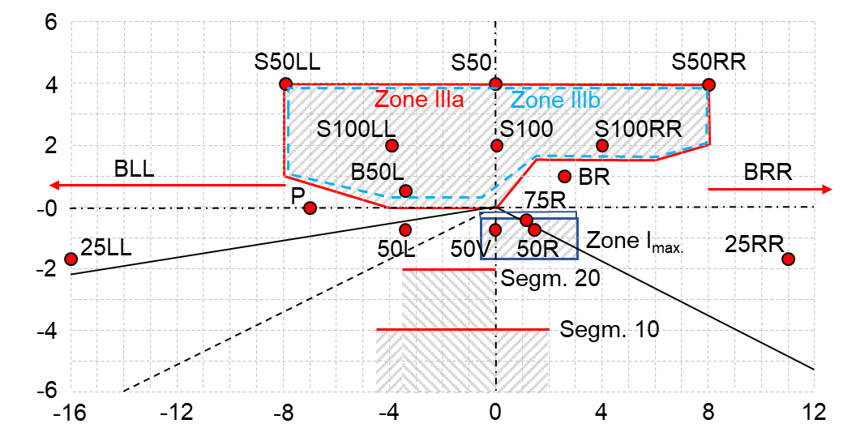

”

II. Justification

1. In paragraphs 3.3.2.4. and 3.3.2.4.4. the proposal intends to clarify the existing provisions.

2. The provisions in paragraph 3.3.2.4.8. are contained in UN Regulation No. 123 (paragraph 4.2.2.3.) but are currently missing in UN Regulation No. 149.

3. The proposal corrects a wrong reference in paragraph 4.5.2.6. The correct reference is item 9.3.3. (a) in Annex 1, not item 9.3.2.3.

4. The proposal also corrects the locations of points 50L and 75L in Figures A4-V and A4-VII.

1. \* In accordance with the programme of work of the Inland Transport Committee for 2021 as outlined in proposed programme budget for 2021 (A/75/6 (Sect.20), para 20.51), the World Forum will develop, harmonize and update UN Regulations in order to enhance the performance of vehicles. The present document is submitted in conformity with that mandate. [↑](#footnote-ref-1)