INF.47/Rev.1
Economic Commission for Europe
Inland Transport Committee
Working Party on the Transport of Dangerous Goods
Joint Meeting of the RID Committee of Experts and the
Working Party on the Transport of Dangerous Goods
Geneva, 21 September – 1 October 2021 30 September 2021
Item 2 of the provisional agenda
Tanks
Marking of tanks carrying flammable liquefied gases that are fitted with safety valves
Transmitted by Liquid Gas Europe on behalf of
the BLEVE working group
1. With the mandatory requirement for the fitting of safety valves in tanks transporting flammable liquified gases being adopted further work has been requested on the marking of tanks fitted with safety valves.
2. To aid emergency services the proposal also includes an identification letter that will be displayed in a placard, this will also require a new paragraph (6.8.3.2.9.6).
3. Additionally, two new transitional measures will also be required in 1.6.3 and 1.6.4.
Proposal 1: new 6.8.3.2.9.6
“6.8.3.2.9.6 Safety valve mark
6.8.3.2.9.6.1 Tanks fitted with safety valves in accordance with 6.8.3.2.9 shall display the mark as set out in 6.8.3.2.9.6.2 to 6.8.3.2.9.6.5.
6.8.3.2.9.6.2 The mark shall consist of a white square with dimensions of 250 mm x 250 mm with the letters ‘SV’ 120 mm high in black.
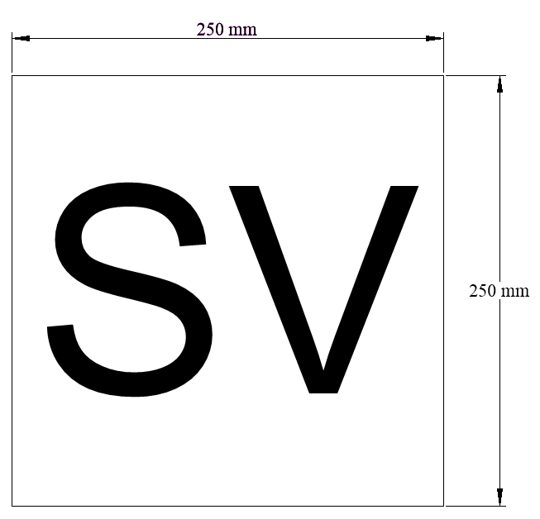
6.8.3.2.9.6.3 The material used shall be weather-resistant and ensure durable marking. The mark shall not become detached from its mount in the event of 15 minutes’ engulfment in fire. It shall remain affixed irrespective of the orientation of the tank.
6.8.3.2.9.6.4 The letter ‘P’ (letters ‘SV’) shall be indelible and shall remain legible after 15 minutes’ engulfment in fire.

(RID:)
6.8.3.2.9.6.5 |  | The marks shall be displayed on both sides and both ends of tank-containers.
(ADR:)
6.8.3.2.9.6.5 | The marks shall be displayed  on both sides and the rear of fixed tanks and on both sides and both ends of demountable tanks. | on both sides and both ends of tank-containers.
Proposal 2: Transitional measures
(ADR:)
1.6.3 Insert the following new transitional provisions:
“1.6.3.xx Fixed tanks (tank-vehicles) and demountable tanks that are already fitted with safety valves meeting the requirements of 6.8.3.2.9 as applicable from the 1st January 2023 do not need to have the mark in accordance with 6.8.3.2.9.6 before the 31st December 2024.”
(RID/ADR:)
1.6.4 Insert the following new transitional provision:
“1.6.4.xx Tank-containers that are already fitted with safety valves meeting the requirements of 6.8.3.2.9 as applicable from the 1st January 2023 do not need to have the mark in accordance with 6.8.3.2.9.6 before the 31st December 2024.”

