Economic Commission for Europe
Inland Transport Committee
Working Party on the Transport of Dangerous Goods 17 September 2021
Joint Meeting of the RID Committee of Experts and the
Working Party on the Transport of Dangerous Goods
Geneva, 21 September – 1 October 2021
Item 6 of the provisional agenda:
Interpretation of RID/ADR/ADN
Clarification on the UN Model Regulations (and ADR) 6.2.2.7.5 – placement of cylinder marking groups
Transmitted by WLPGA and Liquid Gas Europe
Summary
Executive summary: 6.2.2.7.5 requires that the manufacturing, operational and certification marks shall be placed in three groups and the example shows that the three groups are placed in a single group. However, that is shown as an example and the LPG industry has followed the guidance in ISO13769 and placed the groups of marks in separate locations. Some inspection bodies are following the example shown in 6.2.2.7.5 and are requiring all of the three groups of marks to be placed together, whereas other inspection bodies allow the three groups of marks to be placed in separate locations.
Action to be taken: Revise the wording of 6.2.2.7.5 so to clar that the three groups of makings do not need to be placed together.
Related documents: None.
Introduction
1. This proposal has been prepared for final submission to the ECOSOC Sub-Committee of Experts on the Transport of Dangerous Goods (59th session) of 29 November to 8 December 2021. However, as ADR includes the same text and subsequently, following the above meeting decisions, any changes will be transposed later into ADR, it has been considered helpful to hear also the views of the Joint Meeting in advance, and possibly improve/amend the proposal accordingly.
Background
2. 6.2.2.7.5 currently reads as follows:
"6.2.2.7.5 The above marks shall be placed in three groups:
- Manufacturing marks shall be the top grouping and shall appear consecutively in the sequence given in 6.2.2.7.4 except for the marks described in 6.2.2.7.4 (q) and (r) which shall be adjacent to the periodic inspection and test marks of 6.2.2.7.7.
- The operational marks in 6.2.2.7.3 shall be the middle grouping and the test pressure (f) shall be immediately preceded by the working pressure (i) when the latter required.
- Certification marks shall be in the bottom grouping and shall appear in the sequence given in 6.2.2.7.2.
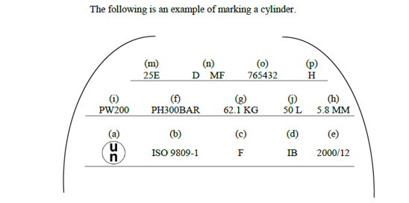"
3. The LPG industry has followed guidance in ISO 13769 and separated the three groups of markings. Standard EN 14894 Annex A states also that the groups can be in a single location or in separate locations. However, some inspection bodies have stated that a separation of the three groups is not permitted, whereas other inspection bodies have permitted separation.
4. The groups themselves are clearly distinguishable and thus a defined sequence on the cylinder is not necessary for understanding and clarity. Furthermore, since there are cylinders in different sizes and shapes, it is not always possible to have enough space for all groups to be placed together and still have an easy-to-read size.
Action to be taken
5. Revise the text of 6.2.2.7.5 so that it is clear that the three groups of markings do not need to be placed together.
6. Amend 6.2.2.7.5 to read as follows (new text in bold and underlined, deleted text in strike-through):
"6.2.2.7.5 The above marks shall be placed in three groups:
- Manufacturing marks shall be in a single the top grouping and shall appear consecutively in the sequence given in 6.2.2.7.4 except for the marks described in 6.2.2.7.4 (q) and (r) which shall be adjacent to the periodic inspection and test marks of 6.2.2.7.7.
- The operational marks in 6.2.2.7.3 shall be in a single the middle grouping and the test pressure (f) shall be immediately preceded by the working pressure (i) when the latter required.
- Certification marks shall be a single the bottom grouping and shall appear in the sequence given in 6.2.2.7.2.
The following is an example of marking a cylinder, but the groups may be placed in separate locations.


