 | INF.13
Economic Commission for Europe  Inland Transport Committee  Working Party on the Transport of Dangerous Goods  Joint Meeting of Experts on the Regulations annexed to the  European Agreement concerning the International Carriage  of Dangerous Goods by Inland Waterways (ADN)  (ADN Safety Committee)  Thirty-eighth session  Geneva, 23–27 August 2021  Item 4(b) of the provisional agenda  Proposals for amendments to the Regulations annexed to ADN:  other proposals |  | 22 July 2021  English
UN 1972 - Request to correct an inconsistency in Table C, Column (2)
Transmitted by FuelsEurope
Introduction
1. With the introduction of a ship type G-2-4-1;3 capable of carrying UN 1972, a discrepancy between the existing and new entry was observed in Table C, Column (2).
2. The new (2nd) entry for UN 1972 in Table C omits to refer to the term : “LIQUID”, in line with Chapter 1.2.
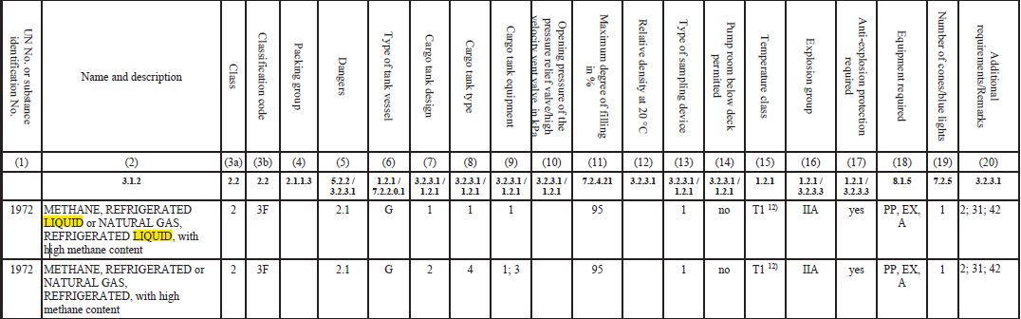

3. Chapter 1.2 – Definitions and units of measurements speaks of Liquefied Natural Gas (LNG) as “..a refrigerated liquefied gas…”.
4. With the exception of Table C, other references to this UN number in the English version of ADN (such as Column (20) remark 42, Table A as well as Table B correctly refer to METHANE, REFRIGERATED LIQUID or NATURAL GAS, REFRIGERATED LIQUID.
5. After having compared the official language versions, the English, German as well as the Russian language version would require a correction of the 2nd entry of UN 1972 in Table C.
6. The German version would further require the correction of a small typo in 3.2.3 and 3.2.4.3 – L : “Bemerkung 42”
7. The French version of ADN is not impacted. If the Russian version would need additional corrections on this UN number other than those proposed here below could however not be assessed.
Proposed corrections
(deletions are stricken through, additions in bold and underlined)
8. Table C, UN 1972 second entry, in the English, German and Russian language versions:
1972 | METHANE, REFRIGERATED LIQUID or NATURAL GAS, REFRIGERATED, LIQUID with high methane content | 2 | 3F |  | 2.1 | G | 2 | 4 | 1; 3 |  | 95 |  | 1 | no | T1 ¹²⁾ | IIA | yes | PP, EX, A | 1 | 2; 31; 42
1972 | METHAN, TIEFGEKÜHLT, FLÜSSIG oder ERDGAS,  TIEFGEKÜHLT, FLÜSSIG mit hohem Methangehalt | 2 | 3F |  | 2.1 | G | 2 | 4 | 1; 3 |  | 95 |  | 1 | nein | T1 ¹²⁾ | IIA | ja | PP, EX, A | 1 | 2; 31; 42
1972 | МЕТАН ОХЛАЖДЕННЫЙ ЖИДКИЙ или ГАЗ ПРИРОДНЫЙ ОХЛАЖДЕННЫЙ ЖИДКИЙ с высоким содержанием метана | 2 | 3F |  | 2.1 | G | 2 | 4 | 1; 3 |  | 95 |  | 1 | нет | T1 ¹²⁾ | IIA | да | PP, EX, A | 1 | 2; 31; 42
9. Additionally, the German language version, Chapter 3.2.3 (Spalte (20) – Bestimmung der zusätzlichen Anforderungen oder Bemerkungen”) as well as Chapter 3.2.4.3 - L (Bestimmung der Eintragungen der zusätzlichen Anforderungen und Bermerkungen) both contain the same typo.
Bemerkung 42 : „ …bei UN 1972 METHAN, TIEFGEHÜHLT TIEFGEKÜHLT, FLÜSSIG oder ERDGAS, TIEFGEKÜHLT, FLÜSSIG mit hohem Methangehalt“.
Request to the ADN Safety Committee
10. FuelsEurope invites the ADN Safety Committee to take note of the proposed corrections and when in agreement, to assess if these can be implemented effective ADN 2023.
11. If the proposed corrections under items 8 and 9 can be agreed upon, FuelsEurope furthermore asks the committee if a discussion needs to be started in WP.15, WP.15/AC.1, WP.15/AC1/HAR to harmonize the regulations.

