 | INF.12
Economic Commission for Europe  Inland Transport Committee  Working Party on the Transport of Dangerous Goods  Joint Meeting of Experts on the Regulations annexed to the  European Agreement concerning the International Carriage  of Dangerous Goods by Inland Waterways (ADN)  (ADN Safety Committee)  Thirty-eighth session  Geneva, 23–27 August 2021  Item 4(b) of the provisional agenda  Proposals for amendments to the Regulations annexed to ADN:  other proposals |  | 22 July 2021  English
Request for merging two UN 1202 entries into one
Transmitted by FuelsEurope
Executive Summary: Two UN 1202 entries exists, without any significant difference.
Action to be taken: The Safety Committee is invited to start a discussion within a working group.
Related documents: None
Introduction
1. There exists in Table C two UN 1202 entries which differ only in the reference to the flash-point (column (2)) and the relative density (column (12)). These are further referred to as Entry 1) and Entry 3).

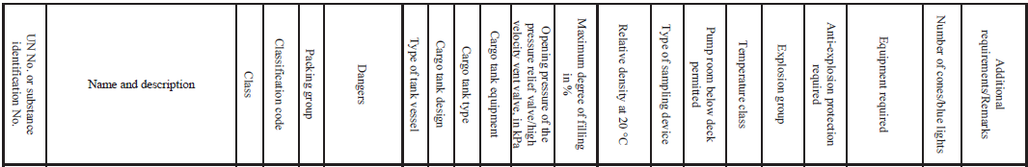
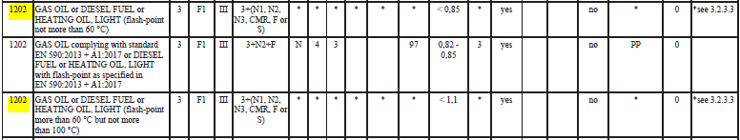

2. The choice of the entry having a flash point lower than 60 °C or between 60 °C and 100 °C has no effect on the classification, nor on the choice of the barge as box one of 3.2.3.3 defines the product as dangerous goods in either case.
3. As per 3.1.2.1, portions of an entry appearing in lower case need not be considered as part of the proper shipping name. It therefor appears that the reference to the flash-point in Column (2) refers to the possible means of evacuation as described in 7.2.4.77 only.
4. For Entry 1) and 3) of UN 1202, the only difference lies in the possible means of evacuation in case of an emergency as described in ADN 7.2.4.77.
5. For Entry 1), having a flash-point of not more than 60°C, options 4, 9, 13 and 14 are not possible.
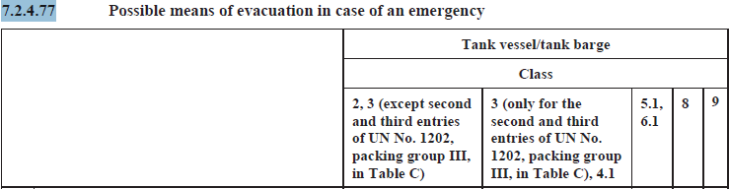
Request to the ADN Safety Committee
6. It should be noted that this double entry is present also in ADR, RID and Table A of ADN, and if anything is changed in ADN, its impact on ADR and RID would have to be taken into consideration.
7. FuelsEurope invites the ADN Safety Committee to start a discussion on the simplification of Table C of ADN, specifically on the possibility to merge Entries 1) and 3).

