Economic Commission for Europe
Inland Transport Committee
Working Party on the Transport of Dangerous Goods
Joint Meeting of the RID Committee of Experts and the
Working Party on the Transport of Dangerous Goods 23 August 2021
Geneva, 21 September – 1 October 2021
Item 2 of the provisional agenda
Tanks
Comments on document ECE/TRANS/WP.15/AC.1/2021/36 - Mandatory fitting of safety valves to tanks carrying flammable liquefied gases
Transmitted by the International Association of Fire and Rescue Services (CTIF)
Introduction
1. The CTIF appreciates the initiative to reduce the likelihood of BLEVE occurring by full fire engulfment and supports the proposals proposed by the BLEVE working group, namely (a) installation of metallic mudguards, (b) installation of engine fire suppression systems and (c) installation of safety valve(s).
2. Furthermore, CTIF supports the proposal to aid the emergency responders by communicating the installation of safety valves by visual means identifiable from a distance. For emergency response the following consequences arise:
(a) Upon arrival on the scene measures especially with reference to the size of the cordoning-off areas will be the same when responding to full fire engulfment of tanks with or without safety valves because all type responders are trained to stay on the safe site, e.g. assume that tanks are not equipped with additional safety means. This holds true for many years until all tanks will be replaced by tanks with safety valves.
(b) Once more information on the scene of such an incident becomes available the existence of safety valves will lead to a better adjustment of precautionary measures and prevent overreacting, e.g. creating too large evacuation zones which are difficult to establish and require an enormous amount of response forces and logistics
Therefore, a clear indication about safety valves readable from a distance is useful and needed.
3. With this paper CTIF wants to invite experts to discuss pros and cons of different options of visual means.

Optical identification of gas tanks fitted with safety valves
- Display on orange plate (proposal 2 for new 5.3.2.3.3)
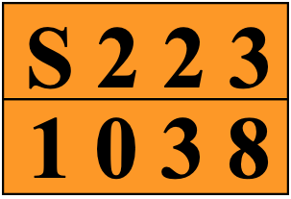
Example: Ethylene, refrigerated liquid (cryogenic liquid)
Obviously, this approach has the advantage that the information is readable from a distance. It has the disadvantage that it will go together with an increase of the list of Hazard Identification Numbers (HIN) with the special meanings. Leaflets, instruction sheets, guides, etc. would have to be updated accordingly. This would also create immediate training needs of all first responders independently of their competence level (see 2a) and the number of tanks fitted with safety valves. Furthermore, this option will not go well with countries using the Emergency Action Code (EAC) instead of the HIN.
- Display on a placard
Version 1 (neutral) | Version 2 (red pattern in analogy to the standard labelling of flammable gases) | Version 3 (green pattern as an illustration of increased safety)
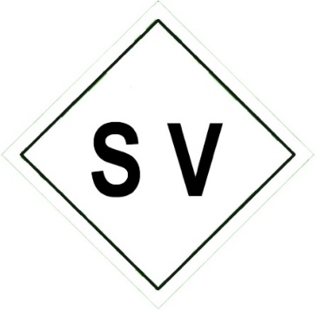 | 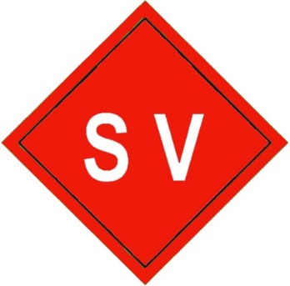 | 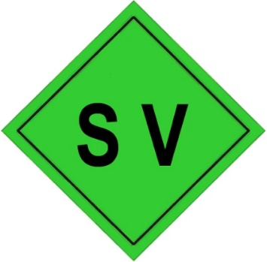
Similar to orange plates placards are well established as useful communication means in ADR/RID.
The letters ‘SV’ would clearly indicate that the tank is equipped with safety valves. This information will be important for Incident Commanders who must decide on evacuation and isolation measures on the scene. They receive special training for hazardous materials response which is not the case for all type of responders, e.g. police, emergency medical personnel and basic fire fighters. Because of the limited number of Incident Commanders, the training requirements are less needed than for the orange plate option.

