UN/SCEGHS/40/INF.19
Committee of Experts on the Transport of Dangerous Goods
and on the Globally Harmonized System of Classification
and Labelling of Chemicals
1 July 2021
Sub-Committee of Experts on the
Globally Harmonized System of Classification and Labelling of Chemicals
Fortieth session
Geneva and online (hybrid), 5-7 July 2021
Item 2 (h) of the provisional agenda
Work on the Globally Harmonized System (GHS):
Improvement of annexes 1 to 3 and further rationalization of precautionary statements
Amendment to ST/SG/AC.10/C.4/2021/2 with regard to paragraphs 25 to 27
Transmitted by the expert from Germany
1. This document aims at amending the proposal on the amendments of the notes below the three "matrix-tables" for flammable gases, pyrophoric gases and chemically unstable gases in Annex 3 Section 3 of the GHS.
Background
2. Chemically unstable gases were introduced in 2011 (4th revised edition of the GHS). Below is a screenshot of the matrix table at that time (that makes it a lot easier to understand):
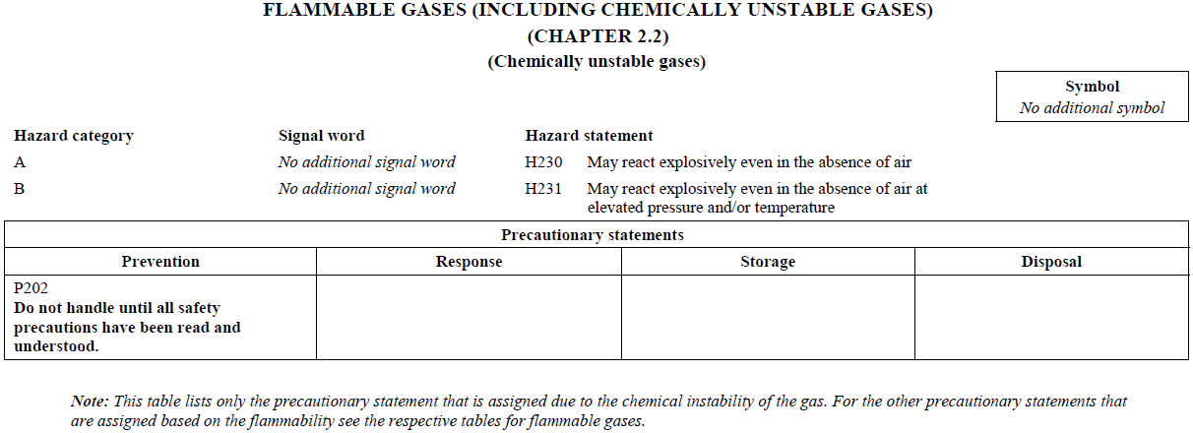
3. At that time, we needed a note hinting at the other P statements for flammability because the table only contained the P-statement that was assigned based on the chemical instability but not the ones that were assigned based on the flammability.
4. Pyrophoric gases were introduced in 2015 (6th revised edition of the GHS). The approach was the same as for chemically unstable gases (only the P-statements for pyrophoricity were given but not those based on flammability) and an equivalent Note was added.
5. In 2017 (7th revised edition of the GHS), in both tables the P statements for flammability were added.
Issue at hand with the proposed amendments of the notes
6. Now, with the changes proposed for the notes in document ST/SG/AC.10/C.4/2021/2, paragraphs 25 to 27, the wording of the 2nd sentence of the notes might become misleading.
7. The proposed wording in paragraph 26 is: "… For the other precautionary statements that are assigned based on the flammability and the chemical instability of the gas, see the respective table for chemically unstable gases A and B." (and equivalently in the other respective note to the matrix table for chemically unstable gases as proposed in paragraph 27).
8. The underlined text might imply that there are other P statements for flammability in the respective other matrix table. But there aren’t. There are only the same P-statements for flammability.
9. In paragraph 25 it is proposed to add a new note to the matrix-table for flammable gases (currently there is no note). Similarly, this new note might be misleading because it also points at "other precautionary statements based on 1A flammability".
Proposal and justification
10. Considering that the tables for pyrophoric gases and for chemically unstable gases in the meantime include also the P statements for flammability and that the note originally was only introduced in order to explain the absence of the P-statements for flammability, we propose the following:
- Remove the notes to the matrix tables for pyrophoric gases and for chemically unstable gases.
- Similarly, we propose not to add a note to the matrix table for flammable gases.
11. This would also be in line with the general principle of the matrix tables: Their purpose is only to inform about the applicable labelling elements (with special focus on the P statements) once there is a classification. Based on the classification, all matrix tables applicable to that classification are relevant. That is also not mentioned below the other tables.
12. The three matrix tables then would also reflect the classification outcome as given in the criteria Table 2.2.1 and especially as shown in the flow-chart: All categories are complete "stand-alone"-classifications.

