|  |  |  |  |
| --- | --- | --- | --- |
|  | United Nations | ECE/TRANS/WP.15/AC.2/2021/25 | |
| Description: _unlogo | **Economic and Social Council** | | Distr.: General  8 June 2021  Original: English |

**Economic Commission for Europe**

Inland Transport Committee

**Working Party on the Transport of Dangerous Goods**

**Joint Meeting of Experts on the Regulations annexed to the   
European Agreement concerning the International Carriage   
of Dangerous Goods by Inland Waterways (ADN)**

**(ADN Safety Committee)**

**Thirty-eighth session**

Geneva, 23–27 August 2021

Item 4 (b) of the provisional agenda

**Proposals for amendments to the regulations annexed to the ADN:   
other proposals**

Provisions of cofferdams

Transmitted by the European Barge Union (EBU) and the European Skippers Organisation (ESO)[[1]](#footnote-2)\*, [[2]](#footnote-3)\*\*

|  |  |
| --- | --- |
| **Related documents:** | INF.21 of the thirty-seventh session of the ADN Safety Committee, submitted by EBU/ESO,  ECE/TRANS/WP.15/AC.2/76, report of the thirty-seventh session. |

Introduction

1. Referring to informal document INF.21 of the thirty-seventh session of the ADN Safety Committee submitted by EBU/ESO, this document is to follow up the topic of “cofferdams”. It was agreed that EBU/ESO would prepare a proposal of amendments for the next session taking into account the historical reasons and all aspects of the use of cofferdam as ballast tank on the vessel, regarding stability and safety.

2. The current provisions on cofferdams seem to be outdated. It should be noticed that since the end of the ‘50’s all barges are constructed by welding the steel plates and frames and the formally used technique of revited (nailed) constructions are of an ancient epoque. A historical overview of the provisions is to be found on pages 7 to 9 of this paper.

3. The adoption of this proposal would demand a minor adaption of the provisions of the ADN and contribute to a direct safety benefit while barges are sailing on the canals and have to pass low bridges.

Background of proposal – incident figures

4. On several canals in Western-Europe, there is very limited height of the bridges to sail under (up to 4.20 m). On some canals, more than 40 low bridges must be passed on a daily basis. Especially empty barges have very limited possibilities to reduce their height (“air draft”) and unfortunately about 30 times per year a wheelhouse hits a bridge as an accident with, in some cases, even lethal results.

5. As mentioned in informal document INF.21 of the thirty-seventh session, the Platform Zero Incidents (“PZI”)[[3]](#footnote-4) incident database show conservative figures about double hull tank barges and bridge collision incidents over the last 5 years:

* 64 incidents registered regarding collision of wheelhouse with a bridge, wheelhouse (partly destroyed), serious damage of the wheel house and navigation apparatus etc. more than € 50.000,-
* 2 incidents registered in which a crew member died as a result of the collision;
* 4 crew members were seriously wounded as result of the collision.

6. These collisions are a big problem for the barging industry and not easy to solve. Due to this critical situation EBU and ESO would like to discuss a probable solution, which has been allowed and used in the past, the use of the cofferdam as extra ballast tank.

7. This is practically easy to be realised and would only require a minor adaptation of the provisions of the ADN. The adoption of the proposal increases the air draft of the ‘average’ barge with approximately 12-16 cm which leads also to an extra 12-16 cm bridge ‘clearance’. This information was provided in informal document INF.21 of the thirty-seventh session.

Proposal

8. To increase safety and avoid outdated provisions about operational aspects of cofferdams, which do not contribute to safety, EBU/ESO proposes the following:

(a) Delete the sentence of ADN 7.2.3.1.1:

**"7.2.3.1 *Access to cargo tanks, residual cargo tanks, cargo pump-rooms below deck, cofferdams, double-hull spaces, double bottoms and hold spaces; inspections***

~~7.2.3.1.1 The cofferdams shall be empty. They shall be inspected once a day in order to ascertain that they are dry (except for condensation water).~~"

(b) Amend ADN 7.2.3.20 by deleting the first sentence and adding “Cofferdams, not fitted out as service spaces” in the second sentence:

**"7.2.3.20 *Water ballast***

7.2.3.20.1 ~~Cofferdams and~~ ~~hold spaces containing insulated cargo tanks shall not be filled with water.~~

Cofferdams, not fitted out as service spaces, double-hull spaces, double bottoms and hold spaces which do not contain insulated cargotanks may be filled with ballast water provided:

– this has been taken into account in the intact and damage stability calculations; and

– the filling is not prohibited in column (20) of Table C of Chapter 3.2."

(c) In ADN 9.3.2.11.5 and 9.3.3.11.5 add “cofferdams, which are not fitted out as service space” as follows:

"9.3.2.11.5/9.3.3.11.5 Double-hull spaces, **cofferdams, which are not fitted out as service space** and double bottoms in the cargo area shall be arranged for being filled with ballast water only. Double bottoms may, however, be used as oil fuel tanks, provided they comply with the provisions of 9.3.2.32/9.3.3.32."

Justification of the proposal

9. It should be noted that after an intensive investigation regarding the provisions of the cofferdams (summary to be found on page 5ff) these provisions seem to originate from approximately 50 years ago, when existing barges in service, constructed before the ‘50’s could be constructed in origin, by revits (nails).

10. It should also be noted that revited plate and frame connections had the intrinsic property of “tears leaking” through the plate connections and through the steel revits. For that reason, it was necessary and considered good practice to inspect the cofferdams (and other spaces) on a daily base and no ballast should be put in the cofferdam as in that case, leakage could not have been determined.

11. This background could be considered as outdated as since the ‘50’s of the twentieth century, ship construction was all made by the improved construction technique of welding and the risk of leaking, therefore, had disappeared. The extraordinary low risk of any potential leakage from cargo tanks into cofferdams, should also be considered in the light of the obligatory testing provisions of cofferdams at the latest every 11 years (referring to ADN 9.3.2.23 and 9.3.3.23) and bulkhead thickness measurement programs of the Class Societies under which also the cofferdams fall, shall be taken into account too.

12. The daily inspection requirement of cofferdams to investigate leakage and the prohibition to fill them with ballast water have become superfluous.

Safety benefit

13. It would help the barging industry to gain a bigger safety marge, sailing under low bridges, which directly results in a safety improvement during the voyage, for ship and crew. Less bridge collision incidents could be expected.

Safety disadvantages

14. For the barging industry it is unclear why it would not be allowed today to ballast by using the cofferdams; EBU and ESO do not see any negative aspect, taken into account the requirement of cofferdams being implemented as compartment into the stability calculations. The cofferdams are equipped to be filled in the case of fire of the engine room anyway (9.3.x.20.2).

15. Both, in practice in the ‘hard copy’ stability booklets on board of many vessels and also in the corresponding stability programs (“loading instruments” according to ADN 1.2 and 9.3.x.13.3), but also in the stability part of the ADN-education (ADN basic training course; 8.2.2.3.1.1, subparagraph “Stability”), “actual fillings” of cofferdams are taken into account as compartment into the stability calculations of double hull vessels.

16. For existing barges, built before 23-5-2000, it is still allowed to use the cofferdam as “ballast tank” anyway until renewal of their certificate of approval, after 2038 by a transitional provision in ADN 1.6.7.2.2.2 for ADN 7.2.3.20.1.

17. This long-term derogation for basically the same double hull vessels also indicates no direct negative safety aspects are applicable.

Practice – information of development of tank fleet and canal sailing

18. The current cofferdam provisions already exist for a long time but in the last three decades, the fleet composition has been changed enormously; from mainly single hull barges in the early ‘90’s towards more than 90 percent double hull barges nowadays.

19. Double hull barges are equipped with ballast tanks (9.3.x.11.5) and to be able to sail on the canals when they are empty of cargo, those ballast tanks are filled frequently to fulfil the necessary reduction of the height of the vessel to be able to sail under the bridges with enough clearance.

20. It is a fact that the double hull barges have a bigger height in the cargo area, to be able to carry more or less the same amount of product, compared to the former single hull barge with the same dimensions of length and width. This reduces the cargo tank sizes in the width of the barge because of the U-formed double hull ballast compartments around the cargo tanks of a double hull barge (on portside, starboard and the bottom under the tanks).

21. In the past, it was a normal procedure to put ballast in the cargo tanks to obtain more air draft, but due to environmental circumstances this practice is no longer applicable since many years.

22. Cofferdams (type N and type C) are equipped to fill them with water within 30 minutes in the case of a fire (9.3.x.20.2). The filling of the cofferdam provides approximately a 40-50 m3 and thus 40-50 tons of water ballast, which increases an extra air draft of approximately 16 cm, which thus results in 16 cm lower air draft and 16 cm additional bridge clearance above the wheelhouse.

23. To give an insight in the practice of sailing on the channels with a (hydraulic) lowered wheelhouse see the pictures attached, showing the clearance of wheelhouse tops under brigdes of the Wesel-Datteln-Kanal in Gemany

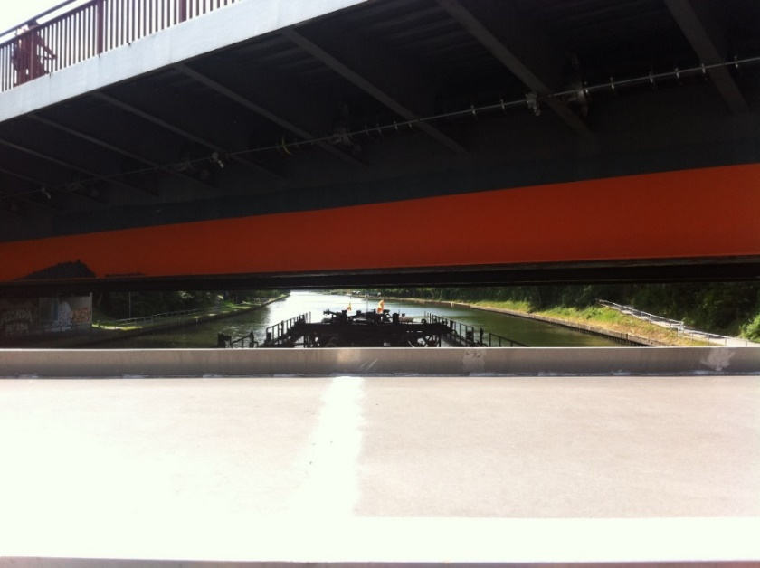

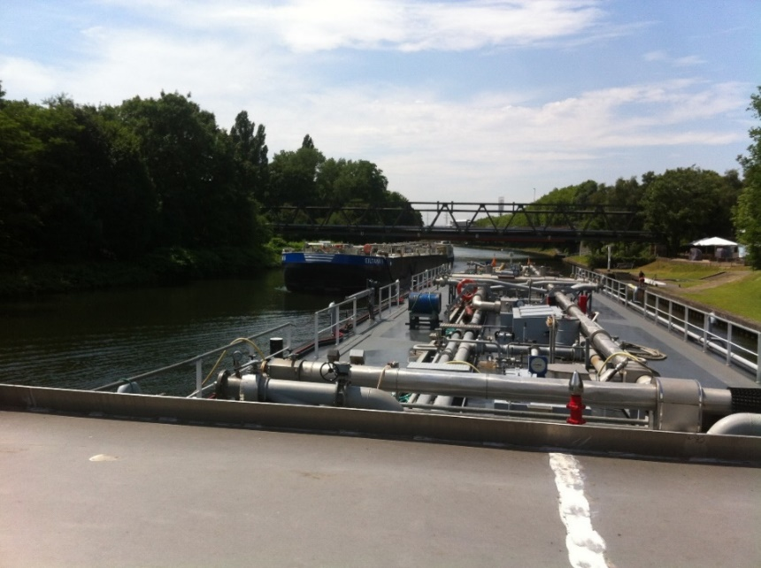

Current provisions of ballast and historical review

24. The current ADN 7.2.3.20 on “Water ballast” stipulates:

“Cofferdams *(and hold spaces containing insulated cargo tanks)* shall not be filled with water.”

25. This provision already exists since a long time in the ADN(R), as far as EBU/ESO could trace back at least in the ADNR of 1997 under Rn. 210.320.

26. ADN 1.6.7.2.2.2 provides a transitional provision for this article 7.2.3.20.1 as follows:

| 1.6.7.2.2.2 Table of general transitional provisions: Tank vessels | | |
| --- | --- | --- |
| Paragraphs | Subject | Time limit and comments |
| 7.2.3.20.1 | Ballast water  Prohibition against filling cofferdams with water | N.R.M.  Renewal of the certificate of approval after  31 December 2038  Until then, the following requirements apply on board vessels in service:  Cofferdams may be filled with water during unloading to provide trim and to permit residue-free drainage as far as possible.  When the vessel is underway, cofferdams may be filled with ballast water only when cargo tanks are empty. |

27. As no date is inserted after “N.R.M.” this implies that the transitional provision is applicable for barges which are built before 26 May 2000 (see ADN 1.6.7.1.2 (b) - last paragraph).

28. After an intensive investigation of the provisions of the ADNR-1972, a comparison overview is given in the table below:

Historical overview Cofferdams - ADNR-1972 and ADN 2021

|  |  |  |
| --- | --- | --- |
|  | **ADNR 1972** | **ADN 2021** |
| **Item / type of construction** | Welded / riveted (nailed) steel ships in service | Welded steel ships only |
| Definition | App. B - Rn.10.102  22. “Cofferdam”; a transverse compartment, wide enough to be inspectable and separated from adjacent spaces by one or more bulkheads that are oil-tight within the meaning of paragraph (3) of this provision. ... (3) In this section the term means that;  - a bulkhead is “oil-tight”, so that it is constructed, welded or riveted with a small pitch *("nails")* , as to prevent leakage of petroleum products; the reliability of the construction is checked by a static test with water. | 1.2 Definitions  *Cofferdam* means an athwartship compartment which is bounded by watertight bulkheads and which can be inspected. The cofferdam shall extend over the whole area of the end bulkheads of the cargo tanks. The bulkhead not facing the cargo area (outer cofferdam bulkhead) shall extend from one side of the vessel to the other and from the bottom to the deck in one frame plane. |
| Design / construction | App. B - Rn. 31.211  Any cofferdams must be constructed in such a way that they can be filled with water in such a way that the static pressure of the water exceeds that of the cargo and prevent the liquid or dangerous gas from entering the cofferdam. The interior of a cofferdam must be accessible. Access and ventilation openings must be below deck. | 9.3.x.20 **Arrangement of cofferdams**  9.3.3.20.1 Cofferdams or cofferdam compartments remaining once a service space has been arranged in accordance with 9.3.3.11.6 shall be accessible through an access hatch.  9.3.3.20.2 Cofferdams shall be capable of being filled with water and emptied by means of a pump. Filling shall be effected within 30 minutes. These requirements are not applicable when the bulkhead between the engine room and the cofferdam has an “A-16” fire protection insulation according to SOLAS 74, Chapter II-2, Regulation 3. The cofferdams shall not be fitted with inlet valves. ... |
|  | **ADNR 1972** | **ADN 2021** |
| **Item / type of construction** | Welded / riveted (nailed) steel ships in service | Welded steel ships only |
| Operational provisions | App. B 31.300 - Section 3  **31.300 General service regulations** 31.301 Checks during transport The cofferdams must be examined once a day to check whether the bulkhead tightness is correct for the substance being transported. If a leak is discovered, the cofferdam must be filled with water. | 7.2.3.20 **Water ballast**  7.2.3.20.1 Cofferdams and hold spaces containing insulated cargo tanks shall not be filled with water.  Double-hull spaces, double bottoms and hold spaces which do not contain insulated cargo tanks may be filled with ballast water provided: – this has been taken into account in the intact and damage stability calculations; and – the filling is not prohibited in column (20) of Table C of Chapter 3.2. |
| Pressure testing | App. B 31.223 **Pressure testing of cargo tanks and cofferdams** ... (2) The cofferdams must be tested with water pressure; the test pressure must correspond to that of a column of water up to 1.5 m above the tank deck. (3) A bulkhead between cofferdam and tank shall be tested on both sides, unless the part of the hull containing the cofferdam is entirely of welded construction. (4) The cofferdams must be tested each time the certificate of approval is renewed. | 9.3.x.2.23 **Pressure test**   9.3.2.23.4 Maximum intervals for the periodic pressure test shall be 11 years. |
| Conclusion | It was not forbidden to put ballast in cofferdams. For some type of barged even storage of materials was allowed (K3-barges - Rn. 31.240) or to put cargo in it. Cofferdams were meant to be used to prevent leakage from cargo tanks to the engine rooms. In the episode of riveted (nailed) plate and frame connections, it seems to be expected on a daily base, that leakages from cargo tanks could occur, caused by tension (stress) on the structure by loading, unloading, movements by waves, etc.  The nail-connection was a weak point. Therefore, daily inspection was necessary. | There is no reason to prohibit ballast in the cofferdam; cofferdams are even created to be filled with water. As barge constructions are welded and cofferdam bulkheads are measured on plate thickness each 5-yearly renewal of Class and tested by pressure, each 11 years, the risk of leakage is due to this schedule practically very unlikely and not to be expected anymore, the bulkheads are fully (gas and liquid-) tight. A daily inspection does not make sense anymore. |
|  | **ADNR 1972** | **ADN 2021** |
| **Item / type of construction** | Welded / riveted (nailed) steel ships in service. Riveted below: | Welded steel ships only |
| Indication of revited frame and welded frame. | Afbeeldingen: constructies_staal |  |

1. \* Distributed in German by the Central Commission for the Navigation of the Rhine under the symbol CCNR-ZKR/ADN/WP.15/AC.2/2021/25. [↑](#footnote-ref-2)
2. \*\* In accordance with the programme of work of the Inland Transport Committee for 2021 as outlined in proposed programme budget for 2021 (A/75/6 (Sect.20) para 20.51). [↑](#footnote-ref-3)
3. [www.platformzeroincidents.nl](http://www.platformzeroincidents.nl) [↑](#footnote-ref-4)