 | INF.3
Economic Commission for Europe  Inland Transport Committee  Working Party on the Transport of Dangerous Goods  Joint Meeting of Experts on the Regulations annexed to the  European Agreement concerning the International Carriage  of Dangerous Goods by Inland Waterways (ADN)  (ADN Safety Committee)  Thirty-eighth session  Geneva, 23–27 August 2021  Item 4 (b) of the provisional agenda  Proposals for amendments to the regulations annexed to the ADN:  other proposals |  | 1 June 2021  English
Special authorization concerning UN 1288 SHALE OIL
Submitted by the Government of the Netherlands
Annexes to document ECE/TRANS/WP.15/AC.2/2021/20

Annex I [Dutch/English only]
Original request for special authorization

Founding member of
Euroshore International

Datum: 8 december 2020
Kenmerk: VOMS/2020/005/an

Per email Ruud.wennekes@ilent.nl
Inspectie Leefomgeving en Transport
ILT/Veiligheid en Instituties
Keten Gevaarlijke Stoffen en
Organismen
Postbus 16191
2500 BD Den Haag

Onderwerp : bijzondere machtiging vervoer UN1288 in tankschepen

Geachte heer Wennekes,

Bijgaand doen wij u de aanvraag voor een bijzondere machtiging voor het vervoer van UN1288 leisteenolie in tankschepen toekomen. Ter toelichting vermelden dat de aanvraag wordt gedaan namens de in het aanvraagformulier vermelden leden van onze vereniging voor de daarbij vermelde vaartuigen. Onze leden zamelen conform de aan hen verleende vergunning UN1288 leisteenolie in en zijn dus transporteur van UN1288 leisteenolie.

Het aanvraagformulier is ingevuld voor de verschillende kwaliteiten en soorten stoffen die onder UN1288 kunnen worden vervoerd. Dat betreft de verschillende fracties van leisteenolie, van de zware fractie tot de lichte (benzine) fractie. Naast deze producten kunnen mengsels met water worden vervoerd. Dat betreft met name waswaters afkomstig van het cleanen van tanks waarin leisteenolie is vervoerd. Deze waswaters bevatten in de regel > 99 % en minder dan 1% leisteenolie. Bij de in het aanvraagformulier vermelde gegevens is steeds de range van de bij ons bekende eigenschappen van de verschillende fracties van leisteenolie ingevuld. Geen rekening is daarbij gehouden met verdunning met water.

Voor de eigenschappen van de verschillende leisteenolie producten hebben wij verschillende MSDS’ en, waaronder die van de producten die aan onze leden ter inzameling zijn aangeboden geraadpleegd. Aanvullend zijn de gegevens uit de ECHA database geraadpleegd. Van niet alle in het aanvraagformulier gevraagde gegevens was informatie beschikbaar. Specifiek voor de rubrieken 3.3 en 3.4 vermelden wij dat in de geraadpleegde MSDS’ en en de Echa database consequent vermeld is dat Leisteenolie non-explosive (100%) is.

Aanvullend op het aanvraagformulier vermelden wij tenslotte dat het benzeen gehalte van schalie olie < 10%.

In de verwachting u hiermee voldoende te hebben geïnformeerd.

Met vriendelijke groet,

Vereniging van Ondernemingen
in de Milieudienstverlening
ten behoeve van de Scheepvaart

Drs A.C.P. Nijdam

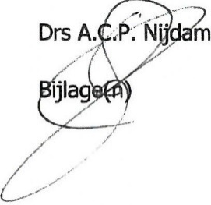

:aanvraagformulier bijzondere machtiging

3.2.4.2 Application form for special authorizations under section 1.5.2
For applications for special authorizations, please answer the following questions and points.* Data are used for administrative purposes only and are treated confidentially.
* For questions not relevant to the subject of the application, write “not applicable”.
Applicant
A.C.P. Nijdam
(Name)
VOMS
(Company)
Kerkplein 3, 4209 AC Schelluinen, Nederland
(Address)
☒ It concerns several applicants. See Annex 1
Summary of the application
Authorization for transport in tank vessels of
Leisteenolie
as a substance of Class
3
Annexes
(with brief description)
- Aanvragers
- Machtigingen
This application concerns the following ships;
Name: Zie Annex I aanvragers....... o.s.n .........................................
Name: ............................................ o.s.n. .........................................
Name: ............................................ o.s.n. .........................................
Name: ............................................ o.s.n. .........................................
Name: ............................................ o.s.n. .........................................
Application made:
At: Schelluinen
Date: .8 december 2020
Signature:
(of the person responsible for the data)
1. General data on the dangerous substance
1.1 Is it a pure substance ☒, a mixture ☒, a solution ☐?
1.2 Technical name (if possible ADN nomenclature or possibly the IBC Code). (International Code for the Construction and Equipment of ships carrying Dangerous Chemicals in Bulk)
Leisteenolie
1.3 Synonym. Schalie olie
1.4 Trade name. Shale oil
1.5 Structure formula and, for mixtures, composition and/or concentration.
Leisteenolie 1-100%, water 0 - 99%
1.6 Hazard class and, where applicable, classification code, packing group.
Klasse 3, classificatiecode F1, VG II en/of III
1.7 UN Number or substance identification number (if known).
1288
2. Physico-chemical properties
2.1 State during transport (e.g. gas, liquid, molten, ...).
Vloeibaar
2.2 Relative density of liquid at 20ºC or at the transport temperature if the substance is to be heated or refrigerated during transport.
0,917 midden fractie
2.3 Transport temperature (for substances heated or refrigerated during transport).
Omgevingstemperatuur
2.4 Melting point or range < -9 ºC.
2.5 Boiling point or range 40 - 645 ºC.
2.5 Vapour pressure at:
- 25ºC 0,06 – 13,5 kPa..................
- 20ºC ........................................
- 30ºC ........................................
- 37.8ºC .....................................
- 50ºC 10,9- 26 kPa...................
- for liquefied gases, vapour pressure at 70ºC ............................),
- for permanent gases, filling pressure at 15ºC ..........................).
2.7 Cubic expansion coefficient 0,000736 – 0.000888........ K⁻¹
2.8 Solubility in water at 20 ºC: 0,1 - 5,74 g/l
Saturation concentration mg/l, or
Miscibility with water at 15 ºC
☐ Complete ☐ partial ☐ none
(If possible, in the case of solutions and mixtures, indicate concentration)
2.9 Colour. Geel tot donkerbruin.................................
2.20 Odour. Bitter/irriterend........................................
2.11 Viscosity 0,637 – 11,1............ mm²/s bij 20 °C.
2.12 Flow time (ISO 2431-1996) ................ s.
2.13 Solvent separation test .......................... .
2.14 pH of the substance or aqueous solution (indicate concentration).
4,8
2.15 Other information.

3. Technical safety properties
3.1 Auto-ignition temperature in accordance with IEC 60079-20-1:2010, EN 14522:2005, DIN 51 794:2003 in ºC; where applicable, indicate the temperature class in accordance with IEC 60079-20-1:2010.
238 – 395 ºC bij 1013 hPa
3.2 Flash-point
For flash-points up to 175 o C
Closed-cup test methods - non-equilibrium procedure
- Abel method: EN ISO 13736:2008
- Abel-Pensky method: DIN 51755–1:1974 or NF M T60-103:1968
- Pensky-Martens method: EN ISO 2719:2012
- Luchaire apparatus: French standard NF T60-103:1968
- Tag method: ASTM D56-05(2010)
Closed-cup test methods – equilibrium procedure
- Rapid equilibrium procedure: EN ISO 3679:2004; ASTM D3278-96 (2011)
- Closed-cup equilibrium procedure: EN ISO 1523:2002+AC1:2006; ASTM D3941-90 (2007)
For flash-points above 175 ºC
In addition to the above-mentioned methods, the following open-cup test method may be applied:
- Cleveland method: EN ISO 2592:2002; ASTM D92-12.
Vlampunt: 10 - 30 ºC, < 20 ºC voor de lichte (benzine) fractie
3.3 Explosion limits:
Determination of upper and lower explosion limits in accordance with EN 1839:2012.
Non-explosive (100%)
3.4 Maximum safe gap in accordance with IEC 60-20-1:2010 in mm.
....................mm.
3.5 Is the substance stabilized during transport? If so, provide data on the stabilizer:
Nee.
3.6 Decomposition products in the event of combustion on contact with air or under the influence of an external fire:

3.7 Is the substance fire intensifying?
Ja
3.8 Abrasion (corrosion)
.................... mm/year.
3.9 Does the substance react with water or moist air by releasing flammable or toxic
gases?
Yes/ no. Gases released: ....................
3.10 Does the substance react dangerously in any other way?
Nee
3.11 Does the substance react dangerously when reheated?
Yes/no
4. Physiological hazards
4.1 LD50 and/or LC50 value. Necrosis value (where applicable, other toxicity criteria in accordance with 2.2.61.1 of ADN).
LD50 > 2000 mg/kg
CMR properties according to Categories 1A and 1B of chapters 3.5, 3.6 and 3.7 of GHS.
Categorie 1B
4.2 Does decomposition or reaction produce substances posing physiological hazards? (Indicate which substances where known)
Nee
4.3 Environmental properties (see 2.4.2.1 of ADN)
Acute toxicity:
LC50 96 hr for fish 5,7............................... mg/l
EC50 48 hr for crustacea 9,7..................... mg/l
ErC50 72 hr for algae ................................ mg/l
Chronic toxicity:
NOEC 47.......... mg/l
BCF ....................... mg/l or log Kow 2,84 bij 23 ºC ............
Easily biodegradable .................... yes/no
5. Data on hazard potential
5.1 What specific damage is to be expected if the hazard characteristics produce their effect?
☐ Combustion
☐ Injury
☐ Corrosion
☐ Intoxication in the event of dermal absorption
☐ Intoxication in the event of absorption by inhalation
☐ Mechanical damage
☐ Destruction
☒ Fire
☐ Abrasion (corrosion to metals)
☐ Environmental pollution
6. Data on the transport equipment
6.1 Are particular loading requirements envisaged/necessary (what are they)?

7. Transport of dangerous substances in tanks
7.1 With which materials is the substance to be carried compatible?
Metalen
8. Technical safety requirements
8.1 Taking into account the current state of science and technology, what safety measures are necessary in the light of the hazards posed by the substance or liable to arise in the course of the transport process as a whole?
Een veiligheidsbril, een paar veiligheidshandschoenen, veiligheidskleding en een paar geschikte veiligheidsschoenen (zo nodig veiligheidslaarzen)
8.2 Additional safety measures
- Use of stationary or mobile techniques to measure flammable gases and flammable liquid vapours.
............................................................................................................
- Use of stationary or mobile techniques (toximeters) to measure concentrations of toxic substances.
............................................................................................................

Annex I
Aanvragers
Deze aanvraag wordt gedaan door de branchevereniging van inzamelaars van scheepsafval namens de onderstaand genoemde leden voor de eveneens onderstaand genoemde schepen. Deze bedrijven vervoeren (afval van) leisteenolie.

Naam bedrijf | Naam schip | Scheepsnummer
Ships Waste Oil Collector B.V. | Aqua Albis | 02333388
 | Aqua Ligera | 06105175
 | Aqua Tiberis | 02335731
CIMS Netherlands B.V. | Denver | 02321340
 | Metis | 02335431
Martens Havenontvangstinstallatie Vlissingen B.V. | Martens 4 | 02323039
 | Martens 5 | 02326607
 | Martens 11 | 02333031
International Slop Disposal B.V. | Hydrovac 12 | 2334947
 | Barbados | 2321170
 | Hydrovac 11 | 2333112
 | Hydrovac 10 | 2331802
 | Main VIII | 2332689
 | Main IX | 2332478
 | Enserv 10 | 8023118
 | Leonore | 02333003

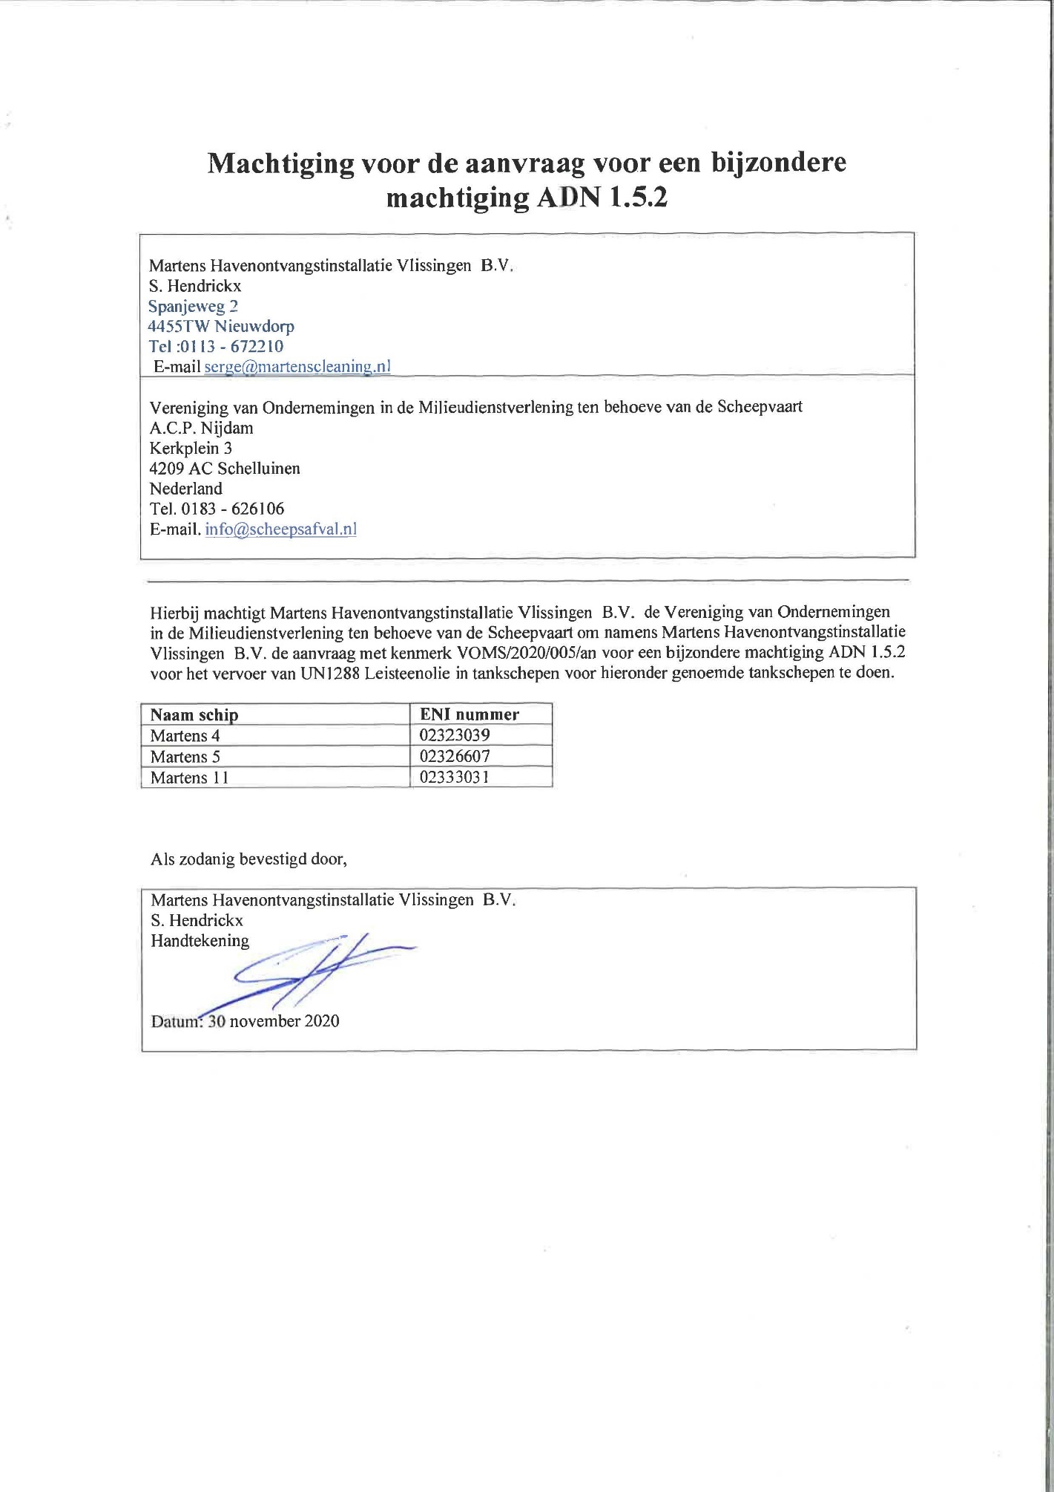
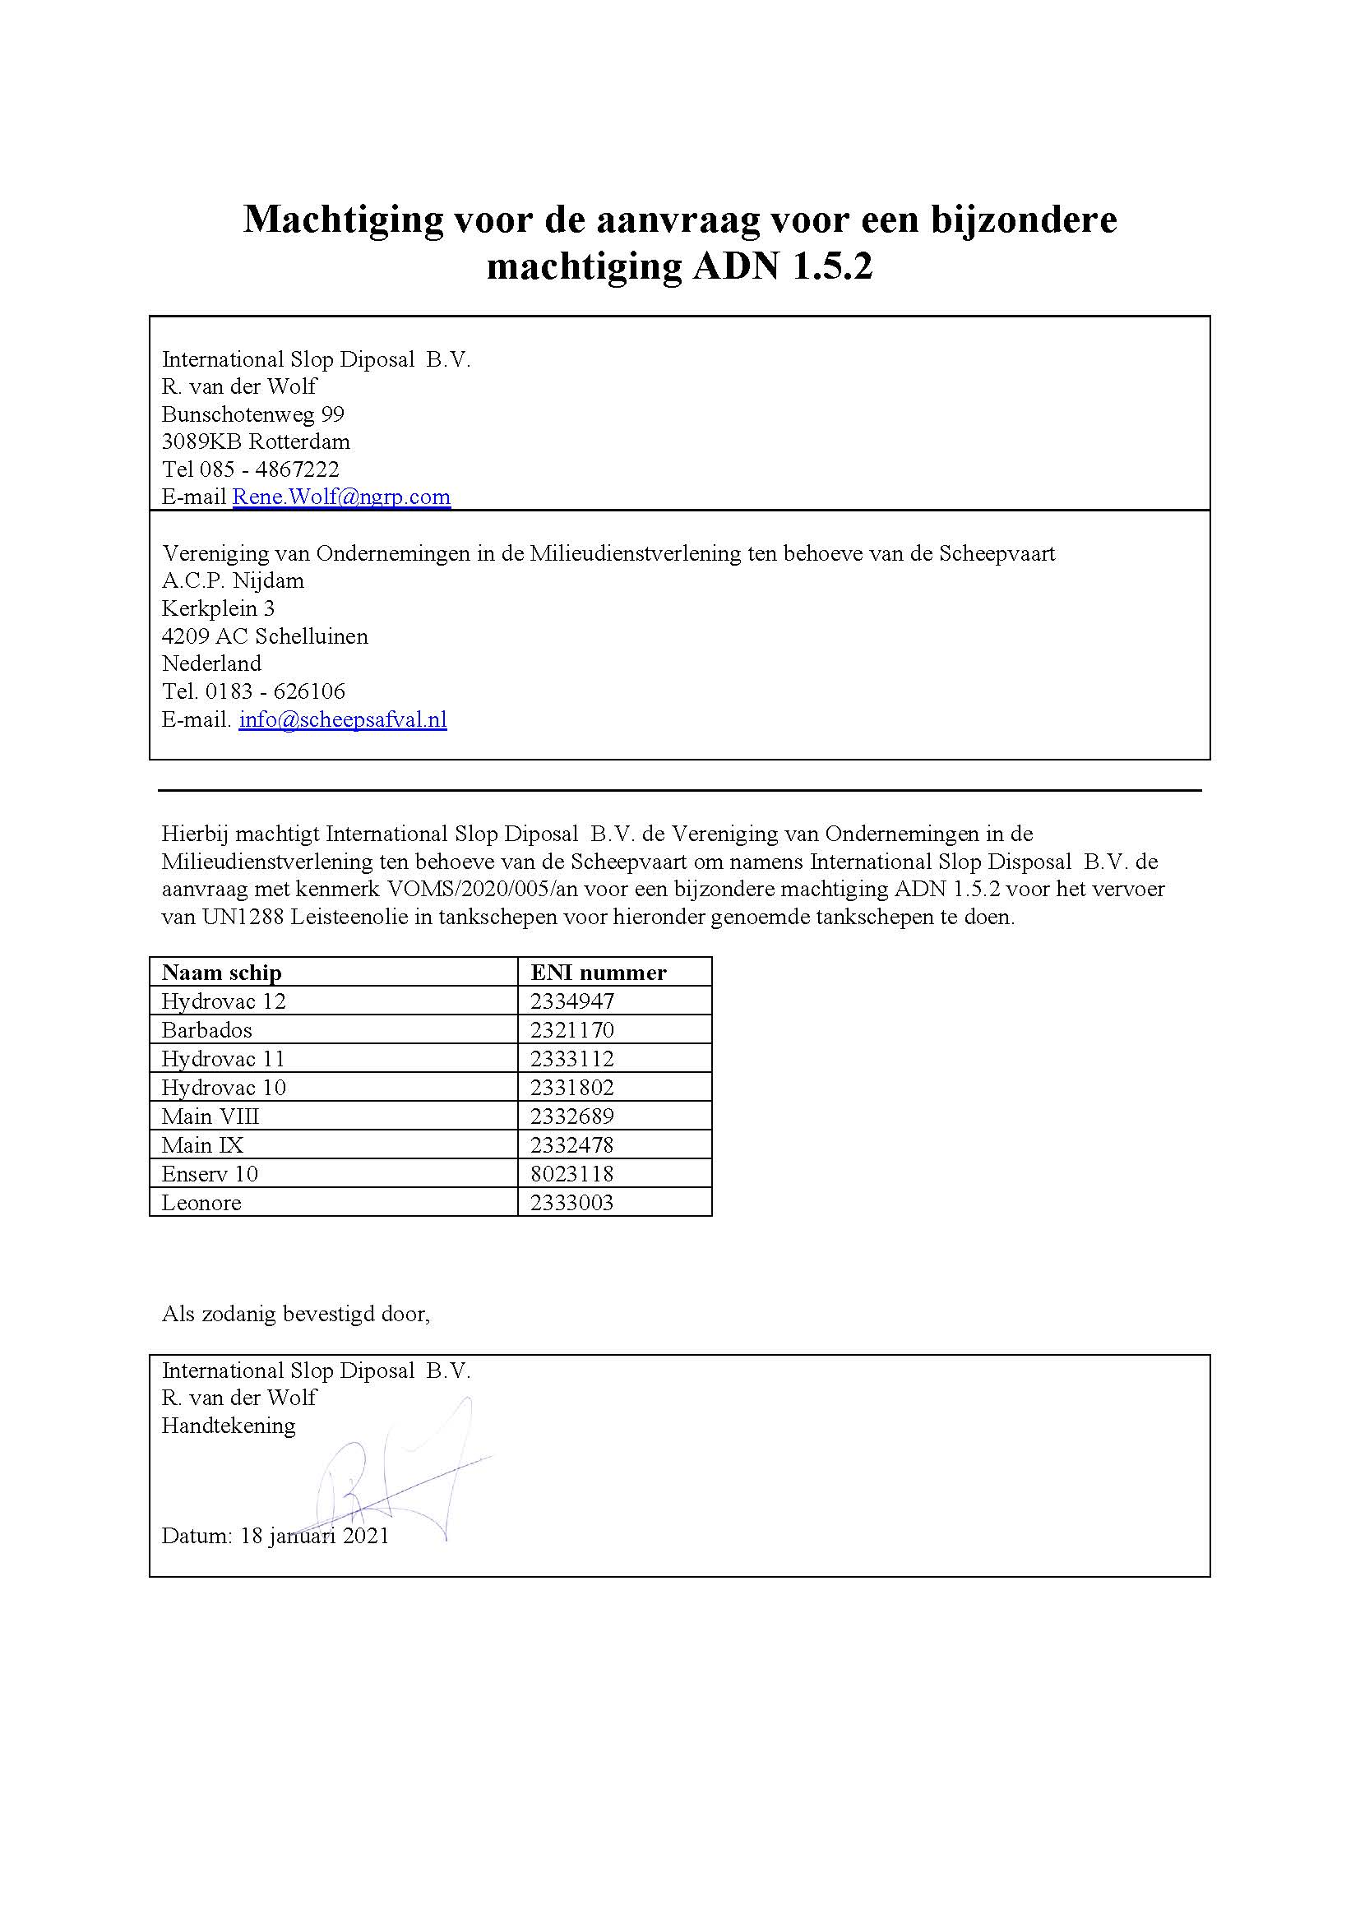
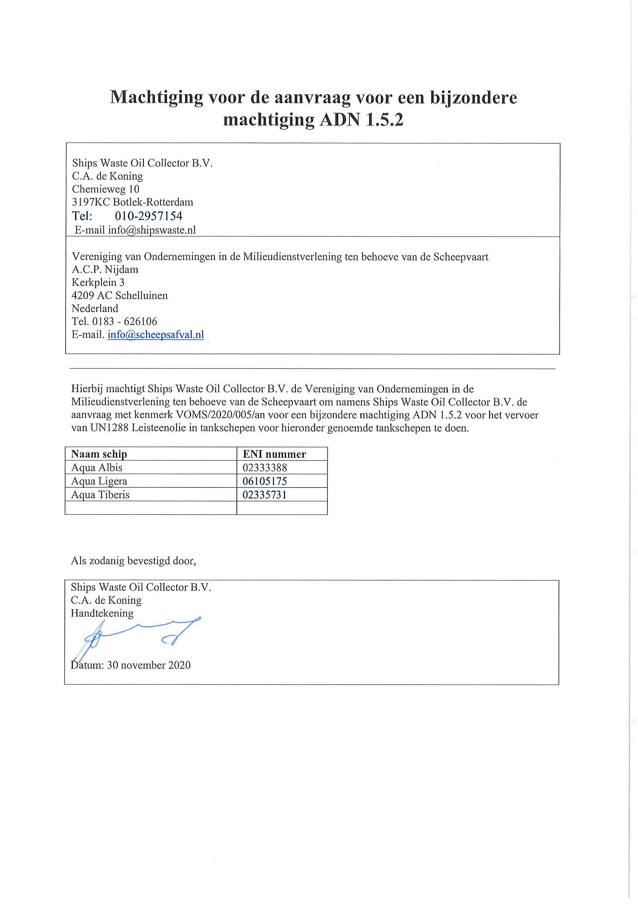
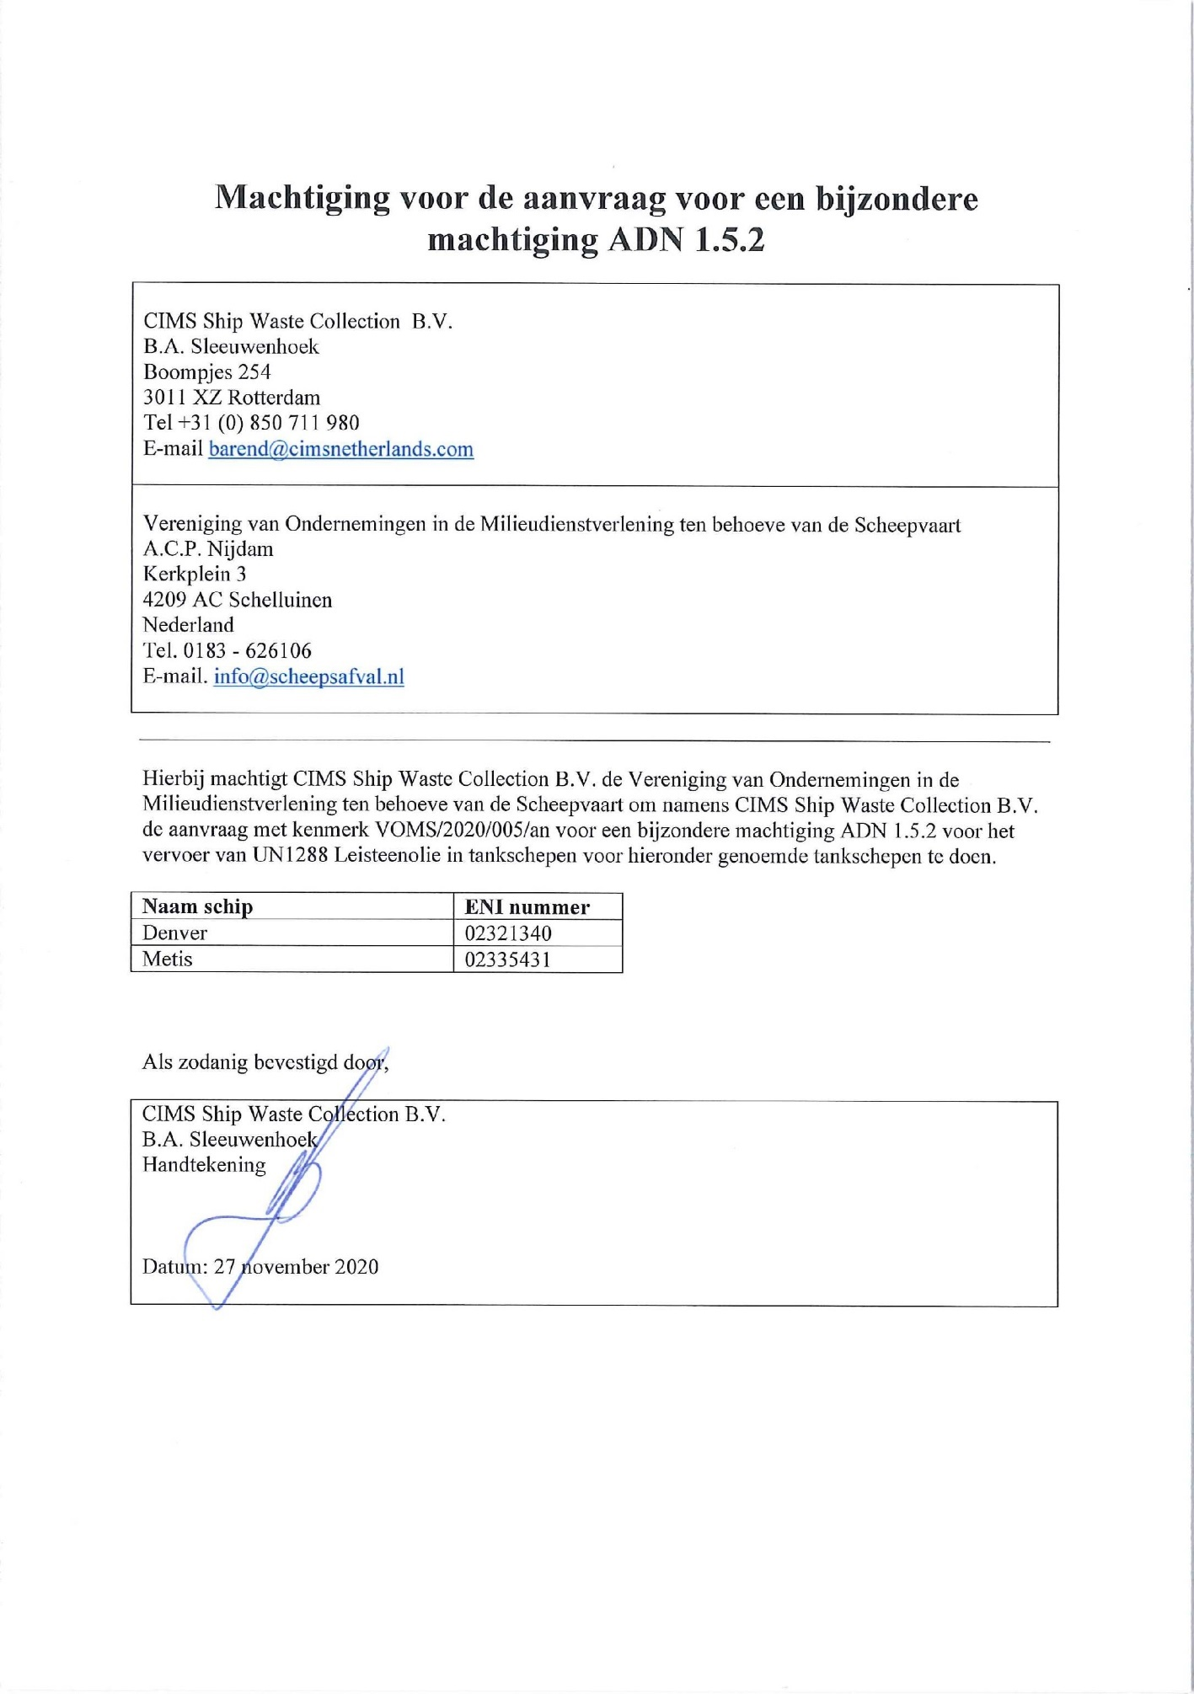

Annex II [Dutch only]
Special authorizations

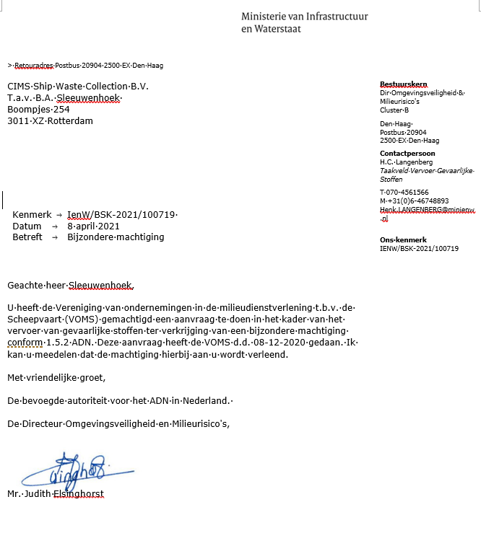

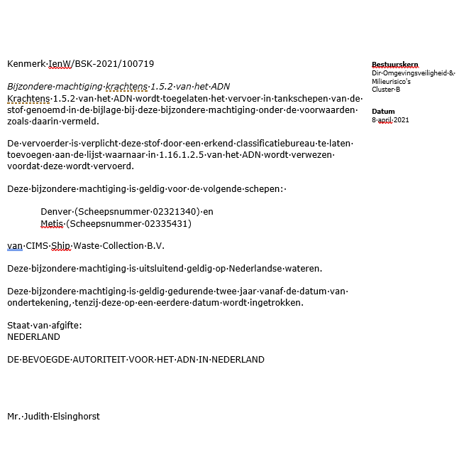

Bijlage behorende bij IenW/BSK-2021/100719
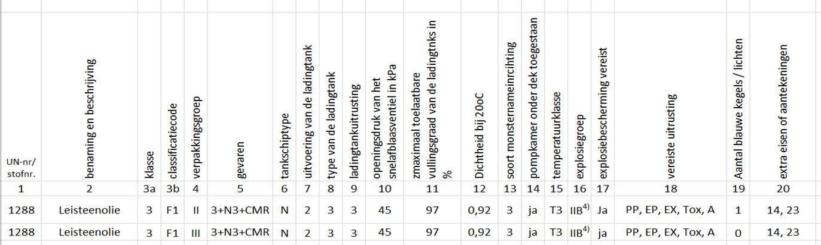

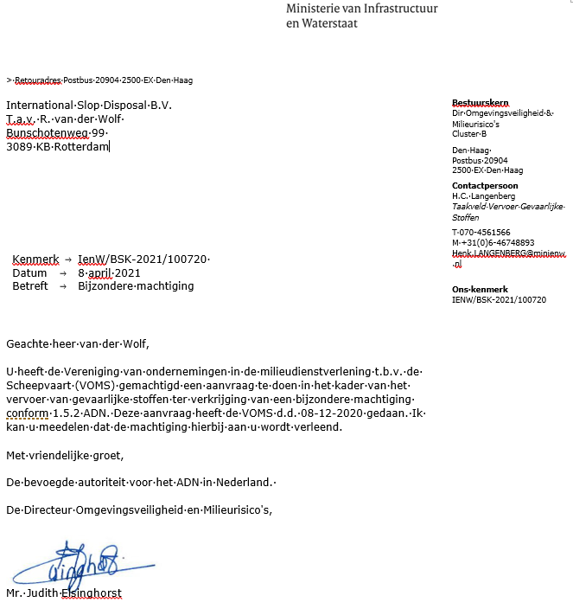

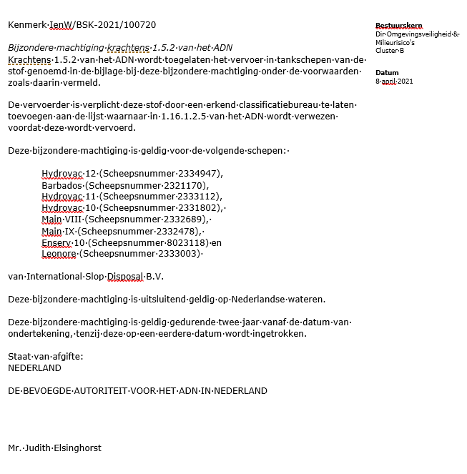

Bijlage behorende bij IenW/BSK-2021/100720

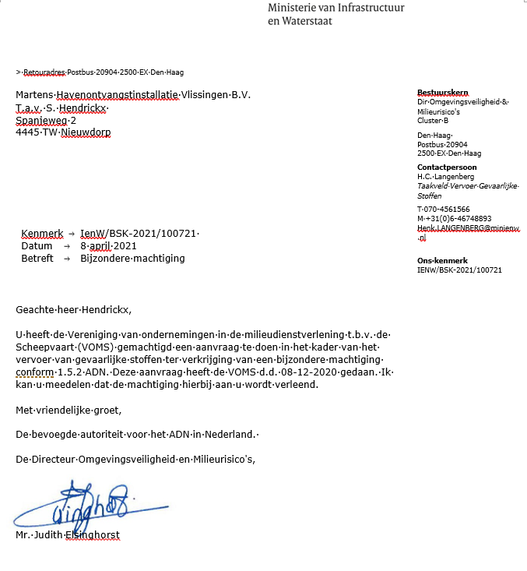

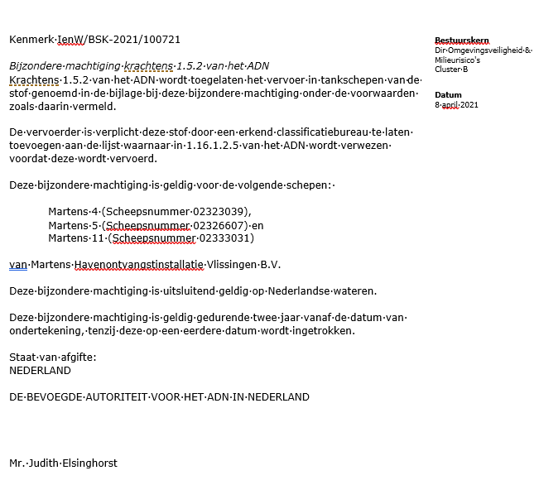

Bijlage behorende bij IenW/BSK-2021/100721

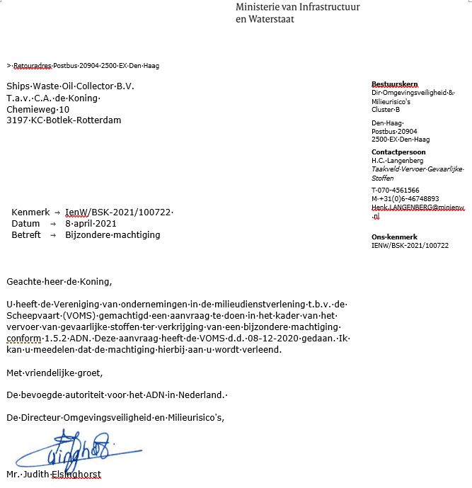

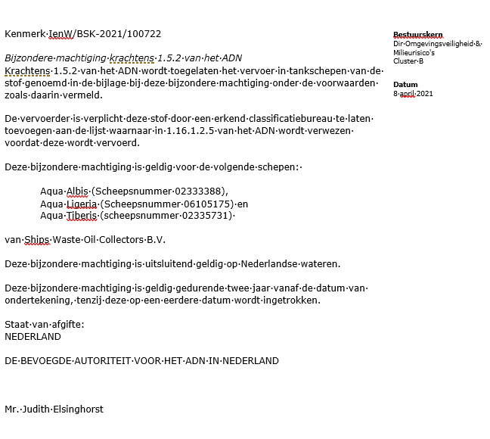

Bijlage behorende bij IenW/BSK-2021/100722

