UN/SCETDG/58/INF.6

Committee of Experts on the Transport of Dangerous Goods
and on the Globally Harmonized System of Classification
and Labelling of Chemicals 18 May 2021
Sub-Committee of Experts on the Transport of Dangerous Goods
Fifty-eighth session
Geneva, 28 June-2 July 2021
Item 6 (b) of the provisional agenda
Miscellaneous proposals for amendments to the Model Regulations
on the Transport of Dangerous Goods: packagings including the use of recycled plastics material
Regulatory aspects on the use of recycled plastics
Transmitted by the expert from Belgium
Introduction
1. As a consequence of the current scientific knowledge and awareness of the human impact on the health status of our planet, a societal tendency and necessity has arisen in which more and more attention is given to the impact of human activities on our surroundings. This is also manifested in the current initiatives taken by the world leaders. For example, the European Commission has announced “The Green Deal” while the new elected president of the United States of America has announced its intention to become climate neutral by 2050.
2. These initiatives also have an influence on the production of plastic packagings. For example, the new levy introduced by the European Commission on packagings made of non-recycled plastics urges the Member States and consequentially also the manufacturers and users of plastics packagings to change the traditional production processes. A way to reduce the amount of non-recycled “virgin” plastics used and to increase the amount of recycled plastics in the production processes is sought . As such, also the manufacturers and users of plastic packagings intended for the transport of dangerous goods are impacted.
3. Even though the UN Model Regulations do foresee in a limited number of prescriptions for the use of recycled plastics material, in general, the Model Regulations have not been written with a more generalized use of recycled plastics material in mind. This has become evident from the recent discussions that have taken place during the last biennium on expanding the use of recycled plastics material as defined in 1.2.1 of the Model Regulations. As evidenced from what was noted in the report of the 57th session on the interpretation of the term “suitable plastics material” (see para. 4), the Model Regulations do not exclude the use of recycled plastics material that is not complying with the definition of 1.2.1. Nevertheless, as exemplified below, Belgium do think this generalized interpretation has further reaching consequences then intended.
4. Extract from the report of the 57th session (ST/SG/AC.10/C.3/114, § 73)
The Sub-Committee agreed that where the term “suitable plastics material” is used within the Model Regulations, the use of recycled plastics material is not prohibited. It was also agreed to look more closely in the next biennium at the scope of the term “suitable plastics material” and the relevant provisions in part 6 and in the definition of recycled plastics material in 1.2.1.
Discussion
5. The figure below shows different possibilities for manufacturing packagings or IBCs from plastic material: they can either be made from virgin material, recycled material as defined in 1.2.1 or suitable material.
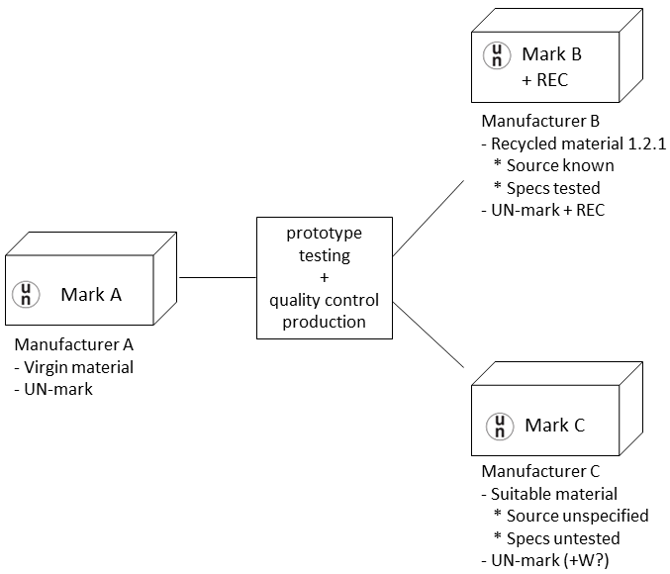
6. As the figure shows, all packagings need to be prototype tested (by an inspection body) and need to pass the performance tests as required by the UN Model Regulations while the production process must be able to guarantee the quality of the produced packagings. However, as far as concerns the use of recycled and/or suitable plastics material, this may lead to a paradoxical situation. In the case recycled plastics material is coming from a well-controlled source as defined in 1.2.1 the material has to comply with all the quality parameters as defined in 1.2.1. Additionally the packaging produced from it has to be marked “REC”. On the other hand, in the case recycled plastics material is coming from a less well-controlled source (not complying with 1.2.1, e.g. recycled household waste) and is just considered “suitable”, there is no specific requirement to verify and test the specs of this material. Additionally, there is also no specific requirement to mark packagings produced from it with “REC”.
7. In addition to the differences within one type of packaging, there are also differences between different types of plastic packagings. An overview of the requirements concerning the plastics material used for the different packaging types can be found in the table below:

Packaging type | Suitable plastics material | Recycled material 1.2.1 only + REC-mark | Reference
Plastics boxes | Yes | No | 6.1.4.13.1
Plastics drums | Yes | Yes | 6.1.4.8.1
Plastics jerrycans | Yes | Yes | 6.1.4.8.1
Composite packagings  - Plastics inner receptacle  - Outer plastics drum  - Outer plastics box  - Outer expanded plastics box  - Outer solid plastics box | Yes  Yes  Yes  Yes  Yes | Yes  Yes  No  No  No | 6.1.4.19.1.1  6.1.4.19.2.8  6.1.4.19.2.9  6.1.4.20.2.10  6.1.4.20.2.10
Woven plastics bags | Yes | No | 6.1.4.16.1
Plastics film bags | Yes | No | 6.1.4.17.1
Flexible IBCs | Yes | Reused material forbidden | 6.5.5.2.1/  6.5.5.2.8
Rigid plastics IBCs | Yes | Yes | 6.5.5.3.2
Inner receptacle composite IBCs | Yes | Yes | 6.5.5.4.6
Flexible large packagings | Yes | No | 6.6.4.2.1
Rigid plastics large packagings | Yes | No | 6.6.4.3.1
8. As indicated in the table, only for drums, jerrycans, rigid plastics IBCs and the inner plastics receptacle of composite IBCs, recycled plastics material must be material as defined in 1.2.1. In contrast, with the exception of flexible IBCs, for other packaging types, the use of recycled material has no additional limitations or requirements other than those that are in place for virgin material.
9. Besides the requirement for the use of plastics material, the requirement for the indication of what plastics material is used is also different. This indication is done by means of the “REC”-mark in case recycled material as defined in 1.2.1 is used. The addition of the “REC”-mark allows to clearly see when a packaging or IBC is produced from recycled material as defined in 1.2.1. This is required by 6.1.3.6 for packagings and by the new 6.5.2.1.2 for IBCs.
10. However, in hindsight of the interpretation of “suitable plastics material” given during the 57th session of the Sub-Committee, this means that an indication of the use of recycled material is only required when recycled plastics material as defined in 1.2.1 is used, this being recycled material with well-defined specs. In contrast, if recycled plastics material is used for which no specific criteria or requirements are given and whose origin may be less well-defined and less well-controlled, no indication on the use of recycled material is deemed necessary. Given the fact that the knowledge on how a packaging made from recycled material may behave is just emerging, this approach seems not quite safe and illogical: packagings from recycled material from a well-known and well-defined source shall be clearly marked with “REC” while packagings made from recycled material that is of a less well-defined and less well-controlled source should not wear an additional mark.
11. It has been brought to our attention that the requirements on the use of recycled plastics material, not in accordance with the definition in 1.2.1 (i.e. suitable plastics material), are interpreted and applied quite differently between competent authorities and inspection bodies. Some are choosing the safe path and only allow the use under very strict regimes (e.g. by derogations for national use). Others are making use of the exceptions foreseen in the Model Regulations (such as 6.1.2.4, using the letter “W” in the mark), allowing these packagings for international transport. Still others certify these packagings in a way very similar to the way packagings from virgin material are certified, also allowing these packagings for international transport.
12. The technical progress in the field of recycling of plastics material is rapidly evolving. Several packagings intended for the transport of dangerous goods, which have been properly designed are manufactured from recycled plastics material that is not in accordance with the definition in 1.2.1 and are already in use. As the production and use of such packaging will most likely increase in the near future, Belgium feels it would be appropriate to have sound and solid harmonised requirements for the use of recycled plastics material in the UN Model Regulations. As explained in the previous paragraph, the observation that different inspection bodies apply different regimes to certify packagings produced from recycled plastics material not complying with the definition in 1.2.1, only strengthens such a point of view.
13. In addition to the issues identified, we have also been informed that the ISO-working group responsible for the revision of ISO 16103:2005 “Transport packaging for dangerous goods — Recycled plastics material” has started the revision process. Nevertheless, a need was expressed by the ISO-working group to get a clearer view on the direction this work should go. Should a more generalized approach on the use of recycled plastics material be taken? Or, is a more specific approach preferred where the different types of packaging and their contents are considered?
Proposal
14. For the reasons explained above, Belgium invites the Sub-Committee to bring forward its view on the following topics concerning the use of recycled plastics material:
- “Suitable plastics material” is a broad and non-specific term and can be interpreted quite differently. Should it be more clearly defined when plastics material can be considered as suitable?
- Depending on what is defined to be “suitable plastics material”, is it deemed necessary to revise what is to be understood as “recycled plastics material”?
- Is solely a performance based approach on the basis of prototype-testing sufficient to determine whether recycled plastics material is suitable? Or, should criteria on the source material be included to determine this?
- Should all types of plastics packaging for dangerous goods be considered equal as far as concerns the use of recycled material or is an approach based on the type of packaging preferred? Additionally, is an approach preferred based on the contents these packagings are intended to hold (e.g. solid vs. liquid contents)?
- Is it necessary that all packaging made from recycled plastics material be marked to distinguish them from packaging made from virgin material?
- Should the more generalized use of recycled plastics for the manufacture of packagings intended for international transport of dangerous goods be regulated in the UN Model Regulations? Or, should this be left to the responsibility of the different competent authorities?

For more background information, we refer to this informative webpage of the Ellen Macarthur foundation: https://www.ellenmacarthurfoundation.org/explore/plastics-and-the-circular-economy

