Twenty-One Years of Adjustments for Quality Change in the U.S. Consumer Price Index

Brendan K. Williams
Bureau of Labor Statistics
May 2021

WORKING DRAFT
Prepared for the Group of Experts on Consumer Price Indices
UNECE, Online Meeting, June 2021

Abstract
Quality change is frequently cited as a source of bias in the CPI. We provide a systematic accounting of the impact of quality adjustments and other item replacement imputations on the U.S. CPI over the past 21 years. We produce counterfactual indexes varying the use of quality adjustment, direct comparisons, and class-mean imputation for all commodities and services in the CPI. We find that hedonic adjustment has a large impact on a limited number of categories in the CPI. Differences due to the treatment of item replacements can be substantial. Our results provide guidance on how item replacement methodologies should be used in the CPI to address biases.

__________________________________________________________
Brendan K. Williams is a Senior Economist in the Branch of Consumer Prices at the Bureau of Labor Statistics (BLS). Mark Bowman, Mickie Chandra, Jason Ford, Sarah Niedergall, Nicole Shepler, and Sarah Van Giezen contributed research to this project. Thank you to Brian Adams, Robert Cage, Jonathan Church, Malinda Harrell, Paul Liegey, Mindy McAllister, Anya Stockburger, and William Thompson for feedback and edits.

Introduction
Quality adjustment in the U.S. CPI received national attention in the mid-1990s as the Boskin Commission investigated quality change as a potential source of bias that amounted to a measurement error that could affect the federal budget by hundreds of billions of dollars (Hulten, 1997). In contrast with the expectations coming out of the Boskin Commission, BLS analysis has generally found hedonic price adjustment has little impact on the headline CPI. Johnson, Stewart, and Reed (2006) estimated that hedonic adjustments for item categories with models introduced since 1998 had a positive impact of 0.005 percent annually. We estimate an effect of -0.04 percent annually from all quality adjustments and an upper bound of -0.09 percent. In contrast to some of the empirical work on hedonic indexes, the theoretical literature suggests that hedonically adjusted indexes should be similar to those produced with conventional methods. The CPI had already made a concerted effort to introduce hedonic adjustment in the early 1990s and continued to expand the use of hedonic estimates following the Boskin Commission’s findings. This paper analyzes the impact of those efforts.
In addition to analyzing quality adjustments, we take a broader look at item replacement and find that excluding price change at item replacement would be deflationary. Previous analysis of quality adjustment impacts on the CPI often neglects the role of item replacement to capture cross-version price change. At least some of the low impact of quality adjustment on the CPI can be explained by considering the item replacement and imputation processes BLS uses when quality adjustments are not available When an item is replaced in the sample with a successor that differs in quality and no adjustment can be made, the BLS will most often use class-mean imputation, an imputation based on similar comparable and adjusted item replacements, rather than show the unadjusted price change. Item replacements (both observed comparisons and imputations) contribute 0.63 percent to inflation annually while the subset of item replacements imputed with the class-mean method contributing 0.17 percent annually. While we find that CPI items with strong item replacement effects generally already use class-mean imputation, we identify additional categories where class-mean imputation should be used based on large item replacements effects. We also identify CPI item categories without apparent item replacement effects. Issues related to item replacement are some of the most significant obstacles to using alternative data (Konny, Williams, and Friedman 2019). Item categories without item replacement effects are candidates for simple matched model methods that simplify the process of adopting alternative data.
Historically, the CPI’s item replacement procedures, including class-mean imputation, have been motivated by the need to capture price change that coincide with product turnover in markets with staggered price-setting. We show that the cumulative price difference implied by a strict matched-model index is too large to be reasonably explained by staggered price-setting alone. This supports the view that item replacements effectively offset product cycle effects in addition to capturing price change introduced at model change. We show that product cycles and cross-version price change have large and often overlooked methodological implications.
In Section 2 we begin the paper with a general discussion of item replacement and its motivation in price indexes. This section includes a review of the theoretical literature on hedonic modeling with a focus on the relationship between hedonically adjusted and traditional indexes. We then detail the specific procedures used by the BLS in the construction of the U.S. CPI. In Section 3, we discuss the data and methodology used for this study and detail the experimental setup of our counterfactual indexes, our primary empirical contribution. In Section 4, we review the counterfactual indexes and their implications regarding the effects of item replacement, class-mean imputation, and quality adjustment on the measured change in the U.S. CPI. Section 5 concludes with a summary and discussion of the implications of our findings for the BLS and price index research more generally.

Item Replacement
Statistical agencies generally collect a set sample of data on a periodic basis (monthly, quarterly, etc.) When a specific item in the sample is no longer available or is updated with a new version, a replacement item is selected and incorporated into the sample. This leads to the fundamental problem of how to represent the price change between the old and replacement varieties. Procedurally, the simplest approach would be to exclude an observation from price index calculation during the period it is replaced. This “deletion” method is equivalent to assuming that the price change between the old and new goods is the measured price change of other goods in a given component index. However, using the deletion method excludes any price change associated with product turnover. Empirically, price changes between models tend to be price increases and excluding these leads to downward biases. Downward bias related to item replacement has been evaluated previously by Hulten (1997), who uses the term “link bias,” and Hobijn (2001). Generally, downward bias has been attributed to staggered price-setting where a seller waits until a new version of a product debuts before introducing an updated pricing scheme. Such price updating at the point of version change could be the result of a variety of behaviors associated with nominal rigidities in the macroeconomic price literature: In the case of menu costs, a restaurant may hold off on price changes until debuting a menu with new offerings; new product offers are associated with new contracts between suppliers and retailers; informational problems or rational inattention, such as sellers avoiding the expense of analyzing market conditions and maintaining pricing schemes until they review market information to inform product offerings and pricing strategies simultaneously.
Other methodological issues in addition to staggered-price setting arise in the item replacement process. Item replacement procedures often involve the desire to capture (at least) four different factors:
- Quality differences between the items
- Change in consumer surplus from product entry/exit
- Staggered price-setting with product updates
- Product cycle effects
Enumerating quality differences between goods at item replacement (1) has been well investigated. While (2) is often associated with adjusting for quality differences at item replacement, there is a more general goal to account for increased (or decreased) utility related to shifts in the varieties available to consumers. Generally, adjustments for variety have not been implemented by national statistical offices (NSOs), in part because NSO surveys are not designed to measure the number of varieties available. Staggered price-setting (3) receives a fair amount of attention from NSOs but is less frequently discussed in the academic literature on price indexes. Product cycle effects (4) have generally received the least attention and, when considered, are typically not distinguished from (3). We discuss the implications of product cycles further here and compare these to the better-understood implications of staggered price-setting.
Hobijn (2001) shows that variation in the markup over the product cycle will bias measured inflation. Williams and Sager (2019) argue that products display a life cycle pattern where prices decline due to aging effects and price discrimination and item replacements are necessary to offset these product cycle factors. Product cycle effects and staggered price-setting both require similar market conditions. Principally, that there are market imperfections that allow two pricing regimes to occur simultaneously (violating the “law of one price”). In the case of staggered price-setting, no difference in consumer valuation between pricing regimes is necessarily implied and the timing of price change is directly related to model change, which may or may not occur with regular periodicity. In the case of product cycles, these patterns generally occur with temporal regularity and may imply differences in consumer valuation. Systematic changes in valuation can occur because of product cycles related to factors such as fashion (latest style versus last season’s), seasonality (winter clothing at the end of season), or obsolescence (evolving phone charging cable standards).
For staggered pricing-setting to explain the difference between price indexes with item replacement and strict matched-model indexes, there must be a shift in the pricing function independent of consumer valuation (i.e., a real price change in aggregate). Given stable prices, a market with staggered price-setting will produce consistent price indexes whether or not item replacement is used. In contrast, product cycle effects may lead to price indexes showing large amounts of price change and volatility and differences between relinked and strict matched-model indexes, even when the overall pricing function remains unchanged. Ueda, et al. (2018) show that the pattern of new goods having higher prices than old persists even in deflationary regimes. This provides evidence that cross-version price change may be driven by product cycle effects rather than staggered price-setting in certain cases. The need to include cross-version price change in price indexes motivates the use of quality adjustment to remove the quality difference between these goods while capturing the change in pricing regimes.
To capture price change associated with product updates, a price index should reflect the change between pricing regimes. However, if the regime change results from product cycles, price comparisons might preferably be limited to comparisons between similar regimes. For example, comparing summer pricing to summer pricing for clothing, instead of showing intermediate price comparisons to winter. In cases where comparable item replacements cannot be matched, class-mean imputation is used. While class-mean imputation is typically justified by the view that price increases coincide with the introduction of new models, it can also be used to offset product cycle effects. In a fixed-weight index, intermediate comparisons to other regimes will cancel and reduce to a same-regime comparison. However, in non-fixed-weight indexes, these comparisons can be problematic (see Williams and Sager, 2019 for more discussion).
As NSOs move to using transaction data, the treatment of item replacement and cross-version pricing becomes more complex. CPIs typically capture this price change at product turnover through the item replacement process: When goods exit the sample due to lack of availability, price comparisons are made between exiting and entering sampled goods. Item replacement is a natural concept in a fixed sample where there is a one-to-one correspondence between obsolete goods and their successors. As statistical agencies increasingly work with non-survey data (e.g., scanner data), the necessity of “linking” or “relinking” methods remains apparent in order to capture the price change between versions. Relinking methods construct matches between entering or exiting product varieties match or aggregate similar varieties into consolidated units in order to reflect price change that would be omitted because of product turnover. (Examples of related methods include Van Loon, 2019; Chessa, 2019; Bertolotto, 2019). Relinking can be thought of as a generalization of the item replacement process, which is typically limited to constructing one-to-one matches between exiting goods and entrants into a sample.
Multilateral methods have become one of the favored ways of handling transaction data since they reduce (or eliminate) problems regarding chain drift. Indexes with chain drift and product cycle effects may have similar behavior since chaining together price declines over several product cycles will lead to an index with substantial drift. This form of drift can be thought of as product cycle drift, which arises when valuation of goods and attributes shift in a systematic way. Several papers have shown empirically that multilateral methods do not address this form of drift (Greenlees and McClelland 2010, Williams and Sager 2019, ONS). Similarly, conventional hedonic methods may not resolve these issues.

Hedonic Theory
A wide variety of empirical and theoretical work has investigated the impact of hedonic estimates on price indexes. There are two fundamental approaches to estimating hedonic regressions. One involves simply trying to predict the price of an item based on its characteristics as a means of addressing the problem of missing prices (Griliches 1991), generally with a non-structural hedonic model. The second approach typically employs structural models in order to obtain demand estimates for the components of an item. The hedonic method used by the BLS for the CPI follow the first approach of imputation. In these cases, the missing prices must differ in some way from observed prices for the hedonic index to produce a different estimate than a matched-model index, presumably by incorporating some aspect of quality lost in the matched model estimate. When used as a means of imputation, hedonic regressions can be considered as reduced-form models that predict prices based on feature sets. The resulting indexes should be substantially similar to matched-model or overlap price indexes. Building on an early version of Triplett (2006), Diewert (2003) shows that hedonic adjustments will be equivalent to the overlap method. Diewert also finds hedonically adjusted indexes behave similarly to conventional matched models produced by NSOs with hedonic adjustments gaining an advantage over matched-model indexes with low match rates between time periods. Aizcorbe, Corrado, and Doms (2003) analyze the relationship between hedonic dummy variable regression and matched-model indexes and the conditions in which they are similar. Essentially, for hedonic imputation to significantly alter an index, the hedonic price imputations must reflect pricing behavior that is systematically different from conventional price index calculation.
Several papers give economic interpretations for the hedonic models typically used by NSOs . One approach to interpreting hedonic indexes is based on finding bounds to the cost-of-living; this set of work, including Pollack (1983) and Pakes (2003), interprets a hedonic equation with an analogy to cost-of-living theory where the current period cost of a set of features (goods in a traditional price index) chosen by consumers in the base period provides an upper bound to the change in cost of living, which corresponds to a Laspeyres index. Pakes notes that this approach captures welfare change when a product is vertically differentiated. When a product is horizontally differentiated, more powerful methods of demand estimation must be used. Discrete-choice models are designed to measure welfare changes in markets with horizontally differentiated goods. Moreover, Pakes notes that this hedonic will not capture all welfare change due to new goods since the benefits of increased variety or the surplus to infra-marginal consumers are not realized. Feenstra (1995) identified the conditions in which a hedonic price index could be interpreted as an exact measure of consumer welfare. Feenstra showed that a linear regression could produce an exact hedonic approximation in a competitive market where marginal costs and marginal values for characteristics would be equivalent. Feenstra also identifies other special cases where a linear regression would be exact. Structural hedonic methods, such as Bajari and Benkard (2005), could be used. Bajari and Benkard built on the two-stage estimation technique of Rosen (1974). NSOs generally have not had the data sources necessary to estimate welfare effects using these formal demand models (Groshen, et al. 2017), but the increased availability of transaction data makes this a promising future path.
In addition to differing methods for hedonic estimates, there are also several ways of incorporating these estimates into price indexes. Going back to Hicks (1940) and the idea of a “reservation price” where a good had zero demand, research has typically focused on estimating the prior period price of a new good, and the BLS has implemented this method for applying quality adjustments. Pakes (2003) focused on the prices of exiting goods. This approach was applied to BLS data in Erickson and Pakes (2011) in which data collectors are thought to be more likely to miss the final period of a product cycle since the retailer may have lowered the price to clear the item out of inventory. As a result, obsolete or clearance items may be underrepresented in the price index because data collectors do not price items once they are discontinued and no longer stocked. Erickson and Pakes show that price trends at the end of the product cycle are distinct and omitting them introduces a selection bias which Erickson and Pakes address with hedonic imputation to impute the price for goods in the period that they exit.
Hedonic methods do not automatically address shifts in pricing regimes unless certain methods are employed. Frequently, studies use hedonic regression to directly calculate indexes rather than constructing conventional indexes with hedonic adjustment. These indexes do not capture cross-version price change and are susceptible to product cycle drift. As discussed in Hobijn (2001), product cycle effects may bias hedonic estimates. Hobijn suggests accounting for this by introducing product age into hedonic models. Greenlees and McClelland (2010) found that hedonic indexes displayed drift unless parameter estimates were constrained to have a constant value over the entire period used to estimate an index, but the imposition of these constraints conflicts with hedonic theory. Cross-version price change could be incorporated into hedonic estimation in a number of ways including through hedonic imputation indexes that predict prices specific to a pricing regime and construct price comparisons between regimes.

Item Replacement in the U.S. CPI
Item replacements occur in the U.S. CPI when a sampled unique product is no longer available and is not expected to return. A replacement product in the same item category from the same outlet (typically a particular store location or website) is selected. Data collectors find the most similar replacement item based on the features of the original item as described on a data collector’s checklist. Analysts then decide how the price change for the item replacement should be treated in the index. When an estimate of the value of quality change between the original and replacement items is available, the analyst adjusts the price to show estimated, constant quality price change. When no estimate is available, the analyst decides whether the replacement is considered non-comparable to the old good or comparable (in which case, the entire nominal price change is reflected in the index). The CPI currently uses hedonic and component cost methods for quality adjustment.
The BLS uses hedonic methods that do not accord with any of the welfare interpretations discussed above. A hedonic function usually is estimated on a set of prices from some time period before its use. Model updates do not follow a fixed schedule, and new models are generally produced when an analyst determines that the previous model does not produce useful estimates. Data for a model typically come from a two-month period (since many items have bimonthly collection). The hedonic price function simply states that the price of an item Z is a function of its n component characteristics z₁, z₂, …, z_{n}.
$$p\left(Z\right)=\left(z_{1},z_{2},…,z_{n}\right)$$
The function can be estimated with a linear regression. Typically, BLS uses a model where the price is assumed to be a semi-log functional form
$$p_{t-n}\left(Z\right)=exp⁡({βX}_{t-n}+e_{t-n})$$
When a replacement product replaces an old one, price change is measured as the change from a price imputed in the prior period to an observed price in the current period $(P_{New, t}$). The estimate of the price of the new good in the prior period, (${\hat{P}}_{New, t-1}$) is based on the new good’s characteristics. For items with semi-log models, the BLS uses a formula to adjust the prior period price given the difference in characteristics in order to predict a prior period price for the new item:
$${\hat{P}}_{New,t-1}={P_{Old,t-1}*e}^{\left({\hat{β}X}_{New,t}-\hat{β}X_{Old,t-1}\right)}$$
This leads to the price relative, $\frac{P_{New, t}}{{\hat{P}}_{New, t-1}}$. Procedurally, ${\hat{P}}_{New, t-1}$ is created by adding a quality adjustment value, QA, to the prior period price in the CPI system. The QA is the difference between the predicted price of the new item and the price of the old item as illustrated in the equation below:
$${QA}_{t-1}={\hat{P}}_{New,t-1}-P_{Old,t-1}$$
Note that this procedure does not take into account the residuals of the hedonic estimate. The omission of residuals may raise concerns regarding bias due to the “retransformation problem” that arises when a logarithmic dependent variable is transformed into a linear prediction as discussed in Pakes (2003) and Triplett (2006). While the linear estimates produced by the BLS’s semi-log models will be subject to retransformation bias, there is no bias when the prices are used in geometric indexes since the omitted error term will have a mean zero stochastic effect on the price index. However, the retransformation problem applies to arithmetic indexes including the BLS’s Laspeyres (Lowe) indexes where the stochastic effect of incorporating a hedonic imputation will not be mean zero.
The BLS has used several other forms of quality adjustment in addition to hedonic estimates. Manufacturer cost estimates have been used for new and used vehicles to adjust for specific changes between model year versions of vehicles. A markup factor is applied to the manufacturer cost to approximate the retail value of the change (see Williams and Sager, 2019, for further details). Manufacturer cost estimates have an advantage over hedonic adjustments in cases where quality changes are unique to a model or non-parameterizable. A similar process is used to adjust for changes in personal computers. The BLS used hedonic models for computer quality adjustments in the CPI until 2002 when it was decided that the BLS’s hedonic modeling process was not keeping up with the frequent changes in component costs due to rapid innovation in the computer industry. At this point the BLS adopted component cost adjustments for computers in the CPI.
Non-comparable replacements that cannot be quality adjusted are imputed—either by the average price change in the same item category and geographic location (“cell-relative” or “non-response imputation,” NRI ) or by the class-mean method (“non-comparable substitution,” NCS) where the class consists of comparable or quality-adjusted item replacement observations. Cell-relative imputation is equivalent to “deleting” the price relative comparing two goods and using the observed price changes in a cell to calculate a basic index. This method is valid under the assumption that the pricing behavior of an item at the end or beginning of its life is no different from the middle—all points in a product’s life cycle are representative of price change in that item generally. In the 1970s, economists had noticed that apparel indexes tended to be drifting downward at implausible rates. The BLS implemented a “return from sale” procedure in which a discontinued product’s price was to exit the sample at its last regular price. This procedure offset price declines due to sales. Class-mean imputation was introduced for new vehicles in October 1989 and extended to a broader set of items in 1992 (see Reinsdorf et. al 1996). Since class-mean imputation had a similar effect of offsetting large declines, it eventually replaced the “return from sale” procedure for apparel.
If there are no source observations in the same geographic area for an imputation then the CPI system moves through a hierarchy of backup areas to find eligible price changes to use for imputation. Since January 2015, class-mean imputations have started with the quality-adjusted and comparable item replacements from the same entry level item (ELI) and primary sampling unit (PSU) before moving through the rest of the area imputation hierarchy. Prior to that month, imputations had started with observations in the same item strata or index area which represent higher levels of item consumption classification and geographic aggregation. Prior to 2020, apparel items were imputed through a hierarchy of similar item categories in the same geographic area rather than looking for observations in the same item category in different areas.
When class mean imputation is used, often the “class” of observations we want to use as the imputation source is not necessarily the set of “item replacements.” Rather we use the class of item replacements as proxy for some other class associated with item replacements such as the price change associated with an annual price update (but not necessarily a product change). In the traditional case used to justify class mean imputation goods have staggered price-setting and price changes tend to occur with the introduction of new models. Ideally, we only want source imputation observations if they reflect updated prices. However, CPI procedural definition of “item replacements” do not always align with the introduction of new market pricing. For example, in the case of college tuition, the CPI typically does not label updated tuition for the new academic year as an item replacement unless a specification, such as the financing package, changes. Ideally, we would want observations to be eligible as imputation sources for updated academic year tuition if and only if they represent price changes updated for the academic year.
Prior to the period covered in this study, the BLS also used overlap pricing as an item replacement method in the CPI. Overlap pricing consists of observing the prices for both the new and old product in time t. The price relatives P_{old, t}/ P_{old, t-1} and P_{New, t+1}/ P_{New, t}. This eliminates the need to impute price relatives, but BLS does not currently use the overlap method for item replacement since data collectors are required to follow the price of the old good until it exits the market. Only one price per sample observation can be collected per month, so price collection for a replacement cannot begin while prices for the old item are still being collected. While overlap pricing is not used for item replacement, the CPI does use it for sample rotation. However, the current use applies the overlap method to the entire set of observations for items in a CPI geographic area and not individual products. Bils (2009) discusses the potential for quality adjusting sample rotations in the CPI, and Lebow and Rudd (2003) discuss the implications of omitting hedonic adjustments from sample rotations. This paper only discusses quality adjustment in terms of within sample item replacement, not sample rotation. The BLS’s use of direct quality adjustment only captures the difference in quality between a product and its replacement within one sample cohort and not across them. No direct measurement is made to account for the difference in quality between sample cohorts and, in effect, quality differences between sample cohorts are accounted for with the overlap method.
The CPI makes several forms of quality adjustments for its Housing survey which operates differently from the Commodities and Services (C&S) survey discussed above. The Housing survey has a preprocessor system for applying quality adjustments in the CPI using parameters derived from hedonic regressions. The Housing survey does not use item replacements like the C&S survey and price change is based on the same rental unit unless imputed. In cases where there are structural changes to rental units, hedonic adjustments are applied to previous period rents to create comparable comparisons to current period rents. Estimates from the same regression model are also used and to correct for age bias from depreciation across all observations on a monthly basis. Ptacek (2013) reports that adjustments for age bias lead to an incremental annual increase of 0.3 percent in the Rent and Owner’s Equivalent Rent indexes, which is consistent with recent unpublished estimates annual age bias effects of 0.29 percent for OER and 0.27 percent for rent from 2015-2020. The Housing survey also applies non-hedonic quality adjustments for changes in utilities, facility adjustments for parking and air conditioning, and other analyst adjustments. This paper does not further evaluate the effect of adjustment on the shelter components of the Housing major group.

Data and Methodology
This paper uses 21 years of micro-level data from the C&S Survey including all item categories underlying the CPI except for those collected in the Housing survey. Following the introduction of the geometric mean formula in January 1999, the methods used for calculating the CPI remained relatively static until 2015 when a new estimation system was introduced. A revision to the geographic sample followed in 2018.
The BLS does not use an explicit designator for quality adjustments in its micro-data. Hedonic, cost-based, quantity, size, price corrections, and other adjustments often use the same mechanism to adjust prices and are denoted with a comparability code of “QC”. Observations with “QC” are further delineated by “price adjustment codes.” In this paper we define quality adjustments as those item replacements with price adjustment codes of QA, for dollar value changes, and “QO” for multiplicative factor quality adjustments. While these codes are typically used for hedonic and other quality adjustments, there are cases where these same codes are used for other adjustments such as those for in size and quantity. While we limit our counterfactual analysis to cases identified as “item replacements,” the definition of an item replacement in the CPI can be subjective. The data collector or analyst may decide that the replacement product does not differ in any price determining aspect from its predecessor in which case this change may be treated as if no change had occurred (“Redescription”). Redescriptions may include small amounts of quality change.
Since price adjustment codes are manually applied and certain codes have the same functional impact, some quality adjustments may be omitted in this experiment and some non-quality changes may be included. Analysts use a designator of “CA” to adjust for changes in shipping and options packages. These changes can be considered quality adjustments, but their values typically come from price lists or previously reported values rather than estimates. We focus on counterfactual indexes excluding “CA” adjustments. No identifier exists to indicate the source of a quality adjustment—whether it comes from a hedonic estimate, manufacturer cost, or other source. Also, we only create counterfactuals for observations that are reported as item replacements. Some observations may have adjusted quality changes but still be considered the same item by the analyst.
This paper focuses on quality adjustments and imputations made at item replacement. When one product is replaced with another in the sample, the data collector will code this as an item replacement. If an outlet no longer sells an item or service remotely similar to the previous one, the data collector may code this as a reinitiation. Reinitiations occur when products differ from their predecessors so much that a different checklist needs to be used to describe the item. The analyst may override this determination to reclassify a close reinitiation as an item replacement. Reinitations were also used for several years to refresh the sample—selecting a new good periodically even when the old one was still available. However, this practice was discontinued as it was expensive and did not have much of an impact.
Price observations labeled as “substitutions” in CPI mico-data are termed item replacements. There may be some difference in data collector or analyst interpretation of what qualifies as a “substitution” versus “same item.” This may lead to some differences in how item replacement and class-mean impacts are estimated. However, the application of imputations is based on this designation.

Counterfactual Index Experiments
We analyzed the impact of quality adjustment by comparing price indexes without quality adjustment to official indexes that included them. We recode quality adjustments as comparable, where the unadjusted prices are used, or non-comparable, where the price change is imputed, and recalculate our price indexes. Previous analysis by the BLS on the impact of hedonic quality adjustment has used alternative comparability codes recorded by analysts alongside their quality adjustments in production. Brown and Stockburger (2006) conducted this analysis on apparel items and other BLS staff have produced internal analysis to evaluate the impact of quality adjustments. In contrast, we use thresholds to determine whether a quality adjustment should be coded as comparable or non-comparable for the relative size of quality adjustments. This allows us to extend the analysis to a broader set of items including those with cost-based quality adjustments and to examine the sensitivity of index behavior in response to the restrictiveness of the threshold.
Simulations of experimental counterfactual indexes were calculated varying the methods used to treat index price change for item replacements. The first index only uses matched model price change, the second eliminates class-mean imputation, and the remaining indexes remove quality adjustments under various assumptions. The differences between the published CPI and the counterfactual indexes quantify three effects: 1) item replacement, 2) class-mean imputation, and 3) quality adjustment. For quality-adjusted item replacements, we produce indexes that treat all replacements as comparable and then vary comparability decisions based on the size of the quality adjustment relative to the prior period price.
The first counterfactual index removes all price relatives related to item replacements (whether they are comparable, non-comparable, imputed by the class-mean, or quality-adjusted). The resulting price index is a “strict matched-model index” where a product must be observed in t and t-1 in order to be included in the index. We refer to this as a “strict” matched-model index where only same product version price change is used in contrast with the published index, which is often referred to as a matched-model index since item replacements can be considered part of the matched model process. The strict matched-model index uses the “deletion method” for dealing with item replacements as the only method of imputation. This is equivalent to using cell-relative imputation to impute the omitted price relatives and would be justified as an imputation if data were missing at random. This index also shares a relationship with the overlap method in that neither shows price change between old and new items. Brown and Stockburger (2006) produce a similar matched-model index for apparel. We measure the difference between the official, production index and this counterfactual as a measure of the impact of item replacement:
$$ItemReplacementImpact\%= \left(\frac{ProductionInx}{StrictMatchedModel}-1\right)*100$$

The second counterfactual index omits class-mean imputation but includes the other aspects of item replacement excluded from the first counterfactual index. A majority of the item strata in the CPI use class-mean imputation. The others use cell-relative imputation where an imputed price is moved based on the observed price change of the entire “cell” (basic component index) rather than the class-mean method of imputing item replacements with the price change of comparable and quality-adjusted item replacements. This second counterfactual replaces class-mean with cell-relative imputations. We measure the class-mean effect as the difference between the percent change in an index without class-mean imputation and production. For this experimental index, all class-mean imputations were replaced with cell-relative imputation. In contrast with the first counterfactual, comparable and quality-adjusted item replacements remained in this second counterfactual index.
We then observe a “class-mean effect” as the difference between the production index and this second counterfactual (“NoClassMean”):
$$ClassMeanImpact\%= \left(\frac{ProductionInx}{NoClassMean}-1\right)*100$$
The remaining set of counterfactual indexes quantify the impact of quality adjustment under various assumptions. The CPI historical data do not specifically identify reason or method used for quality adjustments. CPI systems use the same general mechanisms for quality adjustments, price corrections, and changes in quantity. In the CPI production system, the same processing is done for various adjustments: hedonic, component cost, analyst estimates of quality change, quantity or size changes, and adjustments to reflect price corrections from previous months. In our counterfactual indexes we only change the calculations for those observations with price adjustment codes of “QC” or “QA.” These codes are typically associated with the item replacement quality adjustments of interest in this study, hedonic and cost-based, and are less frequently used for other changes, which we would want to exclude. However, the price adjustment coding is not completely consistent, and it is not always apparent whether the quality-adjustment values are coming from a given quality adjustment method.
For the quality adjustment counterfactual indexes, we convert price change observations that had been quality-adjusted in the CPI to either being comparable or non-comparable (generally receiving class-mean imputation). To achieve this we calculated four indexes that recode quality adjustments depending on the predicted difference between the old and new items so that if the difference were above a certain threshold (5, 10, 15, or 20 percent) the item replacement would be recoded as non-comparable or recoded as comparable if below the threshold. Since the quality adjustment amount is the predicted difference in price due to the difference in characteristics between the old and new items (QA$={\hat{P}}_{New}-P_{Old}$) dividing QA by the prior period price ($P_{Old}$) gives the predicted, proportional change in price due to quality change alone and this value is compared against each tolerance threshold to determine comparability in these counterfactual indexes. Our final counterfactual demonstrates the extreme assumptions that all quality-adjusted item replacements would have been treated as comparable and none would have been quality adjusted or imputed. Since the quality of goods can generally be assumed to be increasing over time, the assumption that all item replacements are comparable in the final counterfactual would lead to the expectation that this index forms an upper bound to the impact of quality adjustments.

Results
The counterfactual index with all quality adjustments converted to comparable price comparisons increased 1.86 percentage points more than the official index over 21 year study period or 0.09 percent annually. Often estimates of bias in the CPI assume that items are generally improving and this appears to be true since the first counterfactual shows higher price levels than the published index. Combining this finding with the assumption that the quality improvement is reflected in the nominal price of the new item, this estimate is an upper bound on the amount of quality bias removed from the CPI over that time period. The Boskin Commission estimated the CPI had a quality bias of 0.6 percent per year. Moulton (2018) updated bias estimates based on CPI improvements and estimated a new product/quality change bias of 0.37 percent per year. This suggests that most estimates of quality change in the CPI are overestimated or cannot be addressed with quality-adjusted item replacements alone.
Likely Table 1: Annualized percent difference between counterfactual and production indexes (Dec 1998-Dec 2019)
 | MatchModel | NoClassMean | Thresh5 | Thresh10 | Thresh15 | Thresh20 | QA to Comp
All | -0.63% | -0.17% | 0.04% | 0.04% | 0.04% | 0.04% | 0.09%
Apparel | -13.19% | -3.46% | -0.22% | -0.14% | -0.12% | -0.09% | 0.03%
Ed.&Comm. | 0.23% | 0.00% | 0.16% | 0.16% | 0.17% | 0.17% | 0.32%
Food | -0.06% | 0.00% | 0.00% | 0.00% | 0.00% | 0.00% | 0.00%
Other… | -0.07% | -0.01% | 0.01% | 0.00% | 0.00% | 0.00% | 0.02%
Housing | -0.07% | -0.03% | 0.00% | 0.00% | 0.00% | 0.00% | 0.01%
Medical | 0.11% | 0.00% | -0.01% | -0.01% | -0.01% | -0.01% | -0.06%
Rec. | -0.30% | -0.14% | 0.11% | 0.09% | 0.10% | 0.11% | 0.59%
Transport. | -0.91% | -0.26% | 0.17% | 0.17% | 0.18% | 0.18% | 0.20%

Table 1 shows the difference between each of the counterfactual indexes and the corresponding production index (the CPI-U All-Items index and the eight major group indexes). The strict matched-model counterfactual index declined relative to the production, All-Items index by 0.63 percent per year. In an era when the CPI averages about 2.2 percent per year, the effect of item replacements demonstrated in this study seem to be a major component of measured price change accounting for more than 29 percent of overall inflation. Similarly, the All-Items counterfactual index without class-mean declines 0.17 percent relative to the published CPI, which is also a significant portion of measured price change (8 percent of overall inflation).

Item Replacement Impact
Figure 1: Item Replacement Impact by Major Group
Figure 1 above illustrates the large difference between the strict matched model only counterfactual indexes (red) and production indexes (black) showing that the “missing at random” assumption is not valid. Data are “missing” at item replacements not because they have been arbitrarily omitted, but, usually, because a conscious decision has been made to discontinue an item. Typically this results in an inventory-clearing sale price at the end of a good’s life that is not typical of the general price change in the market. Moreover, item replacement decisions are not only filling in a missing price, but expressing a relationship on the relative quality of the old goods and their replacements. Often we are not imputing the value for something that is unobserved, but, rather, something that does not exist.
The strict matched-model indexes are generally deflationary compared to the production indexes. The “Apparel” index is extremely deflationary. The overall Apparel index would be 94 percent lower if item replacements were excluded. Moreover, for nine apparel items, the production indexes imply price levels over 1,000 percent higher than the strict matched model counterfactuals. These differences are extreme to the point where they cannot be explained by the staggered price-setting justification for item replacements. For this explanation to work, there would have to be an extremely large change in nominal prices. This provides support for the alternative view that apparel prices are the result of a product cycle and that the item replacement process serves as a method to offset product cycle effects. While product cycle effects are strongest in apparel, they should be considered in price indexes for other items.
In contrast with the other major groups, the “Education and Communication” and “Medical” major groups show upward effects in the strict matched-model index. In contrast with apparel, these major group indexes have actually seen inflation in the time period examined. Moreover, these categories largely contain services which are less likely to have product cycles than physical goods but are still subject to staggered price-setting (see discussion on tuition below, for example).
Item replacement generally has little effect on the “Food” major group. The production index only differs slightly from the counterfactual matched model only index. Since item replacement does not play a major role in food indexes, there appears to be little need for imputations at item replacement such as hedonic adjustments or class-mean imputation. This stands in contrast with the results in Greenlees and McClelland (2011), who found that hedonic indexes for food based on CPI data significantly differed from the corresponding production indexes. However, Greenlees and McClelland did not use the CPI weighting scheme or geographic structure, which may have contributed to these differences. While the overall food category showed little impact from item replacement, we found effects for some lower level food item indexes. These were generally packaged foods where price and packaging changes (including size changes) are introduced simultaneously.

Item Replacement Impact on Lower Level Item Categories
Differences between the official production and strict matched-model indexes show where item replacement procedures have an impact in the index. The presence of a large difference may result from quality adjustments, other adjustments at item replacement, or product cycle effects. For a given item category, a large difference between the production and strict matched-model indexes would suggest class-mean imputation should be used to capture the product cycle offset effect for non-comparable item replacements. For lower level items, our results can assist in identifying item categories where strict matched model price indexes perform similar to official CPI components the need for imputation, comparison decisions, or quality adjustments. This imply analyst review could be reduced for these lower level items since reviewing replacements in these item categories would be unnecessary. Also, in these cases, where price change has no apparent relationship with product change, BLS methods for imputing prices for entering and exiting goods do not impact index measurement. Simple, matched model methods could be applied to non-survey data sources to produce estimates for CPI components.
Our findings indicate that item replacement has strong impacts in several of the major groups including “Apparel,” “Recreation,” and “Transportation” where the production indexes (black) show a substantially higher price level than both the counterfactual indexes constructed by omitting all class-mean imputation (blue) and the index excluding item replacements altogether (red). These impacts accumulate to a large difference between the counterfactual index without item replacement and the official All Items index.
All of the seventeen apparel lower level item categories are among the top twenty in with the largest differences due to item replacement. Even the apparel category with the lowest effect, “Jewelry and Watches,” shows a substantial effect from item replacement compared to other items. In addition to the apparel categories, TA01 (New vehicles), RC01 (Recreational vehicles), and HN01 (Laundry supplies) round out the list of the top twenty lower level categories that show the greatest impact from item replacement.
For lower level item categories using class-mean imputation, we find the cumulative twenty-one year impact of item replacement has a 0.94 correlation with the impact of class-mean imputation. The BLS already uses class-mean imputation extensively. Following its initial introduction to new vehicles and apparel in the early 1990s, class-mean imputation has been extended to almost half of the item categories in the CPI. However, there are several item categories that currently do no use class-mean imputation where our results suggest it would lead to improved estimates. In particular, five lower level item categories with the largest positive item replacement impacts (without item replacement, these indexes would show lower price levels) were “Baby food,” “Motor vehicle insurance,” “Other miscellaneous foods,” “Breakfast cereal,” and “College tuition and fees” (“Internet services…” also showed a large effect but this was removed as an outlier). “Wireless and telephone services” and “Prescription drugs” show large negative effects from item replacement (without item replacement, these indexes would show higher prices levels), but it appears that these are due to one-off quality adjustments and not stable patterns.
College tuition serves as a good example of the most common explanation for the need of class-mean imputation—a case where price change (annually updated tuition) associated with product change (new financial aid options and few structure for the new academic year). Product cycle effects do not drive the item replacement effect for college tuition as it does for physical goods. Rather, this is a case of price-setting behavior correlating with item replacement. For college tuition, price increases tend to appear in August and September for this BLS index and prices are typically unchanged in other months. When price increases are omitted due to item replacements being classified as non-comparable, price change is imputed from the entire index using cell relative imputation, which includes unchanged tuition and fees alongside new academic year prices and tends to underestimate price change when compared to a class-mean imputation based on a new academic year. Recently, collection of college tuition was altered in a way that greatly reduces the number of imputations due to non-comparable replacements mitigating this issue. The other lower level item categories in the same expenditure category, “Tuition, Other School Fees, and Childcare,” also show item replacement effects.
Table 2: Largest Item Replacement Impacts for Items not using class-mean imputation (Dec 1998-Dec 2019)
Rank | Title | Item Code | Item Replacement Impact
1 | Baby food | SEFT05 | 12.48%
2 | Motor vehicle insurance | SETE01 | 9.46%
3 | Other miscellaneous foods | SEFT06 | 7.28%
4 | Breakfast cereal | SEFA02 | 7.11%
5 | College tuition and fees | SEEB01 | 6.92%
6 | Candy and chewing gum | SEFR02 | 5.80%
7 | Frozen noncarbonated juices and drinks | SEFN02 | 5.42%
8 | Cakes, cupcakes, and cookies | SEFB03 | 5.32%
9 | Water and sewerage maintenance | SEHG01 | 5.28%
10 | Coffee | SEFP01 | 5.19%

Quality Adjustment Impact
All four of the threshold counterfactuals imply that quality adjustment reduces the growth rate in the CPI by 0.04 percent annually. This estimate should be considered fairly robust since it holds over the range of threshold tolerances. Generally, cost-based adjustments have an unambiguous downward effect while the impacts of hedonic adjustments were more varied. Hedonic adjustments appear to have the strongest downward impacts in vertically differentiated goods and services, especially telecommunications and appliances. Hedonic adjustments have relatively neutral effects on the video equipment and photography lower level item categories and upward impacts in most apparel items. In apparel, the effects of product cycle overshadow the effects of quality change. At least in the case of apparel, Hulten (1997) seems particularly prescient suggesting that downward bias from product turnover may offset any upward bias from quality change addressed by hedonic adjustment.
Figure 2: Quality adjustment difference from production by major group

For many lower level item categories, hedonic adjustments appear to be little different from match-model methods. In order for a hedonic estimate to differ from a matched-model price change, the price change for entering and exiting goods must be different than the price change for continuing goods. Class-mean imputation can account for the differences between the two classes, basically leaving a difference between the price change in comparable and quality-adjusted item replacements as the only pathway for hedonic adjustment to make a difference in the index.
Similarly, hedonic adjustments have made large differences for lower level service item categories where vertical quality improvements have been made to service plans where price points are maintained (cellphone data limits or internet speeds). In the next section, we explore the impact of quality adjustments and their relation to item replacement effects for a selection of major group and lower level item categories.
Table 3: Cumulative differences between published indexes and quality adjustment counterfactuals (Dec 1998-Dec 2019)
Item Code | Title | No QA (5%) | No QA (20%) | QA to Comparable | Adj Type 2020
SETA02 | Used cars and trucks | 22.209 | 25.042 | 25.045 | Cost
SEED03 | Wireless telephone services | 18.944 | 10.101 | 22.848 | Hedonic
SERA02 | Cable and satellite television and radio service | 16.000 | 16.667 | 18.745 | Hedonic
SEAA03 | Men's shirts and sweaters | 6.257 | 1.112 | 1.171 | Hedonic
SETA01 | New vehicles | 4.949 | 4.786 | 4.792 | Cost
SETA03 | Leased cars and trucks | 4.587 | 3.564 | 4.903 | Cost
SEHK01 | Major appliances | 3.364 | 5.952 | 16.743 | Hedonic
SEEE03 | Internet services and electronic information providers | 1.796 | 2.540 | 5.223 | Hedonic
SEEE04 | Telephone hardware, calculators, and other consumer information items | 1.224 | 0.557 | 6.319 | Hedonic
SERA01 | Televisions | 0.971 | 1.530 | 10.293 | Hedonic
SEEE01 | Personal computers and peripheral equipment | 0.778 | 2.157 | 5.212 | Cost
SERA03 | Other video equipment | -0.236 | 0.180 | 5.273 | Hedonic
SERD01 | Photographic equipment and supplies | -0.789 | 0.317 | 7.826 | Hedonic
SEAD01 | Girls' apparel | -2.188 | -4.308 | -0.713 | Hedonic
SEAC02 | Women's dresses | -4.061 | -11.095 | -4.985 | Hedonic
SEAA04 | Men's pants and shorts | -4.185 | -3.095 | 1.640 | Hedonic
SEAB01 | Boys' apparel | -4.414 | -0.169 | -1.879 | Hedonic
SEAA01 | Men's suits, sport coats, and outerwear | -5.114 | -4.872 | 1.540 | Hedonic
SEAC03 | Women's suits and separates | -5.293 | -1.038 | 5.690 | Hedonic
SEAE01 | Men's footwear | -6.110 | 0.871 | 4.291 | Hedonic
SEAC01 | Women's outerwear | -7.348 | -10.450 | -11.319 | Hedonic
SEAE02 | Boys' and girls' footwear | -7.508 | -3.498 | 1.842 | Hedonic
SEAE03 | Women's footwear | -16.281 | -5.179 | 6.889 | Hedonic
SEED04 | Landline telephone services | NA | NA | NA | Hedonic
SEHA01 | Rent of primary residence | NA | NA | NA | Hedonic
SEHC01 | Owners' equivalent rent of primary residence | NA | NA | NA | Hedonic

Apparel
The BLS’s first hedonic adjustments were applied to apparel items and apparel has remained a focus of hedonic research ever since. Armknecht and Weyback (1989) reported early experimental indexes where hedonic adjustments led to downward impacts on “Women’s coats and jackets” but upward effects on “Women’s suits” index. Liegey (1994) provides estimates of the impact of using hedonic adjustments for apparel in the early 1990s and continued to find mixed directional effects of hedonic adjustments depending on the specific apparel item. Our findings are similar, but most apparel items show that adjustments have an upward effect based on our threshold counterfactuals, and, in aggregate, hedonic adjustments have an upward effect on the apparel major group index.
Apparel has often been the focus for product cycle effects and is clearly the major group category with the largest item replacement impacts. Apparel items have some of the highest rates of turnover in the CPI with 12.9 percent of sample observations undergoing item replacement in 2019. Apparel not only has a product cycle driven by seasonal factors but also a fashion component. Fashion effects lead to downward trends as sellers attempt to sell products at a high price at introduction and then discount items as a style loses trendiness. Sellers may also be undertaking a process of price discovery where novel fashions are introduced at high prices that are then either maintained, if consumer demand provides support, or discounted for products that fail to attract interest. The strict matched-model index for AE02, “Boys' and girls' footwear,” declines from 100 in December 1998 to 4.43 in December 2019 compared to the production index of 116.88. This implies that item replacement has an impact on the cumulative growth rate difference of 112 percentage points and a published index 25.38 times higher than it would be without item replacement (see Table 5). We do not have a precise method of identifying whether item replacement effects are the result of product cycle effects, inflation introduced with version change, or unaccounted for quality change. However, the magnitude of the item replacement effects in apparel can only reasonably be explained by product cycles. While fashions and styles are constantly changing and some innovations have been introduced, apparel items have experienced relatively little systematic quality change in the past few decades. Apparel prices have also trended deflationary over this time period, so there has been little inflation to “miss” in the strict matched-model index. This leaves product cycle effects to explain the bulk of our estimated item replacement impacts.
Our results indicate that quality-adjusted price changes tend to be higher than comparable (unadjusted) apparel item replacements as illustrated in Figure 2. Given the strong product cycle effects in apparel indexes, quality adjustments may have upward effects because they are more likely to represent cross-version price change than comparable substitutions.

Televisions
Televisions were one of the first items in the CPI to begin using hedonic adjustments after apparel, and they have continued to be a focus for hedonic research. Moulton, LaFleur, and Moses (1998) introduced a hedonic model that was adapted and applied in production. Moulton et al. found that hedonic indexes implied substantially lower price change than the conventional television price index. However, when they applied quality adjustments at item replacement instead of using hedonic indexes, the impact was mitigated to an upward effect of 0.1 percent annualized. Moreover, the impact of quality adjustments was actually positive for most of the series (see Figure 1 of Moulton, et al.), suggesting the direction of the effects was not clear. Moulton et al. attribute the additional declines in their hedonic index to the impact of using hedonic estimates instead of overlap imputation at sample rotation even though overlap methods and hedonic adjustments should produce similar results. On the other hand, hedonic indexes may exclude higher price change from item replacements. Moulton, et al. estimated a -0.55 percent annual difference between their hedonically adjusted CPI for televisions and their hedonic indexes omitting overlap imputation at sample rotation. The difference between the published index and our strict matched model counterfactual is an annualized -1.38 percent. Based on our results, the removal of item replacements can plausibly account for the difference between hedonic indexes and indexes with hedonic adjustments.
The difference between strict matched model and production indexes could also be due to unaccounted for quality change that is shown as a price increase at item replacement (even though the bulk of quality change is removed through the combination of current hedonic methods and analyst judgements as can be seen in comparison with the “QA to Comparable” index (purple) in Figure 2. However, if cross-version price differences are entirely due to quality change, the BLS would be better off implementing a strict matched-model index rather than maintaining its current quality adjustment methods for televisions. However, we see some evidence of a fashion component in TVs. The past several years have seen the introduction of several features that signaled high-end products but turned out to only have niche appeal (3D and curved screens).
Erickson and Pakes (2011) also find little difference between matched-model indexes and indexes with hedonic adjustment based on BLS procedures. They introduce an alternative method for estimating a hedonic index that shows substantially larger price declines. They attribute the difference to additional quality attributes captured using their techniques, and hedonic imputations accounting for the end of the television product cycle. Erickson and Pakes impute prices for exiting goods, which unambiguously improves estimation of a fixed-weight geometric price index as a target. Whether this imputation reduces the bias of estimating this target is less clear and depends on the empirical patterns in television sales. If the expenditure share for exiting items is less than the typical monthly expenditure for a product, imputation would lead to exiting items being overrepresented relative to empirical sales measures.
The solution presented in Erickson and Pakes could be viewed as an additional procedure that could be run in parallel with conventional quality adjustment and item replacement, but, additional methods would be necessary to address some of the issues related to item replacement. As proposed, the Erickson and Pakes hedonic regression would not be able to properly incorporate price change associated with a change in price regime. Given inflation introduced with a set of new models, features associated with old models would be perceived as having less value and the net effect of incorporating an imputation would be further price decline even given overall inflation. The Erickson and Pakes approach does not accommodate cross-version price change or product cycle offsetting.
Figure 3: Counterfactual quality adjustment indexes for televisions
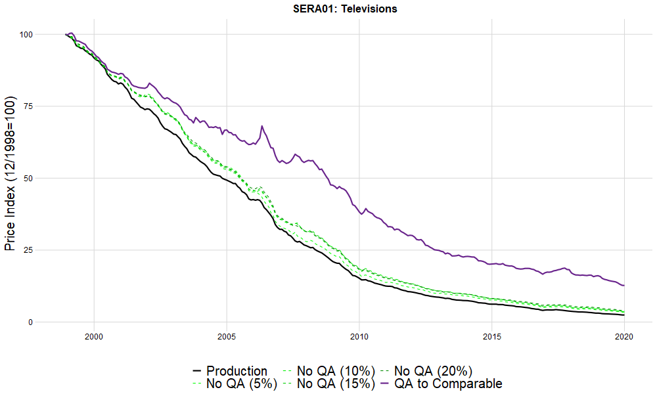

Other video equipment
Our estimates for “Other video equipment,” which has been adjusted with separate hedonic models for camcorders and video players (VCRs, Blu-Ray players, video streamers, etc.), suggest that hedonic adjustments may not have had much of an impact on this index as illustrated in Figure 4. Early BLS research on adjusting for VCRs in Liegey and Shepler (1999) found that quality adjustments had a positive effect on the index and showed less of a decline.
Figure 4: Counterfactual quality adjustment indexes for other video equipment
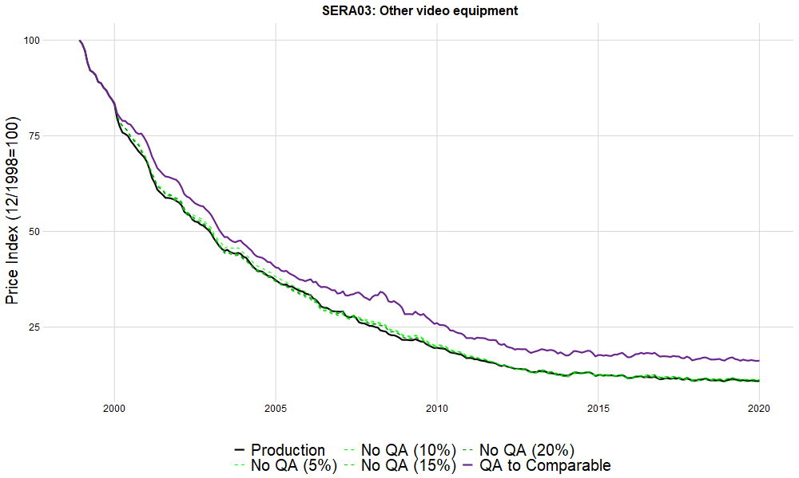

Appliances
Appliances have been one of the areas of greatest interest for hedonic adjustments. Silver and Heravi (2003) produced an exact hedonic model for washers in an early work utilizing scanner data. Moulton and Moses (1997) considered appliances to be low hanging fruit, and this has largely borne out in our results. However, the impact of quality adjustment in appliance indexes is still a fraction of the estimated overall quality bias reported by the Boskin Commission, 5.6 percent annually, as referenced in Moulton and Moses. Hedonic adjustments for appliances (microwaves, refrigerators, and freezers) were introduced by BLS in July 2000, and adjustments for washers and dryers were introduced that October. Johnson, Stewart, and Reed (2006) found these hedonic adjustments had variable annualized effects with downward impacts for washers (-0.78) and microwaves (-0.17) and upward impacts from dryers (0.06) and refrigerators (0.02). While we do not measure impacts at this product level, the lower level item index HK01 (“Major Appliances”) includes these four products as well as ranges and cooktops. Our counterfactuals suggest that quality adjustments, on an annual basis, reduce the price level for “Major Appliances” by 0.2 to 0.3 percent based on the threshold counterfactuals and 0.9 percent compared to the assumption that all quality adjustments would have been comparable.
Figure 5: Counterfactual quality adjustment indexes for major appliances
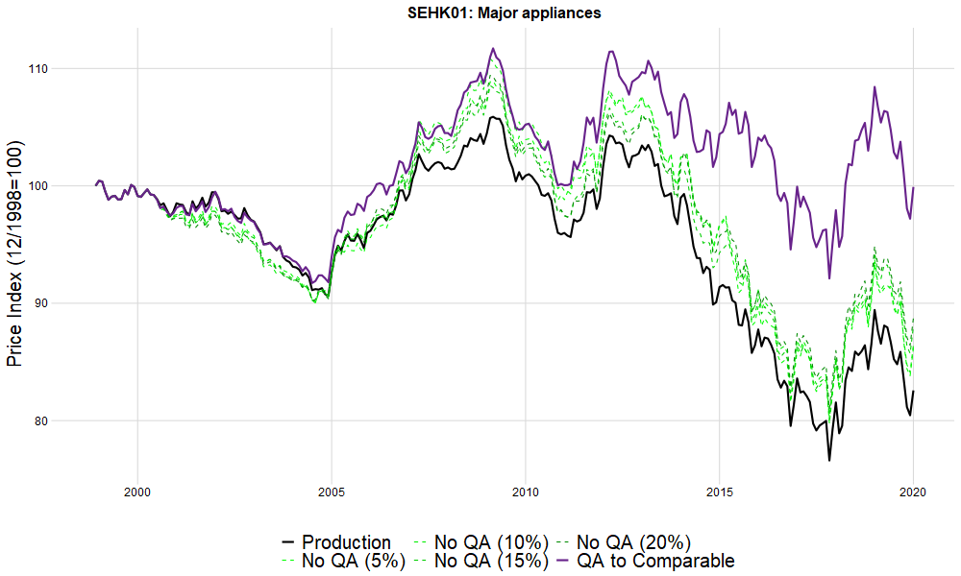

Telecommunications
Hedonic adjustments were incorporated for residential telecommunications in January 2019. Previously, linear quality adjustments were applied to account for changes in the number of channels (Fixler, Greenlees, and Lane, 2001). While the CPI maintains separate indexes for internet, landline telephone, and television services, bundled packages containing combinations of these services can potentially be priced in each of the three lower level category indexes. Hedonic adjustments typically account for faster internet download speeds and the number of television channels included in packages. For wireless telephone services, quality adjustments for data plan limits have been introduced. Adjustments to the internet service index reduced the rate of growth in 2019 (January 2019 to January 2020) in the range of 5.1 to 5.3 percent based on the threshold counterfactual indexes.
While telecommunications have some of the largest impacts from quality adjustment, the welfare interpretation of these adjustments is not clear. The hedonic regression estimates do not satisfy the data requirements or perfect competition assumption for the Feenstra interpretation of a linear regression as an exact hedonic.

Figure 6: Counterfactual quality adjustment indexes for cable and satellite television and radio service
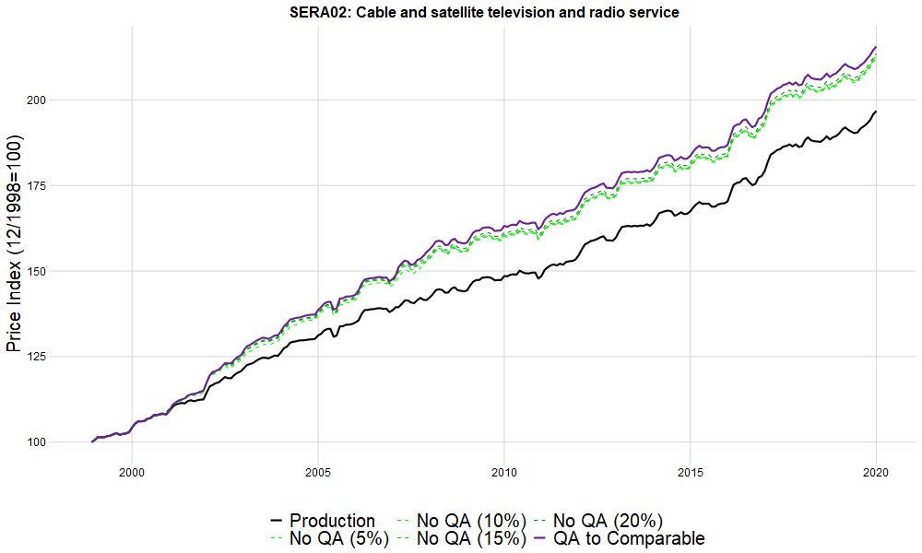

New Vehicles
The new vehicle index is one of the primary employers of manufacturer cost-based quality adjustments in the CPI. The BLS meets with automotive manufacturers annually to obtain information on the cost differences in any components that change between model year versions of a vehicle. The new vehicle analyst applies an estimated markup value to these wholesale component costs to derive an estimate of the retail value of these changes. While this often accommodates small updates between model years, we generally consider vehicle redesigns to be non-comparable item replacements.
Like apparel, the item replacement process for new vehicles is necessary to avoid product cycle drift. The similarity in pricing behavior between apparel and vehicles has been noted (at least) since Pashigwan, et al. (1995). While fashion and seasonality tend to drive price declines over the life of apparel goods, similar patterns in automobile prices may arise from other product cycle factors. Williams and Sager (2019) attribute these declines to intertemporal price discrimination. In this view, the price change at the time of item replacement, which involves replacing a vehicle from a given model year with the same vehicle in the next model year, tends to be a price increase because budget buyers tend to make their purchases at the end of the model year while consumers at the beginning of a model year tend to be less price sensitive. This upward price change offsets the price declines that arise when within-model-year price change as the consumers buying later in the model year becomes more price sensitive.
Figure 7: Counterfactual quality adjustment indexes for new vehicles
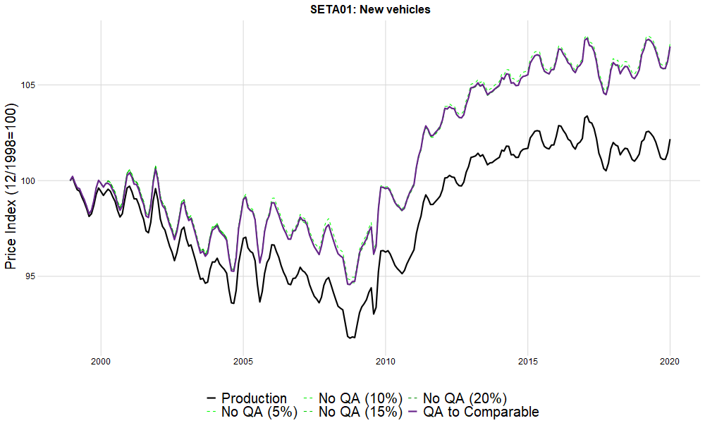
Figure 8: Counterfactual item replacement indexes for new vehicles
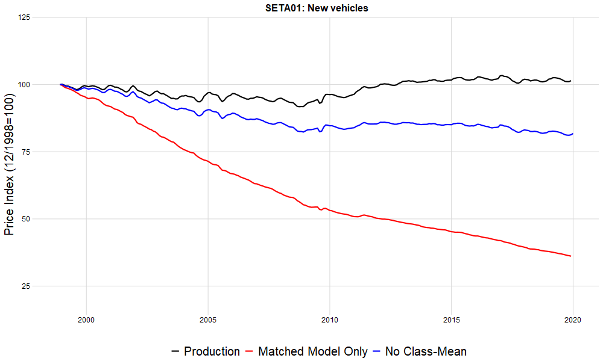

Used Vehicles
For used vehicles, the BLS uses a special methodology first introduced in 1987 where prices are adjusted each month with an estimate of their depreciation following the methodology in Kellar (1988). The depreciation rate for a given vehicle model and vintage is estimated based on the price change of the vehicle relative to the price change of the older counterpart vehicle from the preceding model year. The monthly price change for this vehicle is then adjusted to remove depreciation effects. After twelve months, item replacement occurs and the previous vehicle price (adjusted for depreciation) is compared to the price of a vehicle one model year newer (with no depreciation adjustment). The product cycle is adjusted based on depreciation and the tendency is for adjusted prices to increase and then decline at item replacement. This is the opposite of the pattern that results from the methodology used for new vehicles and most other items where observed prices decline over the product cycle and then reset with a positive price change at item replacement. If the depreciation estimates were offsetting product cycle effects, we would expect price change at item replacement to be similar to within model year (same item) price change. Instead, we find that price change at item replacement tends to be large in magnitude and negative while same item price change tends to be positive and incremental. This suggests the depreciation adjustment may be systematically overestimated and the item replacement relative (which reduces to a price relative without depreciation) offsets the accumulated overestimation.
The unique treatment of depreciation in used vehicles leads to the matched-model index running higher than the official index as illustrated in Figure 9. For almost all other item categories, excluding item replacement effects with a matched-model only index leads to a lower result. New vehicles show price declines during the life-span of a given product, which are then offset at item replacement. In contrast, these declines tend to be treated as depreciation in the used car methodology and are removed from price change estimates on a monthly basis. Were these depreciation estimates accurate, we would expect item replacements to have no systematic effect and the production and strict matched-model only indexes would show little or no difference. The higher matched-model index implies that the used vehicle methodology overestimates depreciation.
In contrast with other indexes, used vehicles shows a large effect from item replacement, but little effect from class-mean imputation as reflected in the yellow line in Figure 10. This is likely because the used vehicle process forces most observations to be substituted at the same time, so that there is little difference between class-mean and cell-relative imputations.

Figure 9: Item replacement counterfactual indexes for used vehicles
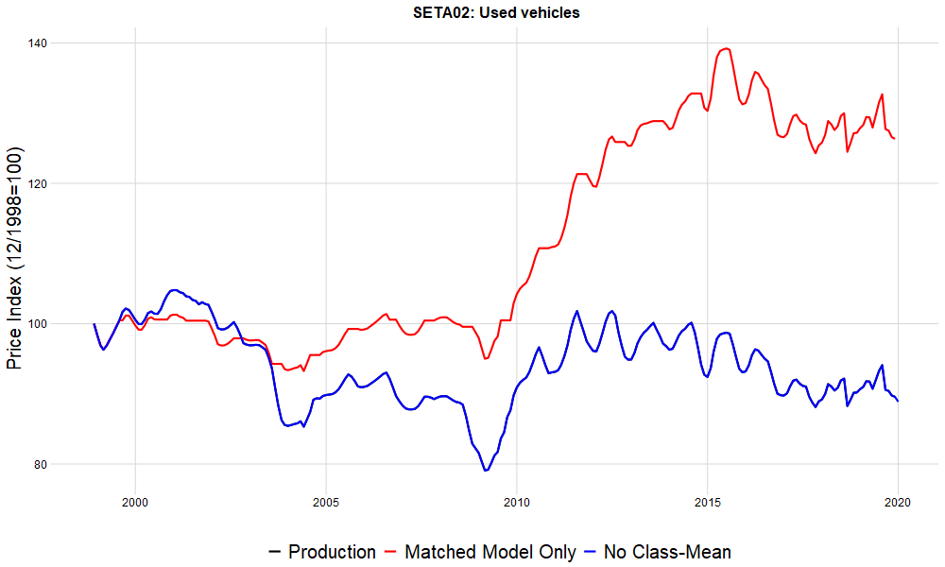
Figure 10: Quality adjustment counterfactual indexes for used vehicles
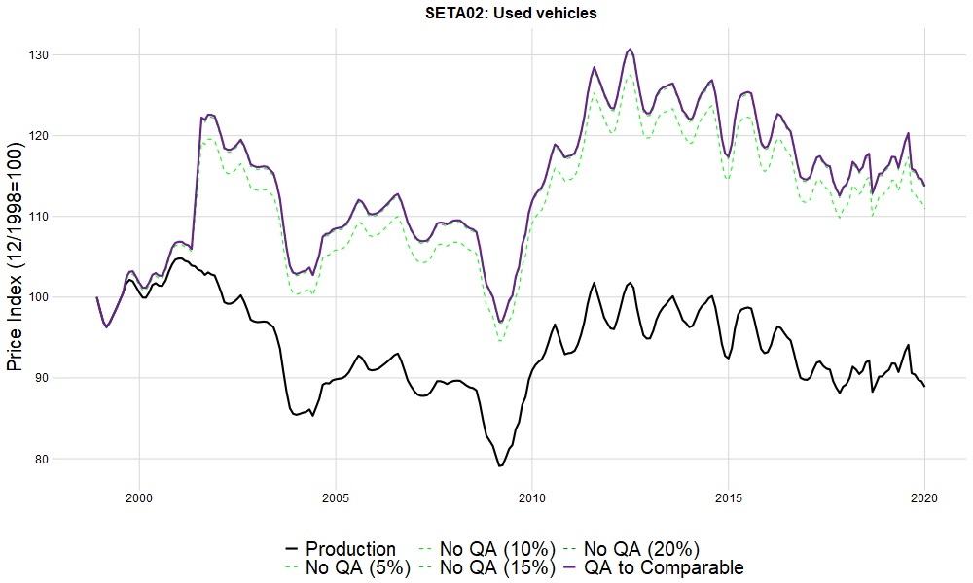

Personal Computers
Figure 11: Counterfactual quality adjustment indexes for personal computers
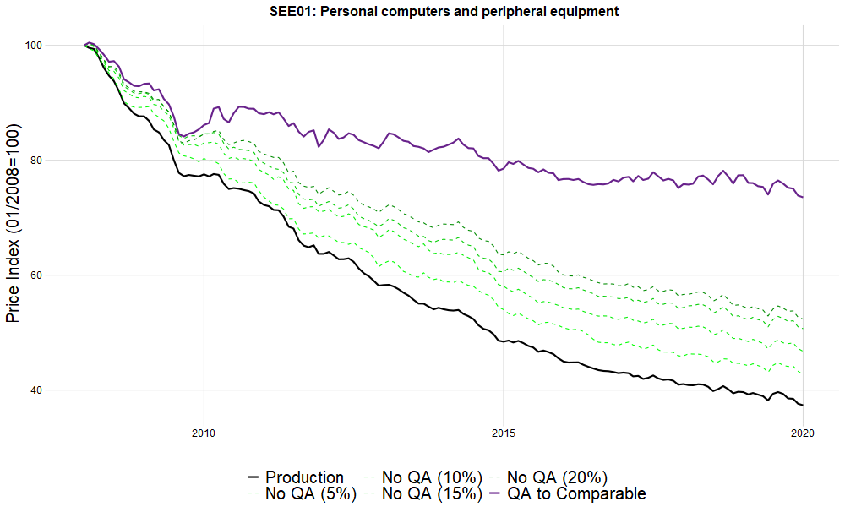

Here our analysis only covers the “Personal computer and peripheral equipment index” after it was rebased at the beginning of 2008. Component cost adjustments were used throughout this period. Based on our counterfactuals, quality adjustments had an annual impact of -1.1 to -2.6 percent per year.

Conclusion
While we find relatively small effects from quality adjustment, we estimate more of an impact than what has been indicated in prior BLS research. We find quality adjustments reduced the measured rate of CPI growth by 0.04 percent per year. Adjustments have clear downward effects on indexes in a few item categories. While it is hard to extrapolate from a relatively small number of cases, it appears that the largest impacts from hedonic quality adjustments come in indexes with unambiguous, vertical differentiated product attributes. However, the hedonic adjustments used by the BLS do not have a clear relationship with hedonic theory. Moreover, BLS does not collect the weighting information needed for demand estimation in its survey data. The cost-of-living interpretation of hedonic estimates requires timely product-level expenditure information that BLS surveys do not collect. Even given ideal weighting information, hedonic indexes should generally be expected to behave like matched-model indexes. Previous research that has implied large differences between hedonic and BLS estimates generally has neglected the importance of item replacement and its role in adjusting for product cycles and capturing cross-version price change.
We found that class-mean imputation, while receiving little attention in research, has a substantial effect on the CPI that is much larger than the effects of quality adjustment. The magnitude of the item replacement effects in apparel indexes is largely explained by product cycles, not staggered price setting, the conventional justification for showing cross-version price change. While both issues can be addressed with item replacement methods, we suggest that certain methodologies might be better applied with a better understanding of an item’s product cycle. Our results indicate a few item categories could be improved with class-mean imputation, but we have found that most item categories in the CPI with strong item replacement effects already use class-mean imputation. In the context of scanner data, item replacement in the form of “linking” has begun to receive more attention. Indexes highly dependent on the specifics of linking processes may not be desirable. In some cases, other methods, including hedonic estimates that account for cross-product price change and product cycles, may be preferred. On the other hand, homogenous items without item replacement effects may not warrant linking.
The BLS has attempted to address several measurement issues with the item replacement process including product cycles, staggered price-setting, welfare gains from new goods, and quality bias introduced by the item replacement process itself. Some of these issues might be better addressed outside the item replacement process. In particular, the introduction of new goods does not need to be directly tied to the exit of a product in the sample. Methods for imputing prior period prices for new goods or current period prices for exiting goods do not necessarily have to be applied as part of the item replacement process. The BLS should consider using methods like Diewert and Feenstra (2021) to handle new goods rather than attempting to use hedonic models at the point of item replacement. BLS should also explore more advanced methods of capturing changes in consumer welfare based on demand modeling. The increased availability of transaction data and other non-survey data may give BLS the opportunity to employ well founded hedonic models as well as other econometric techniques.
This paper has focused on the role of quality adjustment and other aspects of the item replacement process used for the C&S survey portion of the CPI, which represents about 70 percent of the weight in the All-Items index. The remaining 30 percent of the CPI index is driven by housing indexes which use hedonic adjustments for structure, age and other quality dimensions. Ongoing work explores the impact of these housing hedonic adjustments. The BLS also continues to investigate the impact of hedonic imputation and item replacement on statistical uncertainty. Even in cases where hedonic adjustments have little bearing on the magnitude of price change, they may improve CPI estimates by providing more precision than class-mean imputation.

References
Advisory Commission to Study the Consumer Price Index. 1996. "Toward a More Accurate Measure of the Cost of Living." Final Report to the Senate Finance Committee.
Aizcorbe, Ana, Carol Corrado, and Mark Doms. 2003. When do Matched-Model and Hedonic Techniques Yield Similar Price Measures? Working Paper Series 2003-14, Federal Reserve Bank of San Francisco. https://www.frbsf.org/economic-research/files/wp03-14bk.pdf.
Armknect, Paul A., and Donald Weyback. 1989. "Adjustments for Quality Change in the U.S. Consumer Price Index." Journal of Official Statistics 5 (2): 107-123.
Bajari, Patrick, and C. Lanier Benkard. 2005. "Demand Estimation with Heterogeneous Consumers and Unobserved Product Characteristics: A Hedonic Approach." Journal of Political Economy 113 (6): 1239-1276.
Bertolotto, Manuel I. 2019. "Online Price Index with Product Replacement: The Closest-Match Approach." 16trh Meeting of the Ottawa Group. Rio de Janeiro. https://www.ottawagroup.org/Ottawa/ottawagroup.nsf/home/Meeting+16/$FILE/Online%20Price%20Index%20with%20Product%20Replacement%20paper.pdf.
Bils, Mark. 2009. "Do Higher Prices for New Goods Reflect Quality Growth or Inflation." The Quarterly Journal of Economics 124 (2): 637-675. http://www.jstor.org/stable/40506240.
Brown, Craig, and Anya Stockburger. 2006. "Item Replacement and Quality Change in Apparel Price Indexes." Monthly Labor Review 129 (12): 35-45. https://www.bls.gov/opub/mlr/2006/12/art3full.pdf.
Chessa, Antonio G. 2019. "MARS: A method for defining products and linking barcodes of item relaunches." 16th Ottawa Group meeting. Rio de Janeiro. https://www.ottawagroup.org/Ottawa/ottawagroup.nsf/home/Meeting+16/$FILE/A%20method%20for%20defining%20products%20paper.pdf.
Dalton, Kenneth V., John S. Greenlees, and Kenneth J. Stewart. 1998. "Incorporating a geometric mean formula into the CPI." Monthly Labor Review 3-7. https://www.bls.gov/mlr/1998/10/art1full.pdf.
Diewert, W. Erwin. 2003. "Hedonic Regressions. A Consumer Theory Approach." In Scanner Data and Price Indexes, edited by Robert C. Feenstra and Matthew D. Shapiro, 317-348. University of Chicago Press. http://www.nber.org/chapters/c9740.
Diewert, W. Erwin, and Robert C. Feenstra. 2021. "Estimating the Benefits of New Products." In Big Data for Twenty-First Century Economic Statistics, edited by Ron S. Jarmin, Brian Moyer, Matthew D. Shapiro Katharine G. Abraham. University of Chicago Press. http://www.nber.org/chapters/c14281.
Erickson, Tim, and Ariel Pakes. 2011. "An Experimental Component Index for the CPI: From Annual Computer Data to Monthly Data on Other Goods." American Economic Review 101 (5): 1707-1738.
Feenstra, Robert C. 1995. "Exact Hedonic Price Indexes." The Review of Economics and Statistics 77 (4): 634-653.
Fixler, Dennis, John S. Greenlees, and Walter F. Lane. 2001. "Telecommunications indexes in the US Consumer Price Index." Sixth Meeting of the International Working Group on Price Indices. Canberra, Australia. https://www.ottawagroup.org/Ottawa/ottawagroup.nsf/4a256353001af3ed4b2562bb00121564/f7c7eb82a74fc50aca25727a00087bd7/$FILE/2001%206th%20Meeting%20-%20Fixler%20&%20Greenlees%20&%20Lane%20-%20Telecommunications%20Indexes%20in%20the%20U.S.%20Consumer%20Price.
Greenlees, J., and R. McClelland. 2010. "Superlative and Regression-Based Consumer Price Indexes for Apparel Using U.S. Scanner Data." St. Gallen, Switzerland: Conference of the International Association for Research in Income and Wealth.
Greenlees, John S., and Charles C. Mason. 1996. "Overview of the 1998 revision of the Consumer Price Index." Monthly Labor Review 3-9. https://www.bls.gov/opub/mlr/1996/12/art1full.pdf.
Greenlees, John S., and Robert McClelland. 2011. "Does Quality Adjustment Matter for Technologically Stable Products? An Application to the CPI for Food." The American Economic Review 101 (3): 200-205. https://www.jstor.org/stable/29783739.
Griliches, Zvi. 1991. "Hedonic Price Indexes and the Measurement of Capital and Productivity: Some Historical Reflections." In Fifty Years of Economic Measurement: The Jubilee of the Conference on Research in Income and Wealth, edited by Ernst R. Berndt and Jack E. Triplett, 185-206. University of Chicago Press. http://www.nber.org/chapters/c5976.
Groshen, Erica L., Brian C. Moyer, Ana M. Aizcorbe, Ralph Bradley, and David M. Friedman. 2017. "How Government Statistics Adjust for Potential Biases from Quality Change and New Goods in an Age of Digital Technologies: A View from the Trenches." The Journal of Economic Perspectives 31 (2): 187-210. https://www.jstor.org/stable/44235005.
Hicks, J.R. 1940. "The Valuation of the Social Income." Economica 7 (26): 105-124.
Hobijn, Bart. 2001. "Is Equipment Price De‡ation a Statistical Artificat?" Staff Report 139 (Federal Reserve Bank of New York). https://www.newyorkfed.org/medialibrary/media/research/staff_reports/sr139.pdf.
Hulten, Charles R. 1997. "Quality Change in the CPI." Review (Federal Reserve Bank of St. Louis) 87-100. https://files.stlouisfed.org/files/htdocs/publications/review/97/05/9705ch.pdf.
Johnson, David S, Stephen B. Reed, and Kenneth J Stewart. 2006. "Price measurement in the United States: a decade after the Boskin Report." Monthly Labor Review 129 (5): 10-19. https://www.bls.gov/opub/mlr/2006/05/art2full.pdf.
Kellar, Jeffrey H. 1988. "New Methodology Reduces Importance of Used Cars in the Revised CPI." Monthly Labor Review 111 (12): 34-36. http://www.jstor.org/stable/41843067.
Konny, Crystal G., Brendan K. Williams, and David M. Friedman. 2019. "Big Data in the U.S. Consumer Price Index: Experiences and Plans." In Big Data for Twenty-First Century Economic Statistics, edited by Katharine G. Abraham, Ron S. Jarmin, Brian Moyer and Matthew D. Shapiro. University of Chicago Press. http://www.nber.org/chapters/c14280.
Lebow, David E., and Jeremy B. Rudd. 2003. "Measurement Error in the Consumer Price Index: Where Do We Stand?" Journal of Economic Literature 41 (1): 159-201.
Liegey, Paul R. 1994. "Apparel price indexes: effects of hedonic adjustment." Monthly Labor Review 38-45.
Liegey, Paul, and Nicole Shepler. 1999. "Adjusting VCR Prices for Quality Change: a Study Using Hedonic Methods." Monthly Labor Review 122 (9): 22-37.
Moulton, Brent R, Timothy J LaFleur, and Karin E Moses. 1998. "“Research on Improved Quality Adjustment in the CPI: The Case of Televisions." Bureau of Labor Statistics, September.
Moulton, Brent R. 2018. The Measurement of Output, Prices, and Productivity: What's Changed Since the Boskin Commission? The Hutchins Center on Fiscal and Monetary Policy, Brookings Institution.
Moulton, Brent, and Karin Moses. 1997. "Addressing the Quality Change Issue in the Consumer Price Index." Brookings Papers on Economic Activity 1: 305-349.
Office for National Statistics. n.d. "Analysis of product turnover in web scraped clothing data, and its impact on methods for compiling price indices." https://www.ons.gov.uk/methodology/methodologicalpublications/generalmethodology/currentmethodologyarticles/analysisofproductturnoverinwebscrapedclothingdataanditsimpactonmethodsforcompilingpriceindices.
Paben, Steven P., William H. Johnson, and Jonathan F. Schlip. 2016. "The 2018 revision of the Consumer Price Index geographic sample." Monthly Labor Review. https://www.bls.gov/opub/mlr/2016/article/the-2018-revision-of-the-cpi-geographic-sample.htm.
Pakes, Ariel. 2003. "A Reconsideration of Hedonic Price Indexes with an Application to PC's." The American Economic Review 93 (5): 1578-1596. https://www.jstor.org/stable/3132143.
Pashigian, Peter B., Bowen, Brian, and Eric Gould. 1995. "Fashion, Styling, and the Within-Season Decline in Automobile Prices." Journal of Law and Economics 38 (2): 281-309. http://www.jstor.org/stable/725687.
Pollak, Robert. 1983. "The Treatment of 'Quality' in the Cost of Living Index." Journal of Public Economics 20: 25-53.
Ptacek, Frank. 2013. "Updating the rent sample for the CPI Housing Survey." Monthly Labor Review. https://www.bls.gov/opub/mlr/2013/article/updating-the-rent-sample-for-the-cpi-housing-survey.htm.
Reinsdorf, Marshall B., Paul Liegey, and Kenneth Stewart. 1996. "New Ways of Handling Quality Change in the U.S. Consumer Price Index." BLS Working Paper 276. https://www.bls.gov/osmr/research-papers/1996/pdf/ec960040.pdf.
Rosen, Sherwin. 1974. "Hedonic Prices and Implicit Markets: Product Differentiation in Pure Competition." The Journal of Political Economy 82: 34-55.
Silver, Mick, and Saeed Heravi. 2003. "The Measurement of Quality-Adjusted Price Changes." In Scanner Data and Price Indexes, edited by Robert C. Feenstra and Matthew D. Shapiro, 277-316. University of Chicago Press.
Triplett, Jack. 2006. Handbook on Hedonic Indexes and Quality Adjustments in Price Indexes. Paris: OECD Publishing.
Ueda, Kozo, Kota Watanabe, and Tsutomu Watanabe. 2018. "Product Turnover and the Cost of Living Index: Quality vs Fashion Effects." (Federal Reserve Bank of Dallas Globalization and Monetary Policy Institute) (Working Paper No. 337).
Van Loon, Ken. 2019. "Redefining what products are in the context of scanner data and web scraping, experiences from Belgium." 16th Meeting of the Ottawa Group. Rio de Janeiro: Statistics Belgium. https://eventos.fgv.br/sites/eventos.fgv.br/files/arquivos/u161/ottawa_-_belgium_-_ken_vl_0.pdf.
Williams, Brendan, and Erick Sager. 2019. "A New Vehicles Transaction Price Index: Offsetting the Effects of Price Discrimination and Product Cycle Bias with a Year-Over-Year Index." BLS Working Papers (Working Paper 514 ). https://www.bls.gov/osmr/pdf/ec190040.pdf.

Appendix
Figure 12: Cumulative Difference from Production
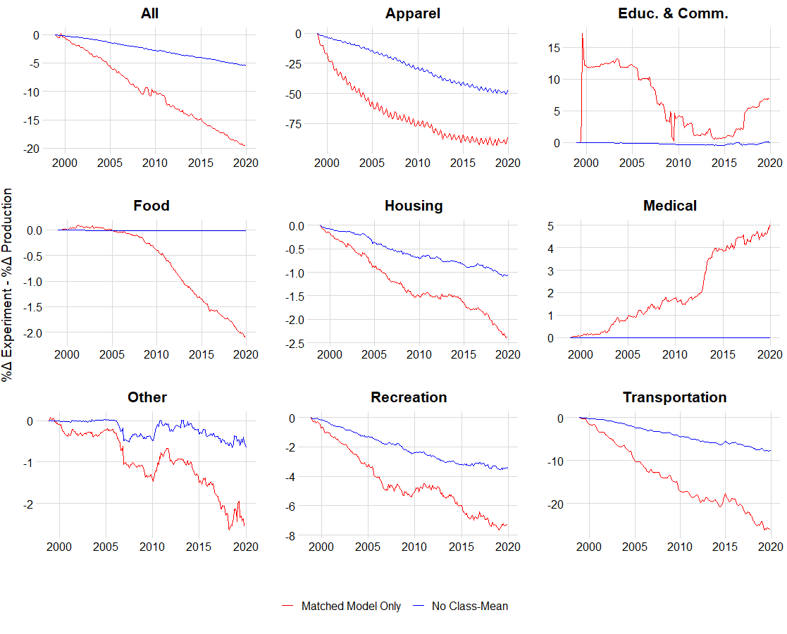
Table 4: Item Replacement Impact (Dec 1998-Dec 2019)
Item Code✝ | Title | Cumulative Impact | Class-mean imputation*
SEAC02 | Women's dresses | 45,284,869.84% | Y
SEAC03 | Women's suits and separates | 80,458.89% | Y
SEAC01 | Women's outerwear | 35,097.18% | Y
SEAD01 | Girls' apparel | 22,402.73% | Y
SEAE03 | Women's footwear | 5,328.70% | Y
SEAE02 | Boys' and girls' footwear | 2,538.44% | Y
SEAC04 | Women's underwear, nightwear, sportswear and accessories | 2,106.24% | Y
SEAB01 | Boys' apparel | 1,346.24% | Y
SEAA03 | Men's shirts and sweaters | 1,064.32% | Y
SEAA01 | Men's suits, sport coats, and outerwear | 827.82% | Y
SEAF01 | Infants' and toddlers' apparel | 609.13% | Y
SEAE01 | Men's footwear | 521.55% | Y
SEAA02 | Men's furnishings | 376.17% | Y
SEAA04 | Men's pants and shorts | 373.93% | Y
SETA01 | New vehicles | 180.73% | Y
SERD01 | Photographic equipment and supplies | 130.37% | Y
SEAG02 | Jewelry | 110.81% | Y
SERC01 | Sports vehicles including bicycles | 100.15% | Y
SEAG01 | Watches | 91.02% | Y
SERC02 | Sports equipment | 61.37% | Y
SERE01 | Toys | 57.51% | Y
SERA03 | Other video equipment | 55.25% | Y
SEHL01 | Clocks, lamps, and decorator items | 52.24% | Y
SEHL03 | Dishes and flatware | 39.74% | Y
SEHJ03 | Other furniture | 39.39% | Y
SEEA01 | Educational books and supplies | 38.27% | Y
SEHH03 | Other linens | 38.18% | Y
SEHJ02 | Living room, kitchen, and dining room furniture | 37.93% | Y
SEHK01 | Major appliances | 37.84% | Y
SEEE04 | Telephone hardware, calculators, and other consumer information items | 37.59% | Y
SERA01 | Televisions | 33.99% | Y
SERA05 | Audio equipment | 33.91% | Y
SETA03 | Leased cars and trucks | 31.57% | Y
SEHK02 | Other appliances | 29.21% | Y
SEHL04 | Nonelectric cookware and tableware | 24.92% | Y
SEHH02 | Window coverings | 24.16% | Y
SEHN02 | Household paper products | 22.88% | Y
SEHJ01 | Bedroom furniture | 22.84% | Y
SERE02 | Sewing machines, fabric and supplies | 19.64% | Y
SERE03 | Music instruments and accessories | 18.67% | Y
SEGE01 | Miscellaneous personal goods | 16.63% | Y
SEHM01 | Tools, hardware and supplies | 15.43% | Y
SEHM02 | Outdoor equipment and supplies | 15.31% | Y
SEHH01 | Floor coverings | 14.82% | Y
SEFT05 | Baby food | 14.27%
SERA06 | Audio discs, tapes and other media | 12.45% | Y
SETE01 | Motor vehicle insurance | 10.45%
SERA04 | Video discs and other media, including rental of video and audio | 8.66% | Y
SEFT06 | Other miscellaneous foods | 7.85%
SEFA02 | Breakfast cereal | 7.66%
SEEB01 | College tuition and fees | 7.43%
SEFR02 | Candy and chewing gum | 6.16%
SEFN02 | Frozen noncarbonated juices and drinks | 5.73%
SEFB03 | Cakes, cupcakes, and cookies | 5.61%
SEHG01 | Water and sewerage maintenance | 5.58%
SEFP01 | Coffee | 5.47%
SETG03 | Intracity transportation | 5.30%
SEFA01 | Flour and prepared flour mixes | 5.22%
SEEB02 | Elementary and high school tuition and fees | 5.16%
SETC01 | Tires | 4.67% | Y
SEMD01 | Hospital services | 4.38%
SEFJ03 | Ice cream and related products | 3.89%
SEFG02 | Processed fish and seafood | 3.79%
SEEC01 | Postage | 3.75%
SETF01 | State motor vehicle registration and license fees | 3.71%
SEFT01 | Soups | 3.65%
SEFM03 | Other processed fruits and vegetables including dried | 3.59%
SEHP02 | Gardening and lawncare services | 3.58%
SERF03 | Fees for lessons or instructions | 3.55%
SEFT02 | Frozen and freeze dried prepared foods | 3.44%
SEHB01 | Housing at school, excluding board | 3.32%
SETC02 | Vehicle accessories other than tires | 3.15% | Y
SEFS02 | Salad dressing | 3.14%
SEFV05 | Other food away from home | 3.04%
SEFV03 | Food at employee sites and schools | 2.99%
SEEB04 | Technical and business school tuition and fees | 2.67%
SETF03 | Parking and other fees | 2.64%
SEHE01 | Fuel oil | 2.42%
SEGB02 | Cosmetics, perfume, bath, nail preparations and implements | 2.38% | Y
SEFT03 | Snacks | 2.29%
SEFB01 | Bread | 2.22%
SEMD02 | Nursing homes and adult day services | 2.20%
SEHG02 | Garbage and trash collection | 2.19%
SERB01 | Pets and pet products | 2.08% | Y
SETD02 | Motor vehicle maintenance and servicing | 2.07% | Y
SEFR03 | Other sweets | 2.07%
SEHP03 | Moving, storage, freight expense | 2.01%
SEHP04 | Repair of household items | 1.95%
SEFM02 | Frozen fruits and vegetables | 1.85%
SEMC03 | Eyeglasses and eye care | 1.80%
SEFV04 | Food from vending machines and mobile vendors | 1.66%
SEFW03 | Wine at home | 1.61%
SEFX01 | Alcoholic beverages away from home | 1.56%
SERB02 | Pet services including veterinary | 1.50%
SETD03 | Motor vehicle repair | 1.48% | Y
SEEB03 | Child care and nursery school | 1.47%
SEFR01 | Sugar and artificial sweeteners | 1.45%
SEFV01 | Full service meals and snacks | 1.44%
SEFM01 | Canned fruits and vegetables | 1.41%
SETD01 | Motor vehicle body work | 1.38% | Y
SEFS01 | Butter and margarine | 1.32%
SEGD01 | Legal services | 1.23%
SEHP01 | Domestic services | 1.13%
SEGB01 | Hair, dental, shaving, and miscellaneous personal care products | 1.04% | Y
SEFK01 | Apples | 1.03%
SEHF02 | Utility (piped) gas service | 0.98%
SEFG01 | Fresh fish and seafood | 0.95%
SEFB04 | Other bakery products | 0.93%
SEFC04 | Uncooked other beef and veal | 0.91%
SEMC04 | Services by other medical professionals | 0.91%
SEFL03 | Tomatoes | 0.88%
SEGD02 | Funeral expenses | 0.85%
SEFC03 | Uncooked beef steaks | 0.84%
SEFV02 | Limited service meals and snacks | 0.81%
SEFL04 | Other fresh vegetables | 0.75%
SEFD01 | Bacon, breakfast sausage, and related products | 0.64%
SEGC01 | Haircuts and other personal care services | 0.62%
SEFE01 | Other meats | 0.54%
SEFK02 | Bananas | 0.51%
SEFK03 | Citrus fruits | 0.47%
SETG02 | Other intercity transportation | 0.46%
SEMC02 | Dental services | 0.37%
SEFK04 | Other fresh fruits | 0.32%
SEGA01 | Cigarettes | 0.29%
SEFS03 | Other fats and oils including peanut butter | 0.29%
SEMC01 | Physicians' services | 0.28%
SEHD01 | Tenants' and household insurance | 0.27%
SEME04 | Medicare and other health insurance - retained earnings | 0.27%
SEFD03 | Pork chops | 0.25%
SEFF01 | Chicken | 0.22%
SEGD04 | Apparel services other than laundry and dry cleaning | 0.19%
SEMD03 | Care of invalids and elderly at home | 0.18%
SERF01 | Club dues and fees for participant sports and group exercises | 0.18%
SEEC02 | Delivery services | 0.10%
SEME02 | Blue cross/blue shield - retained earnings | 0.05%
SETB02 | Other motor fuels | 0.03%
SETG01 | Airline fare | 0.01%
SEHN01 | Household cleaning products | 0.00% | Y
SETB01 | Gasoline (all types) | -0.09%
SEFN03 | Nonfrozen noncarbonated juices and drinks | -0.10%
SEHE02 | Propane, kerosene, and firewood | -0.11%
SEME01 | Commercial health insurance - retained earnings | -0.14%
SEGD05 | Financial services | -0.25%
SEME03 | Health maintenance plans - retained earnings | -0.26%
SEGA02 | Tobacco products other than cigarettes | -0.27%
SEFA03 | Rice, pasta, cornmeal | -0.30%
SEFC02 | Uncooked beef roasts | -0.30%
SEGD03 | Laundry and dry cleaning services | -0.31%
SERF02 | Admissions | -0.38%
SEFJ04 | Other dairy and related products | -0.38%
SEFT04 | Spices, seasonings, condiments, sauces | -0.46%
SERD02 | Photographers and film processing | -0.47%
SEFB02 | Fresh biscuits, rolls, muffins | -0.50%
SEFP02 | Other beverage materials including tea | -0.56%
SEFW02 | Distilled spirits at home | -0.58%
SEHN03 | Miscellaneous household products | -0.61% | Y
SEFH01 | Eggs | -0.68%
SEFW01 | Beer, ale, and other malt beverages at home | -0.78%
SERG01 | Newspapers and magazines | -1.02% | Y
SEFC01 | Uncooked ground beef | -1.12%
SEFN01 | Carbonated drinks | -1.31%
SEFJ02 | Cheese and related products | -1.32%
SEHF01 | Electricity | -1.37%
SEFL02 | Lettuce | -1.43%
SEFJ01 | Milk | -1.45%
SEHB02 | Other lodging away from home including hotels and motels | -1.99%
SETA04 | Car and truck rental | -2.03%
SEFD02 | Ham | -2.26%
SEFL01 | Potatoes | -2.35%
SEFD04 | Other pork including roasts and picnics | -3.37%
SEHL02 | Indoor plants and flowers | -3.97% | Y
SEFF02 | Other poultry including turkey | -4.09%
SERG02 | Recreational books | -4.81% | Y
SEEE01 | Personal computers and peripheral equipment | -6.38% | Y
SERA02 | Cable and satellite television and radio service | -9.85% | Y
SEEE02 | Computer software and accessories | -10.90% | Y
SETA02 | Used cars and trucks | -29.09% | Y
SEED03 | Wireless telephone services | -37.32%
“*” Class-mean imputation is based on use in 2000. A few items have added class-mean imputation over time
“✝” SEEE03 (“Internet services and electronic information providers”) and SEMF01 (“Prescription drugs“) e excluded due production changes and rebasing

Table 5: Cumulative differences between published indexes and quality adjustment counterfactuals (Dec 1998-Dec 2019)
Item Code | Title | No QA (5%) | No QA (20%) | QA to Comparable | Adj Type 2020
SEAA01 | Men's suits, sport coats, and outerwear | -5.114 | -4.872 | 1.540 | Hedonic
SEAA02 | Men's furnishings | -1.001 | 3.345 | -5.787
SEAA03 | Men's shirts and sweaters | 6.257 | 1.112 | 1.171 | Hedonic
SEAA04 | Men's pants and shorts | -4.185 | -3.095 | 1.640 | Hedonic
SEAB01 | Boys' apparel | -4.414 | -0.169 | -1.879 | Hedonic
SEAC01 | Women's outerwear | -7.348 | -10.450 | -11.319 | Hedonic
SEAC02 | Women's dresses | -4.061 | -11.095 | -4.985 | Hedonic
SEAC03 | Women's suits and separates | -5.293 | -1.038 | 5.690 | Hedonic
SEAC04 | Women's underwear, nightwear, sportswear and accessories | -2.470 | 0.979 | -1.329
SEAD01 | Girls' apparel | -2.188 | -4.308 | -0.713 | Hedonic
SEAE01 | Men's footwear | -6.110 | 0.871 | 4.291 | Hedonic
SEAE02 | Boys' and girls' footwear | -7.508 | -3.498 | 1.842 | Hedonic
SEAE03 | Women's footwear | -16.281 | -5.179 | 6.889 | Hedonic
SEAF01 | Infants' and toddlers' apparel | 3.745 | 0.806 | -15.280
SEAG01 | Watches | 0.053 | 0.083 | 0.359
SEAG02 | Jewelry | 1.661 | 1.696 | 1.165
SEEA01 | Educational books and supplies | 6.181 | -4.322 | 7.086 | (Prev hedonic)
SEEB01 | College tuition and fees | -0.396 | -0.478 | 0.102
SEEB02 | Elementary and high school tuition and fees | -0.572 | -0.988 | -1.037
SEEB03 | Child care and nursery school | -0.542 | 0.241 | 2.697
SEEB04 | Technical and business school tuition and fees | -0.211 | -0.215 | 6.184
SEEC01 | Postage | 0.000 | 0.000 | 0.000
SEEC02 | Delivery services | -0.662 | -3.969 | -4.611
SEED03 | Wireless telephone services | 18.944 | 10.101 | 22.848 | Hedonic
SEED04 | Landline telephone services | NA | NA | NA | Hedonic
SEEE01 | Personal computers and peripheral equipment | 0.778 | 2.157 | 5.212 | Cost
SEEE02 | Computer software and accessories | 0.158 | 0.280 | 1.886
SEEE03 | Internet services and electronic information providers | 1.796 | 2.540 | 5.223 | Hedonic
SEEE04 | Telephone hardware, calculators, and other consumer information items | 1.224 | 0.557 | 6.319 | Hedonic
SEFA01 | Flour and prepared flour mixes | 0.035 | 0.035 | 0.035
SEFA02 | Breakfast cereal | -0.070 | 0.057 | 0.130
SEFA03 | Rice, pasta, cornmeal | -0.007 | 0.044 | 0.044
SEFB01 | Bread | 0.023 | 0.047 | 1.844
SEFB02 | Fresh biscuits, rolls, muffins | 0.015 | -0.035 | -2.073
SEFB03 | Cakes, cupcakes, and cookies | 0.054 | 0.054 | -0.247
SEFB04 | Other bakery products | 0.096 | 0.096 | 3.859
SEFC01 | Uncooked ground beef | 0.000 | 0.000 | 0.000
SEFC02 | Uncooked beef roasts | 0.000 | 0.000 | 0.000
SEFC03 | Uncooked beef steaks | 0.000 | 0.000 | 0.000
SEFC04 | Uncooked other beef and veal | 0.000 | 0.000 | -0.303
SEFD01 | Bacon, breakfast sausage, and related products | -0.089 | -0.084 | 0.297
SEFD02 | Ham | -0.002 | -0.065 | 0.184
SEFD03 | Pork chops | 0.072 | 0.072 | -0.283
SEFD04 | Other pork including roasts and picnics | 0.094 | 0.094 | -0.147
SEFE01 | Other meats | -0.072 | -0.058 | 0.057
SEFF01 | Chicken | 0.000 | 0.000 | 0.000
SEFF02 | Other poultry including turkey | 0.000 | 0.000 | 0.000
SEFG01 | Fresh fish and seafood | 0.000 | 0.000 | 0.000
SEFG02 | Processed fish and seafood | -0.071 | -0.071 | 1.252
SEFH01 | Eggs | -0.007 | -0.007 | 0.048
SEFJ01 | Milk | 0.015 | 0.015 | -0.271
SEFJ02 | Cheese and related products | -0.011 | -0.011 | -0.233
SEFJ03 | Ice cream and related products | 0.018 | 0.057 | 0.110
SEFJ04 | Other dairy and related products | -0.045 | -0.071 | -0.200
SEFK01 | Apples | 0.163 | 0.163 | 0.163
SEFK02 | Bananas | 0.009 | 0.009 | 0.009
SEFK03 | Citrus fruits | -0.033 | -0.033 | -0.033
SEFK04 | Other fresh fruits | -0.166 | -0.166 | -0.166
SEFL01 | Potatoes | 0.000 | 0.000 | 0.000
SEFL02 | Lettuce | 0.000 | 0.000 | 0.000
SEFL03 | Tomatoes | 0.000 | 0.000 | 0.000
SEFL04 | Other fresh vegetables | 0.000 | 0.000 | 0.000
SEFM01 | Canned fruits and vegetables | 0.069 | 0.069 | 0.047
SEFM02 | Frozen fruits and vegetables | 0.000 | 0.000 | 0.185
SEFM03 | Other processed fruits and vegetables including dried | 0.000 | 0.000 | 0.000
SEFN01 | Carbonated drinks | 0.097 | 0.099 | 0.243
SEFN02 | Frozen noncarbonated juices and drinks | -0.001 | -0.001 | 0.041
SEFN03 | Nonfrozen noncarbonated juices and drinks | 0.001 | 0.001 | 0.115
SEFP01 | Coffee | 0.000 | 0.000 | 0.000
SEFP02 | Other beverage materials including tea | 0.047 | -0.044 | 2.171
SEFR01 | Sugar and artificial sweeteners | -0.001 | -0.001 | -0.001
SEFR02 | Candy and chewing gum | 0.158 | 0.150 | -0.172
SEFR03 | Other sweets | 0.001 | 0.001 | 0.001
SEFS01 | Butter and margarine | 0.057 | 0.031 | 0.091
SEFS02 | Salad dressing | -0.029 | -0.029 | -0.029
SEFS03 | Other fats and oils including peanut butter | 0.000 | 0.000 | 0.148
SEFT01 | Soups | -0.004 | -0.004 | -0.004
SEFT02 | Frozen and freeze dried prepared foods | 0.002 | 0.002 | 0.116
SEFT03 | Snacks | -0.007 | -0.007 | -0.205
SEFT04 | Spices, seasonings, condiments, sauces | 0.000 | 0.000 | 0.000
SEFT05 | Baby food | -0.001 | -0.001 | -1.356
SEFT06 | Other miscellaneous foods | -0.002 | -0.002 | -0.002
SEFV01 | Full service meals and snacks | 0.002 | -0.008 | -0.008
SEFV02 | Limited service meals and snacks | 0.005 | 0.018 | 0.034
SEFV03 | Food at employee sites and schools | -0.030 | 0.006 | 0.006
SEFV04 | Food from vending machines and mobile vendors | -0.013 | -0.013 | -0.174
SEFV05 | Other food away from home | -0.319 | -0.360 | -0.360
SEFW01 | Beer, ale, and other malt beverages at home | -0.243 | -0.183 | -0.183
SEFW02 | Distilled spirits at home | -0.011 | -0.011 | -0.011
SEFW03 | Wine at home | 0.004 | 0.047 | 0.047
SEFX01 | Alcoholic beverages away from home | -0.066 | -0.093 | -0.115
SEGA01 | Cigarettes | -0.169 | -0.193 | -0.147
SEGA02 | Tobacco products other than cigarettes | 0.050 | 0.050 | 0.050
SEGB01 | Hair, dental, shaving, and miscellaneous personal care products | 0.494 | 0.584 | 0.972
SEGB02 | Cosmetics, perfume, bath, nail preparations and implements | 0.435 | -0.187 | 2.571
SEGC01 | Haircuts and other personal care services | -0.469 | -0.249 | 0.888
SEGD01 | Legal services | 0.065 | -0.733 | -2.812
SEGD02 | Funeral expenses | -0.041 | -0.235 | -4.054
SEGD03 | Laundry and dry cleaning services | 0.210 | -0.169 | 4.313
SEGD04 | Apparel services other than laundry and dry cleaning | 0.349 | 0.064 | 3.335
SEGD05 | Financial services | 1.812 | 1.588 | -0.855
SEGE01 | Miscellaneous personal goods | 0.166 | 0.176 | 0.274
SEHA01 | Rent of primary residence | NA | NA | NA | Hedonic
SEHB01 | Housing at school, excluding board | -0.032 | 0.505 | -0.332
SEHB02 | Other lodging away from home including hotels and motels | -0.376 | -0.790 | 2.335
SEHC01 | Owners' equivalent rent of primary residence | NA | NA | NA | Hedonic
SEHD01 | Tenants' and household insurance | -0.130 | -1.567 | -6.985
SEHE01 | Fuel oil | -0.278 | 0.247 | -24.957
SEHE02 | Propane, kerosene, and firewood | 1.974 | 1.583 | 280.882
SEHF01 | Electricity | -0.338 | -0.391 | -0.213
SEHF02 | Utility (piped) gas service | 0.096 | -0.052 | -0.515
SEHG01 | Water and sewerage maintenance | 0.260 | -1.622 | -31.398
SEHG02 | Garbage and trash collection | -0.069 | -0.104 | 30.884
SEHH01 | Floor coverings | 0.077 | 0.576 | -2.564
SEHH02 | Window coverings | -0.164 | -0.164 | -2.025
SEHH03 | Other linens | 0.000 | 0.000 | 0.000
SEHJ01 | Bedroom furniture | 0.316 | 0.540 | 2.486
SEHJ02 | Living room, kitchen, and dining room furniture | 1.241 | 0.730 | 2.746
SEHJ03 | Other furniture | 0.306 | 0.301 | 0.436
SEHK01 | Major appliances | 3.364 | 5.952 | 16.743 | Hedonic
SEHK02 | Other appliances | 0.137 | 0.041 | -0.158
SEHL01 | Clocks, lamps, and decorator items | -0.006 | -0.005 | 0.014
SEHL02 | Indoor plants and flowers | 0.019 | 0.038 | 1.211
SEHL03 | Dishes and flatware | 0.077 | 0.223 | -0.148
SEHL04 | Nonelectric cookware and tableware | 0.380 | 0.366 | 1.582
SEHM01 | Tools, hardware and supplies | -0.450 | -0.606 | 1.509
SEHM02 | Outdoor equipment and supplies | 0.086 | -0.087 | 0.253
SEHN01 | Household cleaning products | 0.042 | 0.063 | -1.057
SEHN02 | Household paper products | -0.627 | -0.779 | -0.332
SEHN03 | Miscellaneous household products | 0.214 | 0.280 | 1.196
SEHP01 | Domestic services | 0.004 | 0.182 | -12.192
SEHP02 | Gardening and lawncare services | -1.294 | -1.383 | -6.856
SEHP03 | Moving, storage, freight expense | 1.813 | 0.014 | 5.961
SEHP04 | Repair of household items | 0.514 | 0.765 | -0.260
SEMC01 | Physicians' services | 0.073 | -0.083 | -0.335
SEMC02 | Dental services | 0.006 | -0.104 | -0.536
SEMC03 | Eyeglasses and eye care | -0.063 | 0.132 | 0.202
SEMC04 | Services by other medical professionals | -0.136 | -0.092 | 0.940
SEMD01 | Hospital services | -1.698 | -1.585 | -11.110
SEMD02 | Nursing homes and adult day services | -1.009 | -1.154 | -22.677
SEMD03 | Care of invalids and elderly at home | 0.022 | 0.134 | 0.335
SEME01 | Commercial health insurance - retained earnings | 0.000 | 0.000 | 0.000
SEME02 | Blue cross/blue shield - retained earnings | 0.000 | 0.000 | 0.000
SEME03 | Health maintenance plans - retained earnings | 0.000 | 0.000 | 0.000
SEME04 | Medicare and other health insurance - retained earnings | 0.000 | 0.000 | 0.000
SEMF01 | Prescription drugs | NA | NA | NA
SEMF02 | Nonprescription drugs | NA | NA | NA
SEMG01 | Dressings and first aid kits | NA | NA | NA
SERA01 | Televisions | 0.971 | 1.530 | 10.293 | Hedonic
SERA02 | Cable and satellite television and radio service | 16.000 | 16.667 | 18.745 | Hedonic
SERA03 | Other video equipment | -0.236 | 0.180 | 5.273 | Hedonic
SERA04 | Video discs and other media, including rental of video and audio | 13.157 | 13.794 | 17.600
SERA05 | Audio equipment | -1.117 | -0.472 | 1.598
SERA06 | Audio discs, tapes and other media | 0.153 | 0.148 | 0.471
SERB01 | Pets and pet products | -0.115 | -0.067 | 0.357
SERB02 | Pet services including veterinary | -0.864 | 0.863 | 7.250
SERC01 | Sports vehicles including bicycles | 0.043 | 0.380 | -0.365
SERC02 | Sports equipment | 0.077 | 0.037 | -0.013
SERD01 | Photographic equipment and supplies | -0.789 | 0.317 | 7.826 | Hedonic
SERD02 | Photographers and film processing | -0.779 | 0.661 | 2.660
SERE01 | Toys | -0.026 | -0.048 | -0.050
SERE02 | Sewing machines, fabric and supplies | 0.296 | 0.296 | 0.652
SERE03 | Music instruments and accessories | -0.646 | -0.459 | 1.331
SERF01 | Club dues and fees for participant sports and group exercises | 0.273 | 0.382 | 63.839
SERF02 | Admissions | -0.157 | -0.239 | -0.182
SERF03 | Fees for lessons or instructions | -0.625 | -0.854 | 177.850
SERG01 | Newspapers and magazines | -0.917 | -0.771 | -0.532
SERG02 | Recreational books | -0.118 | -0.111 | 0.932
SETA01 | New vehicles | 4.949 | 4.786 | 4.792 | Cost
SETA02 | Used cars and trucks | 22.209 | 25.042 | 25.045 | Cost
SETA03 | Leased cars and trucks | 4.587 | 3.564 | 4.903 | Cost
SETA04 | Car and truck rental | 0.998 | -0.260 | 2.666
SETB01 | Gasoline (all types) | -0.423 | -0.423 | -1.370
SETB02 | Other motor fuels | -0.019 | -0.019 | -0.019
SETC01 | Tires | -0.005 | -0.012 | 0.004
SETC02 | Vehicle accessories other than tires | 0.477 | 0.371 | 7.091
SETD01 | Motor vehicle body work | 0.005 | -0.304 | -0.585
SETD02 | Motor vehicle maintenance and servicing | 0.038 | 0.092 | 0.566
SETD03 | Motor vehicle repair | 0.018 | 0.108 | 0.287
SETE01 | Motor vehicle insurance | 0.012 | -0.001 | 2.458
SETF01 | State motor vehicle registration and license fees | -3.321 | -1.577 | 3.492
SETF03 | Parking and other fees | 2.784 | 1.225 | 7.776
SETG01 | Airline fare | -0.068 | -0.144 | 3.155
SETG02 | Other intercity transportation | -0.578 | 1.305 | -2.775
SETG03 | Intracity transportation | -0.508 | -0.314 | 3.517

In other papers—and in the BLS internally—item replacements are often referred to as “substitutions.” This can lead to confusion by implying a relationship with consumer substitution behaviors, which are not related to BLS item replacement procedures. Specifically, when an item is no longer available and replaced in the sample, data collectors attempt to find a replacement that is most similar to the previous item rather than attempting to resample based on updated consumption patterns.
Most models use a semi-log functional form, but a few use a flexible, Box-Cox, functional form. See Williams (2008) for details on the introduction of Box-Cox adjustments.
Thank you to Craig Brown for supplying these estimates.
Dalton, Greenlees, Stewart (1998).
Paben, Johnson, Schlip (2016).
The BLS maintains several research index calculators to facilitate estimation of counterfactual price indexes using BLS data. These differ from the official production system, which is designed for monthly index processing and has limited ability for recalculating historical indexes. In 2015, the BLS introduced a new production estimation system that led to several methodological changes. We use three different systems to produce our counterfactual indexes here: one to cover 1999 through 2014 based on the methodologies used in the CPI from the 1998 revision (See Greenlees and Mason 1996), one that covers the 2015 to 2020 time period after the estimation system redesign, and one to bridge the two in January 2015.
Another experiment would be to convert all quality adjustments to non-comparable imputations. We tried this, but imputations led to some unexpected behavior that we are investigating.
Excluding EE03 (“Internet services and electronic information providers”) as an outlier
This table is limited to items that currently use hedonic or cost-based adjustments. The appendix contains the complete list for all items.
Table 6, 86.827/86.448= 1.004…
This is the expanded version of Table 3 for all item strata. Table 3 is limited to those that actively use quality adjustment as of 2020. This table reflects the impact of items that previously used quality adjustments and cases where an adjustment besides hedonic or cost-based quality adjustments was applied.

