Submitted by Japan Informal document GRVA-10-27
10th GRVA, 25-28 May 2021
Provisional agenda item 4(d)
Progressing the Lane Change Discussion in the SIG-ALKS

In the SIG-ALKS, Japan, together with the other CP members, is actively participating in the activities/discussions.
This SIG is currently discussing the possibility of increasing the maximum operation speed as well as adding lane change functions to the Automated-Lane-Keep-System.
As for the lane change function, there are two types of lane change, i.e. (1) Emergency Lane Change (ELC) (lane change during Minimum Risk Maneuver (MRM) or lane change for collision avoidance during Emergency Maneuver (EM)) and (2) Regular Lane change (RLC) (lane change for passing vehicles during normal driving).
At 9th session of GRVA, GRVA decided ELC will be prioritize to meet original timeline of June 2021, but this timeline will come soon and direction would be still unclrear. In the SIG-ALKS, there are requests from members that RLC should be discussed and actually is being dicussed together with ELC.
Japan’s opinion, as described in the attached document (Lane change requirement concept), is that RLC and ELC are different requirements, with ELC having a higher priority, while the RLC requirement is complicated and there is a high risk of deviating from the FRAV/VMAD discussion.
Based on the above observation, we recognize the need to clarify the definitions of ELC and RLC in the SIG-ALKS, and, to efficiently progress the SIG discussion, request the GRVA’s recommendation on which of the following options we should pursue.
Option 1: Proceed with a step-by-step approach, setting ELC as a first step and RLC as a second step.
Option 2: Proceed with the RLC function requirement discussion as well, as a temporary solution until we receive the FRAV/VMAD outcome/conclusion (as mentioned above this option comes with a complicated requirement hence may require more complex discission possibly causing the delaying in the schedule).

Japan is willing to continue to be actively involved in the discussion and make contributions as much as possible.

(Refferrence GRVA-09-22)
If required by the discussion to meet the June 2021 objective:
M1 vehicles will be prioritized for higher speed and lane change.
Emergency lane change (during minimum risk manoeuver and evasive manoeuver) will be prioritized for lane change.
Copy from SIG-UNR157-05-04（10,11 May 2021）
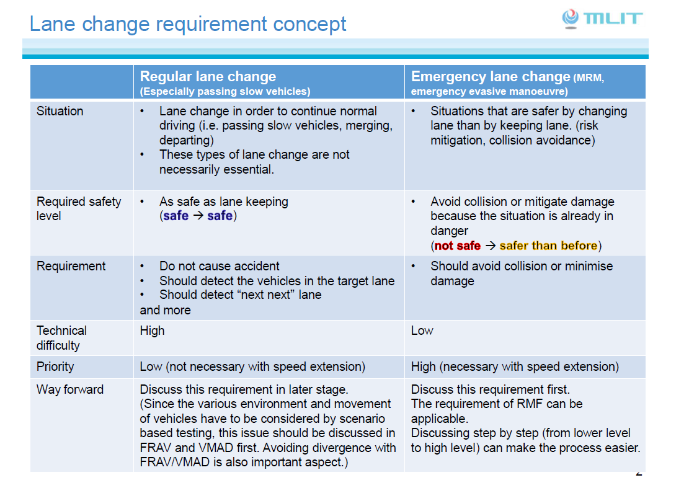
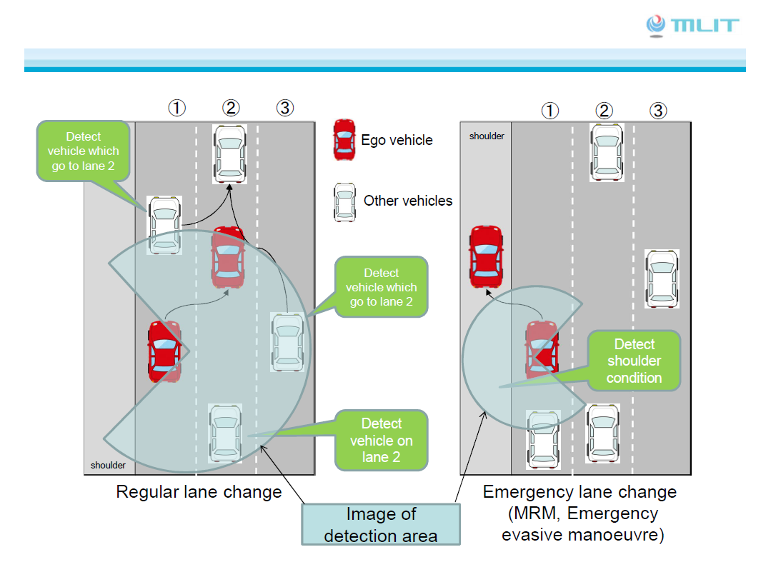

Note by the secretariat : GRVA calls this SIG the « Special Interest Group on UN Regulation No. 157 »

