Proposal of Supplement 2 to the 06 series of amendments to UN Regulation No. 22 (Protective helmets)

The integration to the current text of the working document **ECE/TRANS/WP.29/GRSP/2021/15 to complete the document and confirm limit value** are marked in bold for new or strikethrough for deleted characters.

**I. Proposal**

*New Paragraph 6.3.1.1.*, amend to read:

6.3.1.1. If an accessory has any component to be installed on the exterior of the helmet shell within any of the impact areas foreseen in this Regulation and those parts of the accessory have a thickness of more than **3** mm, the accessory shall be tested together with the helmet and the accessory becomes Specific accessory.

*New Paragraph 6.3.1.2.*, amend to read:

6.3.1.2. The helmet shall have some markings on the exterior of the helmet shell or any visible component to take them as a reference for the installation of the Universal accessories main external components.

The area where to fit the universal accessories shall grant at least **30 mm** of distance from any point of any impact affected area to the lower edge of the helmet shell (the lower rubber rim is considered to be helmet shell for this purpose).

*New Paragraph 6.3.1.5.*, amend to read:

6.3.1.5. If the helmet is prepared to fit speakers, the helmet shall have a dedicated space ~~in the inner EPS~~ of at least **41** mm diameter and a depth of at least **7** mm and be tested as well according to the tests foreseen in point 7.3. in the X point with the speakers simulators defined in Annex 20. In this case, the helmet will be marked as “S”.

*New Paragraph 6.19.6.3.*, amend to read:

6.19.6.3. The maximum weight of the accessory, including its support if any, shall be no more than **200 g.**

*New Paragraph 6.19.8.1.*, amend to read:

6.19.8.1. The material has to be flexible and of a maximum thickness of **2** mm or

*New Paragraph 7.13.4.*, amend to read:

7.13.4. Helmets marked as “UA” must be tested as well with each of the accessory simulators and/or a combination of them, the total weight of the accessories with which the helmet will be tested will not exceed **400g**. The tests done will be specified in the test report. The accessories simulators are defined in Annex 20, Part 3.

*Annex 8 - New figure 1d, amend to read:*

Example of a helmet simulator for accessories projections and surface friction (method B)



*New Annex 20, amend to read:*

Annex 20

Accessories assessment and clamping space dimensions for helmets

**Part 1. Accessories assessment**

1. Measurement of the maximum dimensions of externally fitted accessories:

For the measurement of the dimensions, only the accessory plus the support, if any, have to be measured. If the device is fitted with a foldable antenna, the system must fit in the fixture with the antenna in folded position. If the antenna is flexible, the antenna may exceed the fixture dimensions.

Flexible, thin components can exceed the volume or can be assembled separately on the shell.

1.1 For front mounted accessories:

Accessories must fit in the following fixtures dimensions:

Figure 1

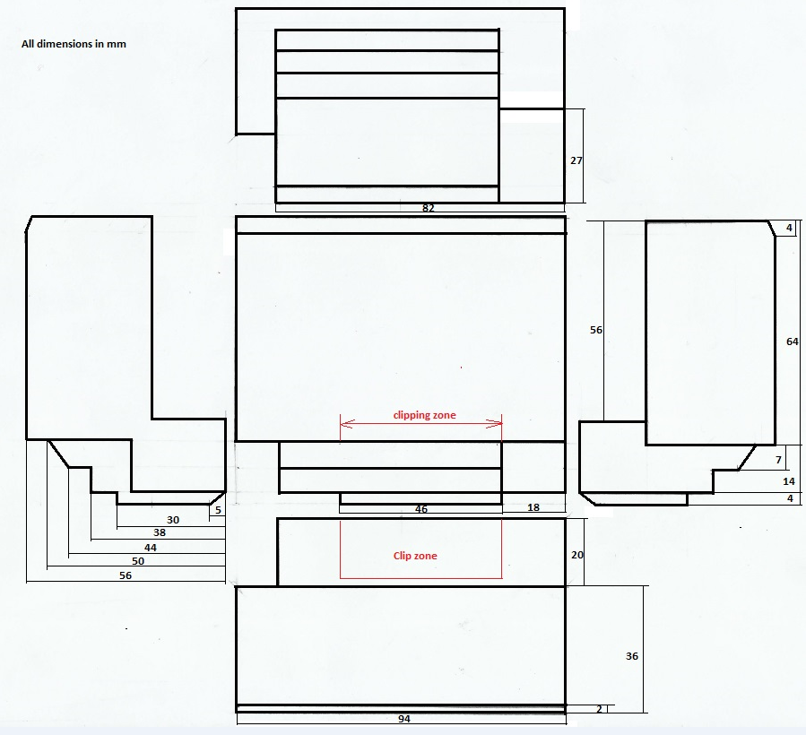

Fixture for left front- side mounting (for right side mounting apply symmetry)

VOLUME: 279,432 mm3

1.2 For side mounting accessories

Figure 2

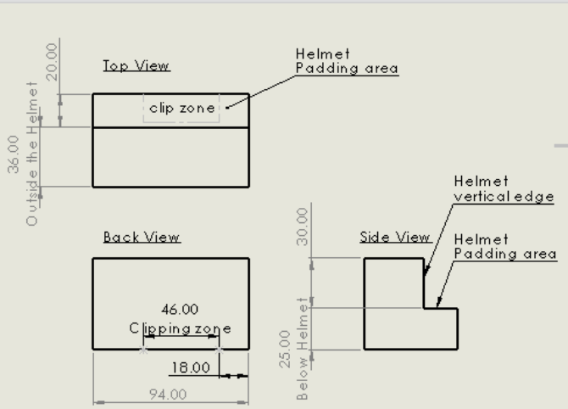.

Fixture for left side mounting (for right side mounting apply symmetry)

VOLUME: 233,120 mm3

1.3 For rear mounting accessories

Figure 3

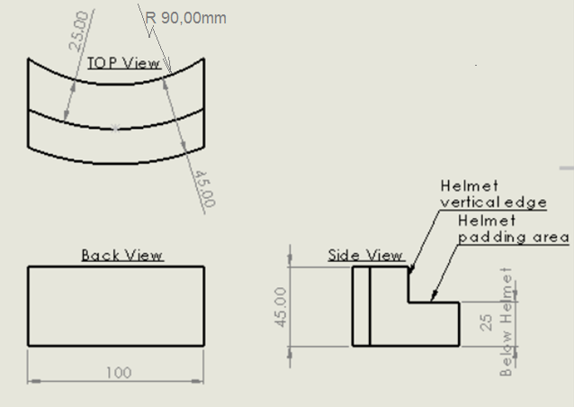

The rear mounting clamping solution offered by the accessories manufacturers will not invade the impact affected area.

VOLUME: 157,957 mm3

1. Maximum dimensions of speakers and microphones:
   1. Speakers

The speakers, measured without comfort cover, must be contained in a cylinder of **40** mm diameter and height **12** mm,.

Note: Speakers with diameter up to 45 mm shall be approved, as options, in order to be installed only on helmets specially approved up to this dimension.

* 1. Microphone

The microphone must be contained in a parallelepiped of the following dimensions:

Length: 35 mm

Width: 18 mm

Height (dimension from the chin protective padding towards the headform): 11,5 mm

The boom, if any, must be flexible and not have an external diameter of more than **8** mm

1. Mechanical characterization of the speakers:

**3.1. The speaker, with an height more than 8 mm, shall be placed between two parallel plates by means of which a known load can be applied, the surface of the plates shall be large enough to contain a circle of at least 65 mm in diameter. An initial load of 10 N shall be applied, the load shall then be increased at a minimum plates speed of 5 mm/min. until the application of a load of 1000 N (-0+10N).**

Example of curve

**3.2 Criteria**

**The height of the speaker when subjected to compression with a load of**

**1000 N (-0+10N) must be less than or equal to 8 mm.**

1. Speakers and microphone simulators for helmet testing
   1. Speaker simulator

The speaker simulator will be made from rigid plastic and will have a dimension of **40 mm (±0,5 mm)** diameter and **8** mm **(±0,5 mm)** thick.

**The helmet manufacturer can allow the possibility of the installation, in a compatible space, also of speakers with a diameter up to 45 mm, in this case the test shall be carried out with a simulator 45 mm (±0,5 mm) diameter and 8 mm (±0,5 mm) thick.**

**This possibility must be clearly indicated in the instructions to the user**

4.2. Microphone simulator

The microphone simulator will be made from rigid plastic and will have:

1. a parallelepipedal shape with the following dimensions:

Length: **35** mm **(±0,5 mm)** (horizontal transversal dimension)

Width: **18** mm **(±0,5 mm)** (vertical dimension)

Height: **11,5** mm **(±0,5 mm)** (horizontal longitudinal dimension)

**Part 2. Clamping space dimensions for helmets (OPTIONAL)**

1. The helmet clamping free space dimensions for front and side mounting will be, at least, the following ones

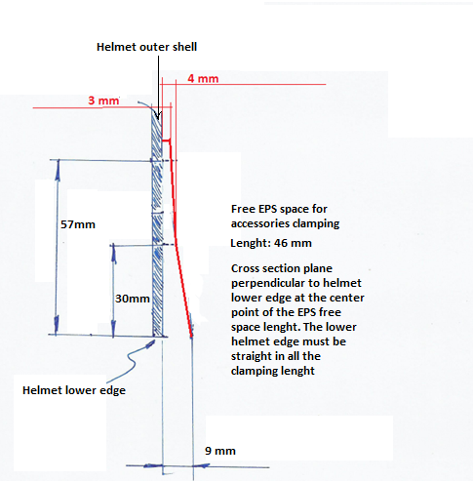

Length of clamping according to the fixture drawings

1. Helmet clamping free space dimensions for rear mounting

The helmet must allow the insertion of a flat metal sheet of **1** mm thickness, as one of the possible fixation systems for rear positioning of the accessories, between the EPS and the external shell.

**Part 3. Accessories simulators for the tests foreseen in 7.13**

The shape will be like the correspondent fixture depending on the helmet positioning and will have the following mass:

1. Front mounted accessories: **200 g (-0+10) g**
2. Side mounted accessories: **200 g (-0+10) g**
3. Rear mounted accessories: **200 g (-0+10) g**

Clamping/fixing of the simulator to the helmet can be done at the Technical Service discretion but method must be noted and filed within the test report. The clamping/fixing system together with the fixture must not exceed the target weight.

Note: Only for testing purposes the fixation of the simulator to the helmet with screws is acceptable

II. Justification

The proposed text integrates and completes document ECE/TRANS/WP.29/GRSP/2021/15, this integration is necessary to specify limit values and procedures left to define at the time of presentation of the working document.

This document had been prepared taking into account indications and information provided by the manufacturers of helmets and accessories and it is based on the outcomes of the tests completed on the most representative available communication accessories and the Helmets ready to be ECE 22.06 approved.

The test procedures and limit values proposed are based on a set of preliminary test activities established to investigate the performance of the products with the final aim to assess their compatibility and the validation of tests equipment and test procedures.

The tests had been completed in compliance with the test procedures stated in the ECE / ONU Regulation 22.06, evaluating the different possible configurations between helmets and accessories.

As base to define the limit to the rigidity of the speaker and the height of the test simulacrum the CEN technical report CEN/TR 16148:2011 (Head and neck impact, burn and noise injury criteria. A Guide for CEN helmet standards committees) has been considered.