Confirmation of GRSP on draft interpretation “one belt route” UN R129

Submitted by the expert from the Netherlands [1]*

The text reproduced below was prepared by the expert from the Netherlands, aiming to seek guidance and consistency on the way “one belt route” is to be interpreted. Discussion in line with Schedule 6 paragraph 1 of the 1958 Agreement Rev. 3.

**Issue**

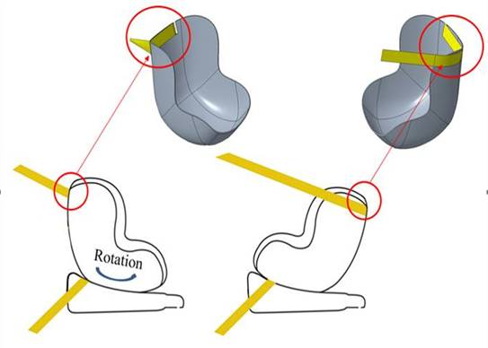

Paragraph 3.2.2. allows a convertible universal belted ECRS, provided there is only one belt route.

Is it acceptable that the belt route uses the same attachments/guidances when changing from forward to rearward facing orientation, but at the same time creating a slightly different belt route ?  
  
**Draft Interpretation Netherlands**

Not allowed; “one belt route” shall be strictly interpreted; only asymmetrical attachments can still be regarded “one belt route”.

**Background**

As discussed in the GRSP-IWG-CRS while setting up the new UN R 129, one important reason for the ‘one belt route’ requirement was to reduce the risk of misuse for ECRS’s which can be used in different orientations (e.g. a convertible ECRS which may be forward or rearward facing).

Quote draft minutes 65e meeting (2016):

* Misuse according to convertible ECRS regarding the switch between rearward facing orientation to forward facing orientation is a very essential point to have only one belt routing.

In document CRS-68-11e-GRP-2017-XX_129-03 the following text has been added:

* The belt route is the result of the combination of an ECRS to a specific seating position of the car.

There shall be only one belt route when a ECRS is installed to a specific seating position.

If the belt route has an asymmetrical layout, its mirror images of the belt routing are defined

as one belt routing.

When moving an ECRS from e.g. the left outboard seating position to the right outboard seating

position the actual route of the adult vehicle belt can be different. If these actual routes differ only

in symmetry, then these 2 actual routes are considered to be mirror images of the same belt route.

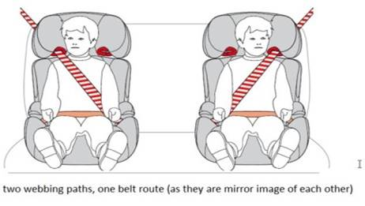

The above mentioned justification is not part of the current text in the Regulation, but can be seen as the basis for the “one belt route” provision”.

Because of this, NL decided that the shown concept does not conform to the definition of ‘one belt route’, since the belt routes in forward facing direction and rearward facing direction differ from each other and may result in misuse by the end user.

There are several alternatives which may be used to prevent misuse, e.g. by using a separate base in combination with a turn able seat shell. De base is installed using the 3-point belt and the turn able

seat shell can be used in both forward and rearward direction without having to re install the 3-point belt. (see example below)

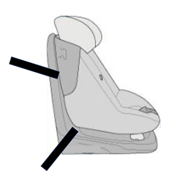

**Request**

1. Do other Contracting Parties to the 1958 Agreement agree with this draft interpretation ?
2. Is there a need to update the current Regulation text ?

For the Netherlands it is important to find consensus about this concept, in order to make sure that a decision about a concept which is not found acceptable by one Contracting Party, in this case the Netherlands, is supported by other Contracting Parties in order to prevent products developed using this concept do not find a back door to the market.

1. * In accordance with the programme of work of the Inland Transport Committee for 2006–2010 (ECE/TRANS/166/Add.1, programme activity 02.4), the World Forum will develop, harmonize and update Regulations in order to enhance the performance of vehicles. The present document is submitted in conformity with that mandate.