**Supporting document to GRE/2021/04**

# In document ECE/TRANS/WP.29/GRE/2021/4 (SIG): Proposal for a new 08 series of amendments to UN R48; “paragraph 6.19.7.5. new” is amended as follows:

# *"6.19.7.4****5.*** *~~The lamps referred to in paragraph 5.11. may be switched ON w~~****W****hen daytime running lamps are switched ON,**~~If this option is chosen~~****~~,~~*** *at least the rear position lamps shall be switched ON.* ***Other lamps may also be switched ON according to paragraph 5.11.***

***However, the rear position lamps and other lamps according to paragraph 5.11. may be switched OFF when the daytime running lamps are switched ON, and remain switched OFF as long as the following conditions are met:***

*•* ***[ambient light conditions outside vehicle are above 7,000 lux (measured according to the requirements of Annex 13).]****"*

In the above text the 7,000 lux is the criteria when the rear Position Lamps or other lamps according to paragraph 5.11 may be OFF. This requirement is still in square brackets and therefore need a decision by GRE.

To get a better understanding what 7,000 lux mean below you find pictures of landscapes in Sweden at illuminance of 370 lux, 1,600 lux and 2,700 lux.

These pictures show that the criteria of 7,000 lux is well chosen. As well as in Annex 13 7,000 lux is the criteria where Dipped-Beam Headlamps have to be switched OFF.

**Illuminance Measurements**

**In “Jokkmokk” a Municipality in Sweden**

**by VOLVO during winter driving tests**

**370 lux**

(Dawn; Clouds)



Fourth of February at 08:20

**1,600 lux**

(Dusk)



Third of February 2021, 2:45pm

**2,700 lux**

(Daytime; clouds)

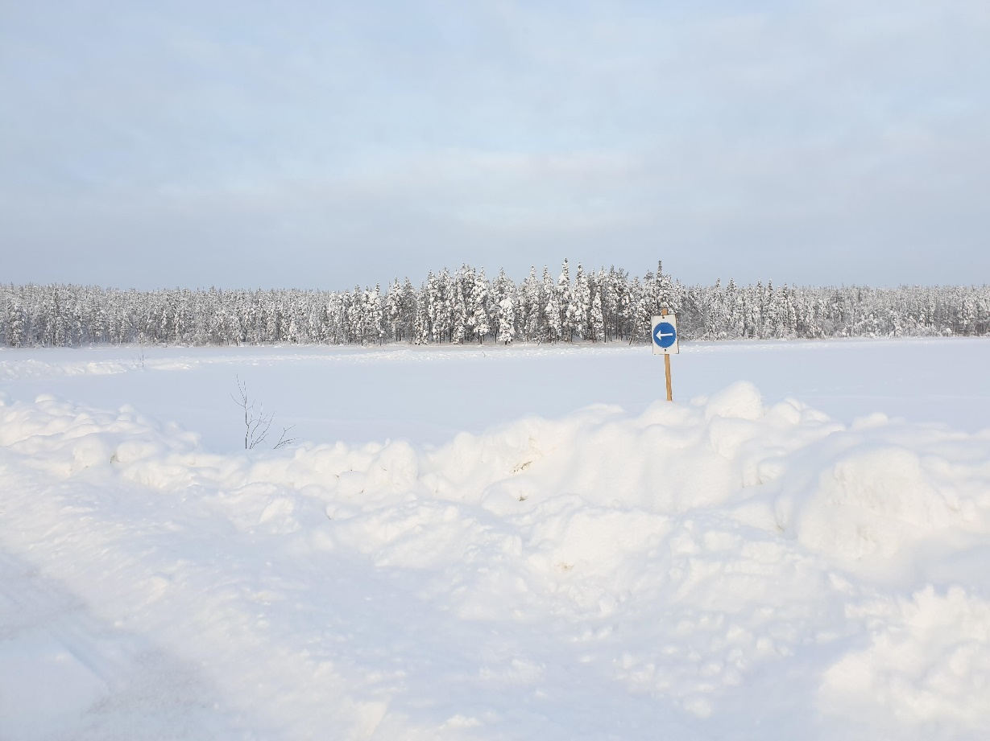

Fourth of February 2021, 12:30