E/ECE/324/Rev.2/Add.128/Rev.4/Amend.4−E/ECE/TRANS/505/Rev.2/Add.128/Rev.4/Amend.4
2 February 2021
Agreement
Concerning the Adoption of Harmonized Technical United Nations Regulations for Wheeled Vehicles, Equipment and Parts which can be Fitted and/or be Used on Wheeled Vehicles and the Conditions for Reciprocal Recognition of Approvals Granted on the Basis of these United Nations Regulations*
(Revision 3, including the amendments which entered into force on 14 September 2017)
_________
Addendum 128 – UN Regulation No. 129
Revision 4 - Amendment 4
Supplement 4 to the 03 series of amendments – Date of entry into force: 3 January 2021
Uniform provisions concerning the approval of Enhanced Child Restraint Systems used on board of motor vehicles (ECRS)
This document is meant purely as documentation tool. The authentic and legal binding text is: ECE/TRANS/WP.29/2020/58.
_________
UNITED NATIONS
Paragraph 5.3., amend to read:
"5.3. Notice of approval or of extension or refusal of approval of an Enhanced Child Restraint Systems pursuant to this Regulation shall be communicated to the Parties to the Agreement which apply this Regulation by means of a form conforming to the model in Annex 1 to this Regulation."
Paragraph 6.3.1.1., amend to read:
"6.3.1.1. The Enhanced Child Restraint System manufacturer shall declare in writing that the toxicity of materials used in the manufacture of restraint systems and accessible to the restrained child is in conformity with the test requirements of EN 71-3:2019, for a Category III material as defined in paragraph 4.2. Table 2 and following the test method of paragraph 7.2., specifically paragraph 7.2.2., Table 3, Category III sampling method. Tests confirming the validity of the declaration may be carried out at the discretion of the Technical Service. This paragraph does not apply to non-integral ECRS with a stature range of 100 cm or above."
Paragraph 6.3.2., amend to read:
"6.3.2. General characteristics
The manufacturer shall declare the maximum and minimum stature of the child that may use each configuration of the Enhanced Child Restraint System.
The stature range shall be verified by measuring the internal geometric characteristics according to paragraph 6.3.2.1., while the external dimensions are adjusted to fit within the applicable size envelope according to paragraph 6.3.2.2."
Paragraph 6.3.2.2.2., amend to read:
"6.3.2.2.2. Non-Integral Class Enhanced Child Restraint Systems
The maximum external dimensions for the width, height and depth of the Enhanced Child Restraint System and the locations of the ISOFIX anchorages system if any, with which its attachments shall engage, shall be defined by the i-Size booster seat fixture as defined in paragraph 2.17.2. of this Regulation.
(a) i-Size booster seat Enhanced Child Restraint Systems shall fit within the ISO/B2 size envelope;
(b) Specific vehicle booster seat Enhanced Child Restraint Systems shall fit:
(i) In vehicle(s) specified in a list; or
(ii) At least in one of ISO/B2 –ISO/B3 size envelope as described in Annex 17, Appendix 5 of UN Regulation No. 16.
When conducting this assessment, the non-integral Enhanced Child Restraint System shall be adjusted to accommodate children of 135 cm stature (height, depth and width dimensions as defined in Annex 18) or to the largest size of its declared stature range if the upper limit is below 135 cm. If the Non-integral Enhanced Child Restraint System is capable of being adjusted to different positions of seat surface inclination, the fitting assessment shall be done in at least one position. If other positions of inclination are outside the limits of the applicable size envelope, the user manual shall indicate that the child restraint may not fit in all approved vehicles when used in one of these positions. If the Non-integral Enhanced Child Restraint System has a declared stature range above 135 cm, and if it is necessary to adjust the child restraint outside the limits of the applicable size envelope for such adjustments (height, depth and width dimensions), the user manual shall indicate that the child restraint may not fit in all approved vehicles when used in one of these positions.
In such cases, an Enhanced Child Restraint System shall still be categorised as an i-Size booster seat for the entire declared stature range, including statures above 135 cm, provided it fits within the applicable size envelope when adjusted for a child of 135 cm stature. If the maximum child stature that fits within the envelope is less than 135 cm, the booster seat shall be categorised as specific vehicle for statures included in the declared range that no longer fit within the envelope."
Paragraph 6.6.4.3.1., amend to read:
"6.6.4.3.1. Injury assessment criteria for frontal and …
... | ... | ... | ... | ... | ... | ... | ... | ...
... | ... |  | ... | ... | ... | ... | ... | ...
Resultant head acceleration  3 ms | ... | ... | ... | ... | ... | ... | ... | ...
... | ... | ... | ...
... | ... | ...
Resultant chest acceleration 3 ms | ... | ... | ... | ... | ... | ... | ... | ...
... | ... | ... | ... | ...
... | ... | ... | ... | ... | ... | ... | ... | ...
…"
"6.6.4.4.1.1. Forward facing Enhanced Child Restraint Systems
Non-integral booster cushion: No part of the head of the dummy shall pass beyond the planes BA and DA as defined in Figure 1 below.
This shall be judged up to 300 ms or the moment that the dummy has come to a definitive standstill, whatever occurs first.
When testing using Q10 dummy the following apply:
(a) The value in relation to the BA plane is 550 mm; and
(b) The value in relation to the DA plane is 840 mm; and
(c) The rebound phase is not considered for the assessment of the plane DA.
(d) In case of dummy contact with a rigid part of the test bench in the rebound phase, the head acceleration criterion during that contact shall not be considered."
Paragraph 6.6.4.4.2., amend to read:
"6.6.4.4.2. When Enhanced Child Restraint Systems …, the head performance criterion (HPC) and the resultant head acceleration 3 ms shall be ... "
Paragraph 6.6.4.5.2., amend to read:
" 6.6.4.5.2. Additional injury assessment criteria for lateral impact

…
... | ... | ... | ... | ... | ... | ... | ... | ...
... | ... |  | ... | ... | ... | ... | ... | ...
Resultant head acceleration  3 ms | ... | ... | ... | ... | ... | ... | ...
... | ... | ... | ...
... | ... | ... | ...
... "
Paragraph 7.1.3., amend to read:
"7.1.3. Dynamic testing for frontal, rear and lateral impact:
- Frontal impact tests shall be performed on all Enhanced Child Restraint Systems within the scope of this regulation.
- Rear impact tests shall be performed on all Rearward and Lateral facing Enhanced Child Restraint Systems within the scope of this regulation;
- Lateral impact tests shall be performed on all Enhanced Child Restraint Systems within the scope of this regulation, except built-in systems and booster cushions;
- The ECRS shall ...
…"
Paragraph 8.1., amend to read:
" 8.1. The test report shall record the results of all tests and measurements including the following test data:
(a) …
…
(i) The following dummy criteria: HPC, Resultant head acceleration Cum 3 ms, Upper neck tension force, Upper neck moment, Resultant chest acceleration Cum 3 ms, Chest deflection, Abdominal pressure (in frontal and rear impact), and …"
Paragraph 9.2.2., amend to read:
"9.2.2. Dynamic tests for lateral impact
The monitoring of resultant head acceleration ... "
Annex 6-Appendix 2
Paragraph 2., amend to read:
"2. Enhanced Child Restraint Systems in the i-Size and specific vehicle categories shall use the following anchorage points: H₁ and H₂."
Annex 18., amend to read:
"Annex 18
Geometrical dimensions of Enhanced Child Restraint Systems
…
Table 1
Applicable to all ECRS |  |  |  |  |  |  | Additional internal dimensions for ECRS with impact shield systems
… | … | … | … | … | … | …
Figure 2
ECRS Measurement Device - Side and Front View of the measuring device
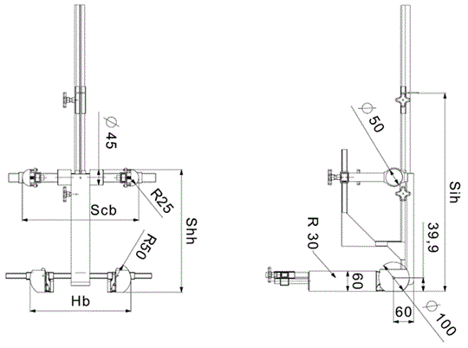
All dimensions in mm
Figure 3
Side and Front View of the measuring device for measurements applicable to Enhanced Child Restraint Systems that feature an impact shield
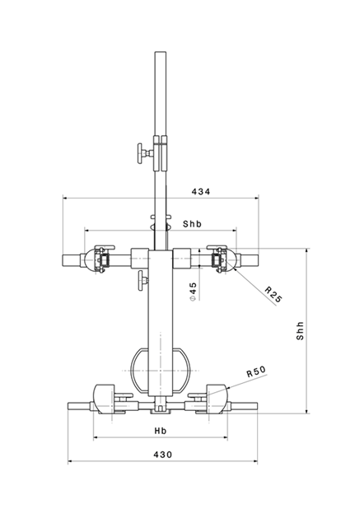 | 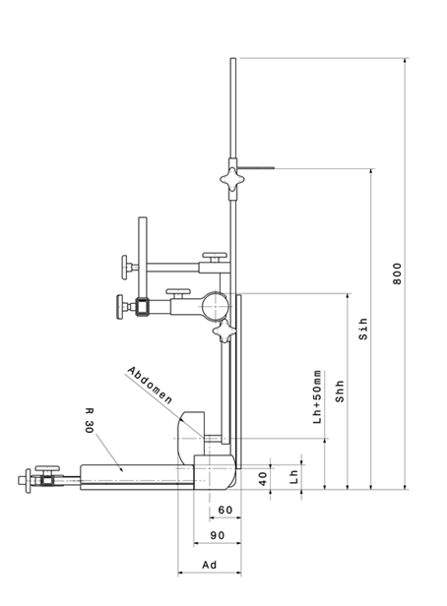
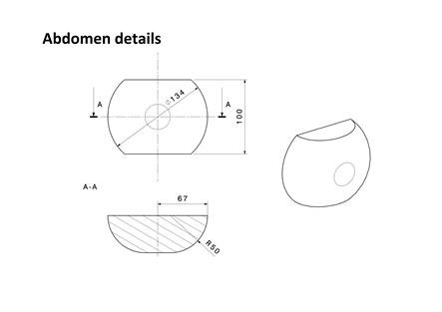
All dimensions in mm
Internal geometry assessment method
This method describes how to conduct the internal geometry assessment, as required by paragraph 6.3.2.1., to verify the stature range of the Enhanced Child Restraint System declared by the manufacturer.
This assessment shall be carried out for each of the following:
(a) For each ECRS orientation (e.g. rearward and forward facing);
(b) For each ECRS type (e.g. integral and non-integral);
(c) For any removable insert (e.g. for use as described by manufacturer’s instructions);
(d) For each occupant restraint method (e.g. harness and shield).
The internal geometry assessment should be conducted with the ECRS placed on a flat surface or connected to a base in the case of ECRS modules.
For integral or non-integral ECRS the device shown in Annex 18, Figure 2 shall be used.
For ECRS with an impact shield the device shown in Annex 18, Figure 3 shall be used.
The mass of the devices described in Figure 2 and Figure 3 shall be 10 kg +/- 1 kg.
1. Determining the Minimum Occupant size
The ECRS should be adjusted to fit the smallest occupant (i.e. headrest height, harness height adjustment, appropriate insert, internal padding, impact shield position), while still fitting within the required ISO volumetric envelope as defined in paragraph 6.3.2.2.
The measurement device shall then be placed in the ECRS. The device shall be aligned centrally to the ECRS.
All measurements shall be taken with the device base in contact with the seat pan of the ECRS and the device backrest in contact with the backrest of the ECRS. All lateral dimensions shall be measured under a contact force of 50 N with the devices described in Figure 2 and Figure 3 of this annex.
The measurements shall be taken in the following order:
1.1. Minimum Shoulder Height (E1)
…
1.1.2. For non-integral ECRS
This measurement shall be taken when the top of the shoulder height cylinders of the device are aligned without interference with the lowest part of the headrest. A 2 cm tolerance may be subtracted from the minimum shoulder height measurement.
1.1.3. For ECRS with an impact shield
This measurement shall be taken when the top of the shoulder height cylinders of the device are aligned without interference with the lowest part of the headrest. A 2 cm tolerance may be subtracted from the minimum shoulder height measurement.
…
2. Determining the Maximum Occupant Size
The measurement … to the ECRS.
All measurements shall be taken with the device base in contact with the seat pan of the ECRS and the device backrest in contact with the backrest of the ECRS. All lateral dimensions shall be measured under a contact force of 50 N with the devices described in Figure 2 and Figure 3 of this annex.
The measurements shall then be taken in the following order:
…"
Annex 23
Paragraph 3, amend to read:
"3. The retracting belt shall be fitted to the anchorages on the test bench, described in Annex 6, Appendix 2 as follows:
(a) Belt anchorage A1 shall be fitted to trolley anchorages B0 (outboard);
(b) Belt anchorage A2 shall be fitted to trolley anchorage A (inboard);
(c) Belt pillar loop P shall be fitted to trolley anchorage C;
(d) Belt retractor R shall be fitted to trolley anchorage such that the spool centre line is positioned on Re.
The value of X in Figure 1 below is 200 ± 5 mm. The effective strap length between A1 and the centre line of the retractor spool Re (when the webbing is fully extracted including the minimum length of 150 mm for testing of Enhanced Child Restraint System) shall be 2,820 ± 5 mm when measured in a straight line without load and on a horizontal surface. With the Enhanced Child Restraint System installed, there shall be a minimum of 150 mm of strap length on the retractor spool".

* Former titles of the Agreement: Agreement concerning the Adoption of Uniform Conditions of Approval and Reciprocal Recognition of Approval for Motor Vehicle Equipment and Parts, done at Geneva on 20 March 1958 (original version); Agreement concerning the Adoption of Uniform Technical Prescriptions for Wheeled Vehicles, Equipment and Parts which can be Fitted and/or be Used on Wheeled Vehicles and the Conditions for Reciprocal Recognition of Approvals Granted on the Basis of these Prescriptions, done at Geneva on 5 October 1995 (Revision 2).

