Submitted by the expert from the  Republic of Korea | Informal document GRVA-09-36  9th GRVA, 1-5 February 2020  Agenda item 8(a)

Proposal for amendments to UN GTR No. 8 (Electronic Stability Control)
The text reproduced below was prepared by the expert from the Republic of Korea, proposing to amendments to UN GTR No. 8 (Electronic Stability Control (ESC)). This proposal is based on the Working document (ECE/TRANS/WP.29/GRVA/2020/34) and Informal document (GRVA-07-64).
The modifications to the existing text of the Regulation are marked in bold for new, and strikethrough for deleted characters.
I. Proposal
Paragraph 5., amend to read:
5. Performance Requirements.
During each test performed under the test conditions of paragraph 6. and the test procedure of paragraph 7.9., the vehicle with the ESC system engaged shall satisfy the directional stability criteria of paragraphs 5.1. and 5.2., and it shall satisfy the responsiveness criterion of paragraph 5.3. during each of those tests conducted with a commanded steering wheel angle of 5A or greater (but limited as per paragraph 7.9.4.), where A is the steering wheel angle computed in paragraph 7.6.1.
Notwithstanding the above, the responsiveness criterion is deemed to be satisfied also for systems where the maximum operable steering wheel angle defined in paragraph 7.9.4. and the lateral displacement prescribed in paragraph 5.3. are achieved at a commanded steering wheel angle less than 5A.
Paragraph 7.9.4., amend to read:
7.9.4. The steering amplitude of the final run in each series is the greater of 6.5 A or 270 degrees, provided the calculated magnitude of 6.5 A is less than or equal to 300 degrees. If any 0.5 A increment, up to 6.5 A, is greater than 300 degrees, the steering amplitude of the final run shall be 300 degrees.
If the above calculated steering amplitude of the final run is greater than the maximum operable steering wheel angle determined by design of the steering system, the final angle amplitude for the series test shall be greater than 98 per cent of the maximum operable angle. However if the automated steering machine fails to complete Sine with Dwell Test due to the mechanical limit of steering equipment during the final angle amplitude for the series test, the final angle amplitude for the series test may be greater than 98 per cent of the maximum operable angle.
II. Justification
1. For ESC test, the final steering wheel angle amplitude is fixed between 270 and 300 degrees, which are absolute values, not the normalized angles that exclude the influence of the steering gear ratio of each vehicle. The vehicle equipped with low geared steering system (i.e. quick steering characteristics) cannot compliant with the ESC regulation because their operable steering wheel angle is less than 270 degrees. For such a vehicle, the final steering wheel angle amplitude for the series of tests could be decided to be the maximum operable steering wheel angle of the steering system if the maximum operable angle is less than 270 degrees.
2. When carrying out the ESC test, the Steering robot should necessarily be used for the ESC test in accordance with “6.3.5. Automated steering machine. A steering machine programmed to execute the required steering pattern shall be used in paragraphs 7.5.2., 7.5.3., 7.6. and 7.9. The steering machine shall be capable of supplying steering torques between 40 to 60 Nm. The steering machine shall be able to apply these torques when operating with steering wheel velocities up to 1,200 degrees per second” of UN GTR No. 8.
3. For the final angle for the series test which have significantly low steering gear ratio, overshoots are likely to occur. ESC tests of 53 vehicle data show up to 2% overshoots.
4. It could be addressed to a specific use case for ESC test which have significantly low steering gear ratio. It gives the opportunity to adjust the 98 per cent of the maximum operable steering angle only when an overshoot occurs. The overshoot results in excessive moments due to the mechanical limit of steering equipment and causes the steering robot not to complete command input, so the steering robot could stop. Therefore, the final angle should be inputted over 98 per cent of the maximum operable steering angle in order to solve this problem.

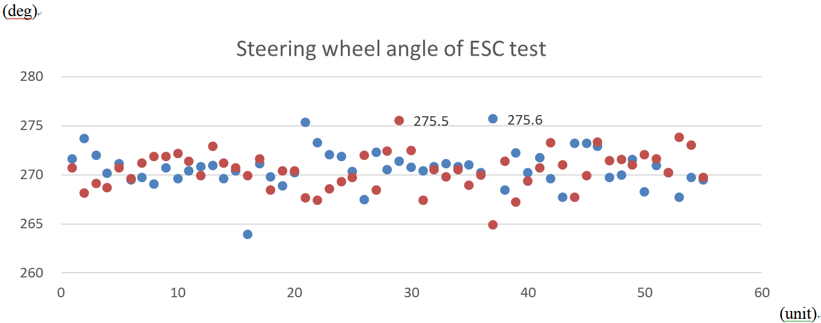

Robot specifications :
- Max Torque : 70Nm at 1,300degree/sec
- Resolution : 0.0006 degree
- Initial Calibration : “Home” mode / “steering zeroing(Straight Drive)” mode





