Proposal for amendments to ECE/TRANS/WP.29/GRVA/2021/9
(Proposal for a Supplement to the 03 series of amendments to UN Regulation No. 79 (Steering equipment)).

This document reflects the outcomes of the discussions held on 28 January 2021 during the workshop organized by Industry on Assistant systems (UN R79). The changes proposed to document GRVA/2021/9 are indicated in blue.

I. Proposal
Paragraph 5.6.4.1.2, amend to read:
5.6.4.1.2. When the ACSF of Category C is in activated (standby mode,) the ACSF of Category B1 shall aim to centre the vehicle in the lane, unless a different position in lane is deemed reasonable due to the situation or resulting from driver input (e.g. when another vehicle is driving close beside).
This shall be demonstrated by the vehicle manufacturer to the Technical Service during type approval.
Paragraph 5.6.4.2.3., amend to read:
5.6.4.2.3. The system shall …
… These conditions shall be ensured by the use of at least two independent means.
In the case of a transition from a road type with a classification permitting an ACSF of Category C, to a type of road where an ACSF of Category C is not permitted, the system shall be deactivated automatically (off mode), unless a missing second lane in driving direction is the only condition not fulfilled from the above (e.g. a connector between two highways).
Paragraph 5.6.4.3., amend to read:
5.6.4.3. Overriding
A steering input by the driver shall override the steering action of the system. The steering control effort necessary to override the directional control provided by the system shall not exceed 50 N.
The system may remain active activated (standby mode) (active mode) provided that priority is given to the driver during the overriding period.
Paragraph 5.6.4.7., amend to read:
5.6.4.7. Critical situation
A situation is deemed to be critical when, at the time a lane change manoeuvre starts, an approaching vehicle in the target lane would have to decelerate at a higher level than 3m/s², 0.4 seconds after the lane change manoeuvre has started, to ensure the distance between the two vehicles is never less than that which the lane change vehicle travels in 1 second.
The resulting critical distance at the start of the lane change manoeuvre shall be calculated using the following formula:
S_{critical} = (v_{rear} - v_{ACSF}) * t_{B} + (v_{rear} - v_{ACSF})² / (2 * a) + v_{ACSF} * t_{G}
Where:
v_{rear} is The actual speed of the approaching vehicle or 130 km/h whatever value is lower
v_{ACSF} is The actual speed of the ACSF vehicle
a = 3 m/s² (Deceleration of the approaching vehicle)
t_{B} = 0.4 s (Time after the start of the lane change manoeuvre at which the deceleration of the approaching vehicle starts)
t_{G} = 1 s (Remaining gap of the vehicles after the deceleration of the approaching vehicle).
[A tolerance of 10 per cent may be applied to the critical distance. The application of this tolerance may lead the distance between the two vehicles at the time the lane change manoeuvre starts to be lower than the critical distance resulting from the formula above.]
Annex 8,
Paragraph 2., amend to read:
2. Testing conditions
The tests shall be performed on a flat, dry asphalt or concrete surface affording good adhesion. The ambient temperature shall be between 0 °C and 45 °C.
At the request of the manufacturer and with the agreement of the Technical Service, tests may be performed under deviating conditions, if the correct function of the system under the prescribed test conditions can be assumed.”
At the request of the manufacturer and with the agreement of the Technical Service tests may be conducted under deviating test conditions (suboptimal conditions, e.g. on a not dry surface; below the specified minimum ambient temperature), whilst the performance requirements are still to be met."

Paragraph 3.5.1.2., amend to read:
3.5.1.2. The requirements of the test are fulfilled if:
(a) The lateral movement towards the marking does not start earlier than 1 second after the lane change procedure was initiated,
(b) The lateral movement to approach the lane marking and the lateral movement necessary to complete the lane change manoeuvre are completed as one continuous movement,
[…]
(j) The direction indicator is deactivated not before the end of the lane change manoeuvre and no later than 0.5 seconds after ACSF of Category B1 has resumed, in case the lateral movement is initiated automatically and the direction indicator control was not fully engaged (latched position) during the lane change manoeuvre.
II. Justification
A. Lane centering (paragraph 5.6.4.1.2.)
1. The suggested change aims to align with the principle agreed for Automated Lane Keeping Systems (ALKS), where the aim of this provision is to achieve stable vehicle behaviour and not necessarily that vehicle is centered in the lane at all times. When the driver adapts the position to a vehicle driving close by in an adjacent lane or drives with an offset to avoid lane ruts, centering the vehicle in lane would not be the appropriate ACSF of Category B1 control strategy.
B. Activation conditions (paragraph 5.6.4.2.3.)
2. When changing from one highway to another, where the road e.g. temporarily changes down to one lane, the ACSF of Category C should be permitted to remain in stand-by, because having to reactivate ACSF of Category while ACSF of Category B1 remains active would not be understandable to the driver.
C. Overriding (paragraph 5.6.4.3.)
3. The original provision contradicts itself, as it refers to the system remaining in standby mode, under the precondition that priority is given to the driver. During standby mode the system would not be allowed to provide any support, so there wouldn’t be any need to require priority to the driver. The proposal aims at clarifying that the Lane Change Procedure may remain active, provided that priority is given to the driver.
D. Tolerance for the Critical Situation (paragraph 5.6.4.7.)
Industry to improve their arguments and justifications for convincing the authorities about the need for tolerances in this case.
4. The amendment aims to recognized that the distance between the lane change vehicle and a vehicle from the rear is predicted as the lane change vehicle approaches the lane marking. A change in dynamic behaviour (e.g. acceleration, deceleration) of the lane change vehicle or the vehicle approaching from the rear as well as tolerances in speed detection can result in the real distance deviating slightly from the prediction. If a tolerance was permitted, the ACSF of Category C would not need to leave as large a safety margin in order to ensure to never fall below the minimum value, which would permit finding suitable gaps more easily.
5. The following calculations show that the proposed tolerance does not significantly increase the criticality of the scenario.
(a) Critical Distance [m] according to the formula of par. 5.6.4.7.:
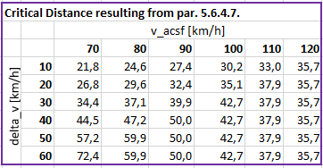
(b) Comparison of the minimum distance [m] resulting from applying 10 per cent tolerance to the critical distance (yellow, left) or permitting 10 per cent tolerance to the remaining distance tg (red, right)
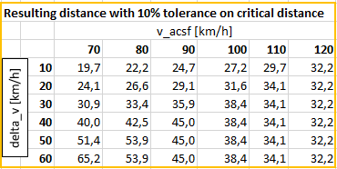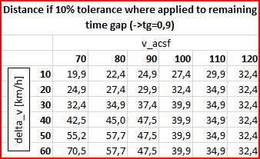

(c) Even if the critical distance is cut short by 10 per cent, the required deceleration [m/s²] of an approaching vehicle in order to ensure a remaining distance to 0.9s doesn’t significantly change.

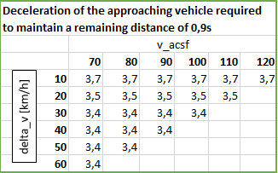

(d) And at all times, even if the critical distance is cut short by 10 per cent, collision avoidance can be ensured by very light braking of the approaching vehicle
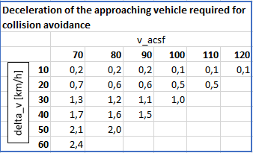
E. Other test conditions (Annex 8, paragraph 2.)
6. This amendment aims to carry over the amendment to UN Regulation No. 79, ACSF of Category B1 already adopted at the fourth session of the Working Party on Automated/Autonomous and Connected Vehicles (GRVA), which read “At the manufacturer's discretion and with the agreement of the Technical Service, a lane with a width of less than 3.5 m may be used, if the correct function of the system on roads with wider lanes can be demonstrated.”, to the other test conditions as well.
7. In order to ensure type approval testing also during the winter months it should be possible to test vehicles also on wet surfaces or at lower temperatures.
F. Pass condition with regard to direction indicator deactivation (Annex 8, paragraph 3.5.1.2. (j))
8. This amendment aims to amend the pass condition with regard to direction indicator deactivation according to the amended provisions on direction indicator deactivation as adopted at fifth session of GRVA, where automatic deactivation is only required when the LCM is initiated automatically and the direction indicator wasn’t fully latched.

