|  |  |  |  |
| --- | --- | --- | --- |
|  | United Nations | ECE/TRANS/WP.29/GRVA/2021/17 | |
| _unlogo | **Economic and Social Council** | | Distr.: General  20 November 2020  Original: English |

**Economic Commission for Europe**

Inland Transport Committee

**World Forum for Harmonization of Vehicle Regulations**

**Working Party on Automated/Autonomous and Connected Vehicles**

**Ninth session**

Item 4 (d) of the provisional agenda

**Automated/autonomous and connected vehicles:  
UN Regulation on Automated Lane Keeping System**

Proposal for amendments to the draft UN Regulation on uniform provisions concerning the approval of vehicles with regards to Automated Lane Keeping System

Submitted by the experts from France[[1]](#footnote-2)\*

The text reproduced below was prepared by the expert from France. It is based on informal document GRVA-07-37. Modifications to the current text of the adopted Regulation (ECE/TRANS/WP.29/2020/81) are marked in bold for new or strikethrough for deleted characters.

I. Proposal

*Insert a new paragraph 9.3.3.,* to read:

**9.3.3. If the manufacturer implements an alternative software identification system, the manufacturer shall demonstrate that the requirements of paragraphs 9.3.2.1. and 9.3.2.3. are met.**

*Insert a new paragraph 9.3.3.1.,* to read:

**9.3.3.1. The vehicle manufacturer shall provide the following information in the communication form of this Regulation:**

**(a) The reference of the alternative software identification system;**

**(b) The process to access software versions identification related data.**

*Paragraph 9.3.3.,* renumber as *paragraph 9.3.4.*

*Annex 1, insert a new item 20.,* to read:

**20. Alternative software identification system**

**20.1. Reference of the alternative software identification system**

**20.2. Process to access software versions identification related data**

**20.3. If applicable, list the relevant parameters that will allow the identification of those vehicles that can be updated with the software represented by the alternative software identification system under item 20.1.**

II. Justification

1. In the context of software update Regulation and its first referencing in UN Regulation No. [157], the Working Party on Automated/Autonomous and Connected Vehicles (GRVA) agreed that the vehicle manufauctuer can choose to use a software identification system that differs from the RxSWIN. The proposal above aims to introduce the same level of requirements independently from the identification system chosen and to introduce additional details to clarify the application for Type Approval Authorities and Technical Services in case an alternative software identification system is implemented.

2. This proposal is submitted together with the corresponding amendment proposal to UN Regulation No. [156].

Figure 1

**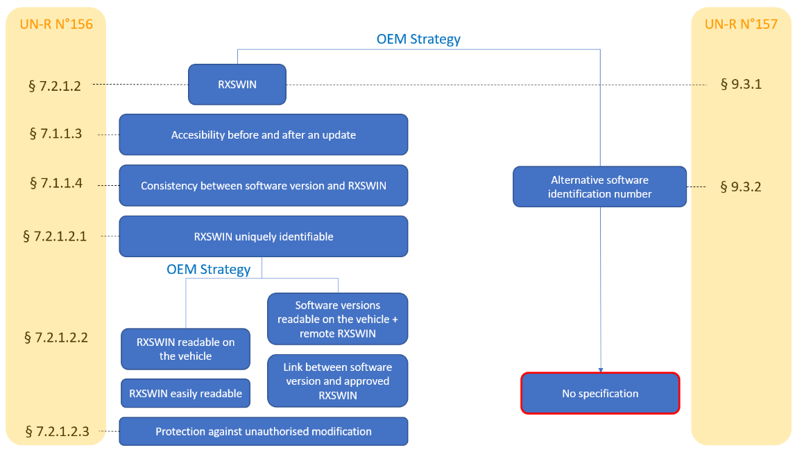Paragraph correspondence between UN Regulations Nos [156] and [157]**

1. \* In accordance with the programme of work of the Inland Transport Committee for 2021 as outlined in proposed programme budget for 2021 (A/75/6 (Sect.20), para 20.51), the World Forum will develop, harmonize and update UN Regulations in order to enhance the performance of vehicles. The present document is submitted in conformity with that mandate. [↑](#footnote-ref-2)