**Workshop**

**“Sustainable urban transport and mobility:**

**Policies and practices on the basis of UNECE Environmental Performance Reviews”**

***Budva, Montenegro, 18-19th June 2019***

**SDGs boxes related to transport and environment**

This document contains selected SDGs boxes related to transport and environment in the EPRs of Albania, Bosnia and Herzegovina and North Macedonia.

.

# ALBANIA

(Third EPR, 2018, excerpt of SDGs boxes related to transport and environment)

**CHAPTER 2: GREENING THE ECONOMY**

**Excerpt from Box 2.3: Target 12.c of the 2030 Agenda for Sustainable Development**

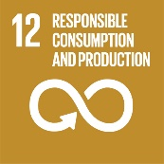

**Goal 12: Ensure sustainable consumption and production patterns**

**Target 12.c: Rationalize inefficient fossil-fuel subsidies that encourage wasteful consumption by removing market distortions, in accordance with national circumstances, including by restructuring taxation and phasing out those harmful subsidies, where they exist, to reflect their environmental impacts, taking fully into account the specific needs and conditions of developing countries and minimizing the possible adverse impacts on their development in a manner that protects the poor and the affected communities**

Studies conducted on the whole Western Balkan region show that fossil fuel subsidies in Albania are relatively modest. Some indirect disincentives to minimize externalities from transportation have been linked to the importation of used vehicles and low level of taxation, justified as social measures.

The Government did not issue a comprehensive, updated list of existing fossil fuel subsidies and does not directly address the topic.

A list of formal subsidies can be delivered based on the scattered initiatives undertaken by the former Ministry of Energy and Industry. Power sector subsidies to be eliminated by 2020 in Albania mainly apply to hydropower, which is the main source of energy in the country.

In general, the level of direct subsidies in the country is already low, which is also due to the strict financial constraints on public budgets. The macroeconomic conditions of the country, as well as the actions envisaged by the country's main strategies, do not provide for a significant amount of subsidies of any type to be supplied; therefore, at the moment no negative evolution is foreseeable in the sector.

The Ministry of Infrastructure and Energy could set up an expert group to prepare a list of subsidies. Based on the list, the Government should collect country-level data on environmentally harmful subsidies and assess the country’s performance. The Government should give more attention to the foundations of a green economy model, by dedicating public officials to the analysis and implementation of measures striving for resource efficiency, sustainable investments and the economic and social sustainability of environmental policies.

**CHAPTER 6: AIR PROTECTION**

**Box 6.2: Targets 3.9 and 11.6 of the 2030 Agenda for Sustainable Development**

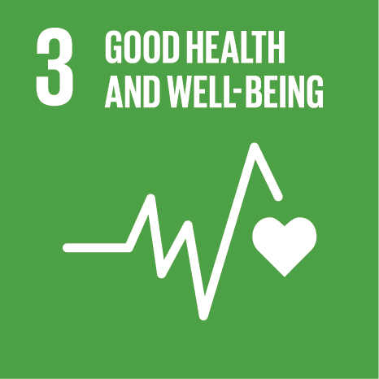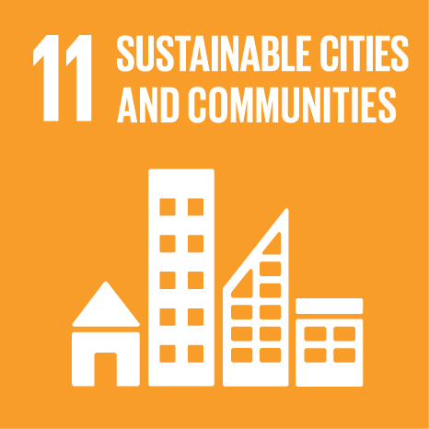

**Goal 3: Ensure healthy lives and promote well-being for all at all ages**

**Target 3.9: By 2030, substantially reduce the number of deaths and illnesses from hazardous chemicals and air, water and soil pollution and contamination**

Under Goal 3: Ensure healthy lives and promote well-being for all at all ages, countries should substantially reduce the number of deaths and illnesses from air pollution (target 3.9). The target is measured by, among other indicators, the mortality rate attributed to household and ambient air pollution. This indicator is not currently in use in Albania.

The 2014 national health report "Albanian population health status" highlights that the health risk from indoor air pollution was substantially reduced in Albania between 1990 and 2010. However, in 2010, this risk factor was still responsible for 6.4 per cent of the total burden of disease in Albania. There was similar reduction of the burden of disease due to environmental pollution by particulate matter, which, in 2010, was responsible for 3.4 per cent of the total burden of disease. In 2012, air quality levels for Tirana were, on more than two occasions, in excess of the WHO Air Quality Guidelines, and therefore it was estimated that each year 500 deaths in the city can be attributed to air pollution.

The most recent data on deaths attributed to bad air quality in Albania comes from a global assessment of exposure and burden of disease related to ambient air pollution (WHO 2016). It is estimated that air pollution in Albania causes 1,842 premature deaths (64 per 100,000 inhabitants), while some 2,740 deaths can be attributed to household (indoor) air pollution.

In order to reduce the number of deaths and illnesses from air pollution, air quality should be improved, but it is also important to regularly assess the impact of air pollution on public health. Therefore, the IPH has to strengthen its cooperation with WHO and develop sufficient expertise for monitoring the impact of air quality on public health, rather than monitoring air quality itself. Particular attention should be given to indoor air pollution, which has the same severe impact on health. This very important role of the IPH is currently not reflected in the legal and policy framework related to air quality.

**Goal 11: Make cities and human settlements inclusive, safe, resilient and sustainable**

**Target 11.6: By 2030, reduce the adverse per capita environmental impact of cities, including by paying special attention to air quality and municipal and other waste management**

Nowadays, more than half the population on the planet lives in cities. Under Goal 11, countries should reduce the adverse per capita environmental impact of cities, including by paying special attention to air quality. Annual mean levels of fine particulate matter in cities should serve as an indicator.

**Figure 6.5: Annual mean concentrations of PM10 in selected cities, 2016, µg/m3**



*Source*: National Environment Agency, 2017.

Figure 6.5 shows that PM10 concentrations in all cities in Albania, except in Shkodër, exceeded the WHO annual mean recommended value (20 µg/m3) in 2016, while concentrations in Tirana exceeded the EU and Albanian annual limit value of 40 µg/m3. The National Inventory on Air Emissions shows that 74 per cent of PM10 emissions in 2015 came from residential stationary plants. The reduction of PM10 concentrations in urban areas can be achieved through implementation of measures recommended in the draft AQMP related to the energy efficiency of buildings and heating systems, as well as measures related to the contribution of road transport, which was 7 per cent in 2015.

**CHAPTER 10: TRANSPORT AND ENVIRONMENT**

**Excerpt from Box 10.1: Targets 3.6, 9.1 and 11.2 of the 2030 Agenda for Sustainable Development**

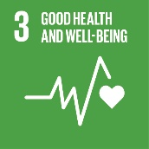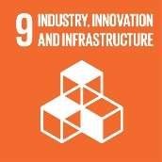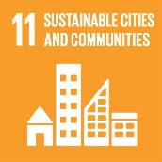

**Goal 3: Ensure healthy lives and promote well-being at all ages**

**Target 3.6: By 2020, halve the number of global deaths and injuries from road traffic accidents**

Albania is focusing attention on road safety and has adopted the same target as set out in the UN Decade of Action (equal to the SDG) to halve the number of deaths by 2020. In 2010, there were 353 fatalities, which means that, for this target to be achieved, the number of deaths should have fallen below 177 by 2020. In 2016, there were 269 fatalities, a fall of about 25 per cent from 2010. Therefore, although there have been significant improvements in road safety, there is still significant work that needs to be done to reach the target set for 2020. In terms of injuries, the picture is considerably worse, as they have actually increased by almost 50 per cent between 2010 and 2016. The implementation of policies aimed at reducing bad driving behaviour, and their enforcement, as well as the introduction of suitable safe vehicles and infrastructure, will be fundamental to ensuring that the targets can be achieved.

**Goal 9: Build resilient infrastructure, promote inclusive and sustainable industrialisation and foster innovation**

**Target 9.1: Develop quality, reliable, sustainable and resilient infrastructure, including regional and transborder infrastructure, to support economic development and human well-being, with a focus on affordable and equitable access for all**

Albania, in cooperation with a number of international donors, is improving transport infrastructure. Investments cover road, rail, maritime and airport infrastructure. These investments are aimed at improving national and international connectivity as well as improving access for the population and for business. Municipalities are also seeking to invest in sustainable infrastructure by building cycle lanes and bus lanes and improving railway lines (both within cities and on the national level). This is being coupled with an increase in the focus of transport policy aimed at improving multimodal transport. To date, however, the infrastructure shortfall is significant across the transport sectors (with the possible exception of aviation), given the size of the country, and the focus of activities needs to be on both improving national links and developing international links to facilitate regional integration.

**Goal 11: Make cities and human settlements inclusive, safe, resilient and sustainable**

**Target 11.2: By 2030, provide access to safe, affordable, accessible and sustainable transport systems for all, improving road safety, notably expanding public transport, with special attention to the needs of those in vulnerable situations, women, children, persons with disabilities and older persons**

Albania has put in place a strategy to improve road safety. It is also investing at a local and national level in public transport. A draft sustainable transport plan has been prepared with the aim of improving the environmental impact of the sector and facilitating the use of public transport across the country.

# BOSNIA AND HERZEGOVINA

(Third EPR, 2018, excerpt of SDGs boxes related to transport and environment)

**CHAPTER 7: AIR PROTECTION**

**Box 7.3: Targets 3.9 and 11.6 of the 2030 Agenda for Sustainable Development**



**Goal 3: Ensure healthy lives and promote well-being for all at all ages**

**Target 3.9: By 2030, substantially reduce the number of deaths and illnesses from hazardous chemicals and air, water and soil pollution and contamination**

**Indicator 3.9.1: Mortality rate attributed to household and ambient air pollution**

For Bosnia and Herzegovina, the annual mortality rate (per 100,000 people) attributed to household and ambient air pollution is estimated by the World Health Organization at 223.6 in 2012 (World Health Statistics, 2016), which is one of the highest mortality rates by air pollution in the world. Air pollution by particulate matter (PM) is the most dangerous factor, but other components (NO2, SO2, PAH, O3) also contribute. By reducing air pollution levels, Bosnia and Herzegovina can reduce the burden of disease from stroke, heart disease, lung cancer and chronic and acute respiratory diseases such as asthma.

In Bosnia and Herzegovina, the WHO Air Quality Guidelines, as well as the less-stringent EU Air Quality Standards, are often largely exceeded in some urban areas. To reduce the mortality rate to the mean European level, substantial measures to reduce air emissions from industry, traffic, households and services are necessary. For large combustion plants, a (draft) national emission reduction plan was set up with clear targets for the reduction of emissions of SO2, NOx and dust. As a preparation for future ratifications of protocols under the CLRTAP, emission reduction plans for other sectors should be made.

**Goal 11: Make cities and human settlements inclusive, safe, resilient and sustainable**

**Target 11.6: By 2030, reduce the adverse per capita environmental impact of cities, including by paying special attention to air quality and municipal and other waste management**

**Indicator 11.6.2: Annual mean levels of fine particulate matter (e.g. PM2.5 and PM10) in cities (population weighted)**

The WHO Air Quality Guideline for the annual mean concentration of PM10 is exceeded in many cities in Bosnia and Herzegovina, as is the EU Air Quality Standard. Results from a few stations are shown in figure.7.1.

**Figure 7.1: Annual mean concentration of PM10, 2015, µg/m3**

*Source*: Air Quality Report for the Federation of Bosnia and Herzegovina for 2015. Air Report for Republika Srpska for 2015, 2016.

*Note*: WHO Air Quality Guideline: 20 µg/m3; EU Air Quality Standard: 40 µg/m3

Exceedances of the WHO Air Quality Guideline for PM2.5 in Tuzla and Lukavac are shown in figure 7.2.

**Figure 7.2: Annual mean concentration of PM2.5, 2015, µg/m3**



*Source*: Air Quality Report for the Federation of Bosnia and Herzegovina for 2015.

*Note*: WHO Air Quality Guideline: 10 µg/m3. There is no EU Air Quality Standard for PM2.5.

# NORTH MACEDONIA

(Third EPR, 2019, excerpt of SDGs boxes related to transport and environment)

**CHAPTER 3: GREENING THE ECONOMY**

**Excerpt from Box 3.4: Target 9.1 of the 2030 Agenda for Sustainable Development**



**Goal 9: Build resilient infrastructure, promote inclusive and sustainable industrialization, and foster innovation**

**Target 9.1: Develop quality, reliable, sustainable and resilient infrastructure, including regional and transborder infrastructure, to support economic development and human well-being, with a focus on affordable and equitable access for all**

The country does not measure indicator 9.1.1 (Proportion of the rural population who live within 2 km of an all-season road). However, the total length of local roads increased by 4.65 per cent in the period 2011–2017, bringing the rural population closer to main roads.

The country provides data for indicator 9.1.2 (Passenger and freight volumes, by mode of transport). It committed to achieve target 9.1 by developing its infrastructure to support economic development and human well-being, making it affordable and equitably accessible for all. Passenger transport increased by 50.6 per cent in the period 2011–2017 (figure 3.1). This increase is reflected in an increase of road passenger transport of 52.7 per cent, while rail passenger transport decreased by 59.3 per cent. However, in absolute value, the share of rail decreased from 1.9 per cent in 2011 to 0.5 per cent in 2017. Urban and suburban passenger transport doubled in the same period and passenger transport by car and taxi increased by 1.5 times. The volume of freight transport increased by 31 per cent in the period 2011–2017; however, the quantity of goods transported by road increased by 37.99 per cent whereas rail freight transport decreased by 42.17 per cent (figure 3.2). Regarding the contribution of transport to CO2-equivalent, the share of transport is expected to increase slightly, but to stay under 10 per cent of contributions to total GHG emissions.

When developing spatial plans, the country should ensure that all-season road infrastructure is located no more than 2 km from the rural population.

**Figure 3.1: Passenger transport, 2011–2017, passenger-km**

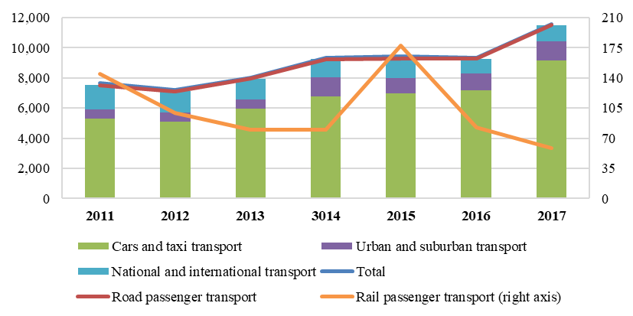

*Source*: State Statistical Office.

**Figure 3.2: Freight transport, 2011–2017, tonne-km**

*Source:* State Statistical Office.

**CHAPTER 6: IMPLEMENTATION OF INTERNATIONAL AGREEMENTS AND COMMITMENTS**

**Box 6.1: Target 11.4 of the 2030 Agenda for Sustainable Development**



**Goal 11: Make cities and human settlements inclusive, safe, resilient and sustainable**

**Target 11.4: Strengthen efforts to protect and safeguard the world’s cultural and natural heritage**

The country has appropriate legal measures in place for the protection of cultural heritage, in particular the 2004 Law on Protection of Cultural Heritage. Most related policy priorities for target 11.4 are identified in the National Strategy for Culture Development 2018–2022. The institutional framework is represented by the Ministry of Culture.

The property “Natural and Cultural Heritage of the Ohrid Region” was initially inscribed on the World Heritage List for its outstanding natural values and was extended a year later to reflect the Region’s extensive cultural attributes. The Ministry of Culture is designated as the competent authority, while the Ministry of Environment and Physical Planning is responsible for the segment on natural heritage. In 2010, the Law on the Management of the World Natural and Cultural Heritage in the Ohrid Region was adopted, and the Management Plan for the Natural and Cultural Heritage of the Ohrid Region with an action plan was prepared and submitted to the UNESCO World Heritage Committee.

However, large infrastructure projects such as the Galičica Ski Centre, A3 express road, Pan-European Corridor VIII and Highway A2 have been put forward with negative impacts on the OUV of the site, which calls for urgent measures on SEA, integrated protection and setting necessary control mechanisms. A joint World Heritage Centre/International Council of Monuments and Sites/IUCN Reactive Monitoring mission on the state of conservation of the site and the scope and development of SEA took place in spring 2017. During 2017, a management committee was set up and a draft plan for integrated protection of the Old Town, detailed urban plans and technical documentation for a number of large-scale infrastructure works have been finalized, but the SEA is still pending.

The Ministry of Environment and Physical Planning should

(a) Strengthen efforts to finalize SEA to comprehensively assess the cumulative impacts of all infrastructure and development plans and other major projects on the property’s OUV, as well as any necessary Heritage Impact Assessments (HIAs);

(b) In collaboration with relevant institutions, undertake a comprehensive comparative study of alternative routes for the railway of the Pan-European Corridor VIII, including those that do not pass in close vicinity of the lakeshore, and specifically avoiding one of the last well-preserved stretches of the lakeshore on the Albanian–Macedonian border.

**CHAPTER 8: AIR PROTECTION**

**Box 8.1: Targets 3.9 and 11.6 of the 2030 Agenda for Sustainable Development**



**Goal 3: Ensure healthy lives and promote well-being for all at all ages**

**Target 3.9: By 2030 substantially reduce the number of deaths and illnesses from hazardous chemicals and from air, water and soil pollution and contamination.**

Among other means, the achievement of target 3.9 is measured by the mortality rate attributed to household and ambient air pollution. During the preparation of the National Plan for Ambient Air Protection in 2012, the Institute of Public Health estimated the health effects attributable to outdoor air PM10 exposure for selected health endpoints in the City of Skopje based on the WHO methodology. In 2010, 110 of 4,602 deaths (deaths from external causes excluded), 420 of 8,630 inpatient hospitalizations from respiratory diseases and 80 of 6,106 inpatient hospitalizations from cardiovascular disease were attributed to exposure to ambient air PM10.

Assessment prepared in the framework of the Green Growth and Climate Change Analytical and Advisory Support Programme of the World Bank Group implemented in North Macedonia in 2012–2013 showed that approximately 1,350 deaths annually are attributable to exposure to PM. People also suffer from the day-to-day consequences of respiratory diseases. It is estimated that several thousand work-years are lost annually due to chronic bronchitis, asthma, hospital admissions and days of restricted activity. PM air pollution cost the economy about €253 million or 3.2 per cent of GDP in 2011. Moreover, the assessment has demonstrated that potential health savings associated with reductions in PM10 and PM2.5 are substantial and could be over 2 per cent of GDP if EU limit values were reached.

One component of the twinning project “Further strengthening the capacities for effective implementation of the acquis in the field of air quality” was dedicated to strengthening the capacities for health impact assessment of air pollution. Activities included analysis of the current capacities of the Institute of Public Health and other central-level institutions to conduct health impact assessment and a draft plan on health impact assessment improvement in the country, including the needs for human and technical resources and information. Training and support on the basic health impact assessment methodologies were provided and a plan for establishing biomonitoring related to air pollution was developed.

In 2017, the Institute of Public Health demonstrated the potential health benefits of reducing PM2.5 levels in the main cities of the country (Bitola, Kavadarci, Kicevo, Kocani, Skopje and Tetovo) to EU limit and WHO guideline values. The current levels of population exposure to PM2.5 are responsible for 1,794 deaths annually in the cities: deaths can be avoided through active interventions to improve air quality. Reduction of PM2.5 levels to the EU limit value will save approximately 874 lives; reduction to the WHO guideline will bring greater health gains – up to 1,464 lives. The age-standardized mortality (rate per 100,000 population) attributed to ambient air pollution in the country is estimated at 46 in the WHO Global Health Observatory data repository. These data are in the United Nations Global Indicators Database and could serve as a baseline to monitor progress.

According to the 2018 report on air quality in Europe (EEA Report No. 12/2018), premature deaths attributable to PM2.5, NO2 and O3 exposure in the country in 2015 were 3,000, 110 and 90 respectively. It also provides data on years of life lost (YLL) attributable to PM2.5, NO2 and O3 exposure in 41 European countries. In North Macedonia, there were 1,469 YLL/105 inhabitants due to exposure to PM2.5, 56 due to exposure to NO2 and 52 due to exposure to elevated concentrations of O3 in 2015; for EU countries, the corresponding data were 820 YLL/105 inhabitants due to exposure to PM2.5, 157 due to exposure to NO2 and 36 due to exposure to O3.

Household air pollution has not received due attention in the legal agenda even though people spend about 75 per cent of their life indoors. The draft strategy on health and environment recognizes the need for indoor air quality monitoring, especially in schools and day-care centres, but it has not yet been adopted. According to the 2007 WHO analysis of the environmental burden of disease by country, exposure to indoor air pollution from solid fuel use (30 per cent of households) in North Macedonia is responsible for fewer than 100 deaths per year. The 2016 WHO Global Health Observatory estimate of the age-standardized mortality (rate per 100,000) in the country attributed to household air pollution is 43. The same data are in the United Nations Global Indicators Database to serve as a baseline.

The joint effects of ambient and household air pollution in terms of attributable age-standardized mortality is estimated at 82.2 – more than twice the corresponding European Regional average of 36.3 – indicating the rather high burden of ill health from air pollution in North Macedonia.

**Goal 11: Make cities and human settlements inclusive, safe, resilient and sustainable**

**Target 11.6: By 2030, reduce the adverse per capita environmental impact of cities, including by paying special attention to air quality and municipal and other waste management.**

More than half the global population lives in cities. The environmental impact of urban living is often expressed through the air pollution level, and annual mean levels of fine PM in cities (population weighted) are used globally to monitor progress towards achievement of target 11.6. Data for reporting on this indicator are available, but the achievement of this target already presents a challenge for the country. The indicator can be found on the official portal of the Ministry of Environment and Physical Planning (http://www.moepp.gov.mk/?page_id=4819&lang=en).

Since there is exceedance of the annual limit value recorded at all measurement stations throughout the country during the whole observed period, on the basis of EEA methodology it is considered that the whole population is exposed to PM10 concentrations exceeding the annual limit value of 40 µg/m3 (figure 8.9). The EEA report “Air Quality in Europe” notes that, according to data from 41 European countries, concentrations above the PM10 annual limit value in 2016 were monitored at 6 per cent of all the reporting stations. Of the 17 stations in North Macedonia, 13 are among that 6 per cent.

**Figure 8.9: Average annual PM10 concentrations in selected cities, 2006–2016, µ/m3**

*Source:* Macedonian Environmental Information Centre, 2018.

Achievement of the 2030 Agenda for Sustainable Development target for reducing the adverse per capita air pollution of cities requires an integrated and intersectoral approach to air quality management. Hence, the problem with quite high emissions of PM10 throughout the country has to be managed from different angles.

Similarly, the annual average PM2.5 concentration for Skopje during the five-year period 2012–2016 is triple the WHO guideline value (10 µg/m3) and higher than the EU limit (25 µg/m3). The WHO Global Health Observatory provides estimates of exposure in the country in terms of the population-weighted average of the mean annual PM2.5 concentrations for 2016. For North Macedonia, the PM2.5 exposure is 33.0 µg/m3 for urban areas and 28.3 µg/m3 for the entire country. The corresponding averages for the European Region were 14.2 µg/m3 and 14.0 µg/m3 respectively. As regards household air pollution, the WHO Global Health Observatory provides country exposure data in terms of the proportion of the population using solid fuels (estimates) and of the population with primary reliance on clean fuels and technologies. In 2013, 33 per cent of the population in North Macedonia (56 per cent in rural areas and 15 per cent in urban areas) used solid fuels for heating and cooking. The proportion of the population with primary reliance on clean fuels and technologies has increased from 44 per cent in 2000 to 66 per cent in 2016.

The Government should:

(a) Continue to implement measures related to improvement of the energy efficiency of households, e.g., efficient windows and heaters;

(b) Further develop the gas supply network with the envisaged establishment of district heating with gas in Bitola;

(c) Strengthen measures related to mitigation of emissions from industry, including energy production;

(d) Advise the City of Skopje to undertake a study on measures needed to enhance its public transport infrastructure to increase its use by the public.