

Informal Document N° 21
(30th GRSP, 3-6 December 2001,
Agenda item 1.4)

Draft amendments to Regulation N° 17
Correlation Between Dynamic and Static
Tests of Station Wagon Barrier Nets.

Brief synopsis of Test Results and Calculations used to
generate in house testing procedures for
Butz-Ieper Automotive Barrier Nets.

T. Sam Crisp.
20th Nov. 01

Page 1

Contents

1. Purpose of report and reasons for static testing.

2. Development of correlation-ship between static and dynamic testing.

3. Transient non-linear finite element analysis results.
(1994)

4. Comparison of dynamic and static test results on production safety nets.

5. Evaluation of dynamic test results to create static test requirement.

6. Photographs of early test equipment.

7. Photographs of latest test equipment.

Page 2

Purpose of this report.

This report is an explanation of the sequence by which we in Butz-Ieper Automotive developed our in house testing of flexible barrier nets and the equipment to test them during development and production. For clarity this report is kept brief but is based on selected results from 8 years of development of the barrier nets that we produce for the European auto industry.

Reasons for static testing.

As an original equipment supplier to the auto industry we are frequently asked to develop components and barrier net assemblies for vehicles that are in an early stage of development. To develop these components it has always been vital to know the loads to which they may be subjected so that components can be cost effectively developed and that we are confident that they will exceed the requirements of use.

Dynamic testing is applied by us where it is essential, such as in the anti-inertia testing of locking systems, but it is much cheaper, convenient, controllable and reproducible to conduct static tests to prove the strength of our products. It is important to our customers that when they conduct expensive dynamic tests on their prototype vehicles that they can be confident that our prototype parts will perform adequately.

Our experiences obviously can be applied to the improvement of the R17 regulation as proposed.

Page 3

Development of correlation-ship between
static and dynamic testing.

In initial studies transient non-linear finite element analysis was employed to study in depth the dynamic response of a fixed barrier net. This was compared with the results obtained from a dynamic test of a net restraining the upper 10 Kg. mass and the resulting net damage. Thus the basic strength requirements of the net components could be defined. ( see report on pages 5, 6, 7, 8 and 9 ).

Based on these results Butz-Ieper Automotive built a static compression test fixture that could be mounted inside a Zwick computer controlled test machine and nets, designed to restrain the upper 10 Kg. mass, were successfully developed for a long period with our customers dynamic test results showing a good correlation ship with our predictions. ( see photo on page 6 ).

Later it became apparent that when we had to design safety barriers that extended from the vehicle floor to the roof further analysis was required. When one of our customers conducted dynamic tests with a tri-axle accelerometer in the 10 Kg. mass we were able to make a direct comparison between a static test and a dynamic test on identical components. (See report on page 10 and 11).

The correlation between results was such that a series of dynamic tests at T.U.V. were run in 1998 with the express aim of developing an internal company static test requirement that would allow the development through static testing of barrier systems capable of restraining both the 10Kg. upper load and the two 18 Kg. lower loads of the R17 proposal with no assistance from the seat backs. These results were analysed (see pages 14, 15, 16 and 17) and a test equipment designed for our internal development work and production verification
( see photo on pages 19, 20 and 21).
This is the equipment described in the proposed amendment to the R 17 regulations.

Page 4

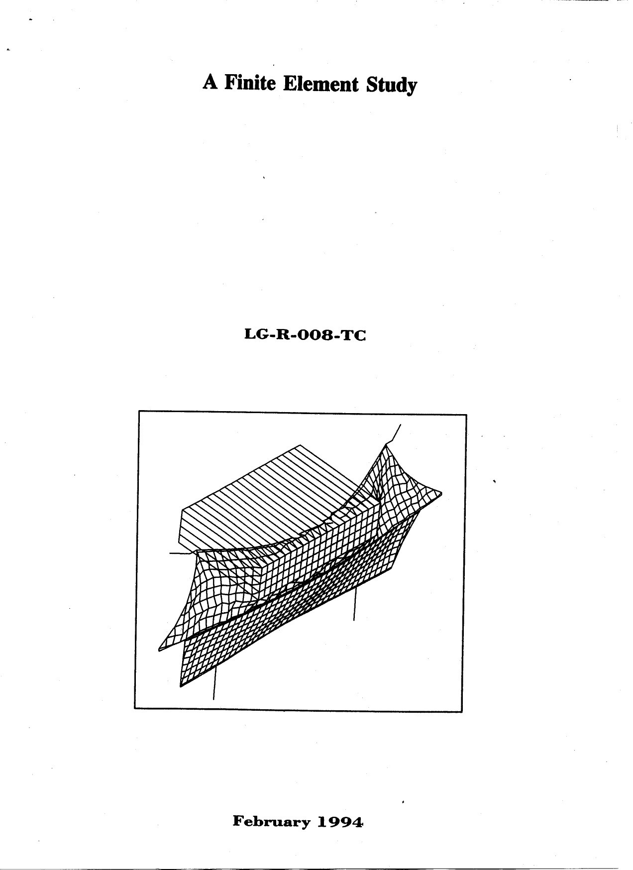
Page 5
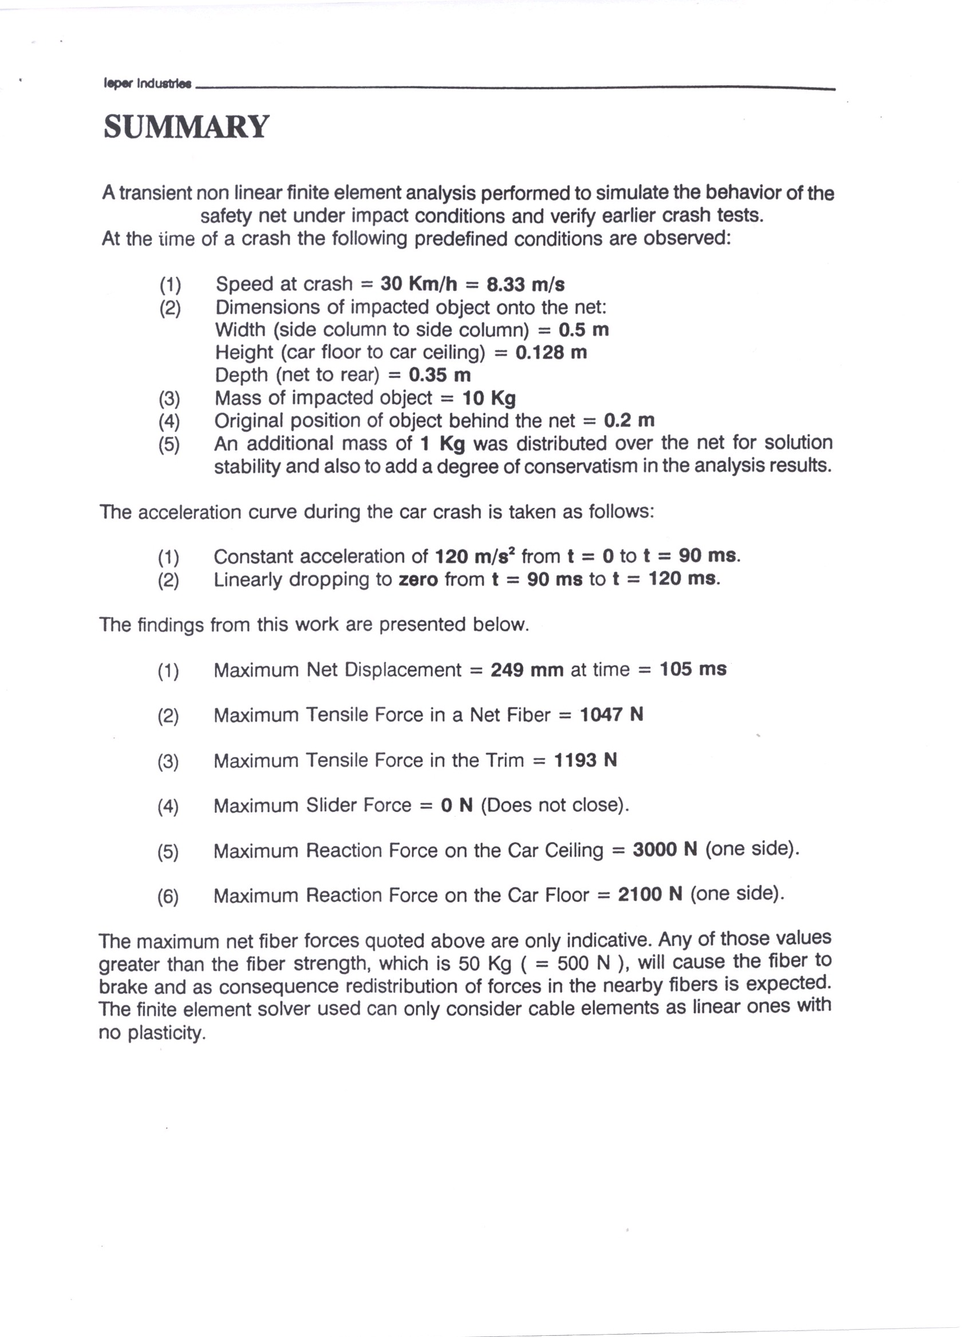

Page 6
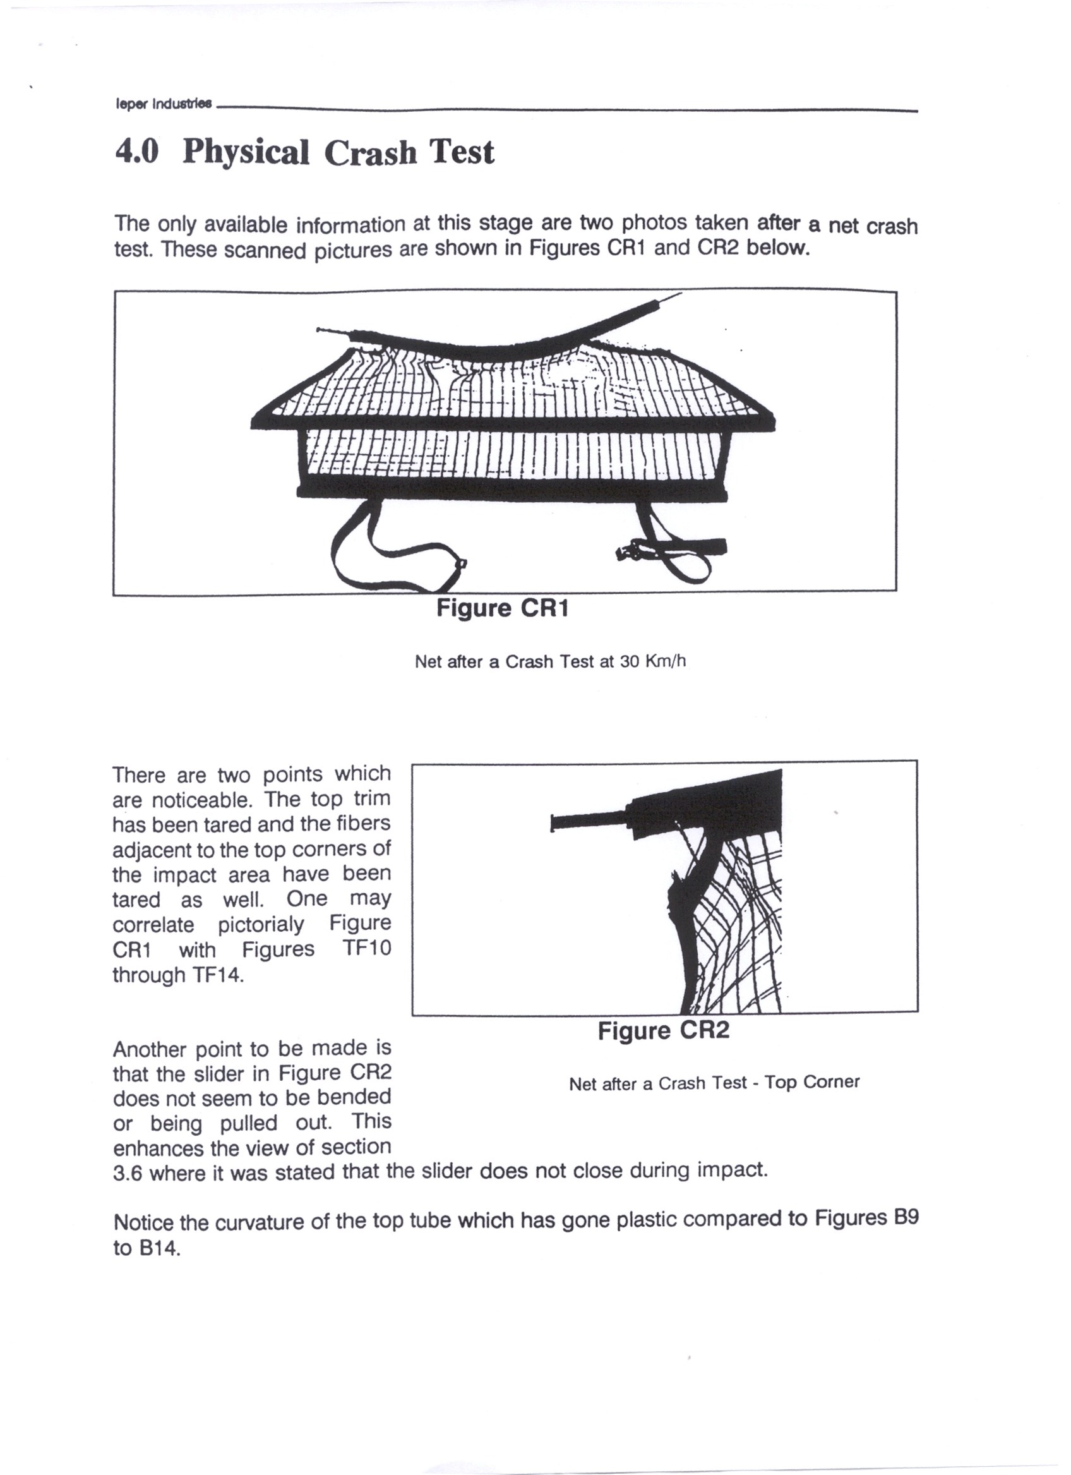

Page 7

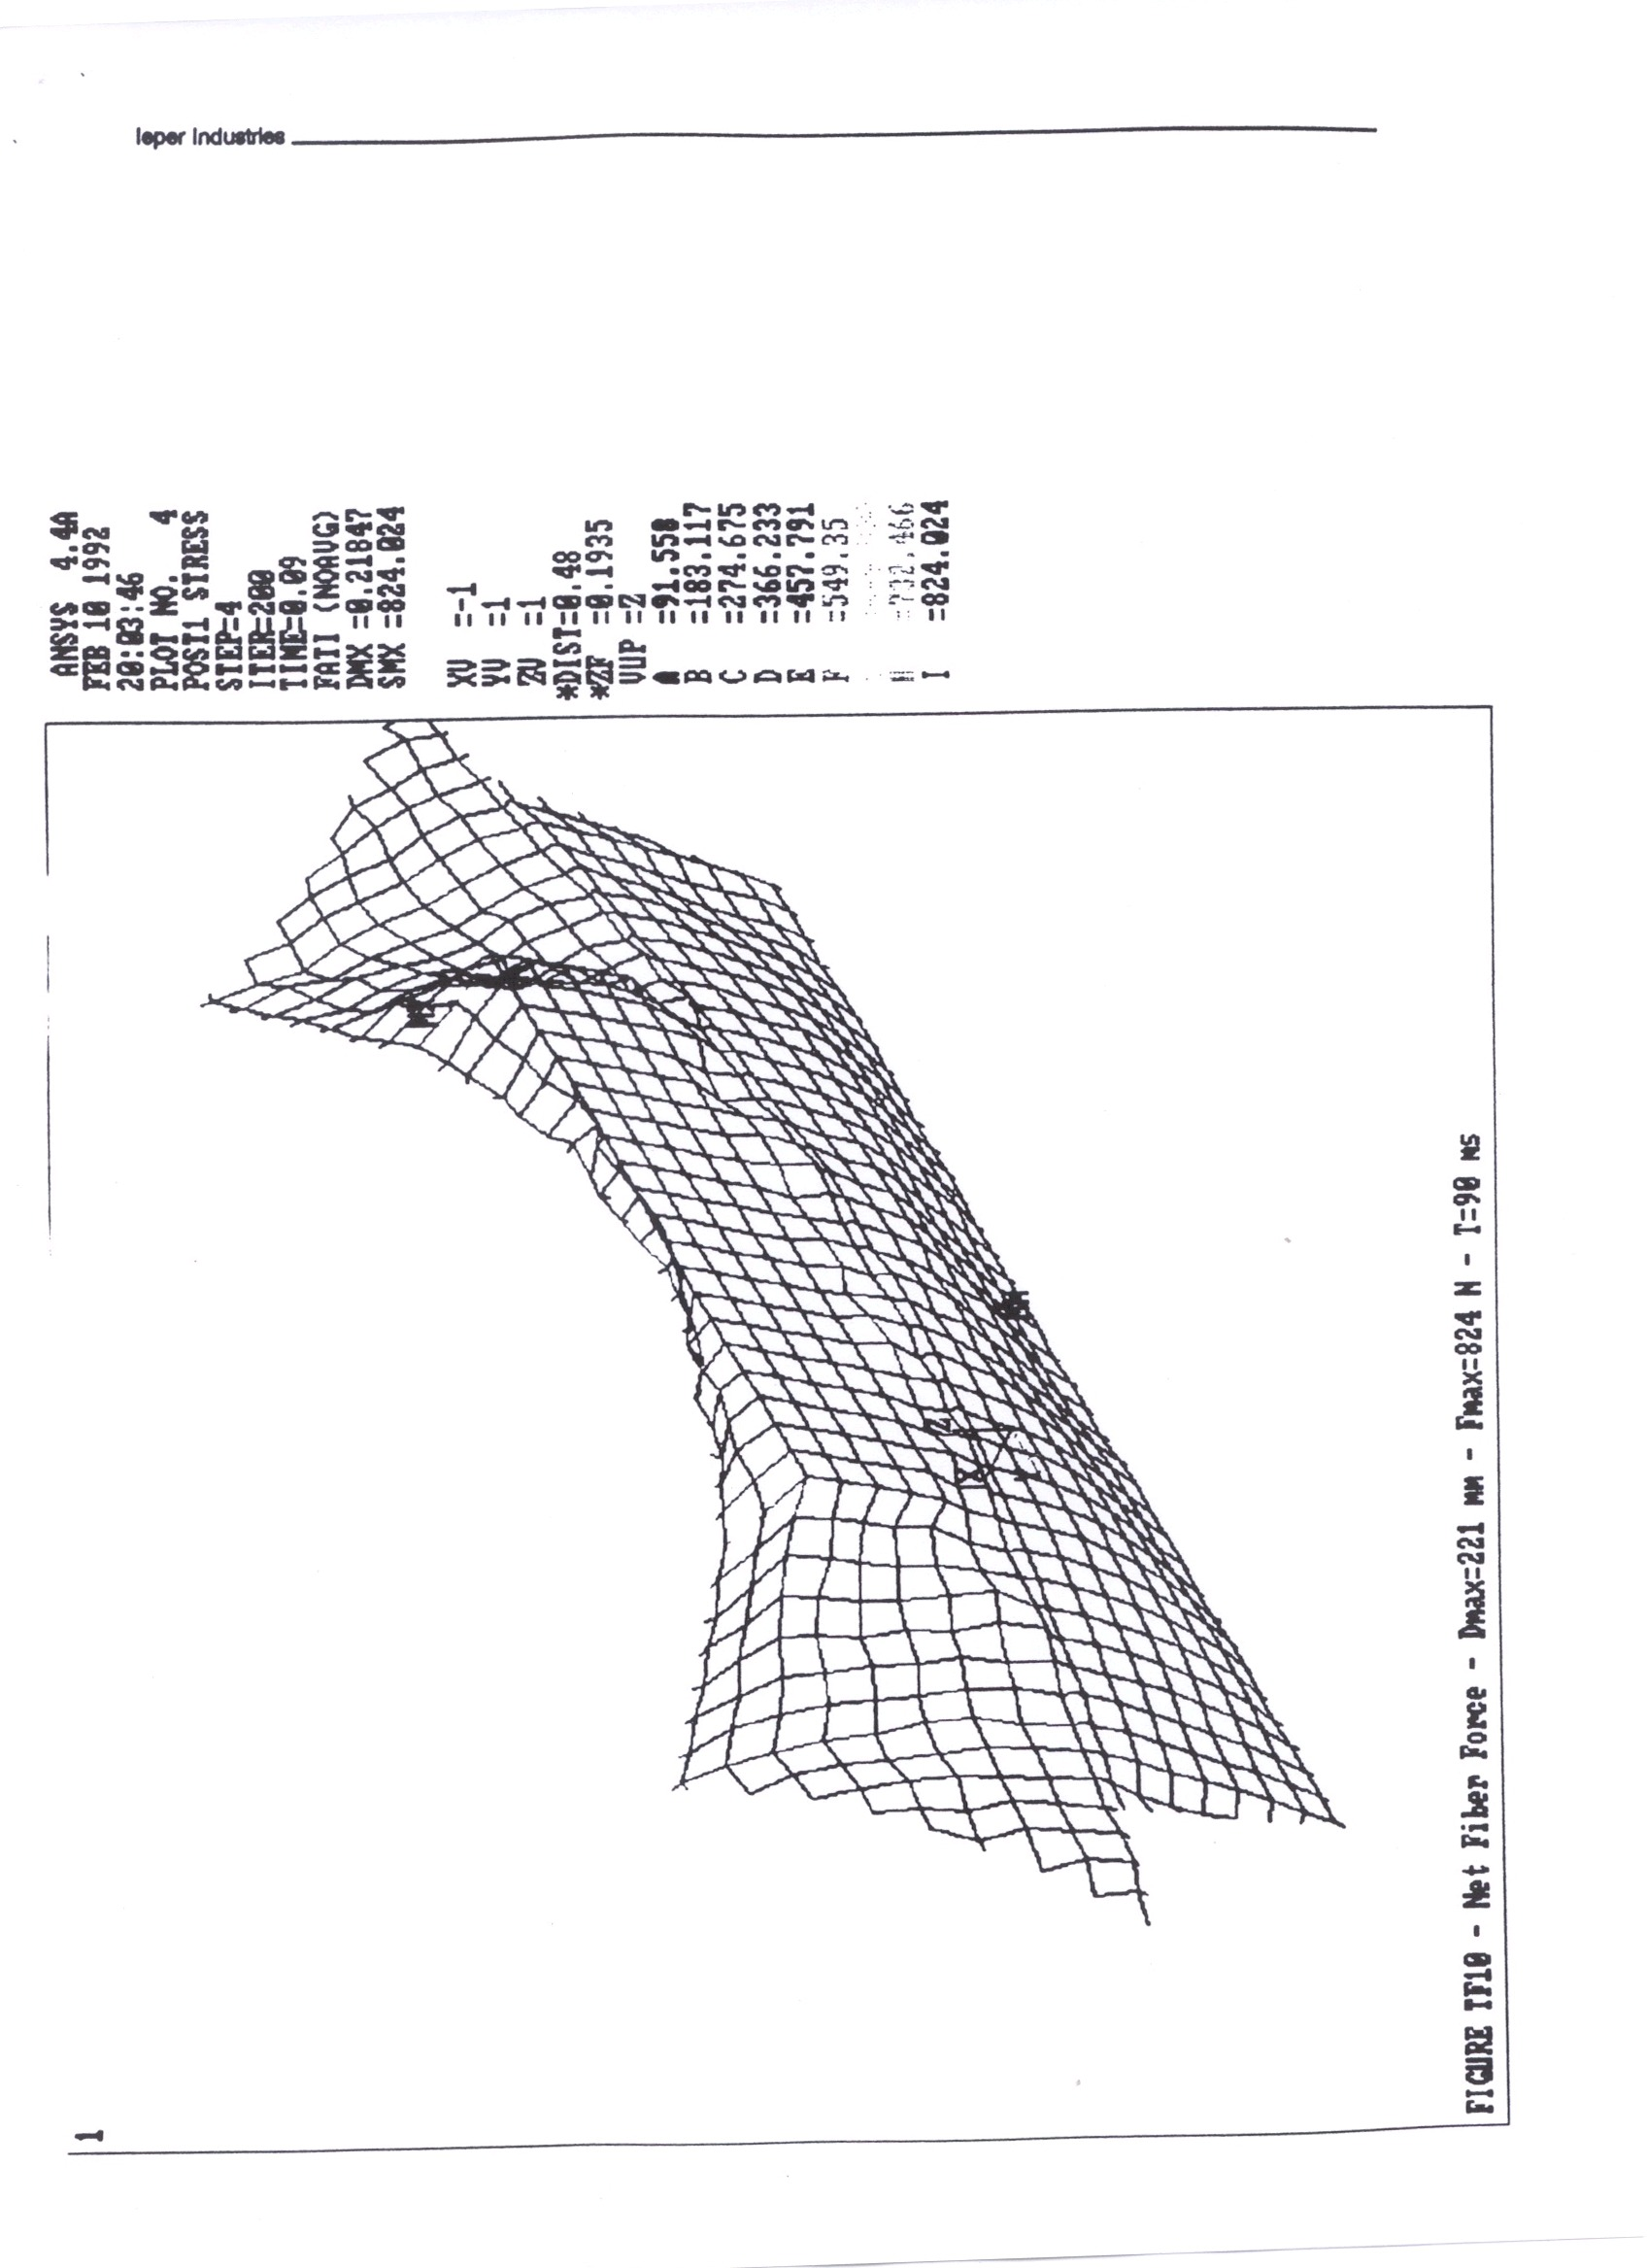

Page 8
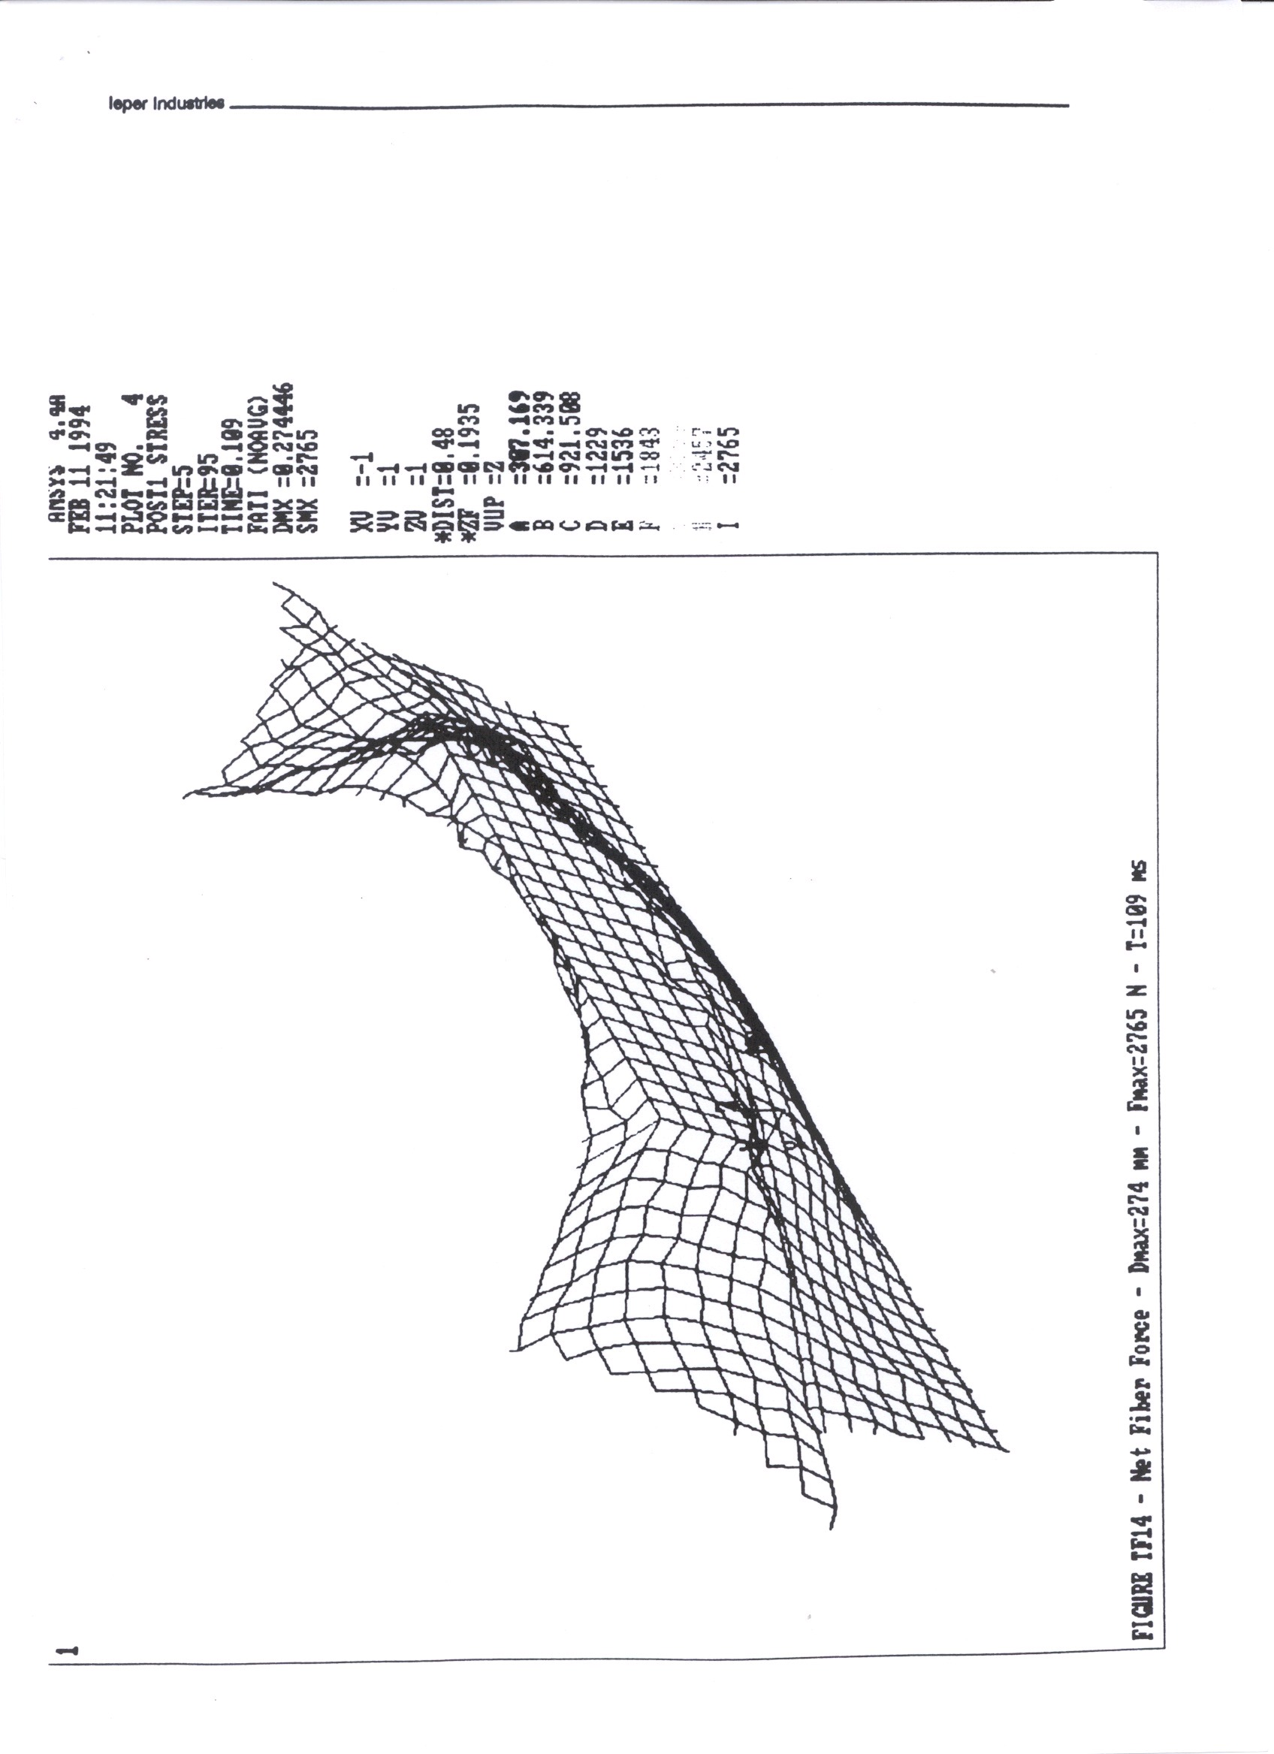

Page 9

Comparison of static and dynamic tests.

barrier nets.

Data source:

Test results were made available from a dynamic test conducted by one of our customers where a plot existed of the longitudinal deceleration of the 10 Kg. mass. This was measured by the sighting of an accelerometer within the mass. The vehicle deceleration was that of a car in a frontal impact at 40 Km. Per hr. The seat was in its normal position and only the 10 Kg. mass was used.

Static tests were conducted on identical barrier nets from our production.
These tests were conducted in the computer controlled Zwick compressive test machine where the net was supported in a rigid steel frame. To deform the net a block having the same form as the leading edge of the 10Kg. mass used in dynamic tests was pressed into the locked net at a speed 100 mm. per minute. The graph of the load against deflection was generated.

Calculation:

The graph of deceleration against time supplied from the dynamic test enabled the calculation of the displacement against time of the mass. As the test was conducted on a ´Hi-G-sled, where the test configuration starts at rest and is accelerated backwards, it also was possible to calculate the force exerted on the mass by the net

By combining the results of these two calculations it was possible to draw a graph of the force deflection curve of the net during the dynamic test.

Results:

The two graphs of load / deflection were matched together to ascertain the starting point of the load application and are to be found attached.

A very close similarity was found both in the form and values of the two deflections in the region of loading experienced during the dynamic test.

The loads on the net during dynamic test were much higher than previously thought ( +/- 600 Kg. ).

The net deflection under load was relatively low. ( +/- 100mm. )

The net deflects a fair distance with a very low force. ( +/- 40 mm. )
Failures of the safety net in static tests were similar to those in dynamic testing.

Page 10

Conclusions:

During safety net development the use of the extensive static testing on the equipment that exists within our company can give a fair indication of the performance that we can expect when our products are tested dynamically by our customers.

Comparative static tests of different materials and constructions can give a good indication of future performance from our products.

Further tests should be carried out with accelerometers in the test blocks to increase our confidence in these results.

Page 11
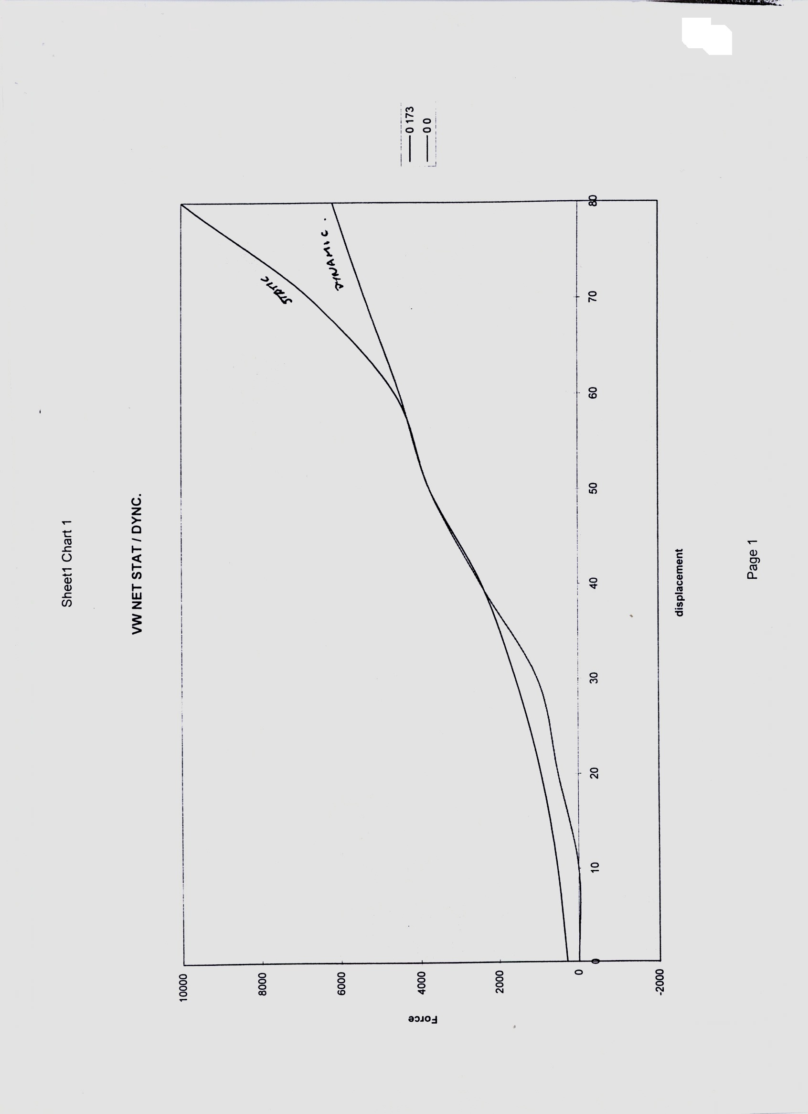

Page 12

Evaluation of dynamic test results.

Test Configuration.

The tests were conducted at T.U.V. Rheinland on 24/07/98.

Net Configuration: Full size Butz-Ieper static net.

Deceleration Pulse: ECE-R44 (ECE R17 ) 47 kmph.

Test Loads: 2 X 18 Kg. + 1 X 10 Kg. as R17.

Instrumentation: Tri-axial accelerometers in each load block

Results.

T.U.V. supplied the resultant deceleration of each test block (see page 14) which could be translated to an instantaneous load on the net as shown in the attached strength calculations. (see pages 15 and 16) The energy verses time graph shown on page 17 gives a smoothed out indication of the total load applied to the net by the test blocks in relationship to time. The flexibility of the net material means that peak values measured in the accelerometers must be filtered to give a meaningful equivalent static load.

Force Applied To Net By Loads ( Averaged ) Upper (1X10Kg.) = 1620N.
Lower (2X18Kg.) = 4300N.

Force Applied To Net By Loads ( Peak )
Upper (1X10Kg.) = 3700N.
Lower (2X18Kg.) = 9500N.

Page 13

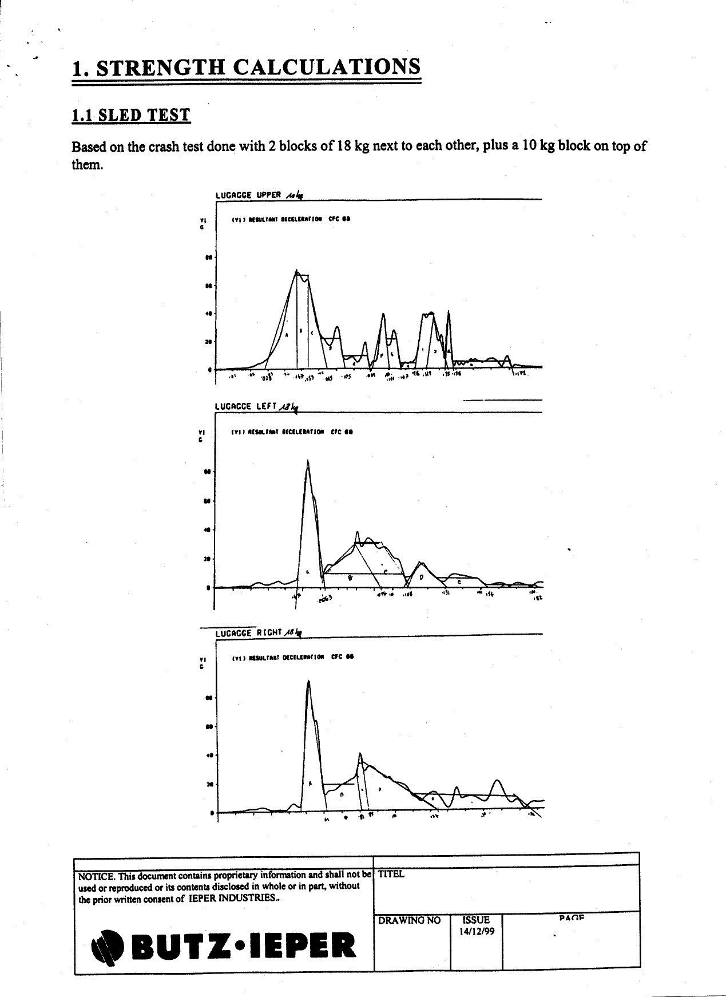

Page 14

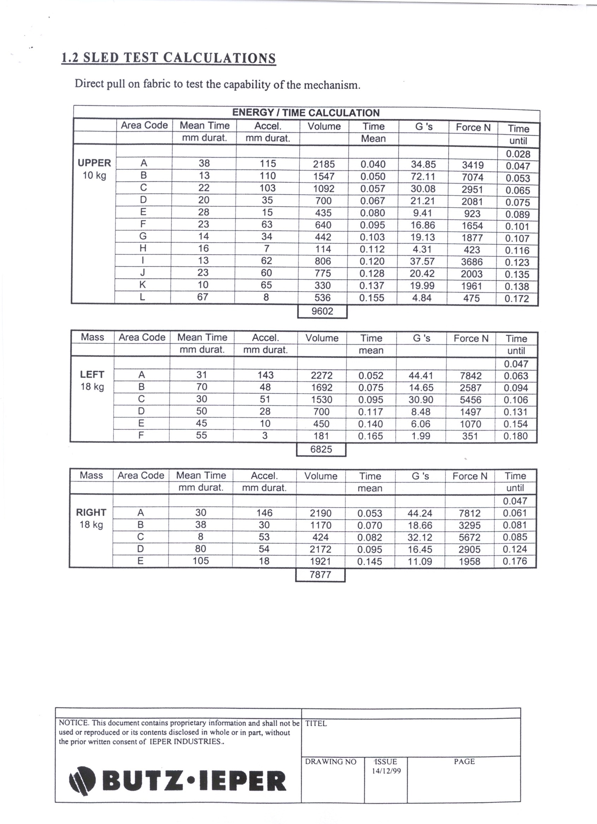

Page 15
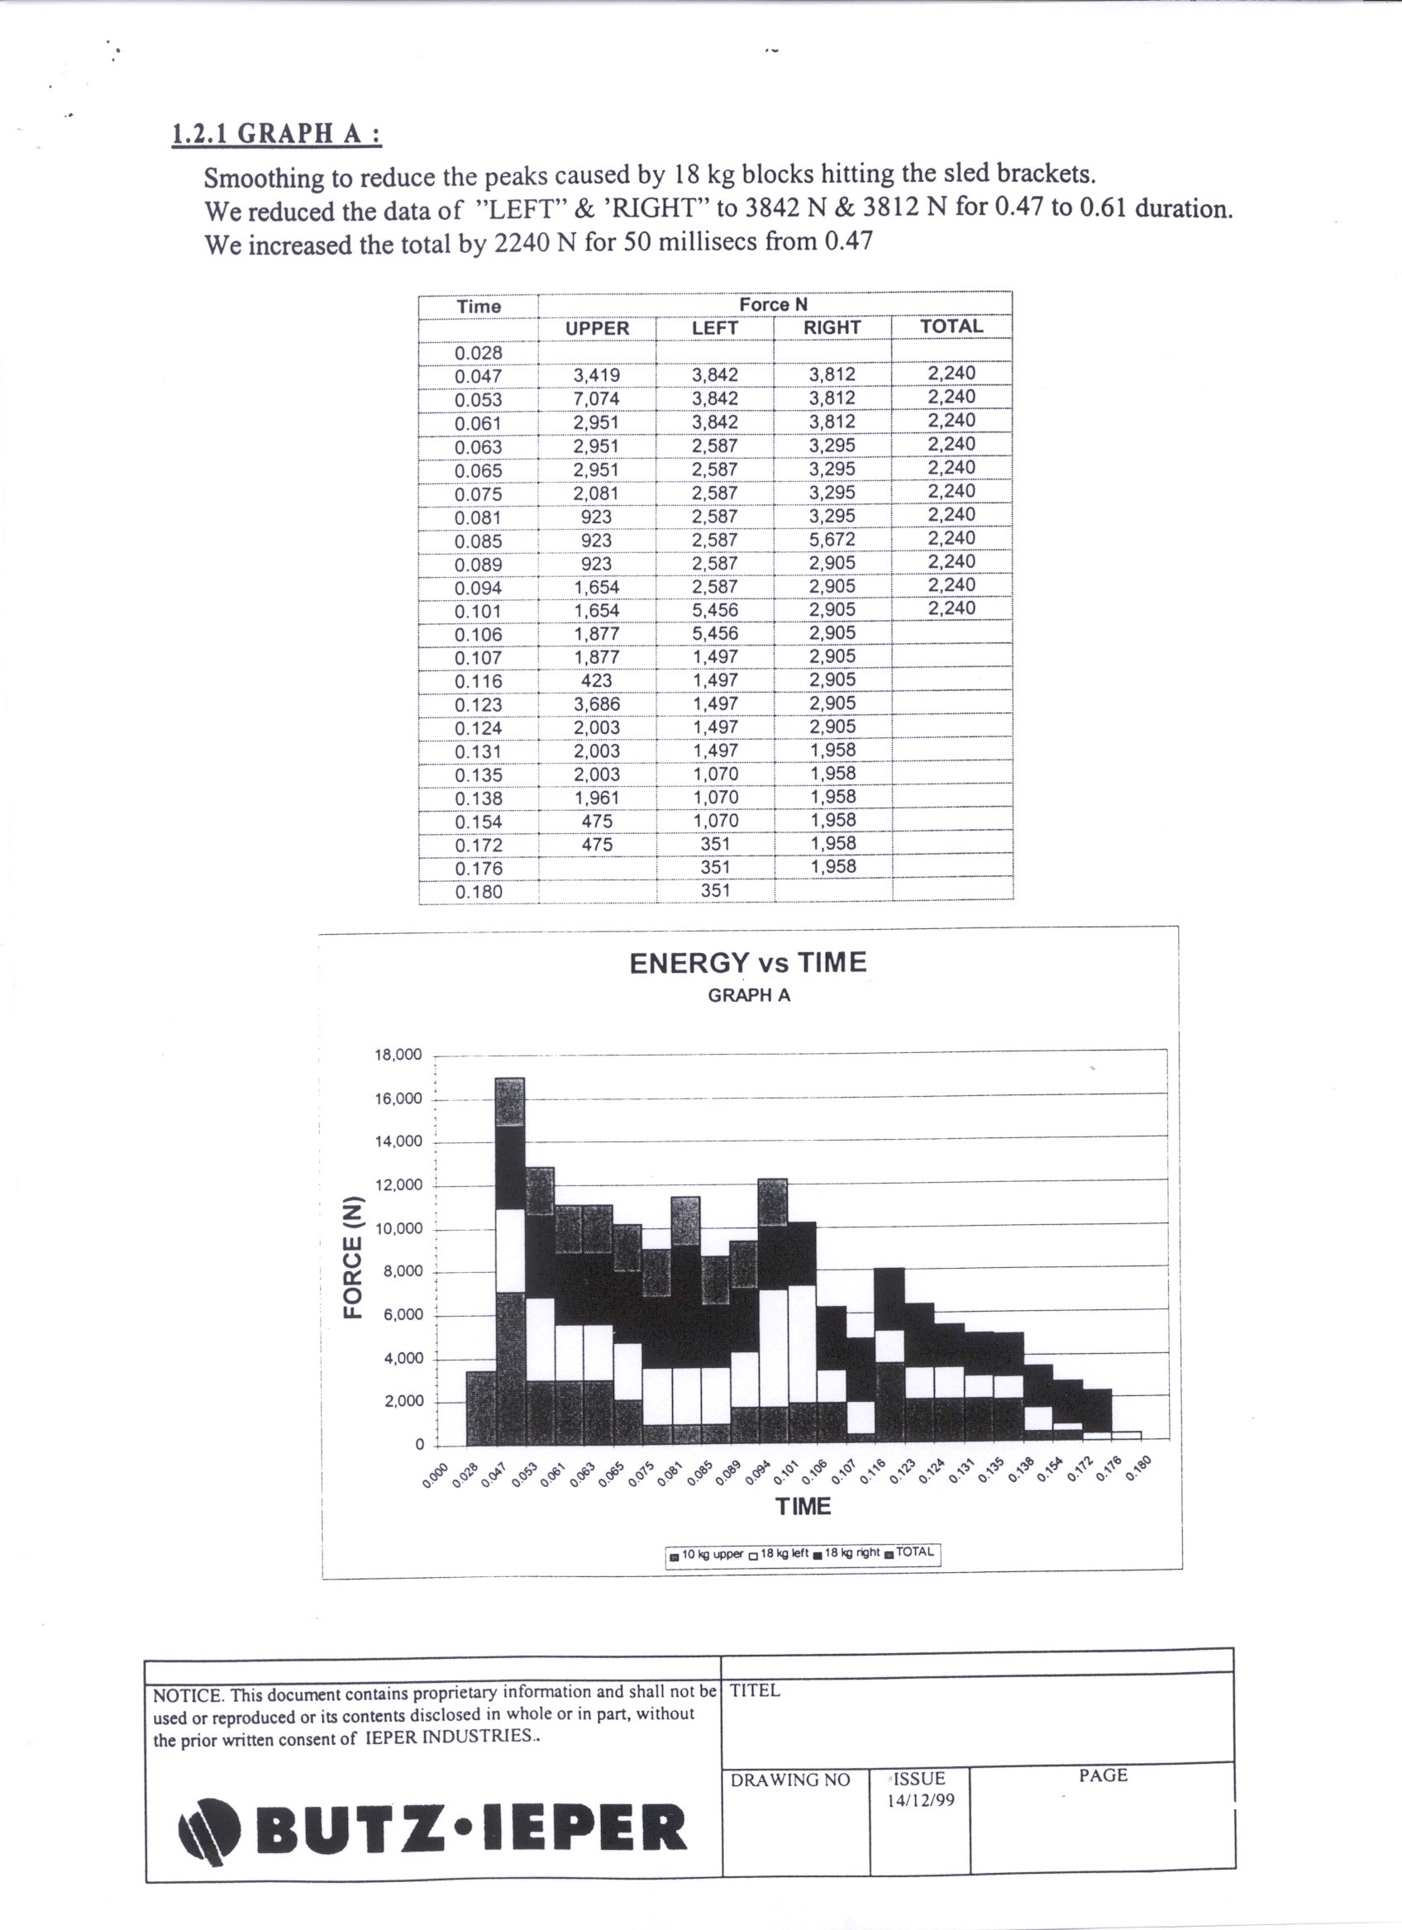

Page 16

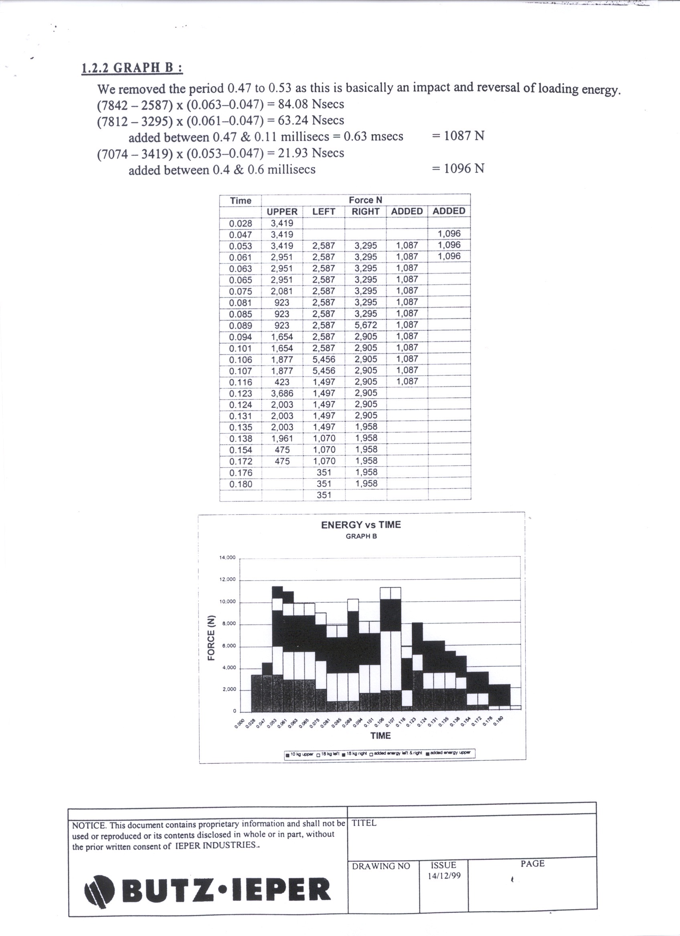

Page 17

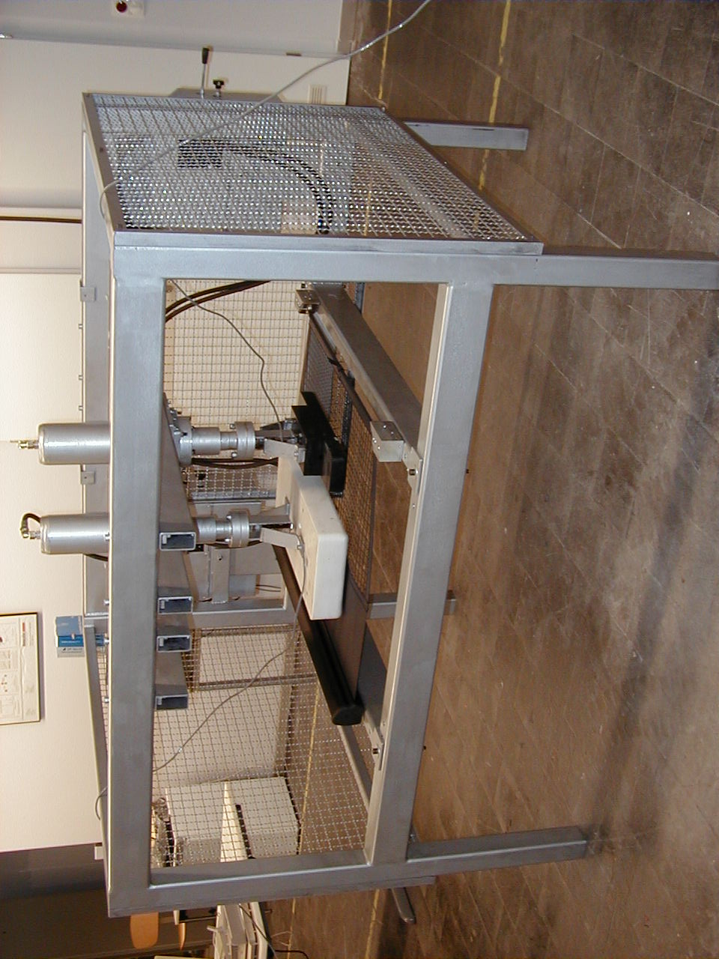

Page 18

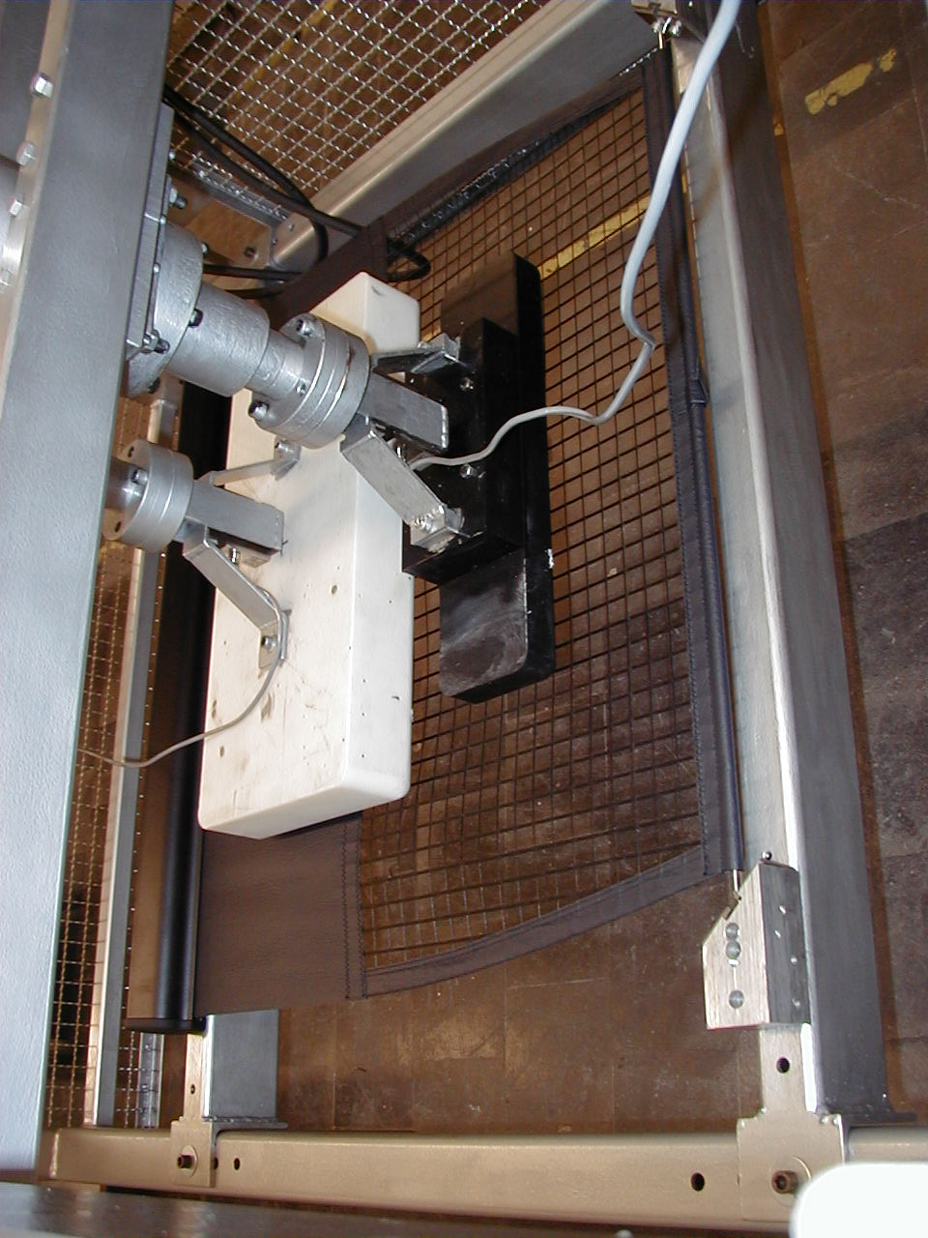

Page 19

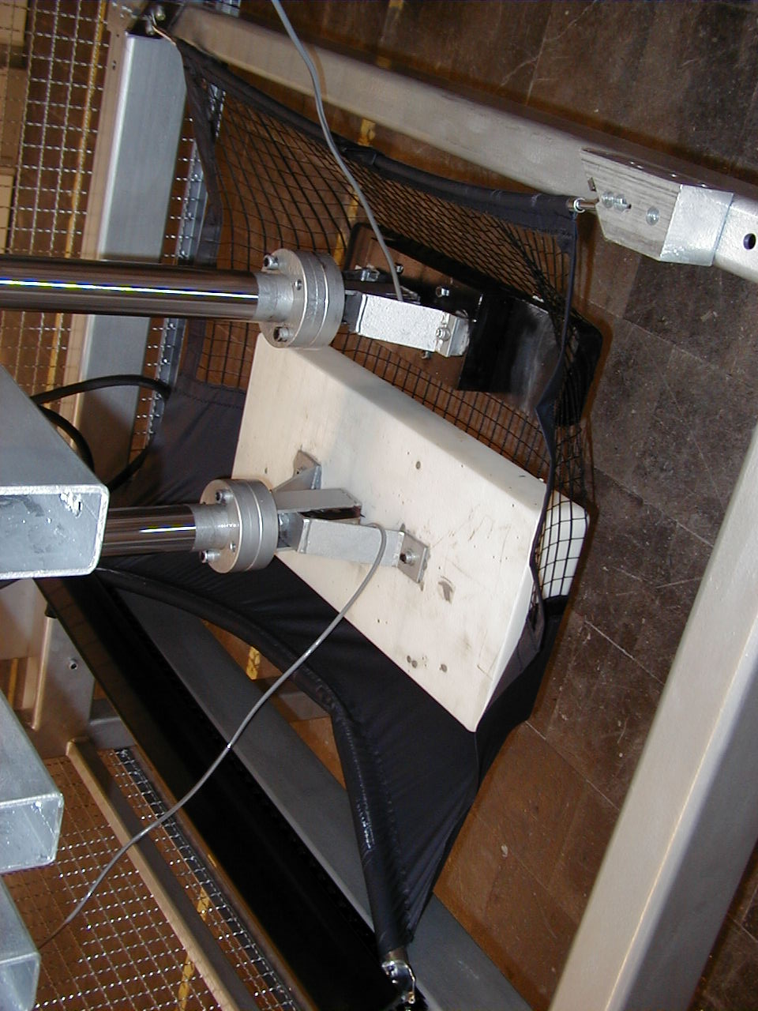

Page 20

