PROPOSAL FOR THE 02 SERIES OF AMENDMENTS TO REGULATION No. 100
(Specific requirements for the electric power train)

Submitted by the Chairman of the group of interested experts on Rechargeable Energy Storage Systems (RESS) */

The text reproduced below was prepared by the Chairman of the group of interested experts on Rechargeable Energy Storage Systems (RESS) and aims at extending the scope of the present Regulation to incorporate additional requirements on Rechargeable Energy Storage Systems (RESS) in accordance with the terms of reference of the group adopted at the forty-ninth session of GRSP (ECE/TRANS/WP.29/GRSP/49 paragraph 31 and Annex V).

Regulation No. 100

UNIFORM PROVISIONS CONCERNING THE APPROVAL OF VEHICLES WITH REGARD TO SPECIFIC REQUIREMENTS FOR THE ELECTRIC POWER TRAIN

CONTENTS

REGULATION Page
1. Scope #
2. Definitions #
3. Application for approval #
4. Approval #

5. PART I: REQUIREMENTS OF A VEHICLE WITH REGARD TO ITS ELECTRICAL SAFETY #

6. PART II: REQUIREMENTS OF A RECHARGEABLE ENERGY STORAGE SYSTEM (RESS) WITH REGARD TO ITS SAFETY #

7. Modifications of the type and extension of the type approval for vehicle type #
8. Conformity of production #
9. Penalties for non-conformity of production #
10. Production definitely discontinued #
11. Names and addresses of technical services responsible for conducting approval tests and of administrative departments #
12.Transitional provisions #

ANNEXES

Annex 1 - Communication concerning approval or extension or refusal or withdrawal of approval or production definitely discontinued:

Part 1: of a vehicle type with regard to its electrical safety pursuant to Regulation No. 100
Part 2: of a type of component or separate technical unit as a RESS with regard to its safety pursuant to Regulation No. 100

Annex 2 - Arrangements of approval marks
Annex 3 - Protection against direct contacts of parts under voltage
Annex 4A - Isolation resistance measurement method for vehicle based tests
Annex 4B - Isolation resistance measurement method for RESS component based tests
Annex 5 - Confirmation method for function of on-board isolation resistance monitoring system
Annex 6 - Essential characteristics of road vehicles or systems
Annex 7 - Determination of hydrogen emissions during the charge procedures of the traction battery
Appendix 1 Calibration of equipment for hydrogen emission testing
Appendix 2 Essential characteristics of the vehicle family
Annex 8 - Testing of RESS
Annex 8A - Vibration
Annex 8B - Thermal shock and cycling
Annex 8C - Mechanical shock (
Annex 8D - Mechanical integrity (RESS based tests)
Annex 8E - Fire resistance
Appendix 1 Dimension and technical data of firebricks
Annex 8F - External short circuit protection
Annex 8G - Overcharge protection
Annex 8H - Over-discharge protection
Annex 8I - Over-temperature protection
1. SCOPE

The following prescriptions apply to:

1.1 PART I: safety requirements with respect to the electric power train of road vehicles of categories M and N, with a maximum design speed exceeding 25 km/h, equipped with one or more traction motor(s) operated by electric power and not permanently connected to the grid, as well as their high voltage components and systems which are galvanically connected to the high voltage bus of the electric power train.

PART I of this regulation does not cover post crash safety requirements of road vehicles;

1.2 PART II: safety requirements with respect to the Rechargeable Energy Storage System (RESS), of road vehicles of categories M and N equipped with one or more traction motors operated by electric power and not permanently connected to the grid.

<JASIC Comment> (copied from RESS-4-3 Rev.2 for a reminder)
As suggested in RESS-2-3, the group should;
- at first, focus on Li-Ion rechargeable batteries to develop the technical requirement, and then
- examine applicability to other types of RESS considering the difference of the chemical characteristics.

2. DEFINITIONS

For the purpose of this regulation the following definitions apply:

2.1. "Active driving possible mode" means the vehicle mode when application of pressure to the accelerator pedal (or activation of an equivalent control) or release of the brake system will cause the electric power train to move the vehicle.

2.2. "Barrier" means the part providing protection against direct contact to the live parts from any direction of access.

2.3. "C rate" is the marked capacity rating of the device under test. nC is the current rate equal to n times the 1 h discharge capacity expressed in Amperes

2.4. "Cell" means a single encased electrochemical unit containing one positive and one negative electrode which exhibits a voltage differential across its two terminals.

2.5. "Conductive connection" means the connection using connectors to an external power supply when the rechargeable energy storage system (RESS) is charged.

2.6. "Coupling system for charging the rechargeable energy storage system (RESS)" means the electrical circuit used for charging the RESS from an external electric power supply including the vehicle inlet.

2.7. "Direct contact" means the contact of persons with live parts.

2.8. "Electrical chassis" means a set made of conductive parts electrically linked together, whose potential is taken as reference.

2.9. "Electrical circuit" means an assembly of connected live parts which is designed to be electrically energized in normal operation.

2.10. "Electric energy conversion system" means a system that generates and provides electric energy for electric propulsion.

2.11. "Electric power train" means the electrical circuit which includes the traction motor(s), and may include the RESS, the electric energy conversion system, the electronic converters, the associated wiring harness and connectors, and the coupling system for charging the RESS.

2.12. "Electronic converter" means a device capable of controlling and/or converting electric
power for electric propulsion.

2.13. "Enclosure" means the physical housing part enclosing the internal units and providing protection against direct contact from any direction of access.

2.14. "Explosion" means sudden release of energy sufficient to cause pressure waves and/or projectiles that may cause structural and/or physical damage to the surrounding of the device under test.

2.15. "Exposed conductive part" means the conductive part which can be touched under the provisions of the protection degree IPXXB, and which becomes electrically energized under isolation failure conditions.

2.16. "External electric power supply" means an alternating current (AC) or direct current (DC) electric power supply outside of the vehicle.

2.17. "Fire" means the emission of flames from a device under test [enclosure]. Sparks and arching shall not be considered as flames.

2.18. "High Voltage" means the classification of an electric component or circuit, if its working voltage is > 60 V and ≤ 1500 V DC or > 30 V and ≤ 1000 V AC root mean square (rms).

2.19. "High voltage bus" means the electrical circuit, including the coupling system for charging the RESS that operates on high voltage.

2.20. "Indirect contact" means the contact of persons with exposed conductive parts.

2.21. "Live parts" means the conductive part(s) intended to be electrically energized in normal use.

2.22. "Luggage compartment" means the space in the vehicle for luggage accommodation, bounded by the roof, hood, floor, side walls, as well as by the barrier and enclosure provided for protecting the power train from direct contact with live parts, being separated from the passenger compartment by the front bulkhead or the rear bulk head.

2.23. "Manufacturer" means the person or body who is responsible to the approval authority for all aspects of the type approval process and for ensuring conformity of production. It is not essential that the person or body be directly involved in all stage of the construction of the vehicle, system, component or separate technical unit which is the subject of the approval process.

2.24. "Module" means an assembly of electrically connected cells with a mechanical supporting structure. In most cases, a serial electrical connection of cells will be applied. A module could contain further functionalities (or their parts) of the RESS as e.g. parts of the cooling system and/or first level cell electronics, but not the RESS control unit. In a RESS, one or more modules could be used.

2.25. “Nominal voltage” is the voltage given by the manufacturer as the recommended operating voltage of the RESS.

2.26. "On-board isolation resistance monitoring system" means the device which monitors the isolation resistance between the high voltage buses and the electrical chassis.

2.27. "Open type traction battery" means a liquid type battery requiring refilling with water and generating hydrogen gas released to the atmosphere.

[2.# "Pack" means an energy storage device encased by an enclosure that includes cells or modules normally connected with cell electronics, voltage class B circuit and over-current shut-off device including electrical interconnections, interfaces for external systems (e.g. cooling, voltage class B, auxiliary voltage).]

2.28. "Passenger compartment" means the space for occupant accommodation, bounded by the roof, floor, side walls, doors, window glass, front bulkhead and rear bulkhead, or rear gate, as well as by the barriers and enclosures provided for protecting the power train from direct contact with live parts.

2.29. "Protection degree" means the protection provided by a barrier/enclosure related to the contact with live parts by a test probe, such as a test finger (IPXXB) or a test wire (IPXXD), as defined in Annex 3.

2.30. "Rechargeable energy storage system (RESS)" means the rechargeable energy storage system that provides electric energy for electric propulsion.

[The RESS includes cells, modules. Furthermore, the necessary ancillary subsystems for physical support, thermal management, electronic control and enclosures are included in the RESS.]

2.31 "Rupture" means openings in the enclosure of the device under test which are created or enlarged by an event and which are sufficiently large for a 12 mm diameter test finger to contact live parts (see ISO20653, IPXXB).

2.32. "Service disconnect" means the device for deactivation of the electrical circuit when conducting checks and services of the RESS, fuel cell stack, etc.

2.33. "Solid insulator" means the insulating coating of wiring harnesses provided in order to cover and protect the live parts against direct contact from any direction of access; covers for insulating the live parts of connectors, and varnish or paint for the purpose of insulation.

2.34. "State of charge" or "SOC" means the state of charge in a device under test expressed as a percentage of rated capacity.

2.35. "Standard cycle" or "SC" means standard cycle consisting of a standard charge and a standard discharge load based on the rated capacity of the RESS.

[2.36. "Type of RESS" means systems which do not differ significantly in such essential aspects as:
(a) the manufacturer's trade name or mark,
(b) the chemistry, physical dimensions, number of the cells,
(c) the structure, configuration, capacity and physical dimensions of the Module(s) and /or RESS and
(d) the necessary ancillary subsystems for physical support, thermal management, electronic control and enclosures.]

2.37. "Vehicle type" means vehicles which do not differ in such essential aspects as:
(a) Installation of the electric power train and the galvanically connected high voltage bus.
(b) Nature and type of electric power train and the galvanically connected high voltage components.

2.38 "Venting" means the release of excessive internal pressure in a manner intended by design to preclude rupture or explosion.

2.39. "Working voltage" means the highest value of an electrical circuit voltage root-mean-square (rms), specified by the manufacturer, which may occur between any conductive parts in open circuit conditions or under normal operating condition. If the electrical circuit is divided by galvanic isolation, the working voltage is defined for each divided circuit, respectively.

3. APPLICATION FOR APPROVAL

3.1. PART I: APPROVAL OF A VEHICLE TYPE WITH REGARD TO THE HIGH VOLTAGE SYSTEM

3.1.1. The application for approval of a vehicle type with regard to specific requirements for the electric power train shall be submitted by vehicle manufacturer or by his duly accredited Representative.

3.1.2. It shall be accompanied by the under-mentioned documents in triplicate and following particulars:

3.1.2.1. Detailed description of the vehicle type as regards the electric power train and the galvanically connected high voltage bus.

3.1.2.2. For vehicles with RESS, additional evidence showing that the RESS is in compliance with the requirements of chapter 6 of this Regulation.

3.1.3. A vehicle representative of the vehicle type to be approved shall be submitted to the technical service responsible for conducting the approval tests and, if applicable, at the manufacturer's discretion with the agreement of the technical service, either additional vehicle(s), or those parts of the vehicle regarded by the technical service as essential for the tests referred to in the chapter 6 of this Regulation.

3.2. PART II: APPROVAL OF A RECHARGEABLE ENERGY STORAGE SYSTEM (RESS)

3.2.1. The application for approval of a component type with regard to safety requirement of the RESS shall be submitted by the RESS manufacturer or by his duly accredited Representative.

    - Detailed description of the type of component or separate technical unit as regards the safety of the RESS.

3.2.3. Component(s) representative of the type of RESS to be approved plus, at the manufacturer's discretion, with the agreement of the technical service, those parts of the vehicle regarded by the technical service as essential for the tests, shall be submitted to the technical service responsible for conducting the approval tests.

3.3. The competent Authority shall verify the existence of satisfactory arrangements for ensuring effective control of the conformity of production before type approval is granted.

4. APPROVAL

4.1. If the type vehicle submitted for approval pursuant to this Regulation meets the requirements of relevant part of Paragraph 5 below and Annexes 3, 4, 5 and 7 to this Regulation, approval of that type this vehicle type shall be granted.

4.2. An approval number shall be assigned to each type approved. Its first two digits (at present 02 for the Regulation in its form) shall indicate the series of amendments incorporating the most recent major technical amendments made to the Regulation at the time of issue of the approval. The same Contracting Party shall not assign the same number to another vehicle type.

4.3. Notice of approval or of refusal or of extension or withdrawal of approval or production definitely discontinued of a vehicle type pursuant to this Regulation shall be communicated to the Parties to the Agreement applying this Regulation, by means of a form conforming to the model in Annex 1, Part 1 or 2 as appropriate to this Regulation.

4.4. There shall be affixed, conspicuously and in a readily accessible place specified on the approval form, to every vehicle or component or separate technical unit conforming to a vehicle type approved under this Regulation an international approval mark consisting of:

4.4.1. A circle surrounding the Letter "E" followed by the distinguishing number of the country which has granted approval. /

4.4.2. The number of this Regulation, followed by the Letter "R", a dash and the approval number to the right of the circle described in Paragraph 4.4.1.

4.4.3. In the case of an approval of a component or separate technical unit of the RESS, the “R” shall be followed by the symbol "[ES]".

4.5. If the vehicle conforms to a vehicle type approved under one or more other Regulations annexed to the Agreement in the country which has granted approval under this Regulation, the symbol prescribed in Paragraph 4.4.1. need not be repeated; in this case the Regulation and approval numbers and the additional symbols of all the Regulations under which approval has been granted in the country which has granted approval under this Regulation shall be placed in vertical columns to the right of the symbol prescribed in Paragraph 4.4.1.

4.6. The approval mark shall be clearly legible and shall be indelible.

4.6.1. In the case of a vehicle, the approval mark shall be placed on or close to the vehicle data plate affixed by the Manufacturer.

4.6.2. In the case of a component or separate technical unit approved as a RESS, the approval mark shall be affixed on the major element of the RESS by the Manufacturer.

4.7. Annex 2 to this Regulation gives examples of the arrangements of the approval mark.

5. REQUIREMENTS OF A VEHICLE WITH REGARD TO ITS ELECTRICAL SAFETY

5.1. Protection against electrical shock

These electrical safety requirements apply to high voltage buses under conditions where they are not connected to external high voltage power supplies.

5.1.1. Protection against direct contact

The protection against direct contact with live parts shall comply with paragraphs 5.1.1.1. and 5.1.1.2. These protections (solid insulator, barrier, enclosure, etc.) shall not be able to be opened, disassembled or removed without the use of tools.

5.1.1.1. For protection of live parts inside the passenger compartment or luggage compartment, the protection degree IPXXD shall be provided.

5.1.1.2. For protection of live parts in areas other than the passenger compartment or luggage compartment, the protection degree IPXXB shall be satisfied.

5.1.1.3. Connectors

Connectors (including vehicle inlet) are deemed to meet this requirement if:

(a) they comply with paragraphs 5.1.1.1. and 5.1.1.2. when separated without the use of tools, or

(b) they are located underneath the floor and are provided with a locking mechanism, or

(c) they are provided with a locking mechanism and other components shall be removed with the use of tools in order to separate the connector, or
(d) the voltage of the live parts becomes equal or below DC 60V or equal or below AC 30V (rms) within 1 second after the connector is separated.

5.1.1.4. Service disconnect

For a service disconnect which can be opened, disassembled or removed without tools, it is acceptable if protection degree IPXXB is satisfied under a condition where it is opened, disassembled or removed without tools.

5.1.1.5. Marking

5.1.1.5.1. The symbol shown in Figure 1 shall appear on or near the RESS. The symbol background shall be yellow, the bordering and the arrow shall be black.



Figure 1 — Marking of high voltage equipment

5.1.1.5.2. The symbol shall also be visible on enclosures and barriers, which, when removed expose live parts of high voltage circuits. This provision is optional to any connector for high voltage buses. This provision shall not apply to any of the following cases:

(a) where barriers or enclosures cannot be physically accessed, opened, or removed; unless other vehicle components are removed with the use of tools

(b) where barriers or enclosures are located underneath the vehicle floor.

5.1.1.5.3. Cables for high voltage buses which are not located within enclosures shall be identified by having an outer covering with the colour orange.

5.1.2. Protection against indirect contact

5.1.2.1. For protection against electrical shock which could arise from indirect contact, the exposed conductive parts, such as the conductive barrier and enclosure, shall be galvanically connected securely to the electrical chassis by connection with electrical wire or ground cable, or by welding, or by connection using bolts, etc. so that no dangerous potentials are produced.

5.1.2.2. The resistance between all exposed conductive parts and the electrical chassis shall be lower than 0.1 ohm when there is current flow of at least 0.2 amperes.
This requirement is satisfied if the galvanic connection has been established by welding.

5.1.2.3. In the case of motor vehicles which are intended to be connected to the grounded external electric power supply through the conductive connection, a device to enable the galvanical connection of the electrical chassis to the earth ground shall be provided.

The device should enable connection to the earth ground before exterior voltage is applied to the vehicle and retain the connection until after the exterior voltage is removed from the vehicle.

Compliance to this requirement may be demonstrated either by using the connector specified by the car manufacturer, or by analysis.

5.1.3. Isolation resistance

5.1.3.1. Electric power train consisting of separate Direct Current- or Alternating Current-buses

If AC high voltage buses and DC high voltage buses are galvanically isolated from each other, isolation resistance between the high voltage bus and the electrical chassis shall have a minimum value of 100 Ω/volt of the working voltage for DC buses, and a minimum value of 500 Ω/volt of the working voltage for AC buses.

The measurement shall be conducted according to Annex 4A "isolation resistance measurement method for vehicle based tests ".

5.1.3.2. Electric power train consisting of combined DC- and AC-buses

If AC high voltage buses and DC high voltage buses are galvanically connected isolation resistance between the high voltage bus and the electrical chassis shall have a minimum value of 500 Ω/volt of the working voltage.

However, if all AC high voltage buses are protected by one of the 2 following measures, isolation resistance between the high voltage bus and the electrical chassis shall have a minimum value of 100 Ω/V of the working voltage:

(a) double or more layers of solid insulators, barriers or enclosures that meet the requirement in paragraph 5.1.1. independently, for example wiring harness;
(b) mechanically robust protections that have sufficient durability over vehicle service life such as motor housings, electronic converter cases or connectors;

The isolation resistance between the high voltage bus and the electrical chassis may be demonstrated by calculation, measurement or a combination of both.
The measurement shall be conducted according to Annex 4A "Isolation Resistance Measurement Method for vehicle based tests".

5.1.3.3. Fuel cell vehicles

If the minimum isolation resistance requirement cannot be maintained over time, then protection shall be achieved by any of the following:

(a) double or more layers of solid insulators, barriers or enclosures that meet the requirement in paragraph 5.1.1 independently;
(b) on-board isolation resistance monitoring system together with a warning to the driver if the isolation resistance drops below the minimum required value. The isolation resistance between the high voltage bus of the coupling system for charging the RESS, which is not energized besides during charging the RESS, and the electrical chassis need not be monitored. The function of the on-board isolation resistance monitoring system shall be confirmed as described in Annex 5.

5.1.3.4. Isolation resistance requirement for the coupling system for charging the RESS

For the vehicle inlet intended to be conductively connected to the grounded external AC power supply and the electrical circuit that is galvanically connected to the vehicle inlet during charging of the RESS, the isolation resistance between the high voltage bus and the electrical chassis shall be at least 1 MΩ when the charger coupler is disconnected. During the measurement, the traction battery may be disconnected.

5.2. Rechargeable energy storage system (RESS)

5.2.1. For the vehicle with the RESS which has been type approved in accordance with PART II of this Regulation, the RESS shall be installed in accordance with the instructions provided by the manufacturer of the RESS [and described in Annex 6 of this Regulation.]

5.2.2. For the vehicle with a RESS which has not been approved in accordance with PART II of this Regulation, the RESS shall comply with the respective requirements of paragraph 6 of this Regulation.

5.2.1. Protection against excessive current

The RESS shall not overheat.

If the RESS is subject to overheating due to excessive current, it shall be equipped with a protective device such as fuses, circuit breakers or main contactors.

However, the requirement may not apply if the manufacturer supplies data that ensure that overheating from excessive current is prevented without the protective device.

5.2.3. Accumulation of gas

Places for containing open type traction battery that may produce hydrogen gas shall be provided with a ventilation fan or a ventilation duct to prevent the accumulation of hydrogen gas.

5.3. Functional safety

At least a momentary indication shall be given to the driver when the vehicle is in "active driving possible mode''.

However, this provision does not apply under conditions where an internal combustion engine provides directly or indirectly the vehicle´s propulsion power.

When leaving the vehicle, the driver shall be informed by a signal (e.g. optical or audible signal) if the vehicle is still in the active driving possible mode.

If the on-board RESS can be externally charged by the user, vehicle movement by its own propulsion system shall be impossible as long as the connector of the external electric power supply is physically connected to the vehicle inlet.

This requirement shall be demonstrated by using the connector specified by the car manufacturer.

The state of the drive direction control unit shall be identified to the driver.

5.4. Determination of hydrogen emissions

5.4.1. This test shall be carried out on all vehicles equipped with open type traction batteries.

5.4.2. The test shall be conducted following the method described in Annex 7 to the present Regulation. The hydrogen sampling and analysis shall be the ones prescribed. Other analysis methods can be approved if it is proven that they give equivalent results.

5.4.3. During a normal charge procedure in the conditions given in Annex 7, hydrogen emissions shall be below 125 g during 5 h, or below 25 x t₂ g during t₂ (in h).

5.4.4. During a charge carried out by an on-board charger presenting a failure (conditions given in Annex 7), hydrogen emissions shall be below 42 g. Furthermore the on-board charger shall limit this possible failure to 30 minutes.

5.4.5. All the operations linked to the battery charging are controlled automatically, included the stop for charging.

5.4.6. It shall not be possible to take a manual control of the charging phases.

5.4.7. Normal operations of connection and disconnection to the mains or power cuts shall not affect the control system of the charging phases.

5.4.8. Important charging failures shall be permanently signaled to the driver. An important failure is a failure that can lead to a disfunctioning of the on-board charger during charging later on.
5.4.9. The manufacturer has to indicate in the owner's manual, the conformity of the vehicle to these requirements.
5.4.10. The approval granted to a vehicle type relative to hydrogen emissions can be extended to different vehicle types belonging to the same family, in accordance with the definition of the family given in Annex 7, Appendix 2.

6. PART II: REQUIREMENTS OF A RECHARGEABLE ENERGY STORAGE SYSTEM (RESS) WITH REGARD TO ITS SAFETY

6.1 General
The procedures prescribed in annex 8 of this Regulation shall be applied unless otherwise stated specifically in the relevant test procedure.

6.2. Vibration

6.2.1. The test shall be conducted in accordance with Annex 8A of this Regulation.

6.2.2. Acceptance criteria;

6.2.2.1. During the test, the device under test shall exhibit no evidence of;
(a) [venting]
(b) electrolyte leakage
(c) enclosure rupture
(d) fire
(e) explosion
The evidence of 6.2.2.1. (a) to (e) shall be checked by visual inspection.

6.2.2.2. After the test, the isolation resistance measured in accordance with Annex 4B of this Regulation shall not be less than 100 Ω/Volt.

6.3. Thermal shock and cycling

6.3.1. The test shall be conducted in accordance with Annex 8B of this Regulation.

6.3.2. Acceptance criteria;

6.3.2.1. During the test, the device under test shall exhibit no evidence of;
(a) [venting]
(b) electrolyte leakage
(c) enclosure rupture
(d) fire
(e) explosion
The evidence of 6.3.2.1. (a) to (e) shall be checked by visual inspection.

6.3.2.2. After the test, the isolation resistance measured in accordance with Annex 4B of this Regulation shall not be less than 100 Ω/Volt.

6.4. Mechanical impact

6.4.1. Mechanical Shock
At the discretion of the manufacturer, either the vehicle based tests in accordance with paragraph 6.4.1.1 of this Regulation or the component based tests in accordance with paragraph 6.4.1.2 of this Regulation shall be conducted.

6.4.1.1. Vehicle based test
[RESS] installed in a vehicle that undergoes a vehicle crash test according to ECE-R12 Annex 3 or ECE-R 94 Annex 3 shall meet the acceptance criteria under 6.4.1.3

[RESS] installed in a vehicle] that undergoes a vehicle crash test according to ECE-R95 Annex 4 shall meet the acceptance criteria under 6.4.1.3

The approval of the [RESS] tested under this condition is limited to the installation in the specific vehicle type.

6.4.1.2. Component based test
The test shall be conducted in accordance with Annex 8C of this Regulation.

6.4.1.3. Acceptance criteria
During the test, including 1 h after the test, the [RESS or pack(s) subsystem(s)] shall exhibit no evidence of
(a) fire
(b) explosion
(c) electrolyte leakage to be less than 7% of the total electrolyte amount or less than 5 l whatever is smaller

After the vehicle based test (6.4.1.1.) the [RESS] located inside the passenger compartment shall remain in the location in which they are installed and [RESS] components shall remain inside [RESS] boundaries. No part of any [RESS] that is located outside the passenger compartment for electric safety assessment shall enter the passenger compartment during or after the impact test procedures.

After the component based test (6.4.1.2.) the [RESS or pack(s)] shall be retained at its mounting locations and components shall remain inside its boundaries.

If the RESS is dedicated to a vehicle where there is no galvanical connection in between DC and AC high voltage buses, the isolation resistance cannot be less than 100 Ω/Volt, otherwise it shall be 500 Ω/Volt.

The evidence of 6.4.1.3. (a) to (c) shall be checked by visual inspection.

6.4.2. Mechanical Integrity
At the discretion of the manufacturer, either the vehicle based tests in accordance with paragraph 6.4.2.1 of this Regulation or the component based tests in accordance with paragraph 6.4.2.2 of this Regulation shall be conducted.

The test applies only to [RESS] intended to be installed in vehicles of category M1 and N1.

6.4.2.1. Vehicle based test
[RESS] installed in a vehicle that undergoes a vehicle crash test according to ECE-R12 Annex 3 or ECE-R 94 Annex 3 shall meet the acceptance criteria under 6.4.2.3

[RESS] installed in a vehicle that undergoes a vehicle crash test according to ECE-R95 Annex 4 shall meet the acceptance criteria under 6.4.2.3

The approval of the [RESS] tested under this condition is limited to the installation in the specific vehicle type.

6.4.2.2. Component based test
The test shall be conducted in accordance with Annex 8D of this Regulation.

6.4.2.3. Acceptance criteria
During the test, including [1] h after the test, the [battery system] shall exhibit no evidence
(a) fire
(b) explosion
(c) electrolyte leakage has to be less than 7% of the total electrolyte amount or less than 5 l whatever is smaller

If the RESS is dedicated to a vehicle where there is no galvanical connection in between DC and AC high voltage buses, the isolation resistance cannot be less than 100 Ω/Volt, otherwise it shall be 500 Ω/Volt.]

The evidence of 6.4.2.3. (a) to (c) shall be checked by visual inspection.

The isolation resistance shall be measured according to Annex 4B.

6.5. Fire resistance
The test is required for the RESS to be placed at a level less than 1.5 m above ground. The test is carried out on one test sample.

At manufacturers discretion, the test can be conducted either vehicle based according to Paragraph 6.5.1or component based according to Paragraph 6.5.2. .

6.5.1. Vehicle based test
The test shall be conducted in accordance with Annex 8E paragraph 2.1.1.1 of this Regulation.

The approval of the RESS tested under this condition is limited to the installation in the specific vehicle type.

6.5.2 Component based test
The test shall be conducted in accordance with Annex 8E paragraph 2.1.1.2 of this Regulation.

6.5.3. Acceptance criteria;

6.5.3.1. During the phase A to D, the device under test shall exhibit no evidence of explosion;

6.5.3.2. During the phase D, the device under test shall exhibit no sustained fire and shall not cause re-ignition of fire continuous for more than [10] seconds.

6.6. External short circuit protection

6.6.1. The test shall be conducted in accordance with Annex 8F of this Regulation.

6.6.2. Acceptance criteria;

6.6.2.1. During the test, the device under test shall exhibit no evidence of;
(a) electrolyte leakage
(b) enclosure rupture
(c) fire
(d) explosion

The evidence of 6.6.2.1. (a) to (d) shall be checked by visual inspection.

6.6.2.2. After the test, the isolation resistance measured in accordance with Annex 4B of this Regulation shall not be less than 100 Ω/Volt.

6.7. Overcharge protection

6.7.1. The test shall be conducted in accordance with Annex 8G of this Regulation.

6.7.2. Acceptance criteria;

6.7.2.1. During the test, the device under test shall exhibit no evidence of;
(a) electrolyte leakage
(b) enclosure rupture
(c) fire
(d) explosion

The evidence of 6.7.2.1. (a) to (d) shall be checked by visual inspection.

6.7.2.2. After the test, the isolation resistance measured in accordance with Annex 4B of this Regulation shall not be less than 100 Ω/Volt.

6.8. Over-discharge protection

6.8.1. The test shall be conducted in accordance with Annex 8H of this Regulation. The RESS which allow the possibility of SOC ≤ 0 are exempted from this test where the manufacturer shall provide evidence to the technical service which shows that any over-discharge and standard charge afterwards does not lead to any situation described in the acceptance criteria prescribed in paragraph 6.8.2 below.

6.8.2. Acceptance criteria;

6.8.2.1. During the test, the device under test shall exhibit no evidence of;
(a) electrolyte leakage
(b) enclosure rupture
(c) fire
(d) explosion

The evidence of 6.8.2.1. (a) to (d) shall be checked by visual inspection.

6.8.2.2. After the test, the isolation resistance measured in accordance with Annex 4B of this Regulation shall not be less than 100 Ω/Volt.

6.9. Over-temperature protection

6.9.1. The test shall be conducted in accordance with Annex 8I of this Regulation.

6.9.2. Acceptance criteria;

6.9.2.1. During the test, the device under test shall exhibit no evidence of;
(a) electrolyte leakage
(b) enclosure rupture
(c) fire
(d) explosion

The evidence of 6.9.2.1. (a) to (d) shall be checked by visual inspection.

6.9.2.2. After the test, the isolation resistance measured in accordance with Annex 4B of this Regulation shall not be less than 100 Ω/Volt.

6.10 Protection against direct contact
The protection degree against direct contact shall be determined according to Annex 3 of this Regulation.

6.11 Emission
Possible emission of gases caused by the energy conversion process during normal use shall be considered.

6.11.1 [Open type traction batteries shall meet the requirements of paragraph 5.4 of this Regulation according to hydrogen emissions.]

Systems with a closed chemical process are considered as emission-free under normal operation (e.g. Li-ion).

The closed chemical process has to be described by the manufacturer.

Other technologies shall be evaluated by the manufacturer and the Technical Service according possible emissions under normal operation.

6.11.2. Acceptance criteria
For hydrogen emissions see paragraph 5.4 of this Regulation.

[Systems with closed chemical process are emission-free and no verification is necessary.]

7. MODIFICATIONS AND EXTENSION OF THE TYPE AND EXTENSION OF THE TYPE APPROVAL FOR VEHICLE TYPE

7.1. Every modification of the vehicle or RESS type with regard to this Regulation shall be notified to the administrative department which approved the vehicle or RESS type. The department may then either:

7.1.1. Consider that the modifications made are unlikely to have an appreciable adverse effect and that in any case the vehicle or the RESS still complies with the requirements, or

7.1.2. Require a further test report from the technical service responsible for conducting the tests.

7.2. Confirmation or refusal of approval, specifying the alteration, shall be communicated by the procedure specified in Paragraph 4.3. above to the Parties to the Agreement applying this Regulation.

7.3. The approval competent Authority issuing the extension of approval shall assign a serial series number to each communication form drawn up for such an extension and inform thereof the other Parties to the 1958 Agreement applying the Regulation by means of a communication form conforming to the model in Annex 1 to this Regulation.

8. CONFORMITY OF PRODUCTION

8.1. Vehicles or RESS Every vehicle approved under this Regulation shall be so manufactured as to conform to the type approved by meeting the requirements of the relevant part(s) or this Regulation set out in Paragraph 5 above.

8.2. In order to verify that the requirements of Paragraph 8.1 are met, suitable controls of the production shall be carried out.

8.3. The holder of the approval shall, in particular:

8.3.1. Ensure the existence of procedures for the effective quality control of vehicles or RESS;

8.3.2. Have access to the testing equipment necessary for checking the conformity of each approved type;

8.3.3. Ensure that test result data are recorded and that the annexed documents remain available for a period to be determined in agreement with the administrative department;

8.3.4. Analyse the results of each type of test, in order to verify and ensure the consistency of characteristics of the vehicle or RESS, making allowance for permissible variations in industrial production;

8.3.5. Ensure that for each type of vehicle or component at least the tests prescribed in the relevant part(s) Paragraph 5 of this Regulation are carried out;

8.3.6. Ensure that any set of samples or test pieces giving evidence of non-conformity with the type of test in question shall give rise to a further sampling and test. All necessary steps shall be taken to re-establish conformity of the corresponding production.

8.4. The competent Authority which has granted type approval may at any time verify the conformity control methods applied in each production unit.

8.4.1. At every inspection, the test records and production records shall be presented to the visiting inspector.

8.4.2. The inspector may take samples at random to be tested in the Manufacturer's laboratory. The minimum number of samples may be determined according to the results of the Manufacturer's own checks.

8.4.3. When the quality level appears unsatisfactory or when it seems necessary to verify the validity of the tests carried out in application of Paragraph 8.4.2., the inspector shall select samples to be sent to the technical service which has conducted the type approval tests.

8.4.4. The competent Authority may carry out any test prescribed in this Regulation.

8.4.5. The normal frequency of inspections by the competent Authority shall be one per year. If unsatisfactory results are recorded during one of these visits, the competent Authority shall ensure that all necessary steps are taken to re-establish the conformity of production as rapidly as possible.

9. PENALTIES FOR NON-CONFORMITY OF PRODUCTION

9.1. The approval granted in respect of a vehicle/RESS type, pursuant to this Regulation may be withdrawn if the requirements laid down in paragraph 8 above are not complied with, or if the vehicle/RESS or its components fail to pass the tests provided for in Paragraph 8.3.5. above.

9.2. If a Contracting Party to the Agreement applying this Regulation withdraws an approval it has previously granted, it shall forthwith so notify the other Contracting Parties applying this Regulation, by means of a communication form conforming to the Model in Annex 1 to this Regulation.

10. PRODUCTION DEFINITIVELY DISCONTINUED

If the holder of the approval completely ceases to manufacture a vehicle/RESS type of vehicle approved in accordance with this Regulation, he shall so inform the Authority which granted the approval. Upon receiving the relevant communication, that Authority shall inform thereof the other Contracting Parties to the 1958 Agreement applying this Regulation by means of a communication form conforming to the model in Annex 1 to this Regulation.

11. NAMES AND ADDRESSES OF TECHNICAL SERVICES RESPONSIBLE FOR CONDUCTING APPROVAL TESTS AND OF ADMINISTRATIVE DEPARTMENTS

The Contracting Parties to the 1958 Agreement applying this Regulation shall communicate to the United Nations Secretariat the names and addresses of the technical services responsible for conducting approval tests and the administrative departments which grant approval and to which forms certifying approval or extension or refusal or withdrawal of approval or production definitely discontinued, issued in other countries are to be sent.

12. TRANSITIONAL PROVISIONS

12.1. As from the official date of entry into force of the 02 series of amendments, no Contracting Party applying this Regulation shall refuse to grant approval under this Regulation as amended by the 02 series of amendments.

12.2. As from [XX] months after the date of entry into force, Contracting Parties applying this Regulation shall grant approvals only if the vehicle type to be approved meets the requirements of this Regulation as amended by the 01 series of amendments.

12.3. Contracting Parties applying this Regulation shall not refuse to grant extensions of approval to the preceding series of amendments to this Regulation.

12.4. Contracting Parties applying this Regulation shall continue to grant approvals to those types of vehicles which comply with the requirements of this Regulation as amended by the preceding series of amendments during the [XX] months' period which follows the date of entry into force of the 02 series of amendments.

12.5. Notwithstanding the transitional provisions above, Contracting Parties whose application of this Regulation comes into force after the date of entry into force of the most recent series of amendments are not obliged to accept approvals which were granted in accordance with any of the preceding series of amendments to this Regulation.

Annex 1 – Part 1



(maximum format: A4 (210 x 297 mm))

COMMUNICATION

issued by: Name of administration:
.......................

Concerning : 2/ APPROVAL GRANTED,
APPROVAL EXTENDED,
APPROVAL REFUSED,
APPROVAL WITHDRAWN,
APPROVAL DEFINITELY DISCONTINUED,

of a road vehicle type with regard to its electrical safety pursuant to Regulation No. 100

Approval No. ........ Extension No. ........

1. Trade name or mark of the vehicle:
2. Vehicle type:
3. Vehicle category:
4. Manufacturer's name and address:
5. If applicable, name and address of manufacturer's representative:
6. Description of the vehicle:
6.1. RESS type:
6.1.1. The approval number of the RESS or description of the RESS 2/
6.2. Working voltage:
6.3. Propulsion system (e.g. hybrid, electric):……………………………………………………
7. Vehicle submitted for approval on:
8. Technical service responsible for conducting approval tests:
9. Date of report issued by that service:
10. Number of report issued by that service:
11. Location of the approval mark:
12. Reason(s) for extension of approval (if applicable): 2/
13. Approval granted/extended/refused/withdrawn: 2/
14. Place:
15. Date:
16. Signature:
17. The documents filed with the request for approval or extension may be obtained on request.
__________
Notes:
1/ Distinguishing number of the country which has granted/extended/refused/withdrawn approval (see approval provisions in the Regulation).
2/ Strike out what does not apply.
Annex 1 – Part 2

(maximum format: A4 (210 x 297 mm))

COMMUNICATION

issued by: Name of administration:
.......................

Concerning : 2/ APPROVAL GRANTED,
APPROVAL EXTENDED,
APPROVAL REFUSED,
APPROVAL WITHDRAWN,
APPROVAL DEFINITELY DISCONTINUED,

of a RESS type as component/ separate technical unit 2/ pursuant to Regulation No. 100

Approval No. ........ Extension No. ........

1. Trade name or mark of the RESS:
2. Type of RESS:
3. Manufacturer's name and address:
4. If applicable, name and address of manufacturer's representative:
5. Description of the RESS:
6. RESS submitted for approval on:
7. Technical service responsible for conducting approval tests:
8. Date of report issued by that service:
9. Number of report issued by that service:
10. Location of the approval mark:
11. Reason(s) for extension of approval (if applicable): 2/
12. Approval granted/extended/refused/withdrawn: 2/
13. Place:
14. Date:
15. Signature:
16. The documents filed with the request for approval or extension may be obtained on request.
__________
Notes:
1/ Distinguishing number of the country which has granted/extended/refused/withdrawn approval (see approval provisions in the Regulation).
2/ Strike out what does not apply.
Annex 2

ARRANGEMENTS OF APPROVAL MARKS

Model A
(see paragraph 4.4. of this Regulation)

Figure 1
To amend
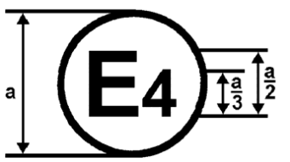

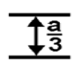

a = 8 mm min.
The above approval mark in Figure 1 affixed to a vehicle shows that the road vehicle type concerned has been approved in the Netherlands (E4), pursuant to Regulation No. 100, and under the approval number 022492. The first two digits of the approval number indicate that the approval was granted in accordance with the requirements of Regulation No. 100 as amended by 02 series of amendments.

Figure 2

To amend
“ES” has to be added & „01” has to be changed into “02”

The approval mark in Figure 2 affixed to a RESS shows that the RESS type (“ES”) concerned has been approved in the Netherlands (E4), pursuant to Regulation No. 100, and under the approval number 022492. The first two digits of the approval number indicate that the approval was granted in accordance with the requirements of Regulation No. 100 as amended by 02 series of amendments.

Model B
(see paragraph 4.5. of this Regulation)
To amend
100 | 01 2492
42 | 00 1628

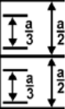

a = 8 mm min.

The above approval mark affixed to a vehicle shows that the road vehicle concerned has been approved in the Netherlands (E4) pursuant to Regulations Nos. 100 and 42 */. The approval number indicates that, at the dates when the respective approvals were granted, Regulation No. 100 was amended by the 02 series of amendments and Regulation No. 42 was still in its original form.

__________
*/ The latter number is given only as an example.
Annex 3

PROTECTION AGAINST DIRECT CONTACTS OF PARTS UNDER VOLTAGE

1. Access probes

Access probes to verify the protection of persons against access to live parts are given in table 1.

2. Test conditions

The access probe is pushed against any openings of the enclosure with the force specified in table 1. If it partly or fully penetrates, it is placed in every possible position, but in no case shall the stop face fully penetrate through the opening.

Internal barriers are considered part of the enclosure

A low-voltage supply (of not less than 40 V and not more than 50 V) in series with a suitable lamp should be connected, if necessary, between the probe and live parts inside the barrier or enclosure.

The signal-circuit method should also be applied to the moving live parts of high voltage equipment.

Internal moving parts may be operated slowly, where this is possible.

3. Acceptance conditions

The access probe shall not touch live parts.

If this requirement is verified by a signal circuit between the probe and live parts, the lamp shall not light.

In the case of the test for IPXXB, the jointed test finger may penetrate to its 80 mm length, but the stop face (diameter 50 mm x 20 mm) shall not pass through the opening. Starting from the straight position, both joints of the test finger shall be successively bent through an angle of up to 90 degree with respect to the axis of the adjoining section of the finger and shall be placed in every possible position.

In case of the tests for IPXXD, the access probe may penetrate to its full length, but the stop face shall not fully penetrate through the opening.

Table 1 - Access probes for the tests for protection of persons against access to hazardous parts

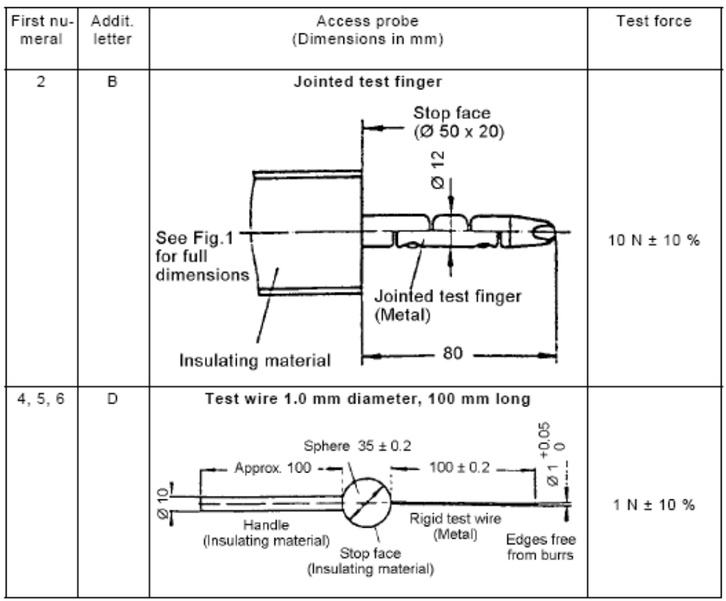
Figure 1 - Jointed test finger

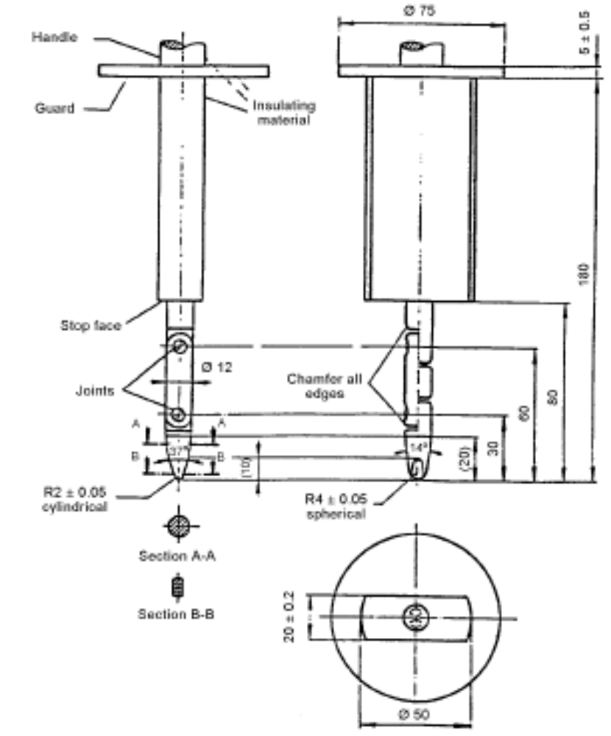

Material: metal, except where otherwise specified
Linear dimensions in millimeters
Tolerances on dimensions without specific tolerance:

(a) on angles: 0/-10°
(b) on linear dimensions: up to 25 mm: 0/-0.05 mm over 25 mm: ±0.2 mm

Both joints shall permit movement in the same plane and the same direction through an angle of 90° with a 0 to +10° tolerance.
Annex 4A

ISOlation Resistance Measurement Method FOR VEHICLE BASED TEST

1. General

The isolation resistance for each high voltage bus of the vehicle shall be measured or shall be determined by calculation using measurement values from each part or component unit of a high voltage bus (hereinafter referred to as the "divided measurement").

2. Measurement method

The isolation resistance measurement shall be conducted by selecting an appropriate measurement method from among those listed in Paragraphs 2.1. through 2.2., depending on the electrical charge of the live parts or the isolation resistance, etc.

The range of the electrical circuit to be measured shall be clarified in advance, using electrical circuit diagrams, etc.

Moreover, modification necessary for measuring the isolation resistance may be carried out, such as removal of the cover in order to reach the live parts, drawing of measurement lines, change in software, etc.

In cases where the measured values are not stable due to the operation of the on-board isolation resistance monitoring system, etc., necessary modification for conducting the measurement may be carried out, such as stopping of the operation of the device concerned or removing it. Furthermore, when the device is removed, it shall be proven, using drawings, etc., that it will not change the isolation resistance between the live parts and the electrical chassis.

Utmost care shall be exercised as to short circuit, electric shock, etc., for this confirmation might require direct operations of the high-voltage circuit.

2.1. Measurement method using DC voltage from off-vehicle sources

2.1.1. Measurement instrument

An isolation resistance test instrument capable of applying a DC voltage higher than the working voltage of the high voltage bus shall be used.

2.1.2. Measurement method

An insulator resistance test instrument shall be connected between the live parts and the electrical chassis. Then, the isolation resistance shall be measured by applying a DC voltage at least half of the working voltage of the high voltage bus.

If the system has several voltage ranges (e.g. because of boost converter) in galvanically connected circuit and some of the components cannot withstand the working voltage of the entire circuit, the isolation resistance between those components and the electrical chassis can be measured separately by applying at least half of their own working voltage with those component disconnected.

2.2. Measurement method using the vehicle’s own RESS as DC voltage source

2.2.1. Test vehicle conditions

The high voltage-bus shall be energized by the vehicle’s own RESS and/or energy conversion system and the voltage level of the RESS and/or energy conversion system throughout the test shall be at least the nominal operating voltage as specified by the vehicle manufacturer.

2.2.2. Measurement instrument

The voltmeter used in this test shall measure DC values and shall have an internal resistance of at least 10 MΩ.

2.2.3. Measurement method

2.2.3.1. First step

The voltage is measured as shown in Figure 1 and the high voltage Bus voltage (Vb) is recorded. Vb shall be equal to or greater than the nominal operating voltage of the RESS and/or energy conversion system as specified by the vehicle manufacturer.

Figure 1 - Measurement of Vb, V1, V2

Electrical Chassis
Electrical Chassis
High Voltage Bus
Energy Conversion
System Assembly
RESS Assembly
V2
V1
Vb
+
-
+
-
Energy
Conversion
System
RESS
Traction System

2.2.3.2. Second step

Measure and record the voltage (V1) between the negative side of the high voltage bus and the electrical chassis (see Figure 1).

2.2.3.3. Third step

Measure and record the voltage (V2) between the positive side of the high voltage bus and the electrical chassis (see Figure 1).

2.2.3.4. Fourth step
If V1 is greater than or equal to V2, insert a standard known resistance (Ro) between the negative side of the high voltage bus and the electrical chassis. With Ro installed, measure the voltage (V1’) between the negative side of the high voltage bus and the electrical chassis (see Figure 2).
Calculate the electrical isolation (Ri) according to the following formula:
Ri = Ro*(Vb/V1’ – Vb/V1) or Ri = Ro*Vb*(1/V1’ – 1/V1)

Figure 2 - Measurement of V1’

Electrical Chassis
Electrical Chassis
High Voltage Bus
Energy Conversion
System Assembly
RESS Assembly
V1´
Vb
+
-
+
-
Energy
Conversion
System
RESS
Traction System
R₀
If V2 is greater than V1, insert a standard known resistance (Ro) between the positive side of the high voltage bus and the electrical chassis. With Ro installed, measure the voltage (V2’) between the positive side of the high voltage bus and the electrical chassis. (See Figure 3). Calculate the electrical isolation (Ri) according to the formula shown. Divide this electrical isolation value (in Ω) by the nominal operating voltage of the high voltage bus (in volts).

Calculate the electrical isolation (Ri) according to the following formula:
Ri = Ro*(Vb/V2’ – Vb/V2) or Ri = Ro*Vb*(1/V2’ – 1/V2)
Figure 3 - Measurement of V2’

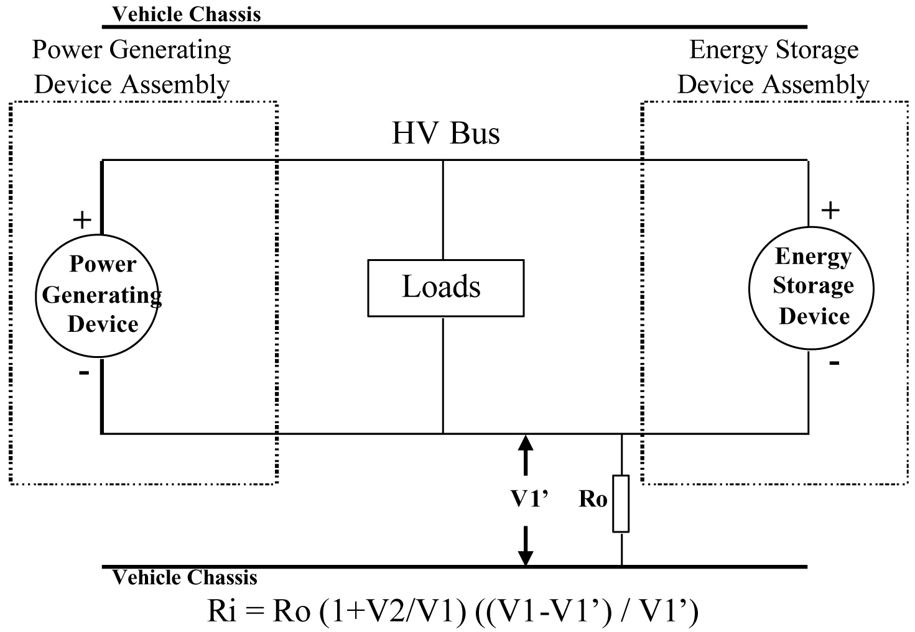
Electrical Chassis
Electrical Chassis
High Voltage Bus
Energy Conversion
System Assembly
RESS Assembly
V2'
+
-
+
-
Energy
Conversion
System
RESS
Traction System
R₀

2.2.3.5. Fifth step
The electrical isolation value Ri (in Ω) divided by the working voltage of the high voltage bus (in volts) results in the isolation resistance (in Ω/V).
NOTE 1: The standard known resistance Ro (in Ω) should be the value of the minimum required isolation resistance (in Ω/V) multiplied by the working voltage of the vehicle plus/minus 20 per cent (in volts). Ro is not required to be precisely this value since the equations are valid for any Ro; however, a Ro value in this range should provide good resolution for the voltage measurements.

Annex 4B

ISOlation Resistance Measurement Method FOR component based tests OF RESS

1. Measurement method

The isolation resistance measurement shall be conducted by selecting an appropriate measurement method from among those listed in Paragraphs 1.1. through 1.2., depending on the electrical charge of the live parts or the isolation resistance, etc.

The range of the electrical circuit to be measured shall be clarified in advance, using electrical circuit diagrams, etc.

Moreover, modification necessary for measuring the isolation resistance may be carried out, such as removal of the cover in order to reach the live parts, drawing of measurement lines, change in software, etc.

In cases where the measured values are not stable due to the operation of the isolation resistance monitoring system, etc., necessary modification for conducting the measurement may be carried out, such as stopping of the operation of the device concerned or removing it. Furthermore, when the device is removed, it shall be proven, using drawings, etc., that it will not change the isolation resistance between the live parts and the electrical chassis or ground connection.

Utmost care shall be exercised as to short circuit, electric shock, etc., for this confirmation might require direct operations of the high-voltage circuit.

1.1. Measurement method using DC voltage from external sources

1.1.1. Measurement instrument

An isolation resistance test instrument capable of applying a DC voltage higher than the working voltage of the high voltage bus or the nominal voltage of the device under test shall be used.

1.1.2. Measurement method

An insulation resistance test instrument shall be connected between the live parts and the electrical chassis or ground connection. Then, the isolation resistance shall be measured.

If the system has several voltage ranges (e.g. because of boost converter) in a galvanically connected circuit and some of the components cannot withstand the working voltage of the entire circuit, the isolation resistance between those components and the electrical chassis can be measured separately by applying at least half of their own working voltage with those component disconnected.

1.2. Measurement method using the RESS as DC voltage
source

1.2.1. Test conditions

The high voltage-bus, if any, shall be energized by the vehicle’s own RESS and/or energy conversion system and the voltage level of the RESS and/or energy conversion system or the device under test throughout the test shall be at least the nominal operating voltage.

1.2.2. Measurement instrument

The voltmeter used in this test shall measure DC values and shall have an internal resistance of at least 10 MΩ.

1.2.3. Measurement method

1.2.3.1. First step

The voltage is measured as shown in Figures 1 and 2 and the high voltage Bus voltage (Vb, Figure 1) or the DUT voltage (Vb, Figure 2) is recorded. Vb shall be equal to or greater than the nominal operating voltage of the RESS and/or energy conversion system.

Electrical Chassis
Electrical Chassis
High Voltage Bus
V2
V1
Vb
+
-
+
-
RESS
Traction System
Energy
Conversion
System
Figure1

Electrical Chassis
V2
V1
Vb
+
-
DUT
Figure 2

1.2.3.2. Second step

Measure and record the voltage (V1) between the negative side of the high voltage bus and the electrical chassis (see Figure 1) or the ground connection (Figure 2)

1.2.3.3. Third step

Measure and record the voltage (V2) between the positive side of the high voltage bus and the electrical chassis (see Figure 1) or the ground connection (Figure 2).

1.2.3.4. Fourth step
If V1 is greater than or equal to V2, insert a standard known resistance (Ro) between the negative side of the high voltage bus and the electrical chassis/ground connection. With Ro installed, measure the voltage (V1’) between the negative side of the high voltage bus and the electrical chassis/ ground connection (see Figure 3 and Figure 4).
Calculate the electrical isolation (Ri) according to the following formula:
Ri = Ro*(Vb/V1’ – Vb/V1) or Ri = Ro*Vb*(1/V1’ – 1/V1)
Electrical Chassis
Electrical Chassis
High Voltage Bus
V1’
Vb
+
-
+
-
RESS
Traction System
Energy
Conversion
System
R₀
Figure 3

Electrical Chassis
V1’
Vb
+
-
DUT
R₀
Figure 4
If V2 is greater than V1, insert a standard known resistance (Ro) between the positive side of the high voltage bus and the electrical chassis/ground connection. With Ro installed, measure the voltage (V2’) between the positive side of the high voltage bus and the electrical chassis/ground connection (Figure 5 and Figure 6). Calculate the electrical isolation (Ri) according to the formula shown. Divide this electrical isolation value (in Ω) by the nominal operating voltage of the high voltage bus (in volts).

Calculate the electrical isolation (Ri) according to the following formula:
Ri = Ro*(Vb/V2’ – Vb/V2) or Ri = Ro*Vb*(1/V2’ – 1/V2)
Electrical Chassis
Electrical Chassis
High Voltage Bus
V2’
Vb
+
-
+
-
RESS
Traction System
Energy
Conversion
System
R₀
Figure 5

Electrical Chassis
V2’
Vb
+
-
DUT
R₀
Figure 6

1.2.3.5. Fifth step
The electrical isolation value Ri (in Ω) divided by the working voltage of the high voltage bus or the RESS/DUT (in volts) results in the isolation resistance (in Ω/V).
NOTE 1: The standard known resistance Ro (in Ω) should be the value of the minimum required isolation resistance (in Ω/V) multiplied by the working voltage of the vehicle or RESS plus/minus 20 per cent (in volts). Ro is not required to be precisely this value since the equations are valid for any Ro; however, a Ro value in this range should provide good resolution for the voltage measurements.

Annex 5

Confirmation Method for Functions of On-board Isolation Resistance Monitoring System

The function of the on-board isolation resistance monitoring system shall be confirmed by the following method:
Insert a resistor that does not cause the isolation resistance between the terminal being monitored and the electrical chassis to drop below the minimum required isolation resistance value. The warning shall be activated.

Annex 6 Part 1

ESSENTIAL CHARACTERISTICS OF ROAD VEHICLES OR SYSTEMS

1. General

1.1. Make (trade name of manufacturer):
1.2. Type:
1.3. Vehicle category:
1.4. Commercial name(s) if available:
1.5. Manufacturer's name and address:
1.6. If applicable, name and address of manufacturer's representative:
1.7. Drawing and/or photograph of the vehicle:
1.8. Approval number of the RESS

2. Electric motor (traction motor)

2.1. Type (winding, excitation):
2.2. Maximum net power and / or maximum 30 Minutes power (kW):

3. RESS
3.1. Trade name and mark of the battery RESS:
3.2. Indication of all types of electro-chemical cells:
3.2.1. The cell chemistry:
[3.2.2. Physical dimensions]:
3.3. Description or drawing(s) or picture(s) of the Module(s) and /or RESS explaining:
3.3.1. Structure
3.3.2. Configuration (number of cells, mode of connection, etc.)
3.3.3. Dimensions:
3.3.4. Enclosures:
3.4. Electrical specification
3.4.1. Nominal voltage (V):
3.4.2. Working voltage (V):
3.4.3. Capacity (Ah):
3.4.4. Maximum current (A):
3.5. Gas combination rate (in per cent):
3.6. Description or drawing(s) or picture(s) of the installation of the RESS in the vehicle:
3.6.1. Physical support:
3.7. Type of thermal management:
3.8. Electronic control:
3.9. Category of vehicles which the RESS can be installed:

4. Fuel Cell (if any)

4.1. Trade name and mark of the fuel cell:
4.2. Types of fuel cell:
4.3. Nominal voltage (V):
4.4. Number of cells:
4.5. Type of cooling system (if any):
4.6. Max Power(kW):

5. Fuse and/or circuit breaker

5.1. Type:
5.2. Diagram showing the functional range:

6. Power wiring harness

6.1. Type:

7. Protection against Electric Shock

7.1. Description of the protection concept:

8. Additional data

8.1. Brief description of the power circuit components installation or drawings/pictures showing the location of the power circuit components installation:
8.2 Schematic diagram of all electrical functions included in power circuit:
8.3. Working voltage (V):

Annex 6 Part 2

ESSENTIAL CHARACTERISTICS OF RESS

3. RESS
3.1. Trade name and mark of the RESS:
3.2. Indication of all types of cells:
3.2.1. The cell chemistry:
[3.2.2. Physical dimensions]:
3.3. Description or drawing(s) or picture(s) of the Module(s) and /or RESS explaining:
3.3.1. Structure
3.3.2. Configuration (number of cells, mode of connection, etc.)
3.3.3. Dimensions:
3.3.4. Enclosures:
3.4. Electrical specification
3.4.1. Nominal voltage (V):
3.4.2. Working voltage (V):
3.4.3. Capacity (Ah):
3.4.4. Maximum current (A):
3.5. Gas combination rate (in per cent):
3.6. Description or drawing(s) or picture(s) of the installation of the RESS in the vehicle:
3.6.1. Physical support:
3.7. Type of thermal management:
3.8. Electronic control:
3.9. Category of vehicles which the RESS can be installed:

Annex 7

DETERMINATION OF HYDROGEN EMISSIONS
DURING THE CHARGE PROCEDURES OF THE TRACTION BATTERY

1. INTRODUCTION

This annex describes the procedure for the determination of hydrogen emissions during the charge procedures of the traction battery of all road vehicles, according to paragraph 5.4. of this Regulation.

2. DESCRIPTION OF TEST

The hydrogen emission test (Figure 7.1) is conducted in order to determine hydrogen emissions during the charge procedures of the traction battery with the on-board charger. The test consists in the following steps:

(a) vehicle preparation,

(b) discharge of the traction battery,

(c) determination of hydrogen emissions during a normal charge,

(d) determination of hydrogen emissions during a charge carried out with the on-board charger failure.

3. VEHICLE

3.1. The vehicle shall be in good mechanical condition and have been driven at 300 km during seven days before the test. The vehicle shall be equipped with the traction battery subject to the test of hydrogen emissions, over this period.

3.2. If the battery is used at a temperature above the ambient temperature, the operator shall follow the manufacturer's procedure in order to keep the traction battery temperature in normal functioning range.

The manufacturer's representative shall be able to certify that the temperature conditioning system of the traction battery is neither damaged nor presenting a capacity defect.
Figure 7.1
Determination of hydrogen emissions during
the charge procedures of the traction battery

Discharge of the traction battery
Ambient temperature 293 to 303 K
Soak
Hydrogen emission test
during a normal charge
END
Soak
Hydrogen emission test
during an on-board charger failure
Ambient temperature 293 K ± 2 K
START
Vehicle preparation
(if necessary)
Discharge of the traction battery
Ambient temperature 293 to 303 K
Maximum 7 days days days
Maximum 15 min
12 to 36 h

36 h
12 to
36 h
Maximum 7 days
Maximum 15 min
Maximum 2 min after connection to mains
Maximum 2 min after connection to mains

to mains

4. TEST EQUIPMENT FOR HYDROGEN EMISSION TEST

4.1. Chassis dynamometer

The chassis dynamometer shall meet the requirements of the 05 series of amendments to Regulation No. 83.

4.2. Hydrogen emission measurement enclosure

The hydrogen emission measurement enclosure shall be a gas-tight measuring chamber able to contain the vehicle under test. The vehicle shall be accessible from all sides and the enclosure when sealed shall be gas-tight in accordance with appendix 1 to this annex. The inner surface of the enclosure shall be impermeable and non-reactive to hydrogen. The temperature conditioning system shall be capable of controlling the internal enclosure air temperature to follow the prescribed temperature throughout the test, with an average tolerance of ± 2 K over the duration of the test.

To accommodate the volume changes due to enclosure hydrogen emissions, either a variable-volume or another test equipment may be used. The variable-volume enclosure expands and contracts in response to the hydrogen emissions in the enclosure. Two potential means of accommodating the internal volume changes are movable panels, or a bellows design, in which impermeable bags inside the enclosure expand and contract in response to internal pressure changes by exchanging air from outside the enclosure. Any design for volume accommodation shall maintain the integrity of the enclosure as specified in Appendix 1 to this annex.

Any method of volume accommodation shall limit the differential between the enclosure internal pressure and the barometric pressure to a maximum value of ± 5 hPa.

The enclosure shall be capable of latching to a fixed volume. A variable volume enclosure shall be capable of accommodating a change from its "nominal volume" (see Annex 7, Appendix 1, paragraph 2.1.1.), taking into account hydrogen emissions during testing.

4.3. Analytical systems

4.3.1. Hydrogen analyser

4.3.1.1. The atmosphere within the chamber is monitored using a hydrogen analyser (electrochemical detector type) or a chromatograph with thermal conductivity detection. Sample gas shall be drawn from the mid-point of one side-wall or roof of the chamber and any bypass flow shall be returned to the enclosure, preferably to a point immediately downstream of the mixing fan.

4.3.1.2. The hydrogen analyser shall have a response time to 90 per cent of final reading of less than 10 seconds. Its stability shall be better than 2 per cent of full scale at zero and at 80 per cent ± 20 per cent of full scale, over a 15-minute period for all operational ranges.

4.3.1.3. The repeatability of the analyser expressed as one standard deviation shall be better than 1 per cent of full scale, at zero and at 80 per cent ± 20 per cent of full scale on all ranges used.

4.3.1.4. The operational ranges of the analyser shall be chosen to give best resolution over the measurement, calibration and leak checking procedures.

4.3.2. Hydrogen analyser data recording system

The hydrogen analyser shall be fitted with a device to record electrical signal output, at a frequency of at least once per minute. The recording system shall have operating characteristics at least equivalent to the signal being recorded and shall provide a permanent record of results. The recording shall show a clear indication of the beginning and end of the normal charge test and charging failure operation.

4.4. Temperature recording

4.4.1. The temperature in the chamber is recorded at two points by temperature sensors, which are connected so as to show a mean value. The measuring points are extended approximately 0.1 m into the enclosure from the vertical centre line of each side-wall at a height of 0.9 ± 0.2 m.

4.4.2. The temperatures of the battery modules are recorded by means of the sensors.

4.4.3. Temperatures shall, throughout the hydrogen emission measurements, be recorded at a frequency of at least once per minute.

4.4.4. The accuracy of the temperature recording system shall be within ± 1.0 K and the temperature shall be capable of being resolved to ± 0.1 K.

4.4.5. The recording or data processing system shall be capable of resolving time to ± 15 seconds.

4.5. Pressure recording

4.5.1. The difference Δp between barometric pressure within the test area and the enclosure internal pressure shall, throughout the hydrogen emission measurements, be recorded at a frequency of at least once per minute.

4.5.2. The accuracy of the pressure recording system shall be within ± 2 hPa and the pressure shall be capable of being resolved to ± 0.2 hPa.
4.5.3. The recording or data processing system shall be capable of resolving time to ± 15 seconds.

4.6. Voltage and current intensity recording

4.6.1. The on-board charger voltage and current intensity (battery) shall, throughout the hydrogen emission measurements, be recorded at a frequency of at least once per minute.

4.6.2. The accuracy of the voltage recording system shall be within ± 1 V and the voltage shall be capable of being resolved to ± 0.1 V.

4.6.3. The accuracy of the current intensity recording system shall be within ± 0.5 A and the current intensity shall be capable of being resolved to ± 0.05 A.

4.6.4. The recording or data processing system shall be capable of resolving time to ± 15 seconds.

4.7. Fans

The chamber shall be equipped with one or more fans or blowers with a possible flow of 0.1 to 0.5 m³/second in order to thoroughly mix the atmosphere in the enclosure. It shall be possible to reach a homogeneous temperature and hydrogen concentration in the chamber during measurements. The vehicle in the enclosure shall not be subjected to a direct stream of air from the fans or blowers.

4.8. Gases

4.8.1. The following pure gases shall be available for calibration and operation:

(a) purified synthetic air (purity <1 ppm C1 equivalent; <1 ppm CO; <400 ppm CO₂; <0.1 ppm NO ); oxygen content between 18 and 21 per cent by volume,

(b) hydrogen ( H₂ ), 99.5 per cent minimum purity.

4.8.2. Calibration and span gases shall contain mixtures of hydrogen (H2) and purified synthetic air. The real concentrations of a calibration gas shall be within ± 2 per cent of the nominal values. The accuracy of the diluted gases obtained when using a gas divider shall be within ± 2 per cent of the nominal value. The concentrations specified in appendix 1 may also be obtained by a gas divider using synthetic air as the dilution gas.

5. TEST PROCEDURE

The test consists in the five following steps:

(a) vehicle preparation,

(b) discharge of the traction battery,

(c) determination of hydrogen emissions during a normal charge,

(d) discharge of the traction battery,

(e) determination of hydrogen emissions during a charge carried out with the on-board charger failure.

If the vehicle has to be moved between two steps, it shall be pushed to the following test area.

5.1. Vehicle preparation

The ageing of traction battery shall be checked, proving that the vehicle has performed at least 300 km during seven days before the test. During this period, the vehicle shall be equipped with the traction battery submitted to the hydrogen emission test. If this cannot be demonstrated then the following procedure will be applied.

5.1.1. Discharges and initial charges of the battery

The procedure starts with the discharge of the traction battery of the vehicle while driving on the test track or on a chassis dynamometer at a steady speed of 70 per cent ± 5 per cent of the maximum speed of the vehicle during 30 minutes.

Discharging is stopped:

(a) when the vehicle is not able to run at 65 per cent of the maximum thirty minutes speed, or

(b) when an indication to stop the vehicle is given to the driver by the standard on-board instrumentation, or

(c) after having covered the distance of 100 km.

5.1.2. Initial charge of the battery

The charge is carried out:

(a) with the on-board charger,
(b) in an ambient temperature between 293 K and 303 K.

The procedure excludes all types of external chargers.

The end of traction battery charge criteria corresponds to an automatic stop given by the on-board charger.

This procedure includes all types of special charges that could be automatically or manually initiated like, for instance, the equalisation charges or the servicing charges.

5.1.3. Procedure from paragraphs 5.1.1. to 5.1.2. shall be repeated two times.

5.2. Discharge of the battery

The traction battery is discharged while driving on the test track or on a chassis dynamometer at a steady speed of 70 per cent ± 5 per cent from the maximum thirty minutes speed of the vehicle.

Stopping the discharge occurs:

(a) when an indication to stop the vehicle is given to the driver by the standard on-board instrumentation, or

(b) when the maximum speed of the vehicle is lower than 20 km/h.

5.3. Soak

Within fifteen minutes of completing the battery discharge operation specified in 5.2., the vehicle is parked in the soak area. The vehicle is parked for a minimum of 12 hours and a maximum of 36 hours, between the end of the traction battery discharge and the start of the hydrogen emission test during a normal charge. For this period, the vehicle shall be soaked at 293 K ± 2 K.

5.4. Hydrogen emission test during a normal charge

5.4.1. Before the completion of the soak period, the measuring chamber shall be purged for several minutes until a stable hydrogen background is obtained. The enclosure mixing fan(s) shall also be turned on at this time.

5.4.2. The hydrogen analyser shall be zeroed and spanned immediately prior to the test.

5.4.3. At the end of the soak, the test vehicle, with the engine shut off and the test vehicle windows and luggage compartment opened shall be moved into the measuring chamber.

5.4.4. The vehicle shall be connected to the mains. The battery is charged according to normal charge procedure as specified in paragraph 5.4.7 below.

5.4.5. The enclosure doors are closed and sealed gas-tight within two minutes from electrical interlock of the normal charge step.

5.4.6. The start of a normal charge for hydrogen emission test period begins when the chamber is sealed. The hydrogen concentration, temperature and barometric pressure are measured to give the initial readings C_{H2i}, T_{i} and P_{i} for the normal charge test.

These figures are used in the hydrogen emission calculation (paragraph 6.). The ambient enclosure temperature T shall not be less than 291 K and no more than 295 K during the normal charge period.

5.4.7. Procedure of normal charge

The normal charge is carried out with the on-board charger and consists of the following steps:

(a) charging at constant power during t₁;

(b) over-charging at constant current during t₂. Over-charging intensity is specified by manufacturer and corresponds to the one used during equalisation charging.

The end of traction battery charge criteria corresponds to an automatic stop given by the on-board charger to a charging time of t₁ + t₂. This charging time will be limited to t₁ + 5 h, even if a clear indication is given to the driver by the standard instrumentation that the battery is not yet fully charged.

5.4.8. The hydrogen analyser shall be zeroed and spanned immediately before the end of the test.

5.4.9. The end of the emission sampling period occurs t₁ + t₂ or t₁ + 5 h after the beginning of the initial sampling, as specified in paragraph 5.4.6. The different times elapsed are recorded. The hydrogen concentration, temperature and barometric pressure are measured to give the final readings C_{H2f}, T_{f} and P_{f} for the normal charge test, used for the calculation in paragraph 6.

5.5. Hydrogen emission test with the on-board charger failure

5.5.1. Within seven days maximum after having completed the prior test, the procedure starts with the discharge of the traction battery of the vehicle according to paragraph 5.2.
5.5.2. The steps of the procedure in paragraph 5.3 shall be repeated.

5.5.3. Before the completion of the soak period, the measuring chamber shall be purged for several minutes until a stable hydrogen background is obtained. The enclosure mixing fan(s) shall also be turned on at this time.

5.5.4. The hydrogen analyser shall be zeroed and spanned immediately prior to the test.

5.5.5. At the end of the soak, the test vehicle, with the engine shut off and the test vehicle windows and luggage compartment opened shall be moved into the measuring chamber.

5.5.6. The vehicle shall be connected to the mains. The battery is charged according to failure charge procedure as specified in paragraph 5.5.9. below.

5.5.7. The enclosure doors are closed and sealed gas-tight within two minutes from electrical interlock of the failure charge step.

5.5.8. The start of a failure charge for hydrogen emission test period begins when the chamber is sealed. The hydrogen concentration, temperature and barometric pressure are measured to give the initial readings C_{H2i}, T_{i} and P_{i} for the failure charge test.

These figures are used in the hydrogen emission calculation (paragraph 6). The ambient enclosure temperature T shall not be less than 291 K and no more than 295 K during the charging failure period.

5.5.9. Procedure of charging failure

The charging failure is carried out with the on-board charger and consists of the following steps:

(a) charging at constant power during t'₁;

(b) charging at maximum current during 30 minutes. During this phase, the on-board charger is blocked at maximum current.

5.5.10. The hydrogen analyser shall be zeroed and spanned immediately before the end of the test.

5.5.11. The end of test period occurs t'₁ + 30 minutes after the beginning of the initial sampling, as specified in paragraph 5.5.8. The times elapsed are recorded. The hydrogen concentration, temperature and barometric pressure are measured to give the final readings C_{H2f}, T_{f} and P_{f} for the charging failure test, used for the calculation in paragraph 6.

6. CALCULATION

The hydrogen emission tests described in paragraph 5 allow the calculation of the hydrogen emissions from the normal charge and charging failure phases. Hydrogen emissions from each of these phases are calculated using the initial and final hydrogen concentrations, temperatures and pressures in the enclosure, together with the net enclosure volume.

The formula below is used:

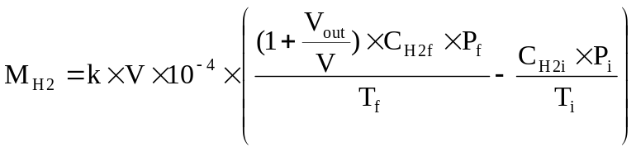
where:

M_{H2} = hydrogen mass, in grams

C_{H2} = measured hydrogen concentration in the enclosure, in ppm volume

V = net enclosure volume in cubic metres (m³) corrected for the

volume of the vehicle, with the windows and the luggage compartment open. If the volume of the vehicle is not determined a volume of 1.42 m³ is subtracted.

V_{out} = compensation volume in m³, at the test temperature and pressure

T = ambient chamber temperature, in K

P = absolute enclosure pressure, in kPa

k = 2.42

where: i is the initial reading
f is the final reading

6.1. Results of test

The hydrogen mass emissions for the vehicle are:

MN = hydrogen mass emission for normal charge test, in grams

MD = hydrogen mass emission for charging failure test, in grams

Annex 7 - Appendix 1

CALIBRATION OF EQUIPMENT
FOR HYDROGEN EMISSION TESTING

- CALIBRATION FREQUENCY AND METHODS

All equipment shall be calibrated before its initial use and then calibrated as often as necessary and in any case in the month before type approval testing. The calibration methods to be used are described in this appendix.

2. CALIBRATION OF THE ENCLOSURE

2.1. Initial determination of enclosure internal volume

2.1.1. Before its initial use, the internal volume of the chamber shall be determined as follows. The internal dimensions of the chamber are carefully measured, taking into account any irregularities such as bracing struts. The internal volume of the chamber is determined from these measurements.

The enclosure shall be latched to a fixed volume when the enclosure is held at an ambient temperature of 293 K. This nominal volume shall be repeatable within ± 0.5 per cent of the reported value.

2.1.2. The net internal volume is determined by subtracting 1.42 m³ from the internal volume of the chamber. Alternatively the volume of the test vehicle with the luggage compartment and windows open may be used instead of the 1.42 m³.

2.1.3. The chamber shall be checked as in paragraph 2.3. If the hydrogen mass does not agree with the injected mass to within ± 2 per cent then corrective action is required.

2.2. Determination of chamber background emissions

This operation determines that the chamber does not contain any materials that emit significant amounts of hydrogen. The check shall be carried out at the enclosure's introduction to service, after any operations in the enclosure which may affect background emissions and at a frequency of at least once per year.

2.2.1. Variable-volume enclosure may be operated in either latched or unlatched volume configuration, as described in paragraph 2.1.1. Ambient temperature shall be maintained at 293 K ± 2 K, throughout the 4-hour period mentioned below.

2.2.2. The enclosure may be sealed and the mixing fan operated for a period of up to 12 hours before the four-hour background-sampling period begins.

2.2.3. The analyser (if required) shall be calibrated, then zeroed and spanned.

2.2.4. The enclosure shall be purged until a stable hydrogen reading is obtained, and the mixing fan turned on if not already on.

2.2.5. The chamber is then sealed and the background hydrogen concentration, temperature and barometric pressure are measured. These are the initial readings C_{H2i}, T_{i} and P_{i} used in the enclosure background calculation.

2.2.6. The enclosure is allowed to stand undisturbed with the mixing fan on for a period of four hours.

2.2.7. At the end of this time the same analyser is used to measure the hydrogen concentration in the chamber. The temperature and the barometric pressure are also measured. These are the final readings C_{H2f}, T_{f} and P_{f}.

2.2.8. The change in mass of hydrogen in the enclosure shall be calculated over the time of the test in accordance with paragraph 2.4 and shall not exceed 0.5 g.

2.3. Calibration and hydrogen retention test of the chamber

The calibration and hydrogen retention test in the chamber provides a check on the calculated volume (paragraph 2.1) and also measures any leak rate. The enclosure leak rate shall be determined at the enclosure's introduction to service, after any operations in the enclosure which may affect the integrity of the enclosure, and at least monthly thereafter. If six consecutive monthly retention checks are successfully completed without corrective action, the enclosure leak rate may be determined quarterly thereafter as long as no corrective action is required.

2.3.1. The enclosure shall be purged until a stable hydrogen concentration is reached. The mixing fan is turned on, if not already switched on. The hydrogen analyser is zeroed, calibrated if required, and spanned.

2.3.2. The enclosure shall be latched to the nominal volume position.

2.3.3. The ambient temperature control system is then turned on (if not already on) and adjusted for an initial temperature of 293 K.

2.3.4. When the enclosure temperature stabilizes at 293 K ± 2 K, the enclosure is sealed and the background concentration, temperature and barometric pressure measured. These are the initial readings C_{H2i}, T_{i} and P_{i} used in the enclosure calibration.

2.3.5. The enclosure shall be unlatched from the nominal volume.

2.3.6. A quantity of approximately 100 g of hydrogen is injected into the enclosure. This mass of hydrogen shall be measured to an accuracy of ± 2 per cent of the measured value.

2.3.7. The contents of the chamber shall be allowed to mix for five minutes and then the hydrogen concentration, temperature and barometric pressure are measured. These are the final readings C_{H2f}, T_{f} and P_{f} for the calibration of the enclosure as well as the initial readings CH2i, T_{i} and P_{i} for the retention check.

2.3.8. On the basis of the readings taken in paragraphs 2.3.4 and 2.3.7 and the formula in paragraph 2.4, the mass of hydrogen in the enclosure is calculated. This shall be within ± 2 per cent of the mass of hydrogen measured in paragraph 2.3.6.

2.3.9. The contents of the chamber shall be allowed to mix for a minimum of 10 hours. At the completion of the period, the final hydrogen concentration, temperature and barometric pressure are measured and recorded. These are the final readings C_{H2f}, T_{f} and P_{f} for the hydrogen retention check.

2.3.10. Using the formula in paragraph 2.4, the hydrogen mass is then calculated from the readings taken in paragraphs 2.3.7 and 2.3.9. This mass may not differ by more than 5 per cent from the hydrogen mass given by paragraph 2.3.8.

2.4. Calculation

The calculation of net hydrogen mass change within the enclosure is used to determine the chamber's hydrocarbon background and leak rate. Initial and final readings of hydrogen concentration, temperature and barometric pressure are used in the following formula to calculate the mass change.

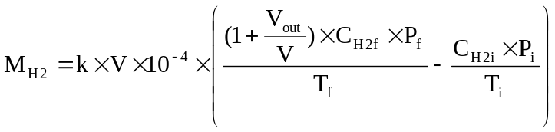
where:

M_{H2} = hydrogen mass, in grams

C_{H2} = measured hydrogen concentration into the enclosure, in ppm volume

V = enclosure volume in cubic metres (m³) as measured in paragraph 2.1.1.

V_{out} = compensation volume in m³, at the test temperature and pressure

T = ambient chamber temperature, in K

P = absolute enclosure pressure, in kPa

k = 2.42

where: i is the initial reading

f is the final reading

3. CALIBRATION OF THE HYDROGEN ANALYSER

The analyser should be calibrated using hydrogen in air and purified synthetic air. See paragraph 4.8.2. of annex 7.

Each of the normally used operating ranges are calibrated by the following procedure:

3.1. Establish the calibration curve by at least five calibration points spaced as evenly as possible over the operating range. The nominal concentration of the calibration gas with the highest concentrations to be at least 80 per cent of the full scale.

3.2. Calculate the calibration curve by the method of least squares. If the resulting polynomial degree is greater than 3, then the number of calibration points shall be at least the number of the polynomial degree plus 2.

3.3. The calibration curve shall not differ by more than 2 per cent from the nominal value of each calibration gas.

3.4. Using the coefficients of the polynomial derived from paragraph 3.2. above, a table of analyser readings against true concentrations shall be drawn by steps no greater than 1 per cent of full scale. This is to be carried out for each analyser range calibrated.

This table shall also contain other relevant data such as:

(a) date of calibration;

(b) span and zero potentiometer readings (where applicable);

(c) nominal scale;

(d) reference data of each calibration gas used;

(e) real and indicated value of each calibration gas used together with the percentage differences;

(f) calibration pressure of analyser.
3.5. Alternative methods (e.g. computer, electronically controlled range switch) can be used if it is proven to the technical service that these methods give equivalent accuracy.

Annex 7 - Appendix 2

ESSENTIAL CHARACTERISTICS OF THE VEHICLE FAMILY

1. PARAMETERS DEFINING THE FAMILY RELATIVE TO HYDROGEN EMISSIONS

The family may be defined by basic design parameters which shall be common to vehicles within the family. In some cases there may be interaction of parameters. These effects shall also be taken into consideration to ensure that only vehicles with similar hydrogen emission characteristics are included within the family.

2. To this end, those vehicle types whose parameters described below are identical are considered to belong to the same hydrogen emissions.

Traction battery:

(a) trade name or mark of the battery

(b) indication of all types of electro-chemical couples used

(c) number of battery cells

(d) number of battery modules

(e) nominal voltage of the battery (V)

(f) battery energy (kWh)

(g) gas combination rate (in per cent)

(h) type(s) of ventilation for battery module(s) or pack

(i) type of cooling system (if any)

On-board charger:

(a) make and type of different charger parts

(b) output nominal power (kW)

(c) maximum voltage of charge (V)

(d) maximum intensity of charge (A)

(e) make and type of control unit (if any)

(f) diagram of operating, controls and safety

(g) characteristics of charge periods

Annex 8

Testing of RESS

1. General test conditions

If not otherwise stated in the test procedure, the following condition shall apply to the tests specified in Annex 8A through Annex 8J;

(a) the test shall be conducted under standard ambient temperature of 20 ± 10 °C.
(b) at the beginning of the test, the state of charge of device under tets shall be adjusted to a value in the upper 50% of the normal operating state of charge range.
(c) at the beginning of the test, all internal and external protection devices which effect the function of the DUT and are relevant for the outcome of the test shall be operational.
(d) at the end of each test, the DUT shall be observed for [1] h at the ambient temperature conditions of the test environment.

2. Test with subsystem of the RESS

If the manufacturer chose related subsystems of the RESS, the manufacturer shall demonstrate such test result can reasonably represent the performance of the complete RESS with respect to the safety performance under similar condition.

[3. Test samples

In principle, each test shall be conducted with different samples of RESS or its subsystem. However, at the discretion of manufacturer with agreement of the technical service, two or more tests can be conducted in series with the same sample where the sequence of the test shall be determined between the manufacture and technical service and after each test necessary inspection and/or maintenance, conditioning may be conducted.]

4. Standard Cycle
The standard cycle is performed at ambient temperature. If needed, the device under test shall be acclimatized at the test temperature prior to performing the SC.

Standard discharge (SDCH):
Discharge rate: 1C
Discharge limit (end voltage): specified by battery manufacturer
Rest period after discharge: 30 min or thermal equilibrium at test temperature

Standard charge (SCH):
Charge procedure including termination criteria as defined by battery manufacturer. If not specified, charge with C/3 current.
Rest after charge: 1 h or thermal equilibrium at test temperature

Annex 8A

VIBRATION TEST

1. PURPOSE

The purpose of this test is to verify the safety performance of the RESS under a vibration environment which the RESS will likely experience during the normal operation of the vehicle.

2. INSTALLATIONS

This test shall be conducted either with the complete RESS or with related subsystems of the RESS including the cells and their electrical connections. If certain electronic management unit for the RESS is not integrated, such control unit may not be installed on the device under test. The device under test shall be firmly secured to the platform of the vibration machine in such a manner as to faithfully transmit the vibration.

3. PROCEDURES

The vibration shall be a sinusoidal waveform with a logarithmic sweep between 7 Hz and 50 Hz and back to 7 Hz traversed in 15 minutes. This cycle shall be repeated 12 times for a total of 3 hours for each of three mutually perpendicular mounting positions of the device under tets.

The correlation between frequency and acceleration shall be conduct as shown in table 1:

Table 1: Frequency and acceleration

Frequency  [Hz] | Acceleration  [m/s2]
75 - 18 | 10
18 - 30 | 5
30 – 50 | 2

At the request of the manufacturer, a higher acceleration level as well as a higher maximum frequency can be conducted.
At the request of the manufacturer a test profile determined by the vehicle-manufacturer, verified to the vehicle application and agreed by the technical service can be used as a substitute of the frequency – acceleration correlation of table 1.

Open circuit voltage of the device under test, if requested by the manufacturer, may be measured prior to initiation of vibration and after the vibration.

After the vibration, a standard cycle as described in Annex 8, Appendix 1 shall be conducted, if not inhibited by the device under test.

Annex 8B

THERMAL SHOCK AND CYCLING TEST

1. PURPOSE

The purpose of this test is to verify the resistance of the RESS to sudden changes in temperature. The RESS undergo a specified number of temperature cycles, which start at standard ambient temperature followed by high and low temperature cycling. It simulates a rapid environmental temperature change which a RESS will likely experience during its life.

2. INSTALLATIONS

This test shall be conducted either with the complete RESS or with related subsystems of the RESS including the cells and their electrical connections. If certain electronic management unit for the RESS is not integrated, such control unit may not be installed on the device under test.

3. PROCEDURES

The device under test shall be stored for at least six hours at a test temperature equal to 72 ± 2 °C, followed by storage for at least six hours at a test temperature equal to -40 ± 2°C. The maximum time interval between test temperature extremes is 30 minutes. This procedure is to be repeated at least 5 total cycles are completed, after which the device under test shall be stored for 24 hours at standard ambient temperature (20 ± 10 °C).

After the storage of 24 hours, a standard cycle as described in Annex 8, Appendix 1 shall be conducted, if not inhibited by the device under test.

Annex 8C

Mechanical shock

1. PURPOSE

The purpose of this test is to verify the safety performance of the RESS under inertial loads which may occur during vehicle crash situation.

2. INSTALLATIONS

This test shall be conducted either with the complete RESS or with related subsystems of the RESS including the cells and their electrical connections. If certain electronic management unit for the RESS is not integrated, such control unit may not be installed on the device under test. The device under test shall be connected to the test fixture only by the intended mounting methods.

3. PROCEDURES

The device under test shall be applied to the shock levels described in Table 5 and 6 in both positive and negative directions.

For every of the 4 evaluation conditions, a separate device under test can be used.

In order to determine potential for fire hazard an evaluation for potential flammable concentrations of vapors shall be included by use of a minimum of two continuous spark sources located near anticipated sources of vapour such as vent opening or at the vent duct. The continuous spark sources are to provide at least two sparks per second with sufficient energy to ignite natural gas. (Reference to CSDS UL 2580-2011)

Table 5 – Shock levels in direction of travel
 | Acceleration
[RESS] fitted vehicles of categories M1 and N1 | 20g
[RESS] fitted vehicles of categories M2 and N2 | 10g
[RESS] fitted vehicles of categories M3 and N3 | 6.6g

Table 6 – Shock levels horizontally perpendicular to the direction
of travel
 | Acceleration
[RESS] fitted vehicles of categories M1 and N1 | 8g
[RESS] fitted vehicles of categories M2 and N2 | 5g
[RESS] fitted vehicles of categories M3 and N3 | 5g

Diagram 1 – minimum shock pulse
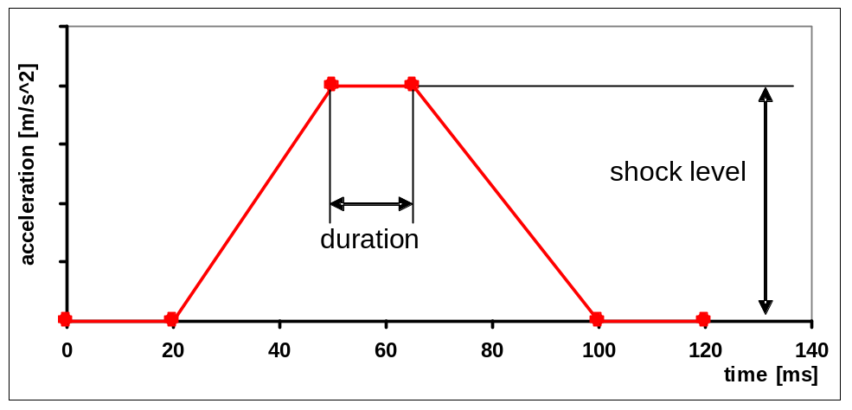

Diagram 2 – sinus shock pulse
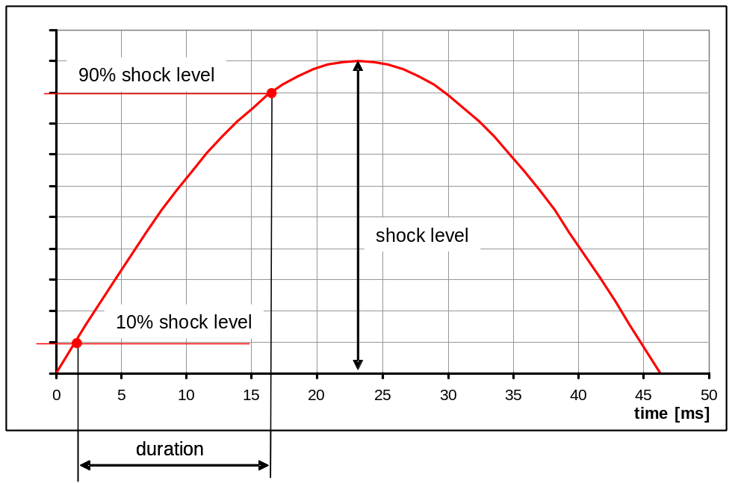

The test pulse shall describe a half sinus with duration of 15ms between 10% and 90% of the shock level.

The test pulse shall be within the minimum and maximum curve as described in diagram 1 to 6. A higher shock level and longer duration as described in the maximum curve in diagram 1 to 6 can be applied to RESS if recommended by the manufacturer.

Diagram 1 Diagram 2
M1, N1 Shock levels and duration in direction of travel M1, N1 Shock levels and duration in horizontally perpendicular to the direction of travel
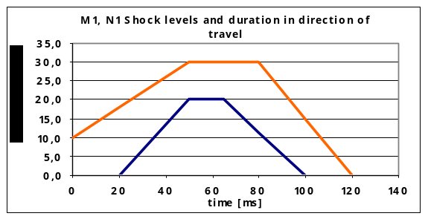
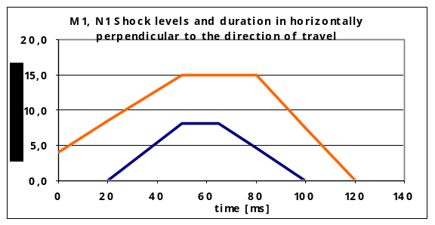

Diagram 3 Diagram 4
M2, N2 Shock levels and duration in direction of travel M2, N2 Shock levels and duration in horizontally perpendicular to the direction of travel
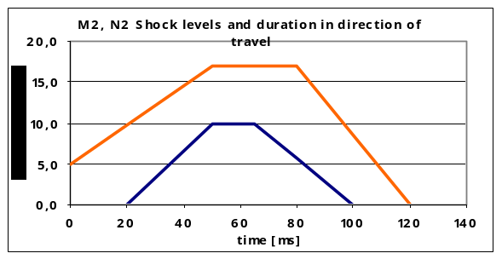
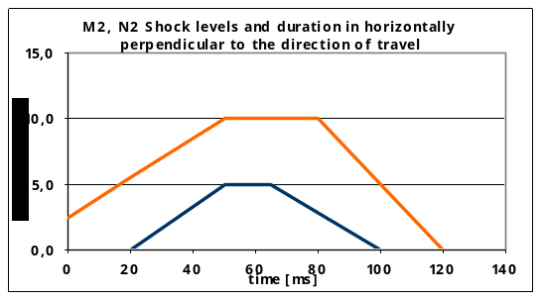

Diagram 5 Diagram 6
M3, N3 Shock levels and duration in direction of travel M3, N3 Shock levels and duration in horizontally
perpendicular to the direction of travel
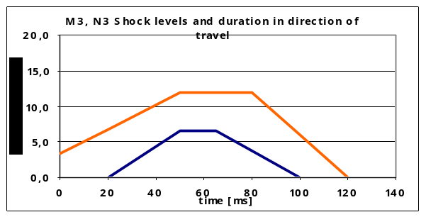
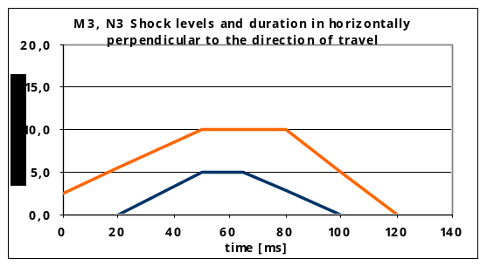

Annex 8D

Mechanical integrity

1. PURPOSE

The purpose of this test is to verify the safety performance of the RESS under contact loads which may occur during vehicle crash situation.

2. INSTALLATIONS

This test shall be conducted either with the complete RESS or with related subsystems of the RESS including the cells and their electrical connections. If certain electronic management unit for the RESS is not integrated, such control unit may not be installed on the device under test. The device under test shall be connected to the test fixture only by the intended mounting methods.

3. PROCEDURES

Crush a [RESS or pack(s)] between a resistance and a crush plate described in figure 7 with a force of [100 kN] [X seconds; how fast] during [Y seconds; how long ] at least 100 ms should be limited to a duration of [100] ms in direction of travel and horizontally perpendicular to the direction of travel of the [RESS].

[Optionally, this test can be conducted with the mechanical load according to ECE-R12 Annex 3 or ECE R94 Annex 3 in the direction of travel and with the mechanical load according to ECE R95 Annex 4 in the direction horizontally perpendicular to the direction of travel. The mechanical load shall be determined by the vehicle manufacturer using test or simulation data and agreed by the Technical Service.]

Figure 7:
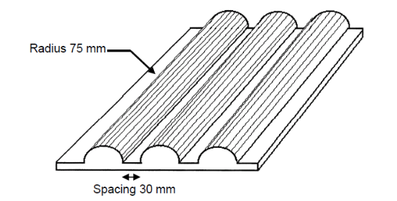

[Dimension of the crush plate: 600 mm x 600 mm or smaller

Annex 8E

Fire resistance

1. PURPOSE

The purpose of this test is to verify the resistance of the RESS, against exposure to fire from outside of the vehicle due to e.g. a fuel spill from a vehicle (either the vehicle itself or a nearby vehicle). This situation should leave the driver and passengers with enough time to evacuate and no re-ignition of fire should occur in a later stage.

2. INSTALLATIONS

2.1 This test shall be conducted either with the complete RESS or with related subsystems of the RESS including at least the cells and their electrical connections. If certain electronic management unit for the RESS is not integrated into the enclosure, such control unit may not be installed on the device under test. In cases if the relevant subsystems of the RESS are distributed over the vehicle, the test may be conducted on each relevant subsystem of the RESS.

2.1.1. At the discretion of the manufacturer, the device under test shall be installed either;

2.1.1.1. Vehicle based test
The device under test is mounted in a testing fixture simulating actual mounting conditions as far as possible; no combustible material should be used for this except the material that is part of the RESS. The method whereby the device under test fixed in the fixture shall correspond to the relevant specifications for its installation. In the case of RESS designed for a specific vehicle use, vehicle parts which affect the course of the fire in any way shall be taken into consideration; or

2.1.1.2. Component based test
The device under test shall be placed on a grating table positioned above the pan, in an orientation according to the manufacturer’s design intent. The grating table shall be constructed by steel rods, diameter 6-10 mm, with 4-6 cm in between. If needed the steel rods could be supported by flat steel parts.

2.2. The flame to which the device under test is exposed shall be obtained by burning commercial fuel for positive-ignition engines (hereafter called "fuel") in a pan. The quantity of fuel poured into the pan shall be sufficient to permit the flame, under free-burning conditions, to burn for the whole test procedure. The fuel temperature should be standard ambient temperature.
It shall be insured that the fire covers the whole area of the pan during whole fire exposure. The pan dimensions shall be chosen so as to ensure that the sides of the device under test are exposed to the flame. The pan shall therefore exceed the horizontal projection of the device under test by at least 20 cm, but not more than 50 cm. The sidewalls of the pan shall not project more than 8 cm above the level of the fuel at the start of the test.

2.3. The pan filled with fuel shall be placed under the device under test in such a way that the distance between the level of the fuel in the pan and the device under test bottom corresponds to the design height of the device under test above the road surface at the unladen mass if paragraph 2.1.1.1. is applied or approximately 50 cm if paragraph 2.1.1.2. is applied. Either the pan, or the testing fixture, or both, shall be freely movable.

2.4. During phase C of the test, the pan shall be covered by a screen. The screen shall be placed 3 cm +/- 1 cm above the fuel level measured prior to the ignition of the fuel. The screen shall be made of a refractory material, as prescribed in Annex 8F - Appendix 1. There shall be no gap between the bricks and they shall be supported over the fuel pan in such a manner that the holes in the bricks are not obstructed. The length and width of the frame shall be 2 cm to 4 cm smaller than the interior dimensions of the pan so that a gap of 1 cm to 2 cm exists between the frame and the wall of the pan to allow ventilation. Before the test the screen shall be heated to 308 K +/- 5 K (35 degrees C +/- 5 degrees C). The firebricks may be wetted in order to guarantee the repeatable test conditions.

2.5. If the tests are carried out in the open air, sufficient wind protection shall be provided and the wind velocity at pan level shall not exceed 2.5 km/h.

3. PROCEDURES

3.1. The test shall comprise of three phases B-D, if the fuel is at standard ambient temperature. Otherwise the test shall comprise of four phases A-D.

3.1.1. Phase A: Pre-heating (Figure 1)
The fuel in the pan shall be ignited at a distance of at least 3 m from the device under test. After 60 seconds pre-heating, the pan shall be placed under the device under test. If the size of the pan is too large to be moved without risking liquid spills etc. then the device under test and test rig can be moved instead of the pan.

Figure 1
Phase A: Pre-heating

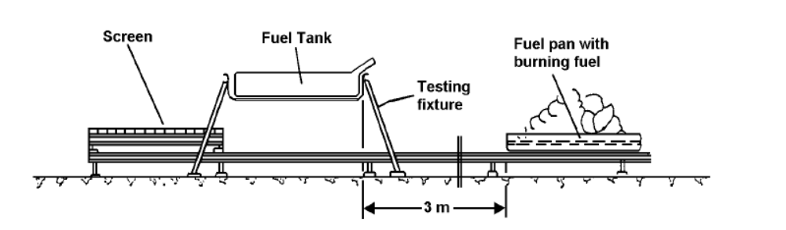
3.1.2. Phase B: Direct exposure to flame (Figure 2)
For 70 seconds the device under test shall be exposed to the flame from the freely burning fuel.

Figure 2
Phase B: Direct exposure to flame
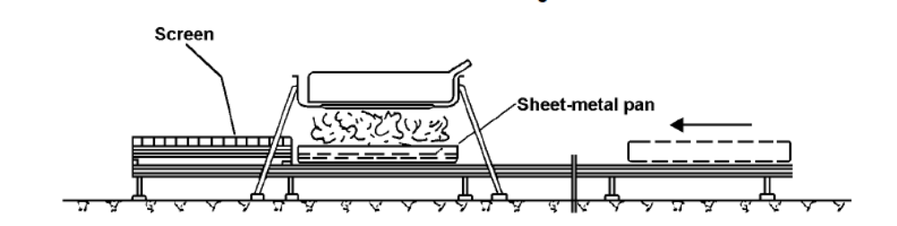

3.1.3. Phase C: Indirect exposure to flame (Figure 3)
As soon as phase B has been completed, the screen shall be placed between the burning pan and the device under test. The device under test shall be exposed to this reduced flame for a further 60 seconds.
Instead of conducting Phase C of the test, Phase B may be continued for additional 60 seconds at the manufacturer’s discretion in those cases there is no reason to believe that this might pose a lower risk than the normal phase C.

Figure 3
Phase C: Indirect exposure to flame
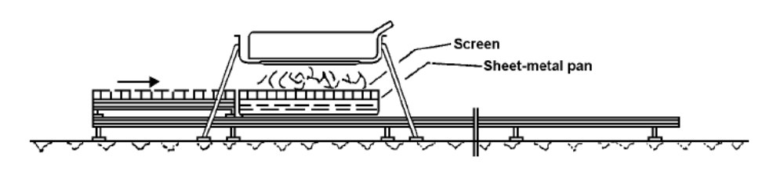

3.1.4. Phase D: End of test (Figure 4)
The burning pan covered with the screen shall be moved back to its original position (phase A). No extinguishing of the device under test shall be done. After removal of the pan the device under test shall be observed until such time as the surface temperature of the device under test has decreased to ambient temperature or has been decreasing for a minimum of 3 hours.

Figure 4
Phase D: End of test
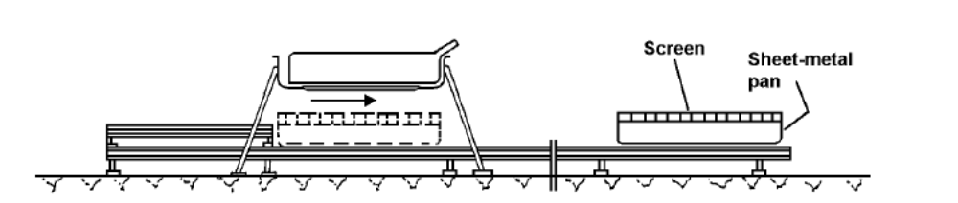

Annex 8E - Appendix 1

Dimension and Technical Data of Firebricks

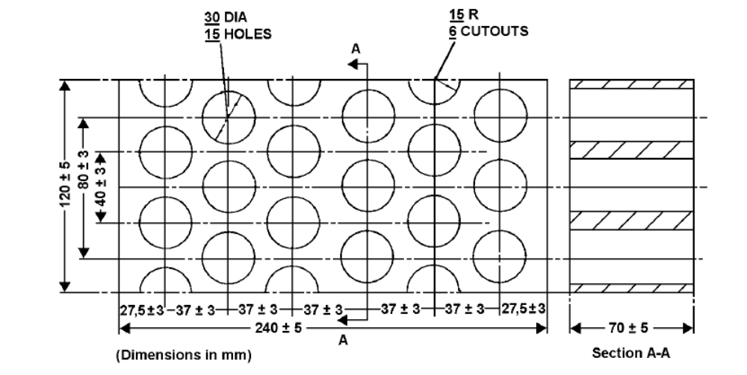

Fire resistance (Seger-Kegel) SK 30

Al2O3 content 30 - 33 per cent

Open porosity (Po) 20 - 22 per cent vol.

Density 1,900 - 2,000 kg/m3

Effective holed area 44.18 per cent

Annex 8F

External short circuit protection

1. PURPOSE

The purpose of this test is to verify the performance of the short circuit protection. This functionality, if implemented, shall interrupt or limit the short circuit current to prevent the RESS from any further related severe events caused by short circuit current.

2. INSTALLATIONS

The following test may be conducted with the complete RESS under standard operating conditions as defined by the manufacturer.

3. PROCEDURES

At the beginning all relevant main contactors shall be closed.

During the external short circuit protection test the external resistance shall not exceed [0.1] ohm.

This short circuit condition is continued for at least one hour after the device under test external case temperature has stabilised, which means that the temperature varies by a gradient of less than [4°C through 1 hour] or the operation of the protection function to interrupt or limit the short circuit current is confirmed.

Direct after "External Short Circuit" a standard cycle as described in Annex 8 Appendix 1 shall be conducted, if not inhibited by the RESS.

Annex 8G

Overcharge protection

1. PURPOSE

The purpose of this test is to verify the performance of the over-charge protection. This functionality, if implemented, shall interrupt or limit the charge current to prevent the RESS from any further related severe events caused by over-charge current and or voltage.

2. INSTALLATIONS

The following test may be conducted with the complete RESS under standard operating conditions as defined by the manufacturer.

3. PROCEDURES

At the beginning all relevant main contactors shall be closed.

External charge control of the test equipment shall be disabled.

The device under test shall be overcharged with at least two times charge current referring to normal charge mode of application which is agreed by manufacturer and Technical Service

The upper limit of the power supply voltage shall be set to not exceed 20% of the maximum device under test voltage.

Charging shall be continued until
• the device under test (automatically) interrupts or limits the charging or
• external case temperature has stabilised, which means that the temperature varies by a gradient of less than [4°C through 1 hour]

Direct after "Overcharge Protection" a standard cycle as described in Annex 3 has to be conducted if not inhibited by the device under test.

Annex 8H

Over-discharge protection

1. PURPOSE

The purpose of this test is to verify the performance of the over-discharge protection. This functionality, if implemented, shall interrupt or limit the discharge current to prevent the RESS from any further related severe events caused by over-discharge.

2. INSTALLATIONS

The following test may be conducted with the complete RESS under standard operating conditions as defined by the manufacturer.

3. PROCEDURES

At the beginning all relevant main contactors shall be closed.
The test equipment shall not prevent the over-discharge of the DUT.
Perform a standard discharge. When reaching the normal discharge limits, discharging with 1C rate shall be continued.
Discharging shall be continued until;
• the device under test (automatically) interrupts or limits the discharging or
• external case temperature has stabilised, which means that the temperature varies by a gradient of less than [4°C through 1 hour]

Direct after "Over-discharge Protection" a standard cycle as described in Annex 8 Appendix 1 has to be conducted if not inhibited by the device under test.

Annex 8I

Over-temperature protection

1. PURPOSE

The purpose of this test is to verify the function of the protection measures against internal overheating during the operation in the event of a single failure of the thermal control or cooling of the RESS.

2. INSTALLATIONS

[To be defined.]

3. PROCEDURES

When the maximum working temperature of the [RESS], specified by the manufacturer, is exceeded, the battery cannot be operated after this temperature is reached.

The [RESS] shall be placed in a convective oven or climatic chamber (hereby called over-temperature room). The over-temperature room temperature shall be increased until it reaches the maximum working temperature of the [RESS] specified by the manufacturer + 10°C. The over-temperature shall be maintained until the device under test temperature saturates.

Cooling system, if any, shall be deactivated if the [RESS] is able to operate under this condition. In the other cases, the manufacturer shall demonstrate by test that the operation of the [RESS] stops when deactivating its cooling system.

Then the [RESS] doesn't have to fulfill over-temperature test requirements, but the manufacturer shall provide the Technical Service with the relevant information showing that the cooling system is well-dimensioned and fits with the [RESS]’ thermal exchanges.

The manufacturer shall provide the technical service with the relevant technical information dossier of the temperature measurement device.

The RESS shall be continuously charged and discharged between the maximum and minimum voltage at a C/5 current.

The test shall be interrupted when the requirement is satisfied or when the [RESS] reaches or exceeds the maximum working temperature specified by the manufacturer for more than 5 min 4 hr without satisfying the requirement.
Direct after "Over-temperature Protection" the a standard cycle as described in Annex 3 has to be conducted if not inhibited by the [RESS].
- - - - - -

*/ In accordance with the programme of work of the Inland Transport Committee for 2010-2014 (ECE/TRANS/208, para. 106, ECE/TRANS/2010/8, programme activity 02.4), the World Forum will develop, harmonize and update Regulations in order to enhance the performance of vehicles. The present document is submitted in conformity with that mandate.
/ 1 for Germany, 2 for France, 3 for Italy, 4 for the Netherlands, 5 for Sweden, 6 for Belgium, 7 for Hungary, 8 for the Czech Republic, 9 for Spain, 10 for Serbia, 11 for the United Kingdom, 12 for Austria, 13 for Luxembourg, 14 for Switzerland, 15 (vacant), 16 for Norway, 17 for Finland, 18 for Denmark, 19 for Romania, 20 for Poland, 21 for Portugal, 22 for the Russian Federation, 23 for Greece, 24 for Ireland, 25 for Croatia, 26 for Slovenia, 27 for Slovakia, 28 for Belarus, 29 for Estonia, 30 (vacant), 31 for Bosnia and Herzegovina, 32 for Latvia, 33 (vacant), 34 for Bulgaria, 35 (vacant), 36 for Lithuania, 37 for Turkey, 38 (vacant), 39 for Azerbaijan, 40 for The former Yugoslav Republic of Macedonia, 41 (vacant), 42 for the European Community (Approvals are granted by its member States using their respective ECE symbol), 43 for Japan, 44 (vacant), 45 for Australia, 46 for Ukraine, 47 for South Africa, 48 for New Zealand, 49 for Cyprus, 50 for Malta, 51 for the Republic of Korea, 52 for Malaysia, 53 for Thailand, 54 and 55 (vacant), 56 for Montenegro, 57 (vacant) and 58 for Tunisia. Subsequent numbers shall be assigned to other countries in the chronological order in which they ratify or accede to the Agreement Concerning the Adoption of Uniform Technical Prescriptions for Wheeled Vehicles, Equipment and Parts which can be Fitted and/or be Used on Wheeled Vehicles and the Conditions for Reciprocal Recognition of Approvals Granted on the Basis of these Prescriptions, and the numbers thus assigned shall be communicated by the Secretary-General of the United Nations to the Contracting Parties to the Agreement.

