Proposal for amendments to Regulation No. [151] (Blind Spot Information Systems for Heavy Vehicles)
The text was reproduced below was prepared by the experts from the International Organization of Motor Vehicle Manufacturers (OICA) to amend the test method. The modifications to the existing text of the draft Regulation (see ECE/TRANS/WP.29 /2019/28) are marked in bold for new or strikethrough for deleted characters.
- Proposal
Paragraph 6.7., amend to read:
6.7. The manufacturer shall demonstrate, to the satisfaction of the Technical Service and Type Approval Authority, through the use of documentation, simulation or any other means, that the Blind Spot Information signal is not activated, as described in paragraph 6.5.10., when the vehicle passes any other usual stationary object than the traffic sign. In particular, parked cars and traffic cones shall be addressed.

Appendix 1, figure 1, amend to read:
Appendix 1
Figure 1
Dynamic tests
Line C
Bicycle
line of
movement
Theoretical Collision Point
Mark corridor using cones *, spacing not more than 2.5 - 5 m
d_{c}
d_{b}
d_{a}
d_{bicycle}
d_{corridor}
d_{lateral}
l_{corridor}
*: Use standard marker cones with max. height of 0.05 m locally common traffic cones,
height not less than 0.4 m
**: Dashed or dash-dotted lines are for
information only; they should not be
marked on the ground within the
corridor. They may be marked outside
of the corridor.
If not specified, tolerances are +/- 0.1 m
Bicycle
starting
position
d_{d}
Line B
Line A**
Line D

Appendix 1, table 1, amend to read:

Test  Case | v_{bicyclee} [km/h] | v_{Vehicle} [km/h] | d_{lateral} [m] | d_{a} [m] | d_{b} [m] | d_{c} [m] | d_{d} [m] | d_{bicycle}  [m] | l_{corridor}  [m] | d_{corridor} [m] | For information only (not influencing test parameters)
 |  |  |  |  |  |  |  |  |  |  | Impact Position [m] | Turn Radius [m]
1 | 20 | 10 | 1.25 | 44.4 | 15.8 | 15 | 26.1 | 65 | 80 | vehicle width  + 1 m | 6 | 5
2 | 20 | 10 |  |  | 22 | 15 | 32.3 |  |  |  | 0 | 10
3 | 20 | 20 |  |  | 38.3 | 38.3 | 65 - |  |  |  | 6 | 25
4 | 10 | 20 | 4.25 | 22.2 | 43.5 | 15 | 43.2 |  |  |  | 0 | 25
5 | 10 | 10 |  |  | 19.8 | 19.8 | 65 - |  |  |  | 0 | 5
6 | 20 | 10 |  | 44.4 | 14.7 | 15 | 26.1 |  |  |  | 6 | 10
7 |  |  |  |  | 17.7 |  | 29.1 |  |  |  | 3 | 10

II. Justification
- Not warning for static objects, like traffic cones, is an important part of the properties of the blind spot regulation. However, as the current test specification was written, the cones, because of their height, may obstruct the view of the system towards the bicycle. That would prevent the system from tracking the moving bicycle dummy and thereby make the system fail the test. This is even more likely to happen if the cones are placed within a short distance from each other.

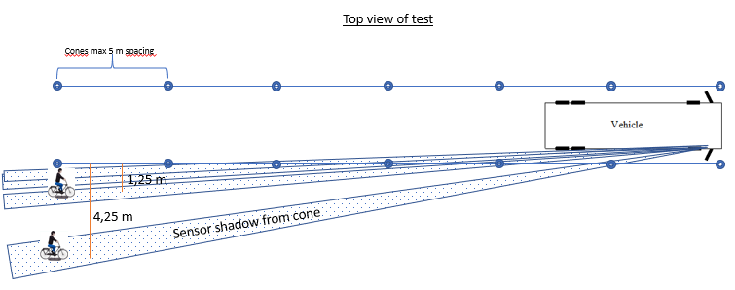

- As a result of how the test case 3 and 5 are designed (equal speed of vehicle and bicycle dummy), no first point of information (D_{d}) will exist. The bicycle dummy will need an acceleration distance to reach the defined speed. This will result in an adjustment of the starting point of the bicycle and therefore the given value for first point of information will not be correct anymore.

