CURRENT ISSUES OF ENSURING HUMAN SAFETY IN PROCESS OF VEHICLES OPERATION

The topic and material of the informational document of the Russian Federation are focused on justification of the need to regulate the emissions of hazardous substances and particulate matters from the wear of tyres and roadway, which at present significantly pollute urban atmosphere during the vehicle operation.
Current development of requirements for vehicle design is regulated in the international legislation by UNECE Regulation 148, which, in general, improves all design elements and functional characteristics step by step within the last 50 years increasing overall integrated safety of the vehicles.
The global indicators in improving vehicle design within the current period are quite impressive because of modern digital technologies penetrating into the transport industry deeper and deeper. Transport automation becomes the main trend of advanced technology developments creating the competitive advantages of modern automotive products. Improvement of vehicle design has already reached such amazing heights that the vehicles become driverless and no ancient cars spreading clouds of smoke are seen on the roads anymore!
However, at present, it is impossible to definitely say that these new technologies fully ensure human safety.
The efficiency of implementing the requirements of the UN Regulations in force is not yet sufficient. According to the WHO data, today, up to 1.5 million people all over the world die annually in road accidents, and up to 1.5 million people of urban population also die annually due to air pollution in cities.
It should be noted that it is the present time period when additional environmental issues were revealed. Back in 2012, the World Health Organization (WHO) proposed to prohibit the usage of diesel-engined vehicles due to the high emission of particulate matters (PM) in their exhaust gases within European cities.
Therefore, today European countries are looking for effective ways to reduce smog formation in large cities in order to decrease the ambient air pollution there.
According to experts, the program of conversion to vehicle electrification forecasts a share of electric vehicles in the total global output of no less than 17% by 2020.
It shall be specifically noted that against the backdrop of the intense searching (or sometimes its imitation) for the transport ecological problem solution by means of electric vehicles (EV) and alternative fuels, the attention to the enormous growth of PM emissions from roadway and tyre wear has been weakened. In our opinion, the usage – insignificant at the moment – of electric cars in cities will not ensure an essential decrease in PM emissions since these cars are driven with the same tyres and on the same asphalt-concrete roadway. This is confirmed by the data of the PM emission surveys carried out in the Russian Federation.
Dynamics of the PM emissions from other vehicles systems (braking systems, tyres) and from roadway wear are shown in Fig. 1 as an example for comparative analysis with regards to the standards of UN Regulations No. 49 and 83 for PM emissions with exhaust gases in case of operation in the megalopolis of Moscow.

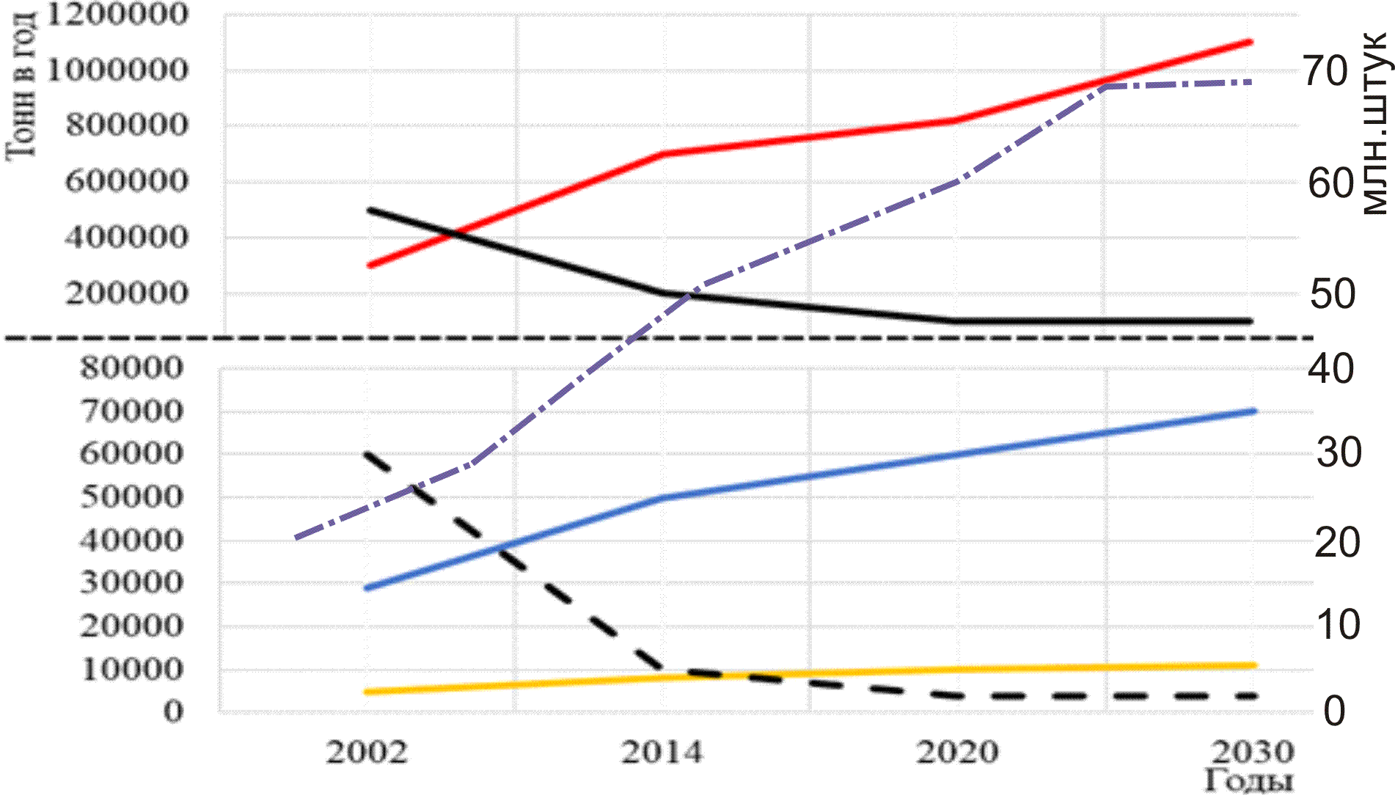 Year
Tons per year
mln vehicles
 | PM emissions from roadway wear |  | PM emissions from braking mechanisms
 | PM emissions with exhaust gases |  | UN standards for PM emissions with exhaust gases
 | PM emissions from tyres |  | Russian Federation vehicle fleet growth, mln pcs

Fig. 1. Dynamics and forecast of annual PM emissions from wear of tyres, braking mechanisms and roadway in Moscow, in tons, compared to the emissions of and emissions standards for PM with exhaust gases.

The series of activities with research and development aimed at improvement of design of vehicles' internal combustion engines carried out by manufacturers and legislators all over the world in the past 50 years ensured significant decrease of emissions of hazardous substances and PM with exhaust gases, however, in this period, due to the increasing vehicle fleet in all major cities of the developing countries, the air is being polluted because of the dramatical increase in particulate matters emissions, first of all from tyres and roadway wear.
One should pay attention to highly representative materials in the report of the
UK submitted in November 2018 at the Working Party on Pollution and Energy (WP.29/GRPE, UNECE Inland Transport Committee) which emphasizes the emissions of particulate matters of 2.5 micrometers and less, which by penetrating into lungs and blood can be transported through the body remaining in human organs and therefore reduce life expectancy.
Fig. 2 shows the results of surveys of actual values of emissions of PM less than 2.5 micrometers from various road transport systems in the UK which, by the values of PM emissions from wear of tyres, roadway and even braking systems, are essentially comparable by level and correspond to the results of the Russian research data shown in Fig. 1.
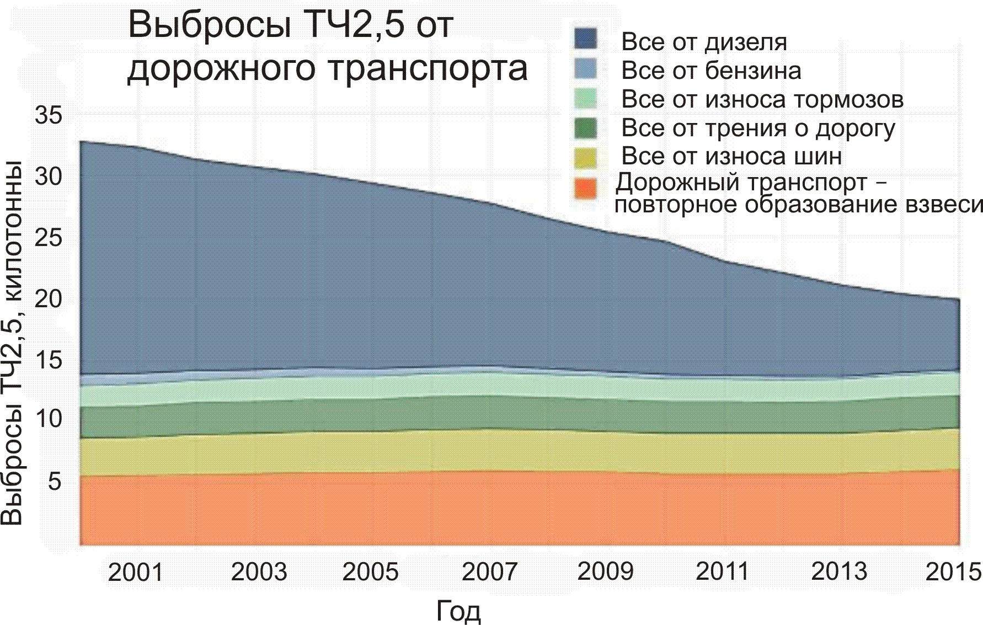
Year
All from diesel
All from gasoline
All from brake wear
All from friction on the road
All from tyre wear
Road transport – repeated formation
of suspended matter
PM2.5 emission, kt
PM2.5 emission from road transport
Fig. 2 Dynamics of actual 2.5 micrometer PM emissions from different vehicle sources in the UK
Highly interesting and important data should be especially noted in the document which was provided earlier at GRPE sessions by European Tyre & Rubber Manufacturers Association (ETRMA), in which the results of the PM chemical analysis are shown for the content of polycyclic aromatic hydrocarbons (PAH) in them that contain cancerogenic substances causing human cancer diseases.
Table 1 provides information on polycyclic aromatic hydrocarbons (PAH) content in PM. The values are expressed in parts per million (ppm) in the matters mix, sampled behind a moving vehicle.
Table 1
Chemical substance | Road particles (RP) | Tyre wear particles  (TWP) | Tyre (tread) particles (TP)
Acenaphthene | 4.08 | 0.04 | 0.13
Phenanthrene | 53.4 | 1.66 | 1.21
Pyrene | 54.84 | 4.77 | 0.06
Anthracene | 7.36 | 0.1 | 0.11
Benzanthracene | 38.65 | 0.18 | 2.87
Benzo(a)pyrene | 12.51 | 0.28 | N.D.
Benzo(k)fluoranthene | 7.4 | 0.02 | 0.92
Chrysene | 17.72 | 0.36 | 2.95
Dibenz(a,h)anthracene | 2.56 | 0.1 | 0.87
Fluoranthene | 82.13 | 0.98 | 1.62
Indeno-1,2,3(c,d)pyrene | 5.36 | 0.21 | N.D.

This list is not an exhaustive one, but it contains the PAHs most widely spread in the environment and considered cancerogenic and able to provoke cancerous diseases in people according to the International Agency for Research on Cancer (IARC).
Due to the abovementioned results of evaluation of amounts of PM emissions from tyre and roadway wear, there has risen a global ecological conflict between the transport and environment in big cities, which by the current time period has become critical both by its level and violent growth.
The comparative results of determination of PM emissions from various vehicle systems in 2015 according to the materials of the research in the Russian Federation (Fig. 1) and the UK (Fig. 2) are given in Figure 3.
%
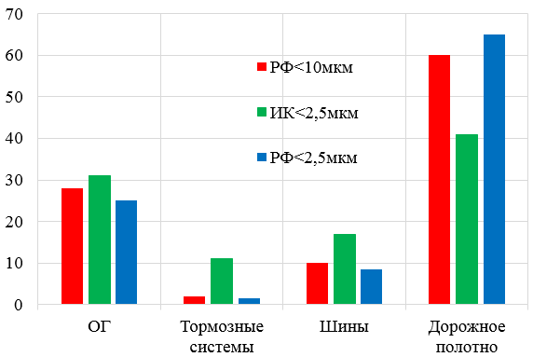
Exhaust Brake Tyres Roadway
gases systems
RF<10 µm

UK<2.5 µm

RF<2.5 µm
Fig. 3 Comparison of PM emissions according to the RF and UK studies.

Thus, nowadays we have the following ratios of PM emissions: 25-30% from engines with exhaust gases; from 3% up to 11% from brake systems; 8-17% from tyres and 42-65% from roadway. That is why the most important issue currently is regulation of PM emissions not only with the exhaust gases, but especially from asphalt roadway and tyre wear, as the bulk of the PM emissions from the roadway wear is more than twice bigger than the PM emissions with the exhaust gases, and if considering the tyre and brake system wear, almost thrice, and it is these non-exhaust emissions which influence the air pollution in the urban environment most significantly today. Thus, the electric vehicles, in case of 100% replacement of all vehicles in urban areas, which is not likely, may reduce the PM emissions in the next 10-15 years for no more than 25-30% only.
Based on the abovementioned, there is a need to promote and activate the discussion of the following issues of concern by the national and international legislators and vehicle manufacturers:
I. In the current situation, where the urban atmosphere is polluted by hazardous PM, it is necessary for our Governments to initiate and sponsor serious research developments related to reduction of the content of hazardous substances in materials used for production of tyres and roadway, while the international community needs to develop the respective regulatory requirements.
II. The tyre manufacturers and road construction services shall revise the existing technology for production of tyres and roadway considering the potential of ongoing research and development in terms of new materials and technologies.

