Proposal for amendments to ECE/TRANS/WP.29/GRSG/2019/33
I. Proposal
Paragraph 7.1.3.3., amend to read:
“7.1.3.3. Determination of the Test Areas for Category 1-2 and 2 Vehicles using the "O" Point
7.1.3.3.1. The straight line OQ which is the horizontal straight line passing through the eye point “O” and perpendicular to the median longitudinal plane of the vehicle.
7.1.3.3.2. Zone I is the zone determined by the intersection of the windscreen with the four planes defined below:
In addition, opaque obscuration can be exempted in Zone I. It is the limited areas where it is intended that a sensing device, e.g. a rain-drop detector, rear view mirror or autonomous sensors, will be bonded to the inner side of the windscreen. The opaque obscuration where such devices may be applied is defined in paragraph 7.1.3.3.3. of this annex.
P1 a vertical plane passing through point O and forming an angle of 15° to the left of the median longitudinal plane of the vehicle;
P2 a vertical plane symmetrical to P1 about the median longitudinal plane of the vehicle.
If this is not possible (in the absence of a symmetrical median longitudinal plane, for instance) P2 shall be the plane symmetrical to P1 about the longitudinal plane of the vehicle passing through point O.
P3 a plane passing through a transverse horizontal line containing O and forming an angle of 10° above the horizontal plane;
P4 a plane passing through a transverse horizontal line containing O and forming an angle of 8° below the horizontal plane;
Figure 4
Determination of Zone I

7.1.3.3.3. Determination of the opaque obscuration
P5 a plane passing through a transverse horizontal line containing O and forming an angle of 5° above the horizontal plane
P6 a vertical plane passing through O and inclined at 20° to the right of the X axis in the case of left-hand drive vehicles and to the left of the X axis in the case of right-hand drive vehicles.
P7 a plane symmetrical to P6 in relation to the longitudinal median plane of the vehicle;
7.1.3.3.3.1. At the discretion of the vehicle manufacturer, one of the two following paragraphs may apply: (See Figure 4(a) or Figure 4(b))
7.1.3.3.3.1. Any opaque obscuration bounded downwards by P5 and laterally by P6 and P7; (See Figure 4(a))
7.1.3.3.3.1.2. Any opaque obscuration bounded downwards by P5, provided it is inscribed in an area 300 mm wide centred on the longitudinal median plane of the vehicle.

Figure 4(a)
Zone I (example of a left-hand steering control vehicle)
(Upper obscuration area as defined in paragraph 7.1.3.3.3.1.1.)
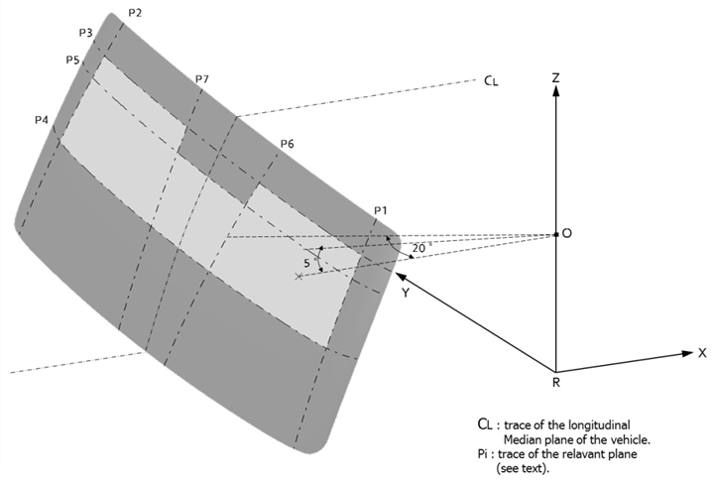
corrected
Figure 4(b)
Zone I (example of a left-hand steering control vehicle)
(Upper obscuration area as defined in paragraph 7.1.3.3.3.1.2.)

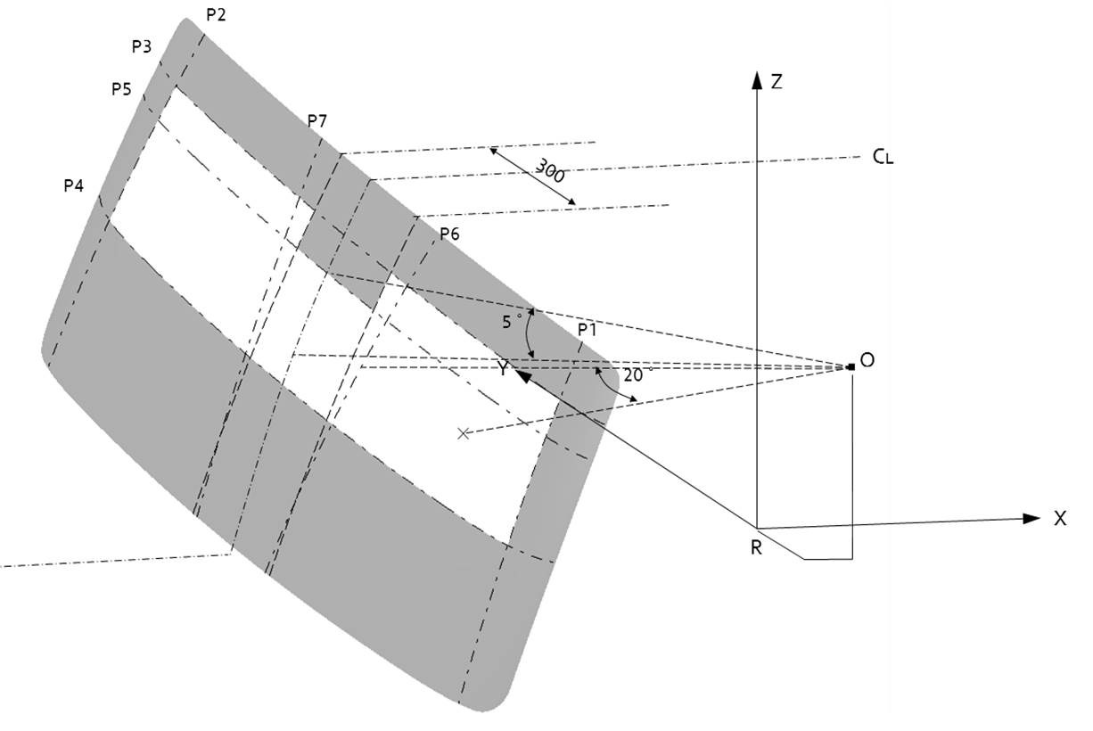

II. Justification
1. In the case of open type loadings tray in trucks, interior mirror application is required to secure rear view.
2. Various safety and convenience options (Lane Departure Warning Systems (LDWS), Autonomous sensors, etc.) for trucks are being installed or under development. If these options are fitted on the underside dashboard-top of the windshield glass, it may limit the driver’s direct front of vision (with potential negative consequences to safety).
3. For the optimization of installation, the above options may be integrated with the interior mirror. However it is difficult for some models to install the interior mirror, since Zone I may be intruded. Therefore, the opaque obscuration which can be used for installation of the above safety and convenience options must be permitted additionally. For this reason, some new planes such as P5, P6, and P7 shall be added.
4. On the other hand, the new opaque obscuration for Category 1-2 and 2 Vehicles has to be equal level with the one for Category 1-1 vehicles using the “V” points in order not to violate safety. So the Republic of Korea proposes the 5° above to determine the P5.

