|  |  |  |  |
| --- | --- | --- | --- |
|  | United Nations | ECE/TRANS/WP.29/2019/18 | |
| Description: _unlogo | **Economic and Social Council** | | Distr.: General  19 December 2018  Original: English |

**Economic Commission for Europe**

Inland Transport Committee

**World Forum for Harmonization of Vehicle Regulations**

**177th session**

Geneva, 12-15 March 2019

Item 4.9.2 of the provisional agenda

**1958 Agreement:  
Consideration of draft amendments to existing   
UN Regulations submitted by GRE**

Proposal for Supplement 21 to the 01 series of amendments to UN Regulation No. 53 (Installation of lighting and light-signalling devices for L3 vehicles)

Submitted by the Working Party on Lighting and Light-Signalling[[1]](#footnote-2)\*

The text reproduced below was adopted by the Working Party on Lighting and Light-Signalling (GRE) at its eightieth session (ECE/TRANS/WP.29/GRE/80, paras. 30 and 31). It is based on ECE/TRANS/WP.29/GRE/2018/45 and ECE/TRANS/WP.29/GRE/2018/46, as amended by para. 31 of the report. It is submitted to the World Forum for Harmonization of Vehicle Regulations (WP.29) and to the Administrative Committee AC.1 for consideration at their March 2019 sessions.

Supplement 21 to the 01 series of amendments to UN Regulation No. 53 (Installation of lighting and light-signalling devices for L3 vehicles)

*Insert a new paragraph 2.34.,* to read:

"2.34. "*Exterior courtesy lamp*" means a lamp used to provide supplementary illumination to assist the mounting and dismounting of the vehicle driver and passenger or in loading operations."

*Paragraph 5.9.,* amend to read:

"5.9. No red light which could give rise to confusion shall be emitted from a lamp as defined in paragraph 2.5. in a forward direction and no white light which could give rise to confusion, shall be emitted from a lamp as defined in paragraph 2.5. in a rearward direction. No account shall be taken of lighting devices fitted for the interior lighting of the vehicle. In case of doubt, this requirement shall be verified as follows (see drawing in Annex 4)…"

*Paragraph 5.13.,* amend to read:

"5.13. Colours of the lights

…

Emergency stop signal: amber or red

Exterior courtesy lamp: white"

*Insert a new paragraph 5.15.6.,* to read:

"5.15.6. Exterior courtesy lamp (paragraph 6.15.)."

*Paragraph 6.3.6.*, amend to read:

"6.3.6. Electrical connections

6.3.6.1. The direction indicator lamps shall switch on independently of the other lamps. All direction indicator lamps on one side of a vehicle shall be switched on and off by means of one control.

6.3.6.2. The direction indicator lamps may be switched ON to indicate the status of the device for protection of vehicles against unauthorized use.

6.3.6.3. The indication described in paragraph 6.3.6.2. shall be produced by the simultaneous operation of the direction indicator lamps and shall be in accordance to the following conditions.

In case of single indication: 3 seconds maximum

In case of continuous indication:

Duration: 5 minutes maximum

Frequency: (2 ± 1) Hz

On time: Off time ± 10 per cent

This indication shall be allowed only when the device which starts and/or stops the engine (propulsion system) is set in a position which makes it impossible for the engine (propulsion system) to operate."

*Insert a new paragraph 6.15.,* to read:

"6.15. Exterior courtesy lamp

6.15.1. Presence

Optional for motorcycles.

6.15.2. Number

One or two; however further exterior courtesy lamps to illuminate footrest are permitted. Each footrest shall be illuminated by not more than one lamp.

6.15.3. Arrangement

No special requirement, however the requirements of paragraph 6.15.9.3. apply.

6.15.4. Position

No special requirement.

6.15.5. Geometric visibility

No special requirement.

6.15.6. Orientation

No special requirement.

6.15.7. Electrical connections

No special requirement.

6.15.8. Tell-tale

No special requirement.

6.15.9. Other requirements

6.15.9.1. The exterior courtesy lamp shall not be activated unless the vehicle is stationary and one or more of the following conditions is satisfied:

(a) The device which starts and/or stops the engine (propulsion system) is set in a position which makes it impossible for the engine (propulsion system) to operate; or

(b) A load compartment is opened for access.

The provisions of paragraph 5.9. shall be met in all fixed positions of use.

6.15.9.2. Approved lamps emitting white light with the exception of main beam headlamps and day time running lamps may be activated as courtesy lamp function. They may also be activated together with the exterior courtesy lamps and the condition of paragraphs 5.10. and 5.11. above may not apply.

6.15.9.3. The technical service shall, to the satisfaction of the Type Approval Authority, perform a visual test to verify that there is no direct visibility of the apparent surface of the exterior courtesy lamps, if viewed by an observer moving on the boundary of a zone on a transverse plane 10 m from the front of the vehicle, a transverse plane 10 m from the rear of the vehicle, and two longitudinal planes 10 m from each side of the vehicle; these four planes to extend from 1 m to 3 m above and perpendicular to the ground as shown in Annex 7.

In addition to the conditions described in paragraph 5.4., the requirements prescribed above shall be verified in the following vehicle conditions:

Stand: On a prop stand or a centre stand, and both if applicable

Steering: Straight ahead, and locked in each available position

At the request of the applicant and with the consent of the Technical Service this requirement may be verified by a drawing or simulation."

*Annex 1, insert a new item 9.22.*, to read:

"9.22. Exterior courtesy lamp: yes/no2 "

*Insert a new Annex 7,* to read:

"**Annex 7**

**Observing area towards the apparent surface of exterior courtesy lamps**

Zones of observation

This drawing shows the zone from one side, the other zones are from the front, the rear and from the other side of the vehicle.

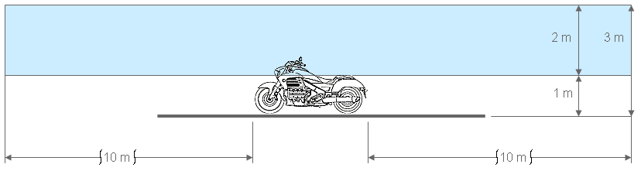

Boundaries of the zones

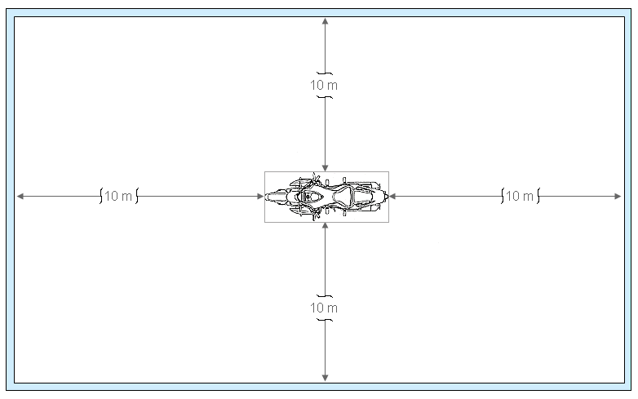"

1. \* In accordance with the programme of work of the Inland Transport Committee for 2018–2019 (ECE/TRANS/274, para. 123 and ECE/TRANS/2018/21/Add.1, cluster 3.1), the World Forum will develop, harmonize and update UN Regulations in order to enhance the performance of vehicles. The present document is submitted in conformity with that mandate [↑](#footnote-ref-2)