|  |  |  |  |
| --- | --- | --- | --- |
|  | United Nations | ECE/TRANS/WP.11/2019/14 | |
| _unlogo | **Economic and Social Council** | | Distr.: General  24 July 2019  Original: English |

**Economic Commission for Europe**

Inland Transport Committee

**Working Party on the Transport of Perishable Foodstuffs**

**Seventy-fifth session**

Geneva, 8-11 October 2019

Item 5 (b) of the provisional agenda

**Proposals of amendments to ATP:**

**new proposals**

The role of measurement uncertainty in conformity assessment decisions in ATP

Transmitted by the Government of Slovenia

Context

1. Since ATP stations need to estimate uncertainties of their measurements, the rules regarding conformity assessment decisions and the role of measurement uncertainty within conformity assessment should be introduced to ATP following metrology standards.

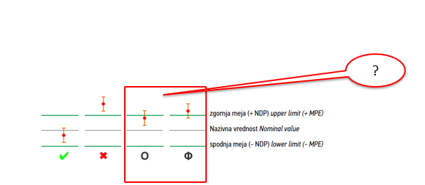

*Picture 1 – Outline of 4 possible measured results options which need to be assessed in conformity assessment decision. Red marking of border line options of results.*

1. Conformity assessment should follow the approach outlined in international metrological practice which can be found in JCGM 106:2012, ILAC-G8:03/2009, OIML G 19 /2017, and Welmec 4.2.-1 / 2006.

State of art

1. In conformity assessment, decision is based on observable data (measured quantities). Because of uncertainty in measurement, there is always the risk of incorrectly deciding.
2. Incorrect decisions are of two types: an item accepted as conforming may actually be non-conforming (this case is called false acceptance or consumer's risk), and an item rejected as non-conforming may actually be conforming (this case is called false rejection or producer's risk).

*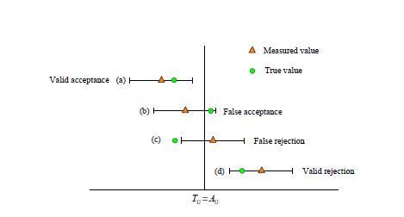 Picture 2 – Acceptance and rejection introduction (Figure 8 JCGM 106 :2012)*

1. According to JCGM 106 :2012, ATP decision rule on tests performed by measurements should follow shared risk rule.

**JCGM 106 :2012 Evaluation of measurement data – The role of measurement uncertainty in conformity assessment** introduces shared risk rule in point 8.2:

***8.2 Decision rule based on simple acceptance***

*8.2.1 An important and widely used decision rule is known as simple acceptance or shared risk. Under such a rule, the producer and user (consumer) of the measurement result agree, implicitly or explicitly, to accept as conforming (and reject otherwise) an item whose property has a measured value in the tolerance interval. As the alternative name `shared risk' implies, with a simple acceptance decision rule the producer and user share the consequences of incorrect decisions*.

*8.2.2 In practice, in order to keep the chances of incorrect decisions to levels acceptable to both producer and user, there is usually a requirement that the measurement uncertainty has been considered and judged to be acceptable for the intended purpose.*

*8.2.3 One approach to such consideration is to require, given an estimate of a measured quantity, that the associated expanded uncertainty U; for a coverage factor k = 2; must satisfy* U < Umax; where Umax is a mutually agreed maximum acceptable expanded uncertainty. *This approach is illustrated by the following example.*

*EXAMPLE In legal metrology, a decision rule based on simple acceptance has been used in the verification of measuring instruments. Consider such an instrument that is required to have an error of indication in the interval [-Emax;Emax]. The instrument is accepted as conforming to the specified requirement if it meets the following criteria:*

1. *in measuring a calibrated standard, the best estimate e of the instrument error of indication E satisfies│e│ ≤ Emax; and*
2. *the expanded uncertainty for a coverage factor k = 2 associated with the estimate e satisfies U ≤ Umax = Emax/3:*

*In terms of the measurement capability index, criterion (b) is equivalent to the requirement that Cm ≥ 3.*

1. In ATP test procedure methods performed by measurements, there exists a definition of maximum acceptable measurement uncertainty (by definition of reference equipment and

instruments and tests procedures accuracy demands), which according to JCGM 106 :2012 can be defined as Umax which is mutually agreed. Therefore, shared risk rule may be used when making conformity assessment for each measurement result: K coefficient, effective refrigerating capacity, temperature, time, surface, electrical energy, speed of rotation, pressure, etc.

1. Use of shared risk rule in case of national or other regulations is also recommended by **ILAC-** **Guidelines on the Reporting of Compliance with Specification G8:03/2009**, in point 2.7 where the rule for decision making in case of national or other regulations (in our case ATP) is shared risk rule:

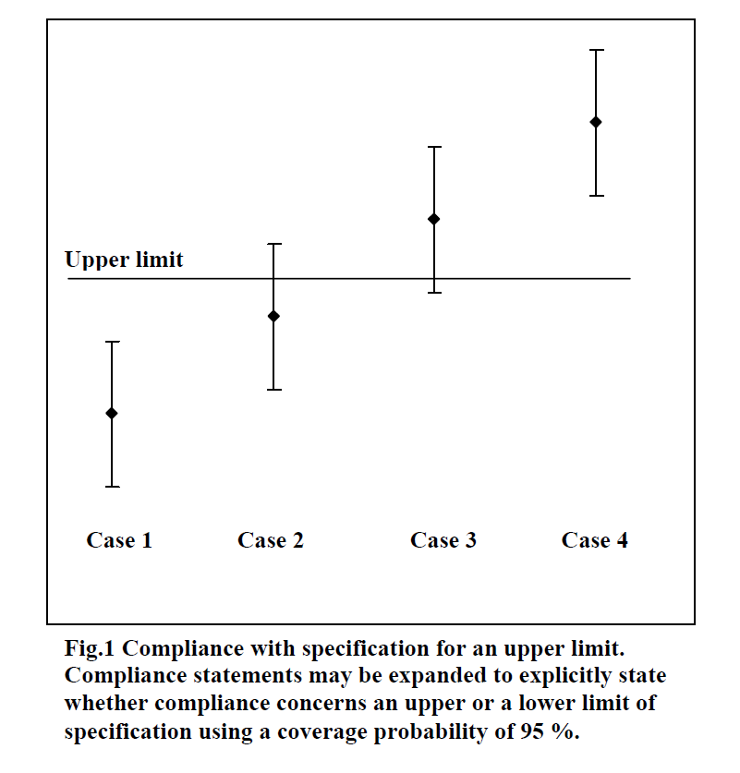

*Picture 3: ILAC-G8:03/2009 – Fig. 1:*

*2.7 If national or other regulations require a decision be made regarding rejection or approval, Case 2 of Fig. 1 can be stated as compliance, and Case 3 of Fig. 2 as noncompliance with the specification limit.*

1. The same rule is recommended in**Welmec 4.2-1 / 2006** and **OIML G 19 /2017.**

Welmec 4.2-1 / 2006 - article 6 : Measurement uncertainty and decision making:

***General requirements on measurement uncertainty***

*In order to make a decision of conformity assessment based on quantitative testing of an instrument, the result of a reading of a particular measuring instrument should be accompanied by its measurement uncertainty, usually a so-called ‘expanded’ uncertainty U. The interval of measurement uncertainty is often y ± U.*

***Decision-making with measurement uncertainty***

*The two main stages in handling uncertainty in decision-making:*

*(i) setting a limit on a maximum permissible measurement uncertainty (MPU);*

*(ii) allowing for risks due to uncertainty by ‘sharing’ risks*

***Accounting for uncertainty in decision-making***

*The two main stages in handling uncertainty in decision-making identified above can be applied to conformity assessment for both new instruments and instruments in-service.*

OIML G 19 /2017 - point 5.3.3 and 5.3.4:

***5.3.3 Shared risk***

*Shared risk, on the other hand, is an agreement between the parties concerned with the outcome of the testing that neither will be given an advantage or disadvantage concerning consideration of measurement uncertainty. Implicit in such an agreement is that the expanded measurement uncertainty UEI is ‘small’ with respect to the MPE (i.e. the ratio (UEI/MPE) is ‘small’) so that the significant risk of an erroneous decision exists for values of ĒI that are only very close to the MPE boundaries. This is illustrated in Figure 4 for two possible different PDFs for a given measurement. The uncertainty UEI associated with the leftmost (red) Gaussian curve is probably too large for a shared risk arrangement, whereas the uncertainty UEI associated with the rightmost (green) Gaussian curve would probably be acceptable for most applications.*

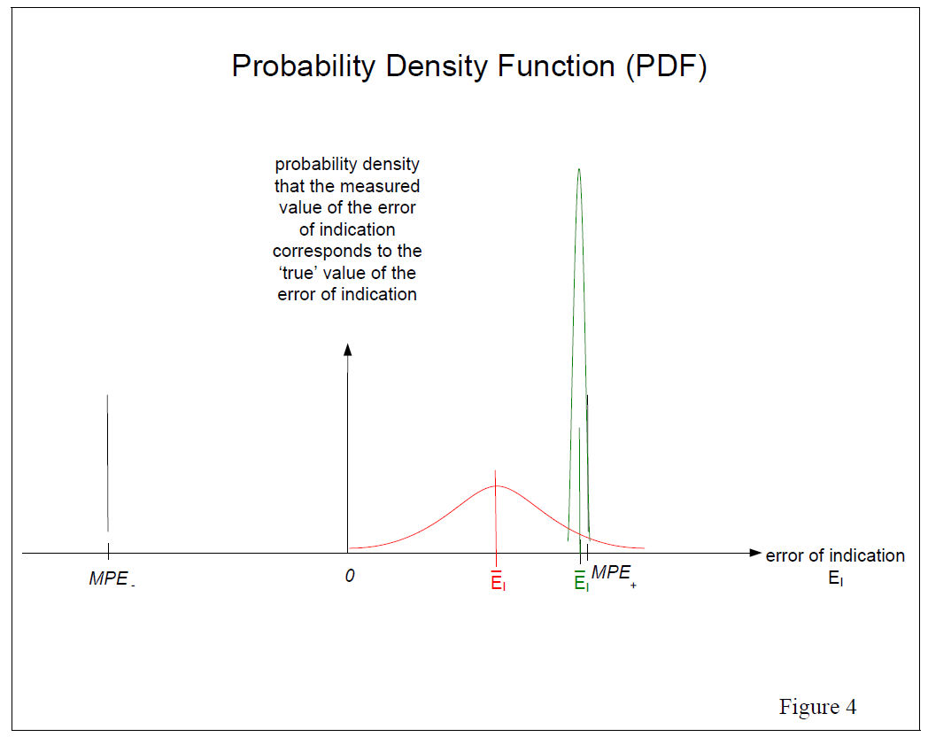

*Picture 4: ILAC-G8:03/2009 – Fig. 4:*

…

*Note that with the shared risk approach it is still necessary to calculate the measurement uncertainty UEI so that the ratio (UEI/MPE) can be examined to see if it is ‘small enough’, as discussed in 5.3.4. Also note that if the maximum permissible errors are to be adjusted for some reason (for example, allowance for in-service conditions) using the guard band method (see 5.3.6), the shared risk approach can still be used with the new or guard banded MPEs.*

***5.3.4 Maximum permissible uncertainty of error of indication***

*It is becoming common to refer to the maximum value that the ratio (UEI/MPE) is allowed to have in terms of a “maximum permissible uncertainty” (denoted symbolically by MPUEI) of the error of indication, defined by:*

*MPUEI ≡ fEI ∙MPE*

*where fEI is a specified number less than one, usually of the order 1/3 or 1/5 (0.33 or 0.2)*.

*…*

*Note that 1/fEI is sometimes called the test uncertainty ratio (TUR). …*

Technical impact of the proposed measure

8. Harmonisation of conformity assessment decisions for all ATP test stations.

Economic impact of the proposed measure

9. N/A

Environmental impact of the proposed measure

10. N/A

Conclusion

11. ATP stations do need to estimate measurement uncertainties of their measurements. Conformity acceptance in ATP should follow shared risk rule.

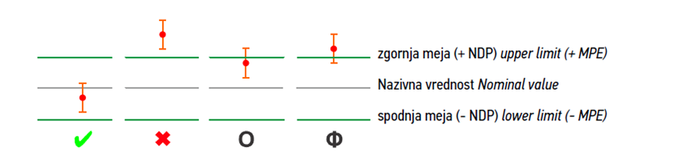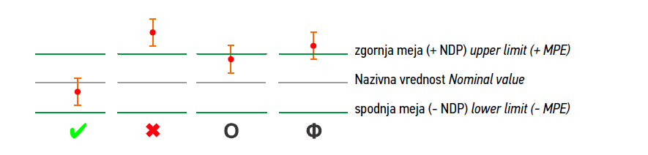

*Picture 5: Outline of 4 possible measured results options which need to be assessed in conformity assessment decisions and decisions made by simple acceptance rule.*

ATP Proposal of amendment (if applicable)

12. Section of ATP concerns by the proposal: Annex I, Appendix 2

**It is proposed to 🗷 add the following paragraph of ATP**

Annex I, Appendix 2

paragraph 9.

**9. CONFORMITY ACCEPTANCE**

Measurement results in all sections of Annex I, Appendix 2 should include estimation of measurement uncertainty which has to be *small enough4* as defined by test procedure in each section of Annex I, Appendix 2.

Conformity acceptance in all sections of Annex I, Appendix 2 should be done by *simple acceptance1* or *shared risk1,2,3,4* decision rule.

**Footnote:**

1 *JCGM 106 :2012 Evaluation of measurement data – The role of measurement uncertainty in conformity assessment - 8.2.*

2 ILAC- Guidelines on the Reporting of Compliance with Specification G8:03/2009, - 2.7.

3 Welmec 4.2-1 / 2006 – 6

4 OIML G 19 /2017 - 5.3.3, 5.3.4