Economic Commission for Europe
Inland Transport Committee
Working Party on the Transport of Dangerous Goods 29 August 2019
Joint Meeting of the RID Committee of Experts and the
Working Party on the Transport of Dangerous Goods
Geneva, 17–27 September 2019
Item 2 of the provisional agenda:
Tanks
Tanks: Interpretation of construction requirements applicable to the opening ends of Vacuum-Operated Waste Tanks (VOWTs)
Transmitted by the Government of the United Kingdom
Summary
Executive summary: This paper provides delegates with additional information on the interpretation of the measures that may be taken to prevent the opening ends of VOWTs from being forced open during a roll-over incident.
Action to be taken: The United Kingdom would welcome an exchange of views on the United Kingdom interpretation of ADR 6.10.3.5(e)
Related documents: Informal Documents INF.30 and INF.39 (paragraph 2) of the March 2019 session and Working Document ECE/TRANS/WP.15/AC.1/2019/25 of the September 2019 session.
Introduction
- This paper provides additional information to supplement that provided by the United Kingdom in Working Document ECE/TRANS/WP.15/AC.1/2019/25.
2. Paragraph 7(c) of 2019/25 informs that hydraulic over centre type clamps used for clamping the opening end in the closed position are fully automatic, controlled by hydraulic linear actuators. A hook style clamp is connected to a hydraulic ram with a series of linkages. When the ram extends, the hook clamp rotates on a pivot and clamps the door shut.
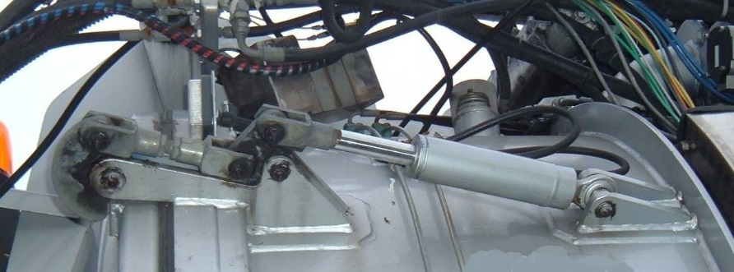
The paper advises that these types of door clamping mechanisms would appear to be vulnerable to damage that could allow the door to be forced open in the event of a roll-over incident and therefore, in our opinion, such design would not seem to meet the requirements of ADR 6.10.3.5 (e) unless additional measures were to be put in place to protect the locking mechanism.
Additional information
3. The following image provides an indication of the protection that can be provided by additional measures to protect hydraulic over centre type clamps in order to prevent the door from being forced open during a roll-over incident.
4. In our opinion, providing this additional protection to hydraulic over centre type clamps results in the requirements of ADR 6.10.3.5 (e) being fulfilled. However, as an alternative to this additional protection, it has been suggested that it would be acceptable for a sufficient number of unprotected over centre type clamps to be used to clamp the rear door in the closed position. The number of clamps would need to be such that, if those on either the left, right and/or top sides of the rear door were damaged in a roll-over, it would be possible for the remaining clamps on the undamaged sides, provided they are so designed, to prevent the rear door from being forced open.
5. As we have previously stated, we are aware of a number of incidents in the United Kingdom where Vacuum-Operated Waste Tanks have been subject to an overturn of 90⁰. We are not aware of any incidents that have involved in a 180⁰ overturn but nevertheless, in 90⁰ overturns the top of these tanks may still be subject to damage.
6. Given that in real world incidents damage would seem to predominantly occur to one side of the tank and the top, this solution would in the view of the United Kingdom be acceptable provided it was demonstrated either by test or by calculation that the absence of clamps on either side and/or the top of the rear door would still result in the door not being forced open.
Conclusion
7. To ensure a consistent approach to interpreting the requirements of 6.10.3.5 (e), the United Kingdom would welcome an exchange of views with other member countries as to whether, in their opinion, the United Kingdom interpretation of this section concurs with their understanding of the requirements.

