|  |  |  |  |
| --- | --- | --- | --- |
|  | United Nations | ECE/TRANS/WP.15/AC.1/2019/25 | |
| _unlogo | **Economic and Social Council** | | Distr.: General  19 June 2019  Original: English |

**Economic Commission for Europe**

Inland Transport Committee

**Working Party on the Transport of Dangerous Goods**

**Joint Meeting of the RID Committee of Experts and the**

**Working Party on the Transport of Dangerous Goods**

Geneva, 17–27 September 2019

Item 2 of the provisional agenda

**Tanks**

Tanks: Interpretation of construction requirements applicable to the opening ends of Vacuum-Operated Waste Tanks (VOWTs)

**Transmitted by the Government of the United Kingdom**[[1]](#footnote-2), [[2]](#footnote-3)\*\*

|  |
| --- |
| *Summary* |
| **Executive summary:**  This paper provides delegates with information on guidance that the United Kingdom intends to provide to its inspection bodies and manufacturer’s regarding compliance with ADR 6.10.3.5. |
| **Action to be taken:** The United Kingdom would welcome an exchange of views on the United Kingdom interpretation of ADR 6.10.3.5 (e) |
| **Related documents:** Informal documentsINF.30 and INF.39 (paragraph 2) of the March 2019 session. |
|  |

Introduction

1. Following concerns raised by inspection bodies in the United Kingdom regarding different interpretations of the construction requirements for Vacuum-Operated Waste Tanks (VOWTs) in Chapter 6.10 of ADR, the United Kingdom has been looking closely at the construction requirements for these vehicles.

2. Accordingly, the United Kingdom is developing guidance that seeks to assist inspection bodies and manufacturers in the interpretation of Chapter 6.10 of ADR. However, in developing this guidance, the United Kingdom would appreciate the views of other member countries as to whether, in their opinion, the United Kingdom interpretation of certain aspects of Chapter 6.10 concurs with their understanding and application of the requirements.

3. In respect of ADR 6.10.3.5 (e) (protection of the openable end and preventing it from being forced open during a roll-over), our intention is to include guidance on the interpretation of this paragraph and include examples of locking devices that are considered to meet the requirements of this section. The guidance will of course, also recognize that other designs may be acceptable if they offer an equivalent (i.e. the same or better) level of safety and inspection bodies will be expected to make an engineering judgement, on a case by case basis, as to whether an alternative design may be appropriate.

Requirements for ‘openable ends’

4. ADR 6.10.3.5 states:

“6.10.3.5 The tanks may be equipped with openable ends. Openable ends shall comply with the following conditions:

(a) The ends shall be designed to be secured leaktight when closed;

(b) Unintentional opening shall not be possible;

(c) Where the opening mechanism is power operated the end shall remain securely closed in the event of a power failure;

(d) A safety or breakseal device shall be incorporated to ensure that the openable end cannot be opened when there is still a residual over pressure in the tank. This requirement does not apply to openable ends which are power-operated, where the movement is positively controlled. In this case the controls shall be of the dead-man type and be so positioned that the operator can observe the movement of the openable end at all times and is not endangered during opening and closing of the openable end; and

(e) Provisions shall be made to protect the openable end and prevent it from being forced open during a roll-over of the vehicle, tank-container or tank swap body.”

Interpretation

5. It would seem clear that 6.10.3.5 (e) requires two elements to be fulfilled: (i) the openable end must be protected and (ii) provisions must be in place to prevent the door being forced open [in the event of a roll-over].

6. To meet both of these requirements, our understanding is that (i) roll-over protection must be provided to the door and (ii) any door locking mechanism must be designed in such a way that it is protected against being forced open in the event of a roll-over.

7. With regard to the types of locking mechanism fitted to the rear doors of VOWTs, our understanding is that there are three designs commonly used:

(a) Manual hand wheel door clamps:

The clamps are protected by the substantial brackets on the tank and door from damage during a roll-over. In the event of a roll-over occurring the hand wheels are designed to fracture and leave a nut securing the door in place, thus preventing the door from being forced open.

It should be noted that, as required by ADR 6.10.3.5 (d), the locking arrangement shown below incorporates a safety device to prevent the door opening when there is still residual pressure in the tank.

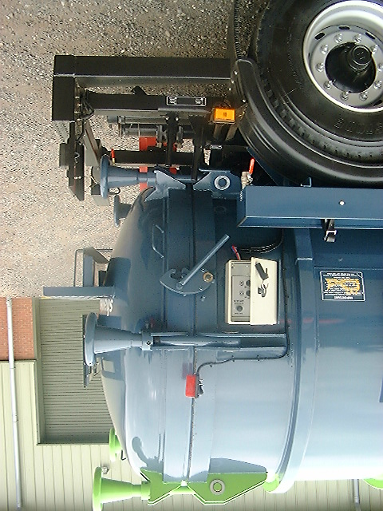

(b) Hydraulic wedge type door clamps:

This type of clamp is fully automatic, controlled by hydraulic linear actuators. The wedge on the end of the ram is guided though slotted brackets on the door and the end of the tank vessel and the wedge pulls the seal tight onto the sealing face. The hydraulic oil is locked in the rams preventing the rams from opening. The circumferential position of the rams around the door ring is likely to mean they are highly unlikely to be damaged in such a way that their effectiveness is reduced in the event of a roll-over and allow the rear door to be forced open.

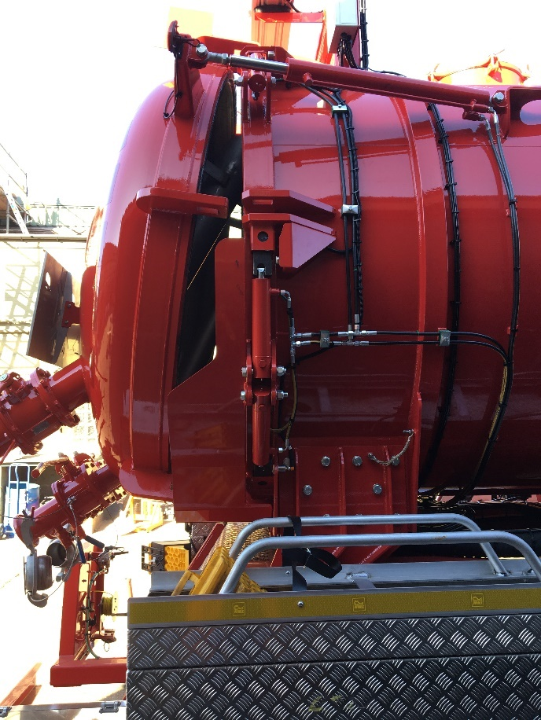

(c) Hydraulic over centre type clamps:

This type of clamp is fully automatic, controlled by hydraulic linear actuators. A hook style clamp is connected to a hydraulic ram with a series of linkages. When the ram extends, the hook clamp rotates on a pivot and clamps the door shut.

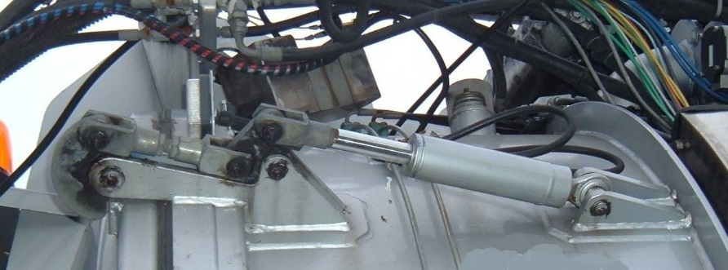

8. With regards to the requirement in 6.10.3.5 (e) for provisions that prevent the door being forced open in the event of a roll-over, our view is that this would be met by examples (a) and (b) but not example (c). The door clamping mechanisms in example (c) would appear to be vulnerable to circumferential forces in the event of a roll-over incident and likely to be subject to damage that might force the clamps and therefore the door open. In our opinion, therefore, example (c) would not seem to meet the requirements of 6.10.3.5 (e).

9. However, should the locking mechanism shown in example (c) be protected, as shown in the image below, in our opinion the requirements of 6.10.3.5 (e) for any door locking mechanism must be designed in such a way that it is protected against being forced open in the event of a roll-over would be fulfilled.

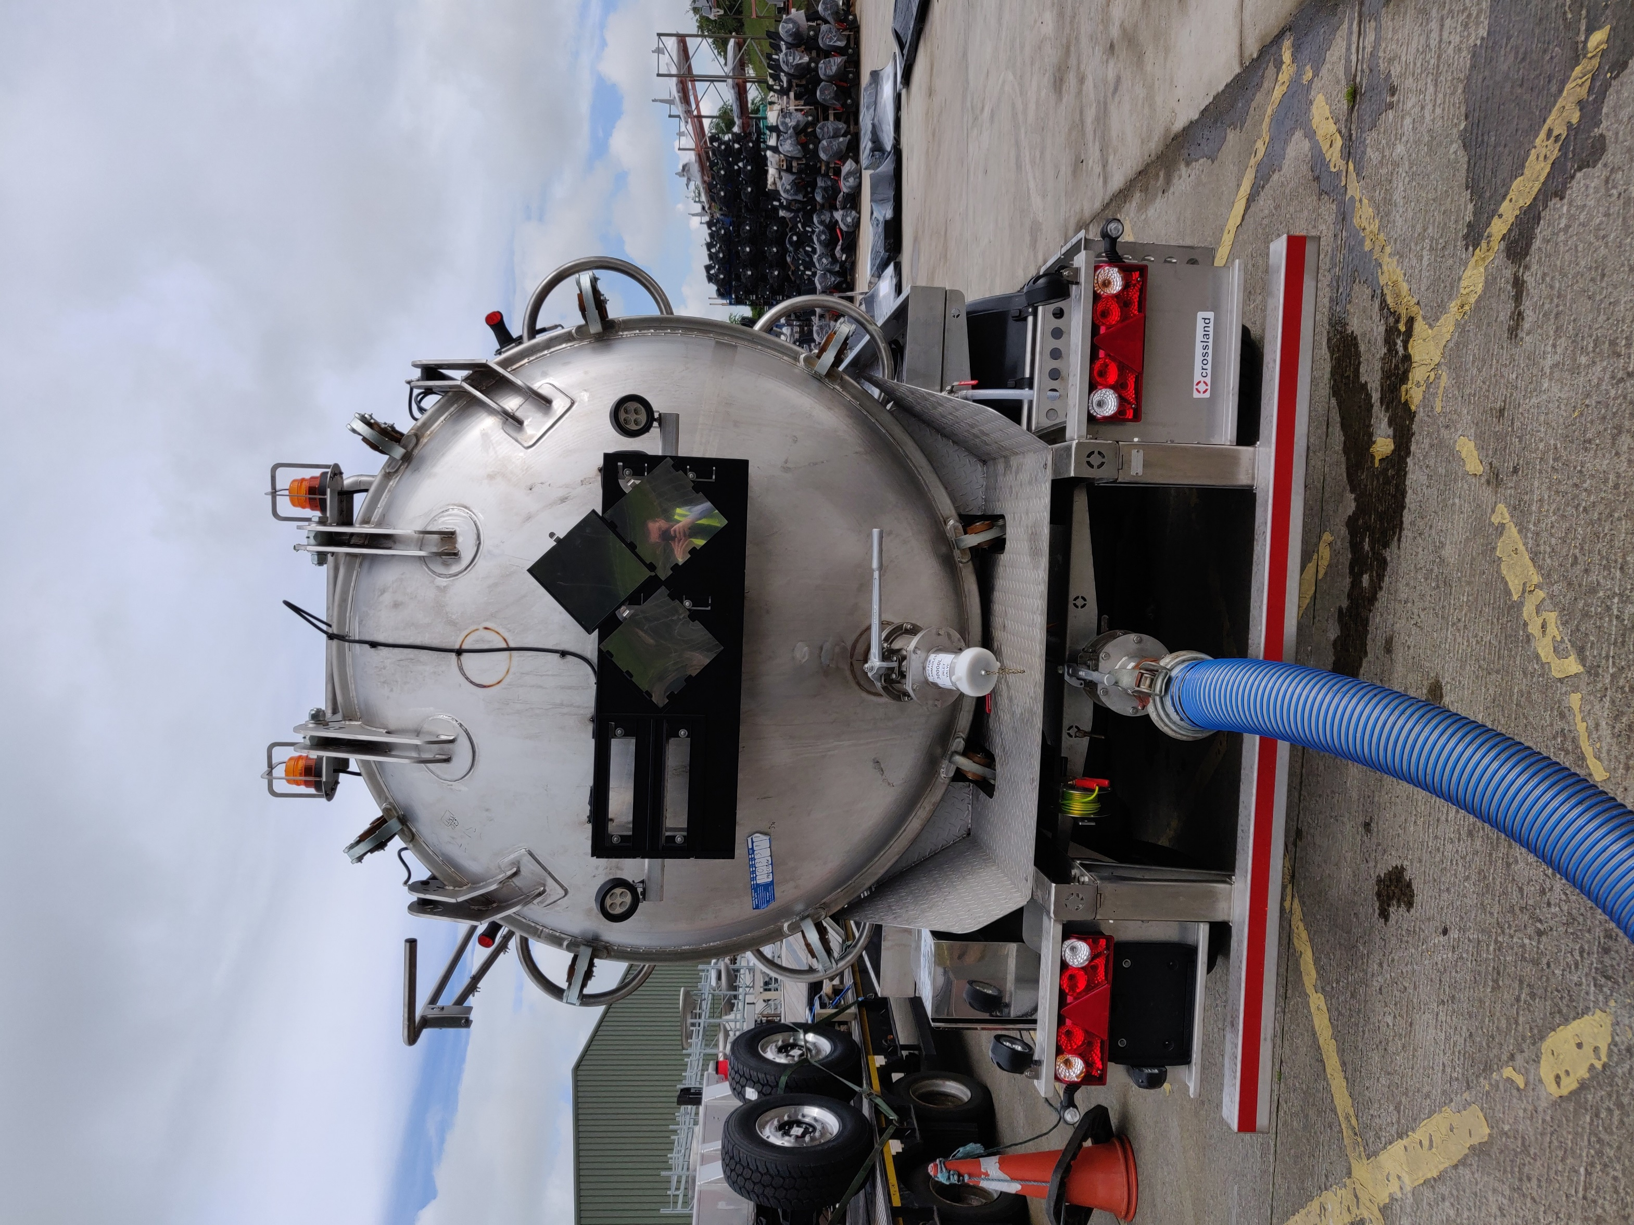

10. Regarding the provision in 6.10.3.5 (e) for the openable end to be protected, in our opinion, all three examples shown above would seem to meet this requirement given that door protection is an integral part to the design of the rear end of the tank.

Conclusion

11. To ensure a consistent approach to interpreting the requirements of 6.10.3.5 (e), we would welcome an exchange of views with other member countries as to whether, in their opinion, the United Kingdom interpretation of this section concurs with their understanding of the requirements.

1. In accordance with the programme of work of the Inland Transport Committee for 2018-2019, (ECE/TRANS/2018/21/Add.1, Cluster 9, (9.2)). [↑](#footnote-ref-2)
2. \*\* Circulated by the Intergovernmental Organisation for International Carriage by Rail (OTIF) under the symbol OTIF/RID/RC/2019/25. [↑](#footnote-ref-3)