INF.31
Economic Commission for Europe
Inland Transport Committee
Working Party on the Transport of Dangerous Goods
Joint Meeting of the RID Committee of Experts and the
Working Party on the Transport of Dangerous Goods 15 March 2019
Bern, 18-22 March 2019
Item 2 of the provisional agenda
Tanks
Vacuum-Operated Waste Tanks (VOWTs) – diverting vapours from the outlets of pump/exhauster units to a place where they will not cause danger
Transmitted by the Government of the United Kingdom

Summary
Executive summary: This paper provides delegates with information on alternative provisions that could be included in RID/ADR for the diverting of flammable or toxic vapours from the outlet of pump/exhauster units of Vacuum-Operated Waste Tanks. This is to reflect technical progress in the interests of safety.
Action to be taken: The United Kingdom would welcome a preliminary exchange of views on the inclusion of such requirements.

Related documents: None.
Introduction
1. Following concerns raised by inspection bodies in the United Kingdom regarding different interpretations of the construction requirements for Vacuum-Operated Waste Tanks (VOWTs) in Chapter 6.10 of ADR, the United Kingdom has been looking closely at the construction requirements for VOWT vehicles.
2. When loading such tanks, a pump/exhauster unit extracts air from inside the vessel and exhausts it out to atmosphere. This operation creates a vacuum inside the tank giving a pressure differential between the outside atmosphere and inside the tank. Atmospheric pressure pushes the load into the tank to fill the void created and the pump continues to run until the tank has been filled.
3. RID/ADR requires the outlet of a pump/exhauster unit to be designed such that any flammable or toxic vapors are diverted to a place where they will not cause a danger (ADR 6.10.3.8 (a)). As a construction requirement, this requires the outlet to be directed to a safe place and this could be considered to be met by a high-level outlet pipe. If such an outlet provision is used, given the length of the pipe it must be deployed into a vertical position before the tank is loaded, shown in the image below.
ADR requirements for pump/exhauster outlets
4. ADR 6.10.3.8 states: “The tanks shall be fitted with the following additional service equipment:
(a) The outlet of a pump/exhauster unit shall be so arranged as to ensure that any flammable or toxic vapours are diverted to a place where they will not cause danger.”
Issue
5. If a VOWT is equipped with a low-level outlet, it is difficult to see how this could be considered safe when climatic conditions could redirect harmful vapours to the loader/operator. Similarly, if a high-level pipe outlet is utilised, our understanding is that it is also possible for the operator to be exposed to any harmful vapours that may be heavier than air.
6. To address this risk, we have seen VOWT’s being fitted with low level outlets that have a mechanism for connecting to an external hose, as shown in the image below.
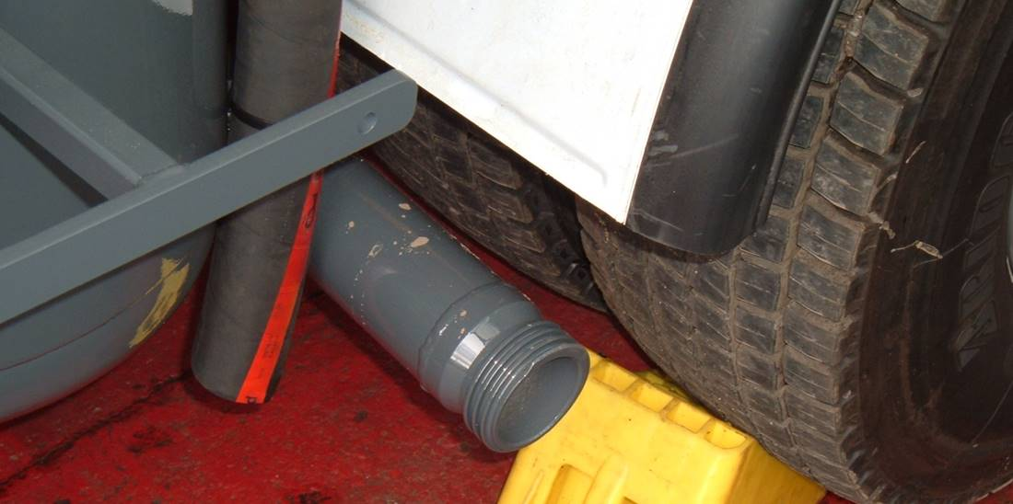
The hose will be connected to either (a) an on-site device that cleans the output from the vacuum pump or (b) an extension hose that is approximately 15m long and allows the vapours to be vented in a safe place (i.e. away from potential hazards, sources of ignition and personnel).
7. Whilst this creates a safe solution for operators, given the specific construction requirement set out in ADR 6.10.3.8 (a), this type of arrangement would not seem to be permitted.
8. We believe therefore, that ADR should be amended to reflect, in the interests of safety, this technical progress. In our opinion this would require an amendment to 6.10.3.8 to recognise alternative tank construction requirements and, an amendment to the operational requirements of Chapter 4.3 to mandate the coupling of an external hose before loading commences.
9. The United Kingdom would welcome a preliminary exchange of views on the inclusion of such requirements. If the initial views of the group are that such amendments could be made, the United Kingdom will look to prepare a formal proposal for discussion at the next session.
__________________________

