|  |  |  |  |
| --- | --- | --- | --- |
|  | United Nations | ECE/TRANS/WP.15/2019/21 | |
| _unlogo | **Economic and Social Council** | | Distr.: General  21 August 2019  English  Original: French |

**Economic Commission for Europe**

Inland Transport Committee

**Working Party on the Transport of Dangerous Goods**

**107th session**

Geneva, 11–15 November 2019

Item 8 of the provisional agenda

**Any other business**

Transport of battery powered vehicles

Transmitted by the Government of Switzerland[[1]](#footnote-1)\*

|  |
| --- |
| *Summary* |
| **Executive summary**: DR regulations for the transport of defective or damaged lithium batteries installed on vehicles powered by electric motors should be specified. |
|  |

Introduction

1. ADR regulations for the transport of defective or damaged lithium batteries installed on vehicles powered by electric motors are not clear. The rules for the transport of vehicles with damaged lithium batteries are also not clearly established.

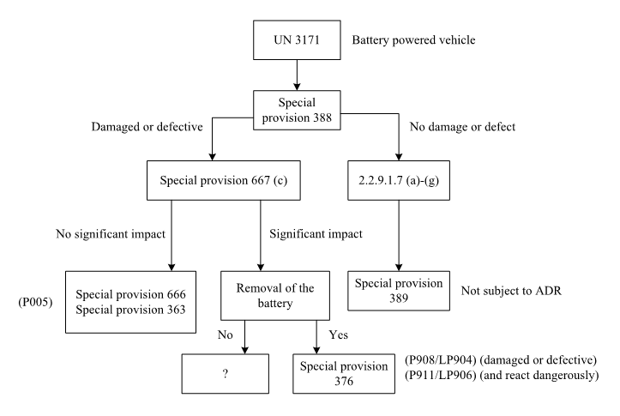2. The danger is recognized, but there are no regulations on transport or packaging for damaged electric vehicles. Damaged or defective lithium batteries can heat up and start to burn. It does not matter whether the batteries are still installed on the electric vehicle or not. In this case, precautions must be taken and the situation brought under control as quickly as possible.

3. To ensure safer transport of potentially dangerous batteries installed on electric vehicles, where lithium batteries are dismantled for transport, we propose the following solution.

4. This could involve a standard 20 ft container with an integrated fire alarm and aerosol fire extinguishing system and straps to attach the load. The fire alarm and extinguishing system is activated once the electric vehicle is loaded. It monitors the vehicle or the lithium battery and automatically sets off an alarm and extinguishes any fire. Overpressure in the container is reduced via a pressure relief valve, such that the container remains intact. The extinguishing aerosol remains active in the container for at least 30 minutes, thus preventing continued combustion or reignition.

5. The advantage of using an extinguishing aerosol is that no water is used and so the transport can be continued until a safe storage area is reached.

6. It also enables crucial time to be gained because fires are extinguished immediately upon detection and active protection is ensured for at least 30 minutes, thus giving the fire fighters valuable time to intervene.

7. We would like to know if other delegations are interested in specifying such a container in more detail in the regulations so that operators can be made aware of the minimum requirements to ensure a sufficient level of safety for the transport of damaged electric vehicles.

1. \* In accordance with the programme of work of the Inland Transport Committee for 2018–2019 (ECE/TRANS/2018/21/Add.1, Cluster 9, 9.1). [↑](#footnote-ref-1)