Economic Commission for Europe
Inland Transport Committee
Working Party on the Transport of Dangerous Goods
107th session 4 November 2019
Geneva, 11-15 November 2019
Item 6 of the provisional agenda:
Interpretation of ADR
Questions of interpretation: Transport of waste batteries / used storage batteries, bulk transport AP 8
Transmitted by the Government of Finland
Introduction
1. When transporting waste batteries on road, bulk transport is allowed. According to dangerous goods list in 3.2.1 of ADR, the special provision AP8 regarding bulk carriage is allocated for UN 2794 Batteries, wet, filled with acid (and also for UN 2795 Batteries, wet, filled with alkali, UN 2800 Batteries, wet, non-spillable, UN 3028 Batteries, dry, containing potassium hydroxide solid).
The special provision AP8 for the carriage of goods of Class 8 in bulk requires that the design of the load compartment of vehicle or containers shall take account of any residual currents and impacts from the batteries.
AP8 reads:
“The design of the load compartment of vehicles or containers shall take account of any residual currents and impacts from the batteries.
The load compartments of vehicles or containers shall be of steel resistant to the corrosive substances contained in the batteries. Less resistant steels may be used when there is a sufficiently great wall thickness or a plastics lining/layer resistant to the corrosive substances.
NOTE: Steel exhibiting a maximum rate of progressive reduction of 0.1 mm per year under the effects of the corrosive substances may be considered as resistant.
The load compartments of vehicles or containers shall not be loaded above the top of their walls.
Carriage is also permitted in small plastics containers which shall be capable of withstanding, when fully loaded, a drop from a height of 0.8 m onto a hard surface at -18 °C, without breakage.”
2. Packing instruction P801 for the same UN-numbers instructs more accurately about protection against short circuits (“Batteries shall be protected against short circuits.”).
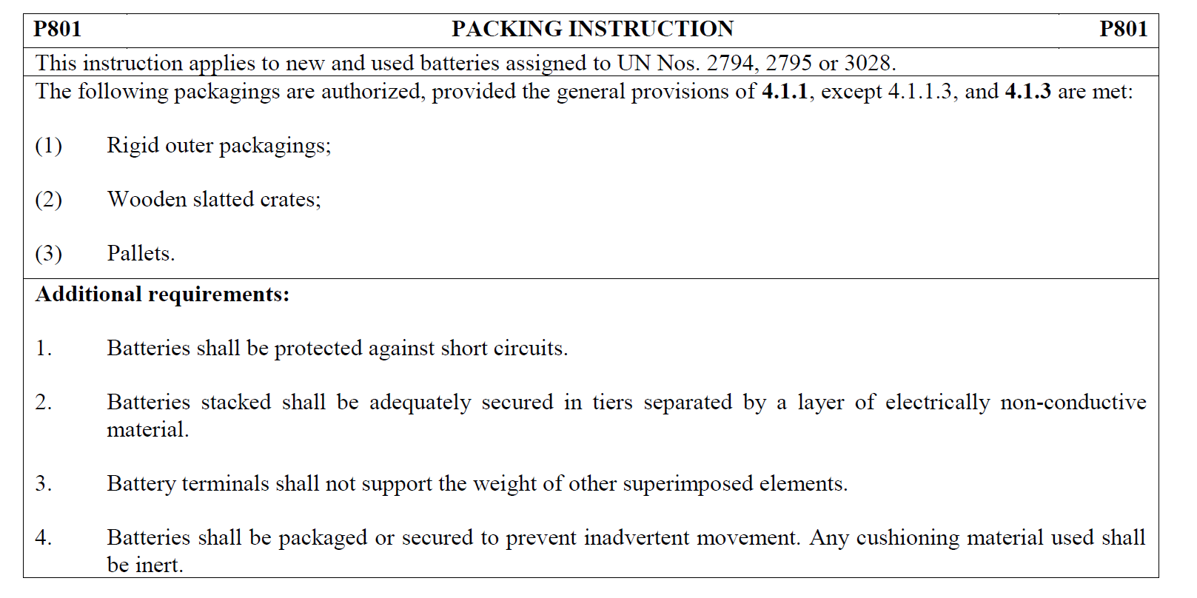
(P801a applicable to the same UN numbers is more in line with AP8, but it will be removed from the regulations with the ADR 2021 amendments.)
3. In 2021 ADR, P801 will read (direct requirement to protect batteries against short circuits or measures shall be taken to prevent short circuits):
P801 PACKING INSTRUCTION P801
This instruction applies to UN Nos. 2794, 2795 and 3028 and used batteries of UN No. 2800.
The following packagings are authorized, provided that the provisions of 4.1.1.1, 4.1.1.2, 4.1.1.6, and 4.1.3 are met:
- Rigid outer packagings, wooden slatted crates or pallets.
Additionally, the following conditions shall be met:
(a) Batteries stacks shall be in tiers separated by a layer of electrically non-conductive material;
(b) Battery terminals shall not support the weight of other superimposed elements;
(c) Batteries shall be packaged or secured to prevent inadvertent movement;
(d) Batteries shall not leak under normal conditions of carriage or appropriate measures shall be taken to prevent the release of electrolyte from the package (e.g. individually packaging batteries or other equally effective methods); and
(e) Batteries shall be protected against short circuits.
(2) Stainless steel or plastics bins may also be used to carry used batteries.
Additionally, the following conditions shall be met:
(a) The bins shall be resistant to the electrolyte [that was] contained in the batteries;
(b) The bins shall not be filled to a height greater than the height of their sides;
(c) The outside of the bins shall be free of residues of electrolyte [contained in the batteries];
(d) Under normal conditions of carriage, no electrolyte shall leak from the bins;
(e) Measures shall be taken to ensure that filled bins cannot lose their content;
(f) Measures shall be taken to prevent short circuits (e.g. batteries are discharged, individual protection of the battery terminals, etc.); and
(g) The bins shall be either:
(i) covered; or
(ii) carried in closed or sheeted wagons/vehicles or containers.

4. Finland invites the Working Party to exchange views on the interpretation on the protection against short circuit in bulk carriage:
- Can used storage batteries (waste) be carried safely in bulk without protection against short circuit?
- Are batteries required to be protected against short circuit in bulk carriage in accordance with AP8?
- Does “The design of the load compartment of vehicle or containers shall take account of any residual currents and impacts from the batteries.” mean that batteries need to be protected against short circuit?
- What does the requirement “The design of the load compartment of vehicle or containers shall take account of any residual currents and impacts from the batteries.” mean in practise?
- Is it possible to fulfill the requirement on safe transport in any other way than by protecting batteries against short circuit? How?

