Proposal for Supplement 8 to the 00 series of amendments, Supplement 5 to the 01 series of amendments,
Supplement 4 to the 02 series of amendments and Supplement 1 to the 03 series of amendments to UN Regulation No. 129
Submitted by the expert from the European Association of Automotive Suppliers
The text reproduced below was prepared by the expert from the European Association of Automotive Suppliers (CLEPA) to include corrections related to CLEPA formal document ECE/TRANS/WP.29/GRSP/2018/28 to clarify that certain information for users is displayed sufficiently. The modifications to the formal document are marked in bold for new or strikethrough for deleted characters.
I. Proposal
Paragraph 4.5., amend to read:
"4.5. ……

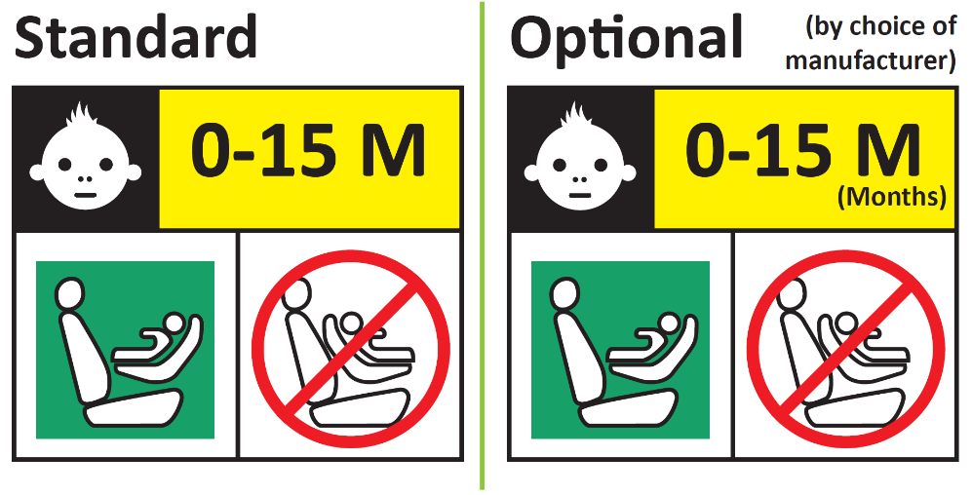
Forbidden sign – red
Label outline, vertical and horizontal lines black
Square - green
Background white
Top symbol white on black background
All text black on yellow or amber background
Background white

…..

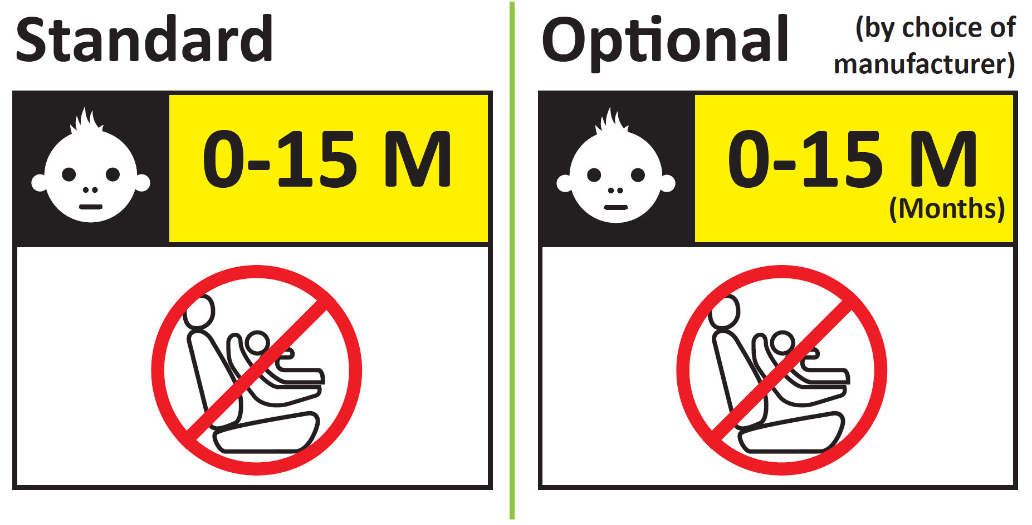”

II. Justification
- Paragraph 4.5. specifies labels that emphasise that the ECRS should not be used by children under 15 months. For consistency reasons, the same layout is chosen for both, the rearward/forward facing and the forward facing only label.
- This proposal adapts the pictogram of the white face on the black background which is placed next to the age range. The face is adapted from a smiling face to a neutral face to handle the conflict between a smiling face and a forbidden sign below.

