Proposal for amendments to UN Regulation No. 116
(Protection of vehicles against unauthorized use)
The text reproduced below was prepared by the expert from OICA to amend the definition for keys. The modifications to the current text of UN Regulation No. 116 are marked in bold characters for new and strikethrough for deleted characters.
I. Proposal
Paragraph 5.1.5., amend to read:
"5.1.5. "Key" means any physical device or electronic solution designed and constructed to provide a method of operating a locking system which is designed and constructed to be operated only by that physical device or electronic solution. The hardware (e.g. smartphone) provided by other than car manufacturer is not included in electronic solution."
Paragraph 6.1.8., amend to read:
"6.1.8. "Key" means any physical device or electronic solution designed and constructed to provide a method of operating a locking system which is designed and constructed to be operated only by that physical device or electronic solution. The hardware (e.g. smartphone) provided by other than car manufacturer is not included in electronic solution."
Paragraph 8.1.6., amend to read:
"8.1.6. "Key" means any physical device or electronic solution designed and constructed to provide a method of operating a locking system which is designed and constructed to be operated only by that physical device or electronic solution. The hardware (e.g. smartphone) provided by other than car manufacturer is not included in electronic solution."
II. Justifications
At the 106th session of GRSG (May 2014), the expert from EC informed GRSG on new innovative vehicle alarms systems, such as silent alarm or door-unlocking, using smart phone (GRSG-106-38) and questioned the need to develop an appropriate amendment to UN Regulation No. 116. The topic was further discussed at the 107th session of GRSG (Sept. 2014). The expert from Germany provided the information (GRSG-107-08) that Type Approval of some of these solutions had been refused because the smart phone signal was considered an additional key, not provided by the vehicle manufacturer, which could potentially interfere with the original alarm system from the manufacturer.
However, the key itself is not the protection device (antitheft device), the key is merely an activation device. Each device of the regulation (device for unauthorized use, alarm system or immobilizer) may have its own key for locking/unlocking. For example, locking and unlocking of the door lock system is not in scope of UN Regulation No. 116.
In order to access vehicle, not only physical keys can be used but also purely electronical ones.
According to the current definition of "key", a smartphone cannot be covered as "only by that device". This is the reason why "electronic solution" is added to definition. The hardware (e.g. smartphone) and software transmitting the electronic solution to the vehicle are not in the scope of UN Regulation No. 116. If the electronic solution is defined as a key, it is reasonable that the electronic solution transmitted from the hardware fulfils the requirements of paragraph 5.2.7. (Electrical/electronic locking systems - See Fig.1)

Fig.1
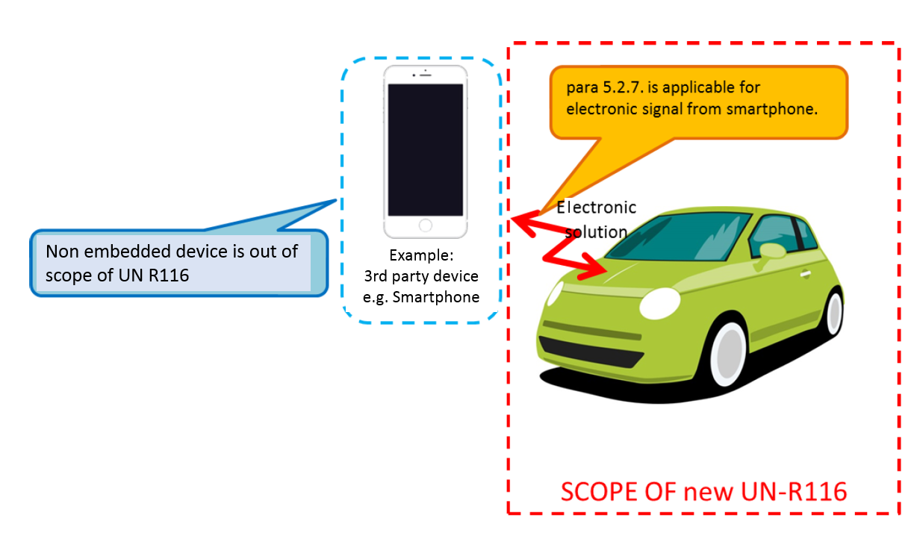
The proposal introduces a distinction between key as an electronic solution and Hardware and Software used to transfer this electronic solution, and amends UN Regulation No. 116 such that new innovative systems are appropriately addressed in the regulation. New innovative systems use components that are not embedded in the vehicle, this means e.g. devices, hardware, operating systems, communication channels, backend servers which are used for setting or unsetting locking systems, by transferring the electronic solution.
The proposal clarifies that the electronic solution must fulfil the requirements to UN Regulation No. 116 as being a key, while all hardware and software only used for transferring the electronic solution are not covered by the scope of UN Regulation No. 116. Still per paragraph 5.4, the manufacturer must ensure safety of the vehicle.
Examples for existing keys:
- Physical key with transmitter (from OEM) = steering lock is set/unset by physical key, alarm and immobilizer is set/unset by electronic solution, physical device provided from OEM to customer
- Smartphone as a key = Smartphone (Non-OEM) + Access App (OEM)+ Electronic solution (OEM)
- Smartphone as a key = Smartphone (Non-OEM) + Access App (car pool, non-OEM) + Electronic solution (OEM)
- Internet access = computer hardware (Non- OEM) + browser(non-OEM) + web page (in car delivery, non-OEM) + Electronic solution (OEM)

___________________

