|  |  |  |  |
| --- | --- | --- | --- |
|  | United Nations | ECE/TRANS/WP.29/GRSG/2018/17 | |
| _unlogo | **Economic and Social Council** | | Distr.: General  20 July 2018  Original: English |

**Economic Commission for Europe**

Inland Transport Committee

**World Forum for Harmonization of Vehicle Regulations**

**Working Party on General Safety Provisions**

**115th session**

Geneva, 9-12 October 2018

Item 3 of the provisional agenda

**UN Regulation No. 26 (External projections of passenger cars)**

Proposal for Supplement 4 to the 03 series of amendments to UN Regulation No. 26 (External projections for passenger cars)

Submitted by the expert from France[[1]](#footnote-2)\*

The text reproduced below was prepared by the expert from France to clarify in UN Regulation No. 26 the requirements on windscreen wipers. The modifications to the current text of UN Regulation No. 26 are marked in bold characters.

**I. Proposal**

*Paragraphs 6.4. to 6.4.2.,* amend to read (inserting a new Figure 0):

"6.4. Windscreen wipers

6.4.1. The windscreen wiper fittings shall be such that the wiper shaft **(numbers 3 in Figure 0 below)** is furnished with a protective casing which has a radius of curvature meeting the requirements of paragraph 5.4. above and an end surface area of not less than 150 mm². In the case of rounded covers, these shall have a minimum projected area of 150 mm² when measured not more than 6.5 mm from the point projecting furthest. These requirements shall also be met by rear window wipers and headlamp wipers.

6.4.2. Paragraph 5.4. shall not apply to the wiper blades **(number 1 in Figure 0 below)** or to any supporting members **(numbers 2 in Figure 0 below)**. However, these units shall be so made as to have no sharp angles or pointed or cutting parts.

Figure 0

**Example of parts distribution**

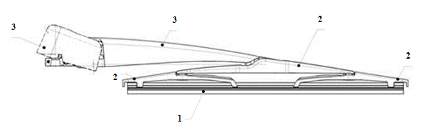

"

II. Justification

In order to avoid any misunderstanding on requirement applied to parts of the windscreen wiper, a simple generic drawing presenting the concerned areas seems to be the best way for an appropriate application of the provisions.

1. \* In accordance with the programme of work of the Inland Transport Committee for 2014–2018 (ECE/TRANS/240, para. 105 and ECE/TRANS/2014/26, cluster 02.4), the World Forum will develop, harmonize and update UN regulations in order to enhance the performance of vehicles. The present document is submitted in conformity with that mandate. [↑](#footnote-ref-2)