Transmitted by IWG ASEP
Informal document GRB-68-03
(68th GRB, 12-14 September 2018,
agenda item 4 (b))

Interim Report by GRB IWG ASEP
About UN R51.03
ASEP by Paragraph 6.2.3 Last Sentence
Informal Document to GRB 68 (Sep-2018)

- Scope of this paper
Regulations shall be precise and explicit to enable authorities, companies and technical services to assess compliance of products with the requirements of a regulation. There shall be as little ambiguity or room for interpretation as possible. Sometimes it might be difficult to provide clear specification, as the regulator might wish to express a certain expectation. However, in this case background information is needed, to enable manufacturer to develop proper in-house requirements for compliance assessments.
The experts providing this paper deem it necessary to provide clarification and guidance on the interpretation and application of paragraph 6.2.3. last sentence of UN R51.03:

“The sound emission of the vehicle under typical on-road driving conditions, which are different from those under which the type-approval test set out in Annex 3 and Annex 7 was carried out, shall not deviate from the test result in a significant manner.”

Consideration and clarification is particularly needed on:

- the meaning of “typical on-road driving conditions” relative to the test conditions specified in Annex 3 and Annex 7 see item 4.a.
- the meaning of “shall not deviate […] in a significant manner” see item 4.b.
- the meaning of “test result” of this Regulation see item 4.c.
This document provides authorities, companies and technical services with guidance regarding the interpretation of paragraph 6.2.3. last sentence of UN R51.03.
This document is not intended to specify additional tests exceeding the requirements of Annex 7. Compliance at test conditions which are difficult to perform on today’s typical exterior sound emission test tracks are recommended to be performed by virtual assessment, for example by calculations based on test data (similar to indoor testing according to ISO 362-3). A framework for virtual assessment shall be developed during the ongoing ASEP Revision.
It is necessary to keep in mind that the concept of ASEP target on sound emission systems that can be actively controlled, for example silencer systems with variable geometries (as defined in UN R59.02 paragraph 2.3.) or sound generators.
For the moment, no amendment to UN R51.03 is planned, but will be taken into consideration for the ongoing general ASEP revision. This document shall as well serve as guidance for authorities, manufacturer and technical services for design, development and compliance assessment.
- Historical Background for ASEP Development
The Additional Sound Emission Provisions (ASEP) have been developed between 2005 and 2010 in a GRB Informal Working Group. The terms of reference (GRB report TRANS/WP.29/GRB/40)^{[1]} mandated the group to

“[…] develop a complementary test method and evaluation criteria for insertion into Annex 10. The complementary test method shall cover the noise emission under higher engine speeds and loads than the proposed procedure in TRANS/WP.29/GRB/2005/5 [Proposal for Draft Amendments to Regulation No. 51], as amended”.

The Informal Working Group presented its work status and its latest proposals in 2/2010 to GRB51, without offering a clear direction. The chairman of GRB summarized the work of the group and provided a compromise proposal to GRB52 in 9/2010 (TRANS/WP.29/GRB/2010/9). Paragraph 6.2.3 of TRANS/WP.29/GRB/2010/9 provided the following specification at the time:

“6.2.3. Additional sound emission provisions
The additional sound emission provisions apply to vehicles of categories M1 and N1 only. They are preventive requirements intended to also cover the driving performance of the vehicle in real traffic, which can be environmentally relevant in terms of sound emissions and which differs from those during type approval testing, described in Annex 3, of Regulation No 51.”

Further clarification was provided in paragraph 6.2.3.3 of TRANS/WP.29/GRB/2010/9:

“6.2.3.3. The sound emission of the vehicle under normal driving conditions different from the conditions of the type approval test in Annex 3 shall not differ considerably from what can be expected from the type approval test result for this specific vehicle with regard to technical practicability. This is fulfilled if the requirements of Annex 10 are met.”

These provisions were clear and consistent. By compliance to Annex 10 it was assumed that a vehicle will satisfy the declared intention outlined at that time in paragraph 6.2.3. second sentence and paragraph 6.2.3.3. first sentence.

In the course of political debate in the year 2012 and 2013 in the European Union, the importance was raised, that the sound emission of a vehicle should not only be limited to the operation conditions, provided by the control range of Annex 10 (today Annex 7). It was further decided to move the intention for a proper vehicle sound emission to a more prominent place. Therefore, paragraph 6.2.3 second sentence and paragraph 6.2.3.3. last sentence were merged together and provide today’s specification in paragraph 6.2.3. of UN R51.03:

“6.2.3 Additional sound emission provisions
[…] The sound emission of the vehicle under typical on-road driving conditions, which are different from those under which the type-approval test set out in Annex 3 and Annex 7 was carried out, shall not deviate from the test result in a significant manner.”

Although, the technical outline by GRB was clear in 2010 (TRANS/WP.29/GRB/2010/9), the political intention resulting in a modification of the original text finally introduced to UN R51.03 cannot be ignored. The proposal below provides an approach to restore the political will on a technical basis, using the concept of ASEP Annex 7.

- Technical Background
Noise emission regulations, and the supporting test procedures, are written with the assumption that testing at a limited number of discrete test conditions will provide sufficient information to characterize the vehicle’s sound emission performance. Historically, sound emission testing was first conducted on a “worst case” (2nd gear and/or 3rd gear testing under full acceleration) approach where exhaust systems were the primary contributors to vehicle noise emissions.

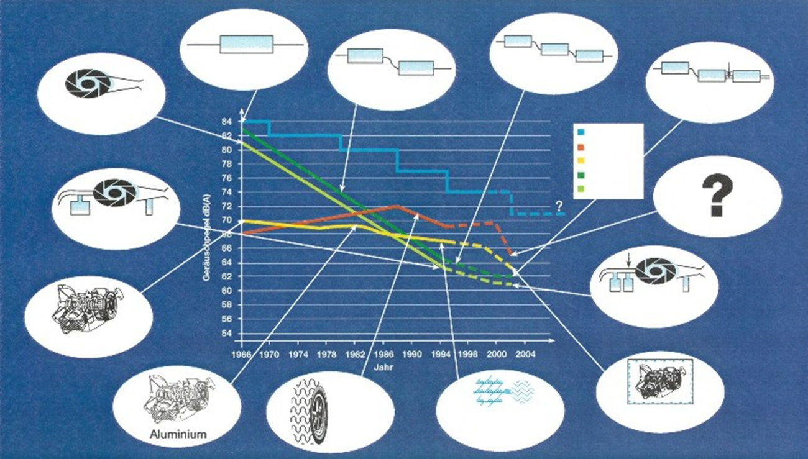
(Source: „Traffic Noise Regulations and Their Effects on Traffic Noise“ by P. Ehinger, S. Moser Dr. Ing. h.c. F. Porsche AG Stuttgart , TA Esslingen, Symposium „Auto und Umwelt“ 19.-20. Sept. 1994)

Exhaust systems could be further characterized primarily by the engine speed, i.e., the RPM. From such assumptions, tests such as SAE J366 and SAE J986 were developed which required the maximum rated engine speed to be reached within the measurement zone specified when driving a vehicle on a test track past a pair (left and right) of microphones. Sound from the vehicle at higher speeds were not considered relevant, as a vehicle spends most of its time at lower speeds, and this is especially true when considering the vehicle in proximity to people. This can be seen by looking at any emission or fuel economy test cycle in use anywhere in the world; the vehicle speeds are representative of normal driving in urban or suburban locations.

Modern development of sound emission test procedures have moved away from the principle of “worst case” to the principle of “real world driving”. Examples of these test procedures are UN R51.02 (based on ISO 362:1998 and SAE J1470) and UN R51.03 (based on ISO 362-1:2014 and SAE J2805). Sound emission test procedures are now developed to provide test results corresponding to actual in-use sound emission relevant to typical driving in urban and suburban environments.

The phrase “typical driving” is understood to mean driving conditions which match the conditions of vehicle driving statistically relevant in traffic. These can be described in terms of vehicle speed ranges, acceleration ranges, and/or engine operating speed ranges. The driving cycles and ranges described in tailpipe emissions and fuel consumption regulations are examples of such descriptions. As traffic noise, tailpipe emissions, and fuel consumption are all based on similar, or exactly the same, driving statistics, they have closely aligned operating envelopes. Therefore, whether it is the actual regulated cycle, regulated operating points, “Real Driving Emissions (RDE)”, in-use compliance or any other similar concept, the vehicle speed, accelerations, engine speeds are all similar.

Regulatory implementation of tailpipe versus sound emission regulations have significant differences. The test procedures operate under the assumption that emissions from vehicle operating conditions within the “typical driving” are properly represented by the test values – or in other words, there is no “test beating”.

In the case of a fully passive exhaust system with no active elements and in absence of active controlled sound enhancement systems, this is true or substantially true. In the case of vehicles with active exhaust, engine or other elements, this cannot be assumed to be automatically true. Therefore, the concept of additional sound emission testing as part of regulations to insure the sound emission test results from UN R51.03 Annex 3 (ISO 362-1, SAE J2805) or similar tests are true representative values over the vehicle operating ranges corresponding to typical driving. An example of this is the “Additional Sound Emission Provisions (ASEP)” in United Nations Regulation 51.03 Annex 7.

But whether a regulation has an explicit “off-cycle” requirement or not, representative performance over an operating envelope described by “typical driving” is implied from the ISO and SAE test procedures. It is further implied that the test results from ISO and SAE test procedures are valid for all driver selectable modes, i.e. modes are not a backdoor method of “test beating”.

- Proposal for Clarification
The requirements of paragraph 6.2.3. last sentence of UN R51.03. shall be interpreted as follows:
  - “Typical On-Road Driving”
The term "on-road driving" means any driving situation, either cruising, acceleration or deceleration and including standstill at operation conditions of the vehicle which are used by a driver in traffic. Typical On-Road Driving includes as well situations like braking and gear shifting, etc. However those situations are not within the range of Regulation UN R51.03 and thus not covered by ASEP.
The term "typical" means that a driver reasonably adapts the driving style to the traffic situations and respects traffic rules. The term "typical" does not mean any aggressive, excessive, extreme, illegal or reckless driving.
Many studies have been carried out to assess “typical on-road driving”. GRB has already started in the late 90s in connection with the development of Annex 3 to answer this question (FIGE Study 1998 “Investigations on Improving the Method of Noise Measurement for Powered Vehicles”)^{[2]}. Later GRPE confirmed these findings by studying real in-use driving data of customers for the development of the WLTC (GTR15)^{[3]}. Latest analyses regarding "typical on-road driving" were made in connection with the development of the European Union's Real Driving Emissions (RDE)^{[4]}, leading to a control range as outlined in Commission Regulation (EU) 2017/1151.

These studies demonstrate that "typical on-road driving" means
- vehicle speeds not exceeding 130 km/h, and
- vehicle accelerations below 2 m/s², and
- vehicle performance, defined as vehicle speed multiplied with acceleration v∙a lower than 35 m²/s³.
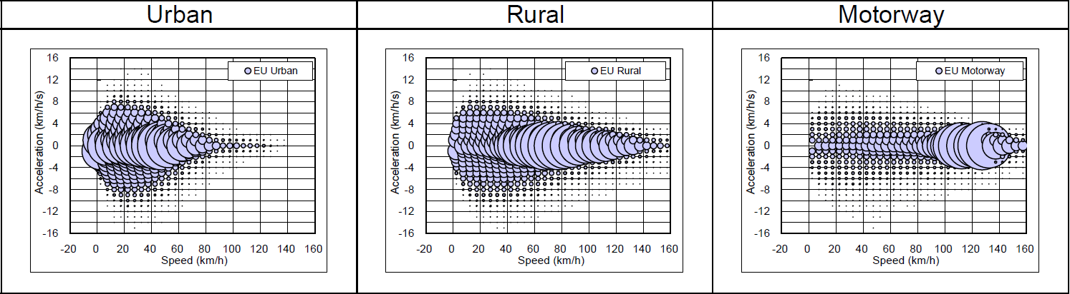
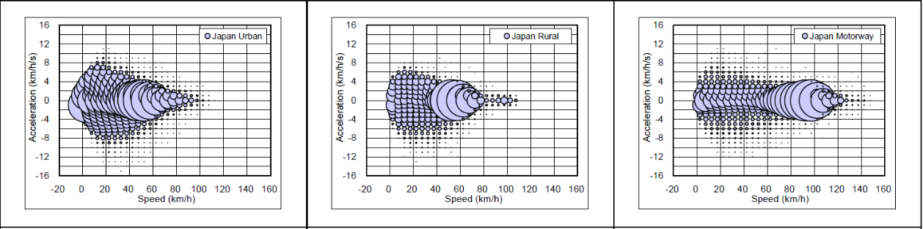
Source: Informal document GRPE-68-03; Figure 4-4 Speed–acceleration distribution in U/R/M category for Europe (upper diagrams) and Japan (lower diagrams)

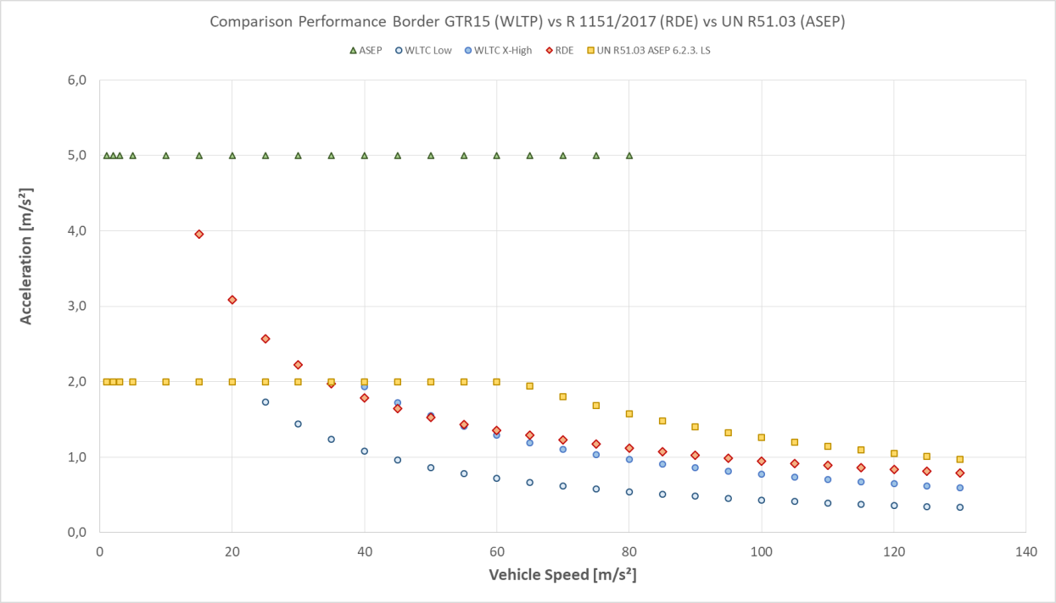
Figure: Comparison Acceleration Profiles WLTC; RDE and UN R51.03 ASEP

This applies to any gears or gear ratios within a range of engine speeds. More statistics, especially on aggressive driving, resulted in a proposal for a maximum engine speed as provided by Annex 7 of UN R51.03 (based on GRB IWG Annex 3 CRP-006 – 2003 Background Information of Germany on Engine Speed)^{[5]}.

Typical driving varies from country to country and may impose difficulties in interpretation, if no discrete values are provided. The maximum legally allowed vehicle speeds on highways or rural roads can be very different, not only from country to country, but even within a country where speeds on streets are especially restricted when many people live close to that road.

For assessment of ASEP compliance, manufacturer will face several difficulties:
- Pull-away situations at very low speeds are undefined, as it is a transient between vehicle standstill and movement with an interference of clutch engagements and tyre slip.
- Today’s test tracks are not designed for the sound assessment at vehicle speeds beyond 80 km/h. Accelerations at speeds beyond 80 km/h are rather low, because higher gears are engaged especially under partial load. Therefore the travel path of a vehicle under test can become very long, much longer compared to the typical test length of a sound emission area.
Summary:
Compliance with “typical on-road driving” as mentioned in paragraph 6.2.3 last sentence shall be defined as follows:
- any gear, except reverse gear and test conditions for gears covered by Annex 7
- any vehicle speed between 15 km/h and 100 km/h
- any acceleration either partial load or full load acceleration leading to a vehicle performance v∙a not exceeding 35 m²/s³, and not exceeding an acceleration of 2 m/s²
- engine speeds of at least 1.5 times of the idle engine speed and not exceeding the maximum engine speed outlined in Annex 7

In future revisions of ASEP the definitions provided above shall be revised.

Compliance at test conditions which are difficult to perform on today’s typical exterior sound emission test tracks are recommended to be performed by virtual assessment, for example by calculations based on test data (similar to indoor testing according to ISO 362-3). A framework for virtual assessment shall be developed during the ongoing ASEP Revision.

  - “Significant Deviation”
The term "significant deviation" means a deviation that is uncommonly loud and that is acoustically obvious to everybody, i.e. everybody can clearly hear the difference. All vehicles have a variation in sound dependent on vehicle speed and engine load (acceleration performance). It is important to appreciate that vehicles cannot have the same sound output under all driving conditions. It is physically and technologically not possible. A vehicle's sound output changes depending on the respective driving conditions. Hence, having a single sound output cannot be the goal.

A “significant deviation” means a difference in sound level for a discrete operation condition for which a reference value is available. Annex 3 and Annex 7 provide these reference values over a wide range of operation conditions, between 20 km/h and 80 km/h.

When comparing same operation conditions at different sound levels, trained people (acoustic experts) will be able to identify a difference in sound levels of 3 dB(A). Below that difference, this is – if at all – only possible in special back-to-back tests, where two sound samples are provided immediately one after the other. However, a difference of 3 dB(A) does not satisfy the criteria of a significant deviation. Non acoustic experts will be able to determine sound level differences from 6 dB(A) upwards. A significant difference for a distinct operation condition cannot be lower than 6 dB(A), but is in an area between 6 dB(A) to 10 dB(A). ^{[6], [7], [8]}

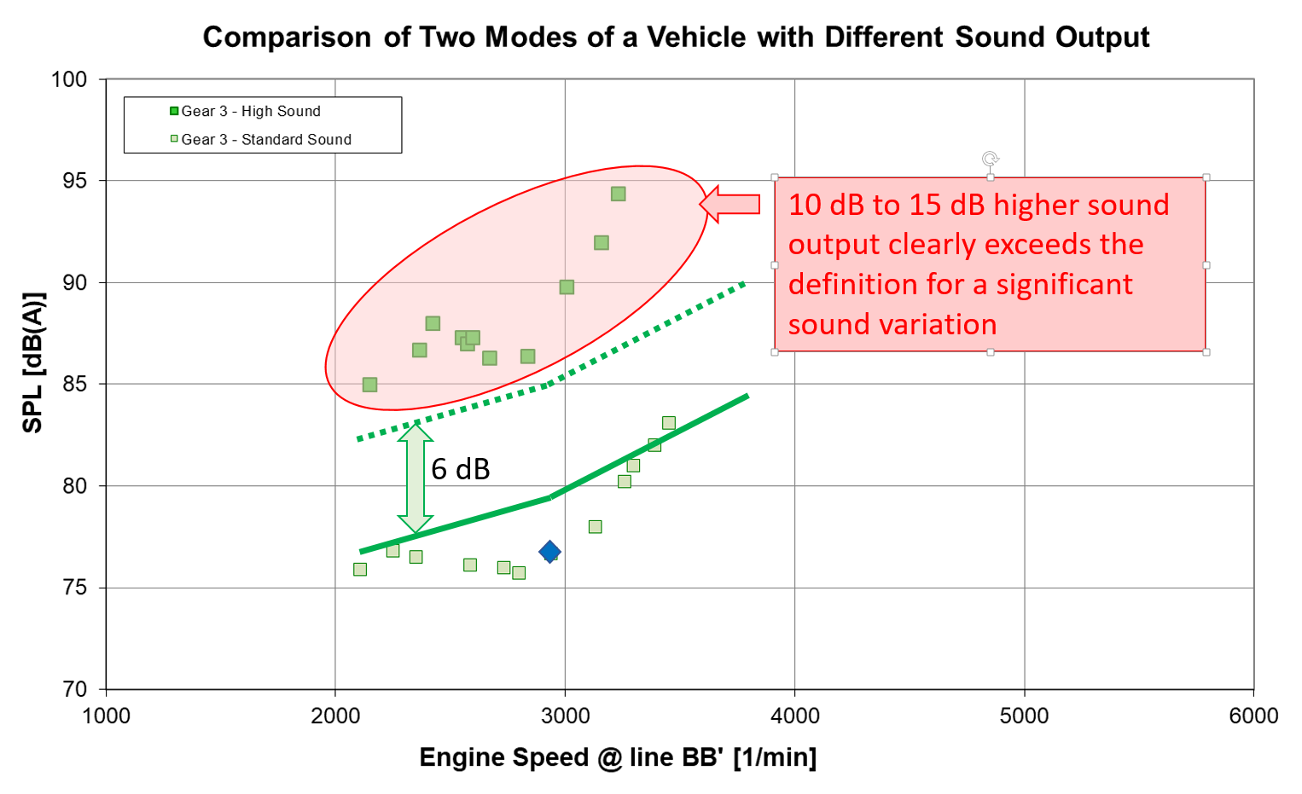

Example for the sound behaviour of a vehicle with mode dependent sound output, which is clearly audible to everybody.
Summary:
A significant deviation is given for a test result if the measured sound level exceeds the sound level for a comparable operation taken as reference by at least 6 dB(A).
  - “Type Approval Test Result”
The term "type approval test results" means a value derived from the test results of Annex 3 or Annex 7 of UN R51.03 for a particular operation condition.
A discrete unique type approval test result does not exist. UN R51.03 Annex 3 and Annex 7 provides a bundle of results. Annex 3 results can be the test results from the acceleration test L_{wot} of a discrete gear or the constant speed test L_{crs} of a discrete gear, or the final calculation result L_{urban}. Test results of Annex 7 are the borderline curves of the Slope-Assessment for the gears falling under the ASEP provisions or a calculation result L_{P1} to L_{P4} of the L_{urban}-Assessment for the point P₁ to P₄ of a gear.

The evaluation methods of Annex 7 of UN R51.03 produce reliable reference values for a larger range of operation conditions. The test results of Annex 3 of UN R51.03 are integrated in Annex 7 of UN R51.03, either for the construction of limitation curves, to which a vehicle may be designed (given for the Slope-Assessment) or for the acceleration performance dependent sound emission relative to the type approval test result (given for the L_{urban}-Assessment).

One can use the construction principles of each evaluation method and extrapolate it to operation conditions outside the control range of Annex 7. While for the “Slope-Assessment” method the regression curves can simply be extrapolated, the construction principle for the L_{urban}-Assessment is more complex.

For accelerations below a_{urban}, the partial power factor for ASEP k_{P_ASEP} shall be set to zero (k_{P_ASEP} = 0). Otherwise the k_{P_ASEP} would result in an unphysically negative value. This means that for all accelerations below a_{urban} no partial load compensation is applied any more.
Summary:
As a reference for the verification of a sound level of a given operation condition which is not covered by the control range of Annex 7, either the regressions curves for the “Slope-Assessment” or the calculation principles of the L_{urban}-Assessment according to Annex 7 of UN R51.03 shall be applied in light of the above mentioned restrictions.

- Integration and Visualization

With foresaid explanations, it is possible to outline a diagram as a simplified scheme for the evaluation methods according to Annex 7 of UN R51.03.

The figure 1 below visualizes a correct approach for the “Slope-Assessment”. The yellow area provides an area that is defined by technical parameters so that authorities, companies and technical services can verify the sound emissions of a vehicle. The ∆L_{ASEP} can be put directly on the borderline. For gears greater than gear i, Annex 7 does not provide a borderline curve. To enable the evaluation of these gears, the same borderline should be used as for gear i shifted by ∆L_{ASEP}. For low gears falling under the scope of Annex 7 for which no boundary curve can be developed due to violation of control range parameters, the borderline of the lowest valid gear of Annex 7 should be used for evaluation of those gears.
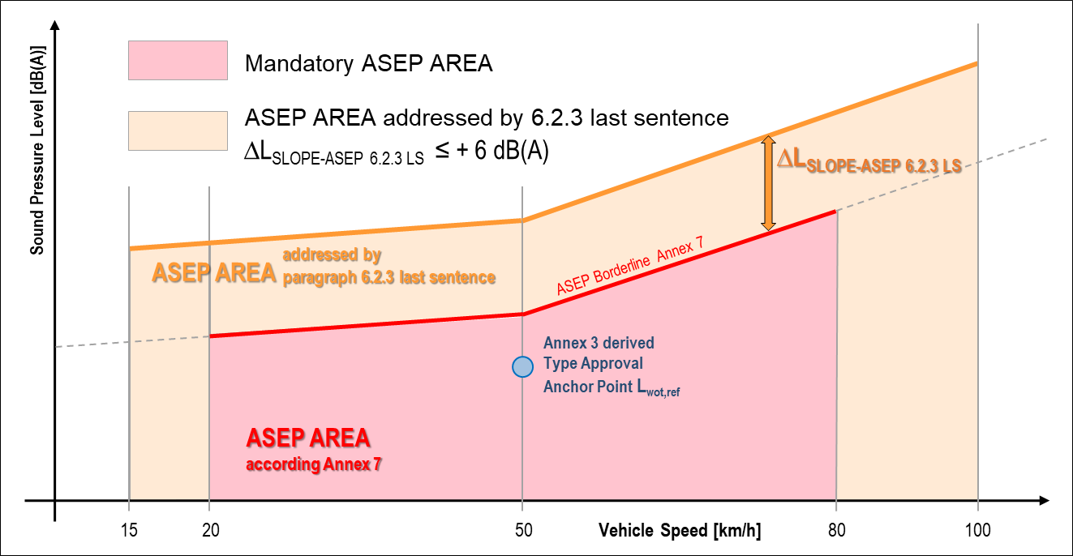
Figure 1: Illustration of the interpretation of paragraph 6.2.3 last sentence for the “Slope-Assessment”
The construction for the “L_{urban}-Assessment” is slightly different. Due to its design, a significant variation of dB(x) cannot be directly used as an add-on value like for the “Slope-Assessment” above. In low gears, up to gear i, the accelerations are more likely to come close to the maximum acceleration suggested for the operation conditions exceeding those of Annex 7. Therefore, a compensation ratio of 1:3 shall be acceptable (approximated ratio between a_{urban} and the maximum acceleration). Instead of 6 dB(A), an add-on of 2 dB(A) is justified.

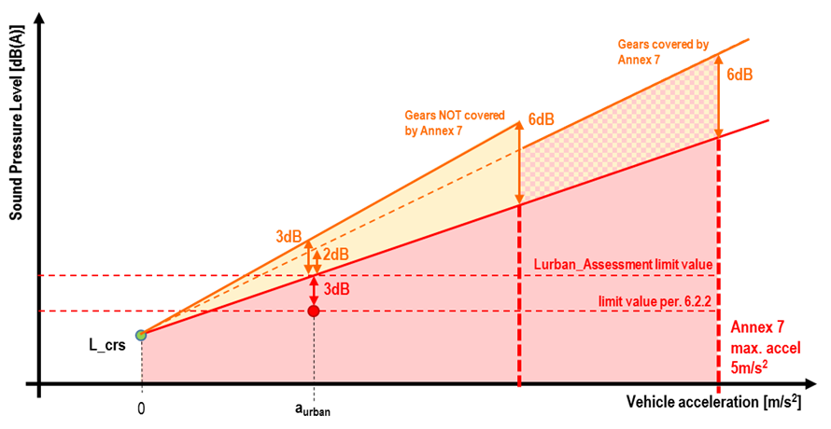
Figure: Quotation of measured sound level by L_{urban}-Assessment

For gears above gear i, it is unlikely that these gears will reach high accelerations, therefore a ratio 1:2 shall be acceptable, leading to an add-on of 3 dB(A).

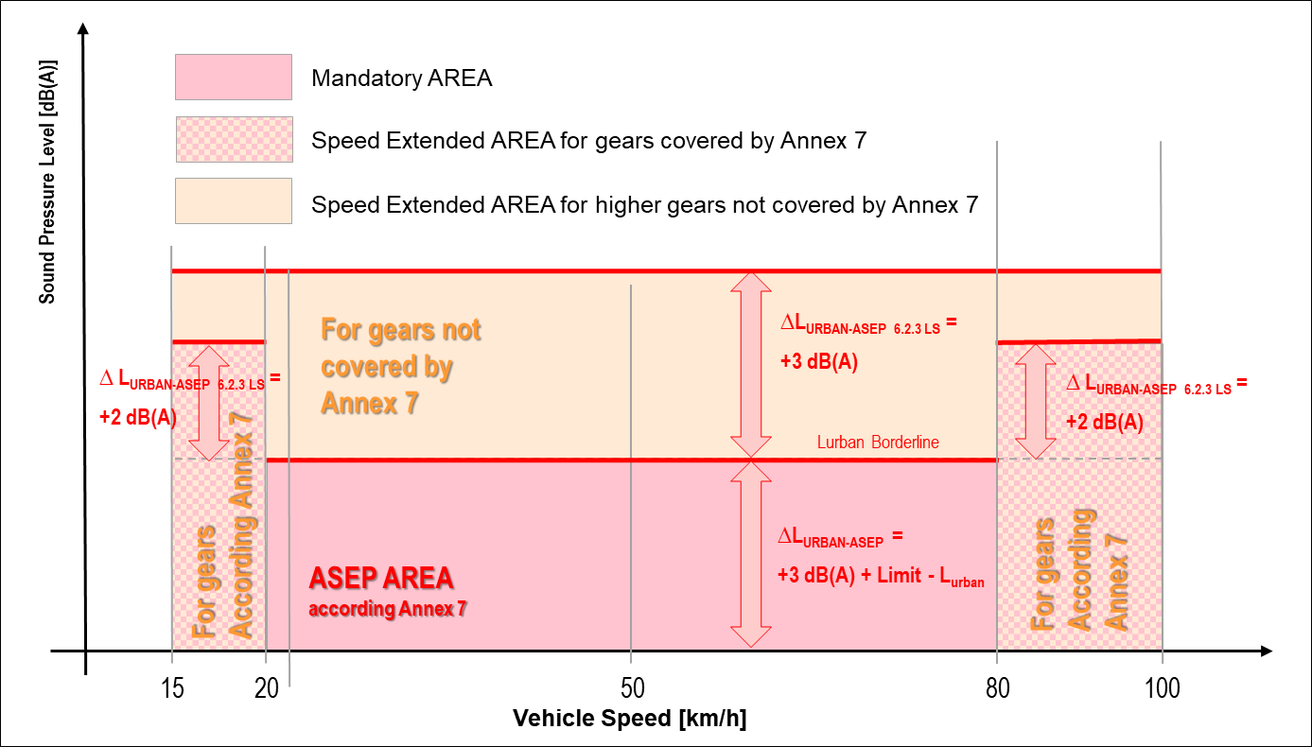
Figure 2 below shows in an indicative way for the limitation concept for the “L_{urban}-Assessment”
Figure 2: Illustration of the interpretation of 6.2.3 last sentence for the “L_{urban}-Assessment”

REFERENCES
[1] Terms of References for Informal Working Group on ASEP;
GRB; 2005; (GRB report TRANS/WP.29/GRB/40)
[2] Investigations on Improving the Method of Noise Measurement for Powered Vehicles;
Heinz Steven; Fige Study 1998
[3] Worldwide harmonized Light vehicles Test Procedure;
UN-ECE; 2014; GTR 15
[4] Real Driving Emissions;
COMMISSION REGULATION (EU) 2017/1151; 1 June 2017;
[5] Background Information of Germany on Engine Speed;
Germany; 2003; GRB IWG Annex 3 CRP-006 – 2003
[6] Perception of level differences (Pegelunterschiede hören);
Eberhard Sengpiel; http://www.sengpielaudio.com;
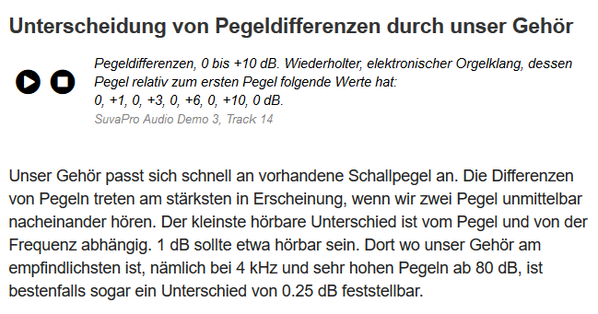
[7] Differentiation of level differences by our hearing (Unterscheidung von Pegeldifferenzen durch unser Gehör); http://www.laermorama.ch/m1_akustik/schallpegel_w.html#pegeldiff

[8] Sound Perception (Geräuschwahrnehmung);
http://www.computational-acoustics.de/html/psychoakustik_gerauschwahrnehmung.html; http://www.computational-acoustics.de/html/akustisches_gedachtnis.html#Gedaechtnis

See EU Framework Directive 2018/858/EC Article 3 (54): “‘virtual testing method’ means computer simulations, including calculations, to demonstrate that a vehicle, a system, a component or a separate technical unit fulfils the technical requirements of a regulatory act listed in Annex II without requiring the use of a physical vehicle, system, component or separate technical unit”
Within the document referenced (TRANS/WP.29/GRB/2010/9) ASEP was covered by Annex 10, while later in the final version of UN R51.03 ASEP is covered by Annex 7.
With the assumption, that the sound performance below 15 km/h is not higher than at 15 km/h.
See EU Framework Directive 2018/858/EC Article 3 (54): “‘virtual testing method’ means computer simulations, including calculations, to demonstrate that a vehicle, a system, a component or a separate technical unit fulfils the technical requirements of a regulatory act listed in Annex II without requiring the use of a physical vehicle, system, component or separate technical unit”

