Creation of a dedicated GR working group for automated/autonomous connected vehicles under WP.29
Autonomous driving is the key technology for future mobility. The trend toward autonomous driving poses not only new challenges from a technical point of view, but also from a regulatory one: as a matter of fact, as automated and increasingly autonomous vehicles are about to take over more and more tasks currently carried out by drivers, significant regulatory efforts will be required to ensure that any such systems achieve the highest degree of safety and harmonisation. The World Forum for Harmonization of Vehicle Regulations (WP.29) as a unique worldwide regulatory forum within the institutional framework of the UNECE Inland Transport Committee therefore, undisputedly, has a particular role to play in that regard and the responsibility to set worldwide standards in the most efficient way.
Background
In response to growing interest and application of technologies for automated, autonomous and connected driving, the WP.29 had established back in 2015 the "Informal Group on Intelligent Transport Systems/Automated Driving (ITS/AD)" with a view to identifying relevant issues for the practical application of automated driving, scrutinising the regulatory measures available and proposing new ones for consideration by WP.29. In close cooperation with the GRRF, concrete steps were undertaken to harmonise regulatory requirements for vehicle automation technologies such as e.g. line keeping assistance systems or advanced emergency braking systems which are considered paving the way towards autonomous driving.
In most recent debates on its working programmes and priorities of work, WP.29 confirmed to give the highest priority to activities on automated, autonomous and connected driving and agreed, at the same time, to establish five new sub-working groups dealing with specific aspects in that area. Also, it was agreed that there is a need for very fast action given the pace of technological developments in that field.
At its 80th session in February 2018, the Inland Transport Committee (ITC) explicitly acknowledged the importance of WP.29 activities related to automated, autonomous and connected vehicles and requested WP.29 to consider establishing a dedicated subsidiary Working Party ("GR").
As regards a future structure, it is commonly acknowledged that it should involve the Contracting Parties of both the 1958 Agreement and 1998 Agreement.
Current state of play
WP.29 established six permanent Working Parties (GRs), i.e. subsidiary bodies that consider specialised tasks, consisting of people with a specific expertise:
- Noise (GRB)
- Lighting and Light-Signalling (GRE)
- Pollution and Energy (GRPE)
- Brakes and Running Gear (GRRF)
- General Safety Provisions (GRSG)
- Passive Safety (GRSP)
The World Forum WP.29 also established a number of Informal Working Groups (IWGs), amongst which the aforementioned IWG for ITS/AD. See Fig-1.
A quantitative assessment of the workload distribution under the current structure is provided in Fig-2.
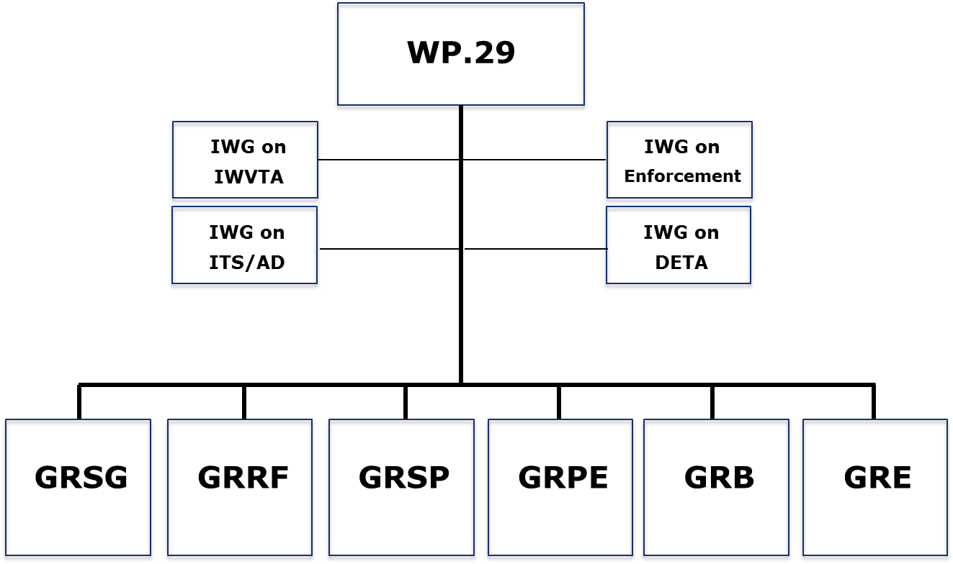
IWG on PTI
Fig-1: Current organisation of working groups under the World Forum for Harmonization of Vehicle Regulations (WP.29).

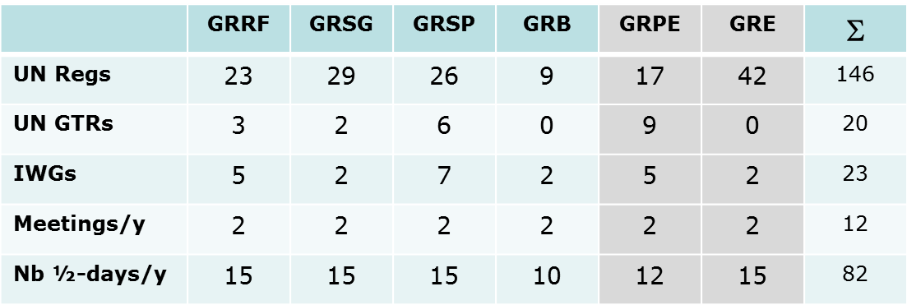
Fig-2: Quantitative assessment of the workload distribution under the current structure

Proposed way forward
With a view to pursuing the existing activities as well as accommodating the new activities on automated and autonomous driving, mainly three options exist:
- Maintaining the current structure of six GRs and converting an existing GR into a dedicated one dealing with automated/autonomous vehicles, with all GRs having an equal status
- Maintaining the current structure of six GRs and converting an existing GR into a dedicated one dealing with automated/autonomous vehicles, having a coordinating function of the other GRs
- Creating a new (7th) GR for automated/autonomous vehicles
Other options, such as e.g. the options of (a) spreading activities on automated/autonomous vehicles over the six existing GRs or (b) adding on the activities on automated/autonomous vehicles to the portfolio of an existing GR were not considered here, as not being in line with the mandate of the ITC.
Following extensive discussions amongst representatives of AC.2 over the last months on the three options at stake, Option 1 was therefore retained at this stage for the following reasons:
- Timing: Option 1 can be endorsed at AC.2 level (in June 2018) and implemented immediately afterwards, which would allow the new converted GR to take up its duties still in the second half of this year. As opposed to this, Option 2 will require additional consultation, while Option 3 would require a lengthy decision procedure, with a formal decision to be taken at ITC level first (i.e. at best in February 2019) and inherent risks of subsequent procedural delays, which would allow the new GR taking up its duties not before the end of 2019, at best – which is clearly in contraction with the need for fast action.
- Resources: Options 1 and 2 do not require any additional resources, neither from the budget nor the staff point of view; it would barely require an organisational re-allocation of activity portfolios amongst the existing GRs and, possibly, an adjustment of the meeting days. As opposed to this, Option 3 would require more staff for the management of the additional GR, as well as increased budgetary resources for the additional meeting weeks.
For the reasons above, Option 3 was put aside at this stage. As for Option 2, it will require additional time for consultation of stakeholders and a decision by ITC, while option 1 is ready for immediate implementation (step 1). Discussion on Option 2 will continue in the context of upcoming meetings of WP.29.
During this step 1, the direct coordination of the work on automation of the different GRs will be delivered by AC.2, in accordance with the rules of procedure of WP.29. While GRVA would lead on the development of Regulations and / or Resolutions for the automation aspects of automated and/or autonomous vehicles, the other GRs will continue to lead on all issues related to automated and/or autonomous vehicles within their respective roles and responsibilities (e.g., GRPE will continue to lead on issues related of pollution and energy of automated and / or autonomous vehicles).
Organisational adaptations
In view of the implementation of a solution that is based on Option 1, the current GRRF working group appears to be the only possible candidate for a conversion into a new GR for automated/autonomous vehicles due to (a) its coverage of relevant topics (brakes, vehicle dynamics) and (b) its deep involvement in automated/autonomous vehicles related activities already as of today.
It is suggested to use for the new working group the denomination of GRVA – "Groupe Rapporteur pour Véhicules Autonomes", in the meaning of encompassing activities for automated, autonomous and connected vehicles.
With a view to achieving a workload distribution amongst the GRs in a balance- and topic-wise meaningful manner, it is suggested to
- To ensure policy coordination and cooperation amongst relevant bodies on automated and autonomous vehicles at the level of WP.29
- Re-allocate all tyre-related activities under GRRF to GRB
- Re-allocate tank vehicle safety-related activities under GRRF to GRSP
- Re-allocate coupling device-related activities under GRRF to GRSG
- Incorporate all current activities of the IWG ITS/AD into GRVA
- Arrange for the mobility of experts in order to ensure that their expertise follows the re-allocated activities
A detailed list of re-allocated activities is provided in Annex 1.
Fig-3 illustrates the new organisation structure; a summary of the workload distribution under the new structure is illustrated in Fig-4.
The decision on the new structure will be based on the above principles. However, its functioning will be monitored and assessed in the course of the coming [twelve] months and conclusions will be submitted to WP.29 in [June] 2019.

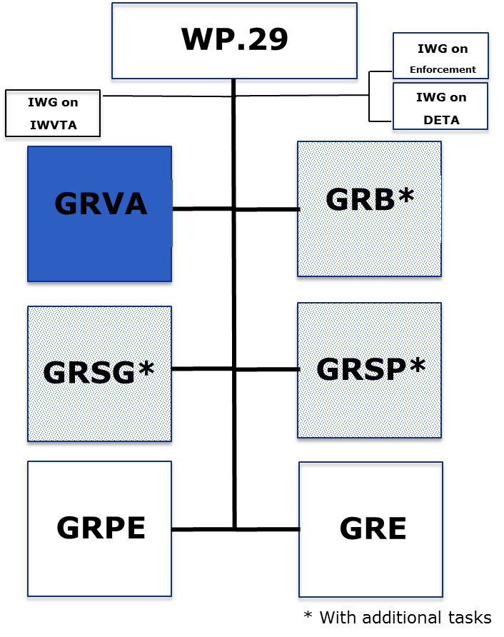
IWG on PTI
Fig-3: New organisation of working groups under the World Forum for Harmonization of Vehicle Regulations (WP.29).

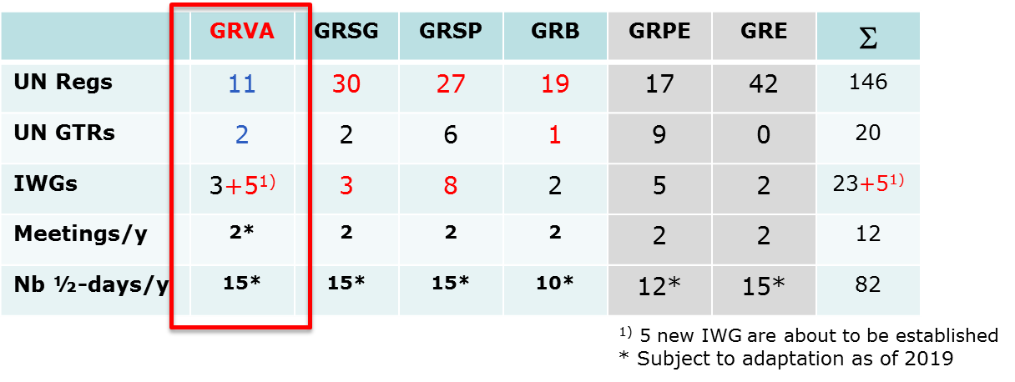Fig-4: Quantitative assessment of the workload distribution under the new structure

A number of further supporting measures and practical adaptations are being suggested in order to allow a smooth and effective uptake of activities under the new organisation:
- The new GRVA should convene for the first time in its new configuration from 25 to 28 September 2018, as initially foreseen for the 86th session of GRRF
- Adapting the name of the working group GRB, in order to reflect the new responsibilities assigned on tyres-related activities, e.g. GRBP (Groupe Rapporteur Bruit et Pneumatiques)
- Adapting the WP.29 work programme and, more particularly, also the agenda of the current GRRF session of September 2018
- Organising, with the support of the GR Chairmen, a discussion at the remaining 2018 WP.29 sessions on the appropriate allocation of the number of half-days to the GR working groups under the new structure
- Exploring, with the support of the Chair and Vice-Chair of WP.29, whether some half-days for WP.29 sessions could be made available for the GR working groups
- Reviewing the functioning of the new organisation one year after its implementation, in particular to reconsider option 2 ("2-step approach"), as well as to check whether the resources allocated to WP29 and each GR working group are in line with the actual needs
- Getting prepared for the requesting additional (staff and/or budgetary) resources in order to address potentially increasing future demand for GRVA activities
- Adapting the terms of reference of WP.29 and the different GR working groups, in order to accommodate the new activities and portfolios

Annex 1
