Transmitted by the experts from IMMA | Informal document WP.29-174-03  (174th WP.29, 13-16 March 2018,  agenda item 4.2.2)
Supplements adopted before or at 173/WP.29 sessions
I Context
After the adoption of the Draft General Guidelines for regulatory procedures and transitional provisions in UN regulations (WP.27/2017/107 as amended) at 173/WP.29, the World forum took note of concerns raised by the representative of OICA in WP.29-173-14 that the new rules for extensions to existing type approvals under paragraph 31(b) of the guideline document were developed after the most recent amendments to UN Regulations, which therefore obviously could not take into account these new Rules. As a result, recently adopted Supplements, could unexpectedly have a retroactive impact on some vehicle type approvals when these are extended.
More specific, in March 2017, the draft Guideline (WP29-171-24) contained the following draft provisions which were discussed and modified during the subsequent 172 and 173/WP.29 sessions:
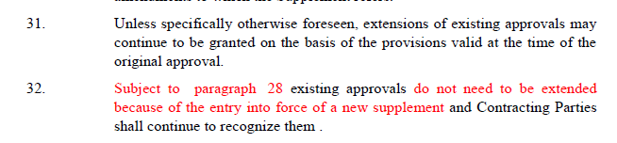
According to IMMA’s understanding, 173/WP.29 could not support the OICA proposal due to concerns with changing provisions or interpretations of the Revision 3 of the 1958 Agreement and its guidelines after their recent adoption. At the time of 173/WP.29, there was a lack of examples of cases producing difficulties for for manufacturers.
Since the 173/WP.29 discussion, IMMA has undertaken analysis of all recent L-category vehicle Supplements subject to the new Guidelines.
In this informal document, IMMA introduces an example related to motorcycle lighting installation requirements raising difficulty for motorcycle manufacturer’s products in some markets of Contracting Parties to the 1958 Agreement as a result of the new rules for type approval extensions.
II. Example of concern: Supplement UN R 50-00 S19

UN Regulation No. 50 for lighting devices applies to front position lamps, rear position lamps, stop lamps, direction indicators, and rear-registration-plate illuminating devices for vehicles of category L.
The UN Regulation No 50.00 does not include installation requirements of lighting and light-signalling as they are speficied in UN Regulation No 53 (for L3 vehicles) and in UN Regulation No. 74 (for L1).
The Supplement UN R 50-00 S19, as adopted at 171/WP.29, introduces a number of requirements from UN Regulations No.53 and No. 74.
In jurisdications of Contracting Parties to the UN Regulation No. 50 that have not acceded to UN Regulations No. 53 and No. 74, the additional requirements introduced with the Supplement UN R 50-00 S19 may be significant for some of manufacturer’s products on the market, subject to an extension of vehicle type approval.
IMMA recognizes that the original intent of UN R 50-00 S19 was not a retroactive application as is currently the case with the new Guideline.
To avoid non-anticipated product changes due to updated product requirements as a result of new rules of implementing supplements, IMMA requests not to apply the UN R 50-00 S19 requirements for extensions to current type approval and requests the UN guideline not to apply to Supplements adopted before or at 173th WP 29.

