|  |  |  |  |
| --- | --- | --- | --- |
|  | United Nations | ECE/TRANS/2018/14 | |
| _unlogo | **Economic and Social Council** | | Distr.: General  12 December 2017  Original: English |

**Economic Commission for Europe**

Inland Transport Committee

**Eightieth session**

Geneva, 20-23 February 2018  
Item 5 (e) of the provisional agenda  
**Strategic questions of a modal and thematic nature:**

**Rail transport**

Strategic Elements for the Working Party on Intermodal Transport and Logistics

Note by the secretariat

|  |
| --- |
| *Summary* |
| This note presents the key strategic elements for the Working Party on Intermodal Transport and Logistics (WP.24) on developing a strategy for 2019-2023, for adoption by the Working Party and then by ITC if possible in 2019. The main objectives of this strategy should be the revitalization of Working Party activities having as results the increased number of countries and delegates in total participating at the Working Party sessions, the concrete outputs produced, the recognition of Working Party’s role in the implementation and achievement of the Sustainable Development Goals. |
| The Committee may wish to **take note** and provide guidance on the preparation of the Working Party’s strategy. |
|  |

I. Introduction

A. Scope

1. The key strategic elements identification should evaluate the main objectives of the Working Party on Intermodal Transport and Logistics, which is to strengthen the framework for sustainable intermodal transport and logistics operations and policies in the ECE region and enhance cooperation between the member countries in addressing the issues through an exchange of experiences and good practices. This includes infrastructure and border crossing questions, as well as the monitoring and updating of relevant legal instruments, i.e. European Agreement on Important International Combined Transport Lines and Related Installations (AGTC) and its protocol on inland waterways.

2. The analysis below is based on quantitative and qualitative data from the period 2010-2017. This period was chosen because the results of work of the Working Party are mainly analytical and intercountry actions, i.e. coordinated development of networks, codes, task forces, workshops, etc., rather than a statistically measured output and therefore input from several years is needed to ensure reliable results.

B. Methodology

3. The methodology, i.e. a historical review including data collection, and strategic analysis, evaluate in parallel the degree to which the Working Party has contributed to (a) strengthening the framework for sustainable intermodal transport and logistics operations and policies in the region; and (b) enhancing the cooperation between ECE member countries in the exchange of experiences and good practices.

4. This methodology has two main advantages: (a) analysis of the external environment in which WP.24 has operated over the last seven years, strategically positioning the Working Party and evaluating the impact on its clients (governments); and (b) measuring the outputs that the Working Party has produced for the seven years, thus obtaining first-hand information on operational restrictions to ensure a complete, fair and unbiased assessment.

II. Findings

A. Historical Review

5. The historical review assessed to what extent topics discussed by WP.24 corresponded with pan-European intermodal transport trends identified during the 2010-2017 period. The actions decided upon by the Working Party and the country responses to these actions were evaluated. The objectives of the historical review are to:

(a) Evaluate the degree to which WP.24 was able to identify current intermodal transport trends and developments;

(b) Evaluate the response of WP.24 to these transport trends and developments; and

(c) Qualitative and quantitative analyses of the responses and activities undertaken.

6. Figure 1 illustrates the pan-European intermodal transport trends and the topics addressed at WP.24 workshops for the time period.

Figure 1

**Pan-European intermodal transport trends versus workshops organized by WP.24**

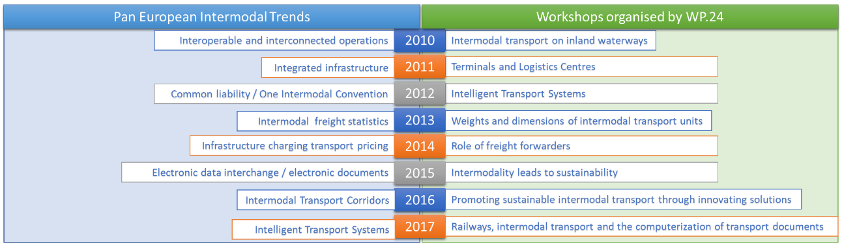

*Source*: ECE Transport Division

7. The blue or left part of the graph illustrates the main intermodal transport topics for the period 2010-2017 at the pan-European level. These were discussed in meetings organized by the relevant main international or regional transport organizations. Since we should ensure an objective selection of what can be considered as “main pan-European intermodal transport topics” for comparison purposes, the above-mentioned method was considered the most reliable.

8. The green or right part of the graph illustrates the main topics discussed during WP.24 workshops organized during the same period. In all cases (or years) the Working Party initiated or considered subjects that were more or less related to intermodal transport trends and topics of major interest in that particular period. For instance, some topics such as the infrastructure pricing, the electronic data interchange, the intermodal transport corridors or the integrated infrastructure were not addressed.

9. Figure 2 illustrates the number of countries, the total number of delegates and the number of speakers during the workshops organized by the Working Party over the period.

Figure 2

**Number of countries, total number of delegates and number of speakers participating at WP.24 sessions**

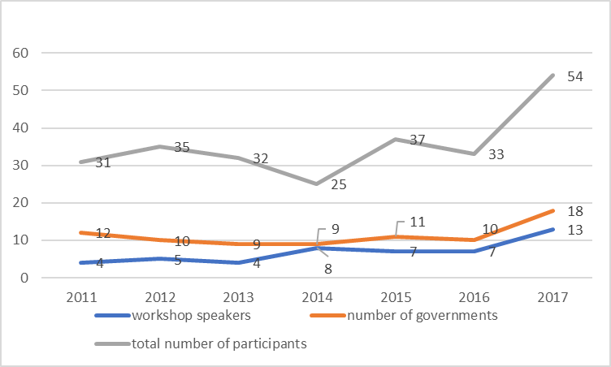

*Source*: ECE Transport Division

10. It is clear from figure 2 that in 2017 when the secretariat undertook efforts to revitalize the Working Party session that the governments responded to the efforts. During this year’s session there was an eighty per cent increase on the number of countries (eighteen compared to an average of ten for the last three years). Also, there was a seventy per cent increase in the number of participants (54 participants this year compared to an average of 31 for the last three years). Furthermore, there was a 95 per cent increase on the number of speakers at the workshop (13 speakers this year comparing to an average of six speakers for the last three years). However, the secretariat pointed out that further efforts are needed in order to further increase the number of countries and the total number of participants attending the sessions. Concrete outputs, new agenda items, daily workshops and a session that should last three days are some of the actions proposed by the secretariat.

B. P.E.S.T. Analysis

11. The Political, Environmental, Social and Technological analysis will help identify the environment in which WP.24 operates and the drivers of activity and change.

12. Political environment: Working Party operates under the Inland Transport Committee to which the Transport Division acts as the secretariat. ECE also comprises the Commonwealth of Independent States where there is a tremendous need for transport facilitation and technical assistance. This includes a geographical area where ESCAP is active in various projects and initiatives, especially on intermodal transport including the dry ports agreement. Funding does not appear to be as scarce for ESCAP as for ECE, and for this reason the former is more project oriented in that area than the latter.

13. The main competitive advantage of the ECE Transport Division is the 57 international transport conventions and agreements that it administers. Although WP.24 provides the secretariat for the administrative committee of the AGTC agreement and its protocol on inland waterways, only some of the contracting parties participate at the administrative committee sessions (7-8 out of 32 contracting parties).

14. Economic environment: Reduced budgets at all levels affect the work of WP.24 directly and indirectly: it means fewer delegates at the meetings, less funds for projects and travelling, less publications, and fewer possibilities to obtain external funds.

15. Social environment: ECE member States represent a colourful cultural, developmental, economical and historical mosaic. Their needs, priorities, and opportunities greatly differ. For instance, the development of intermodal transport corridors in Europe and Asia or the development of national master plan on freight transport and logistics. Different needs, ways of doing business, interoperability issues as well as technological differences are all different challenges that should be addressed.

16. Technological environment: Technological innovation is a key driver of change and operational efficiency. The only technological application that WP.24 takes advantage of is a website. No other applications are used. For more effective and efficient functioning, the Working Party should take advantage of specialized applications both for its regular work‐related communications as well as administrative procedures which so far have been based on traditional methods of doing business. The opportunities to expand its use of technological applications are great, especially for WP.24 that aims to strengthen its position as the Working Party that brings together all other infrastructure Working Parties.

C. S.W.O.T. Analysis

17. The SWOT analysis could help at this stage to identify the strengths, weaknesses, opportunities, and threats that the Working Party faces in order to have a clearer picture of the current conditions and design a strategy that will concretely contribute to Working Party’s revitalization.

| *Strengths* | *Weaknesses* |
| --- | --- |
| (a) The diversity of ECE member States is a great advantage not only because it offers a wealth of best practices in intermodal transport and logistics but also because it leaves a lot of opportunities for implementation of these best practices;  (b) Intermodality is in the heart of sustainable development goals and sustainable transport. The WP has not benefit yet from this unique advantage. | (a) Several of the other Working Parties have global membership, or recognition which is not the case for WP.24;  (b) There is no systematic collaboration with the other WPs of the Division to receive continuous feedback about critical issues and challenges in their line of work. |
| *Opportunities* | *Threats* |
| (a) There are many topics that the market considers them as “hot” such as the liability of the different international agreements, the lack of one intermodal convention, the electronic documents or the electronic data interchange, the city logistics, the passengers intermodal challenges that the Working Party does not address at the moment;  (b) The CTU Code could be a tool that could bring more recognition to Working Party;  (c) Opportunities exist to create better synergies with the results of work in other Working Parties of the Division, especially concerning policy oriented development in their areas of work. This should be capitalised on and better used by WP.24;  (d) The heritage of this WP should be capitalised on and transformed into new projects, publications, research papers, etc.;  (e) Original data and economic analysis on intermodal transport should be created. Original trends should be published. Working teams should therefore be created, with experts for every subject, to create a source of original thinking and data. | (a) Threat that from the point of view of the Governments, WP.24 agenda is not relevant enough that they can support;  (b) There is no working connection between international governmental and non- governmental organizations and the WP.24. This connection is needed to provide intellectual input and fundamental research for further analysis and policy debate as well as to enhance the agenda of the WP;  (c) Lack of sufficient funds could prevent WP.24 to organize and deliver more research studies / new tools / publications that would bring more value to governments and would eventually increase participation at its sessions. |

III. Challenges of Intermodal Transport in different areas of the ECE region [[1]](#footnote-2), [[2]](#footnote-3), [[3]](#footnote-4)

18. Intermodal transport, depending on the region and its infrastructure, regulations and structure of the market, faces different challenges and opportunities. Following we provide a list of those challenges and opportunities that might be considered either as strategic objectives of Working Party’s strategy or could be addressed on a regular basis by the Working Party agenda, workshops, etc.

19. The major challenges of intermodal transport of relevance to member States in ECE region are:

(a) successful revision of European Union Directive 92/106;

(b) successful passage of the Europe on the move package - revising the rules of road haulage with a view to effectively closing the regulatory disparities that favour road transport [closing social and work time, as well as enforcement loopholes exploited by hauliers for cost advantage + the effective implementation of the user-pays principle when it comes to road tolling];

(c) successful amendment of the energy taxation directive 2003/96 to implement the polluter pays principle;

(d) successful digitalisation initiatives in transport such as the single digital EU freight transport document, development of the web portal for rail-related service facilities, effective implementation of the modernised Customs Code, etc.;

(e) preparation of risk management and contingency plans including crisis management. For instance, the Rastatt disruption shows that there is the need to have contingency plans based on robust risk management. For each main line, there must be pre-defined alternatives, to be elaborated and constantly updated together with railway undertakings and multimodal partners;

(f) overcoming national obstacles: Incompatibilities between and particularities of national rail systems result in a situation where available capacity on the rail networks of neighbouring countries cannot be used. The interoperability of the rail network must be strengthened;

(g) international coordination of infrastructure works: Line closures or restrictions, whether planned or unplanned, must be managed in such a way that they ensure viable solutions for existing traffic and limit the negative impact on the quality of service offered to the end customer;

(h) operational cross-border management: The rail freight corridors either we are referring to the European one or to the Euro-Asian ones are an excellent basis for international cooperation on rail freight services, but today they lack essential operational competences to ensure competitive rail services. Possibly, a strong operations centre, one per corridor, should be established to effectively manage long distance rail freight traffic on different networks;

(i) incentives to minimize the impact of disruptions on rail services. The infrastructure manager must be incentivised financially to ensure better planning of infrastructure works and to find solutions that minimize impact on rail services and therefore limit the economic impact on their own organization;

(j) one of the main challenges while organizing intermodal transportation in the Euro-Asian connection is the improvement of the system of cross-border exchange of legally significant electronic documents of different legal instruments. The problems while performing this task are: different levels of Information Technology systems in various countries involved in intermodal transportation. Not all interested parties are ready to switch to paperless technologies. Such an approach creates a gap in the chain of electronic workflow. According to the current practice, the paperwork of a significant part of operations is still widespread when changing means of transport in the intermodal chain. At the same time, each country has its own developing electronic workflow system and programs aimed at improvement of execution and approval processes of the document. A well-established system of interaction between all participants in the transportation process is needed;

(k) the development of intermodal transportation of international postal items and electronic goods in the China-Europe connection;

(l) the need for reducing greenhouse gas emissions is evident and there is a demand for developing more sustainable transport systems. When sustainability is an objective of combined transport, the principle should be that the freight should be transported as far as possible with rail/inland waterways/ maritime and then distributed by road with as short distances as possible;

(m) connecting of different modes of transport into one integrated system allows to synchronize the use and control of transport modes. This interaction takes place at intermodal terminals. Therefore, the development of intermodal terminals/freight villages is crucial for the development of intermodal transport;

(n) minimization of logistics costs therefore the costs of the final product to the consumer. Intermodal transport as well as the intermodal terminals / freight villages create economies of scale the so called collaborative freight management which eliminates the circulation of empty trucks/ delivery vans therefore minimizes the transportation cost per item and reduces all other transport indirect costs such air pollution, traffic, etc.

IV. Guidance by Inland Transport Committee

20. The Inland Transport Committee may wish to consider the above-mentioned information and may wish to provide guidance to the secretariat on how to elaborate and on which points should focus its efforts in order to prepare a comprehensive strategy for the Working Party.

1. Mr. Ralf-Charley Schultze, President, International Union of Combined Road-Rail Transport Companies (UIRR), [www.unece.org/fileadmin/DAM/trans/doc/2017/wp24/Schultze.pdf](http://www.unece.org/fileadmin/DAM/trans/doc/2017/wp24/Schultze.pdf) [↑](#footnote-ref-2)
2. Ms. Natalia Stepanova, Deputy Secretary General, Coordinating Council on Trans-Siberian Transportation (CCTT) [↑](#footnote-ref-3)
3. Mr. Manuel Francisco Martínez Torres, Secretary-General, Europlatforms / Director Algeciras Logistic Area, Red Logistica de Andalucia, Spain [↑](#footnote-ref-4)